HW2: Optical Flow and Video Stabilization
Omri Mali : 212047542, Roy Ziman: 327703013
Section 1
- The constant brightness constraint assumes that the intensity of a specific point (or pixel in discrete domain) remains unchanged as it moves between consecutive frames. This assumption is used to derive the optical flow equation $0 = I_{t} + I_{x}u + I_{y}v$, which relates the spatial and temporal gradients of the image to the velocity components $u$ and $v$. In real-world scenarios, this assumption is often incorrect because factors like changing light sources, shadows, and camera noise affect pixel intensities. For reflective objects, the assumption fails significantly because the brightness of a point varies based on its position relative to light sources and the viewing angle, meaning the two images will not have consistent intensities for the same scene point.
- The aperture problem occurs when a local observation window only views a portion of a contour or edge, making it impossible to determine the true 2D motion because only the movement perpendicular to the edge is detectable. To resolve this ambiguity, we can utilize "special points" such as corners, which provide gradient information in multiple directions to break the 1D motion ambiguity. Mathematically, this is addressed by Lucas-Kanade through the assumption that motion is constant within a small neighborhood around each pixel. By selecting a larger window on these special points, we obtain a sufficient number of equations to solve for the two unknowns ($u$ and $v$), though the window must not be so large that the assumption of uniform motion within that neighborhood fails
- Lucas-Kanade solves the optical flow problem by assuming that the movement $(u, v)$ is constant for all pixels within a small neighborhood surrounding a target pixel. This assumption allows the algorithm to overcome the problem of having two unknowns and only one equation at a single pixel by combining the optical flow equations from all pixels in the window into a single system of equations. By solving this over-determined system, typically using a least-squares approach, the specific velocity of the neighborhood can be calculated.
- The Lucas-Kanade assumption is generally not true around object boundaries because these areas often contain pixels belonging to different objects moving in different directions. Since the algorithm assumes that all pixels within a small neighborhood share a constant, uniform movement , the presence of a motion discontinuity at a boundary violates this premise. As a result, the neighborhood of a boundary pixel will contain multiple distinct velocities, leading to an incorrect or blurred optical flow calculation for that region.
- To correctly find the optical flow on an object's boundaries, we need access to a label image or segmentation map , which identifies exactly which object each pixel belongs to. The solution is to adapt the Lucas-Kanade neighborhood so that it only includes pixels sharing the same label as the target pixel, thereby preventing motion discontinuities from contaminating the calculation. By ensuring the window only aggregates equations from a single object , we maintain the assumption of uniform motion even at the very edge of a boundary, allowing for a sharp and accurate determination of the optical flow for each distinct moving object.
Section 2
4.1. We receive the following results for LK after one step:

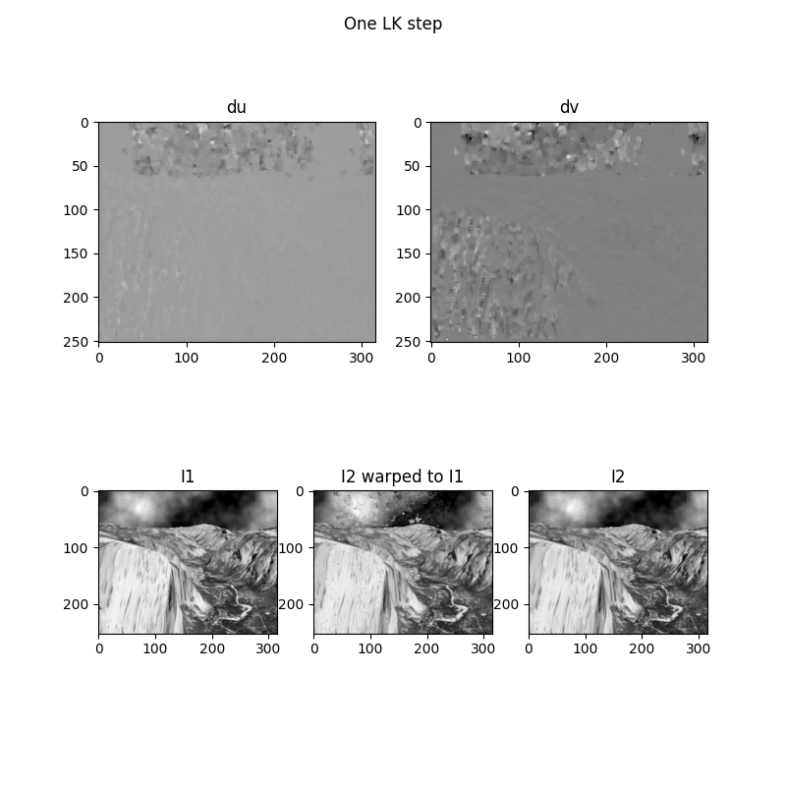

As we can see, the displacement maps reveal that motion estimation is only picking up noisy, localized adjustments, focusing mainly on highly textured structural boundaries like the upper mountain ridges and the waterfall base, while leaving large, smooth regions flat grey (zero motion estimation). When we look at I2 warped to I1, the warped image suffers from severe distortion, tearing artifacts, and pixelated noise in the sky and mountain areas. This indicates that a single LK step at full resolution completely fails to reconstruct a clean transformation matrix between the two frames, leaving them visibly misaligned.
4.2. The one-step LK result is highly imperfect because the physical movement between I1 and I2 violates the fundamental mathematical constraints the optical flow estimation. As we have seen in lecture, LK algorithm relies on a first-order Taylor series approximation, which is strictly valid only for tiny, sub-pixel displacements. Because the actual motion in this video involves relatively large displacements (such as the rapid flow of the water and camera jitter), a single step operating on a small $5× 5$ window can neither register the movement nor converge on the true velocity vectors. Moreover, smooth and uniform areas like the sky suffer heavily from the aperture problem and a lack of spatial gradients, meaning the local neighborhood does not provide enough distinct directional information to solve the over-determined system of equations reliably.
6. After running the full LK algorithm, we receive the following results:
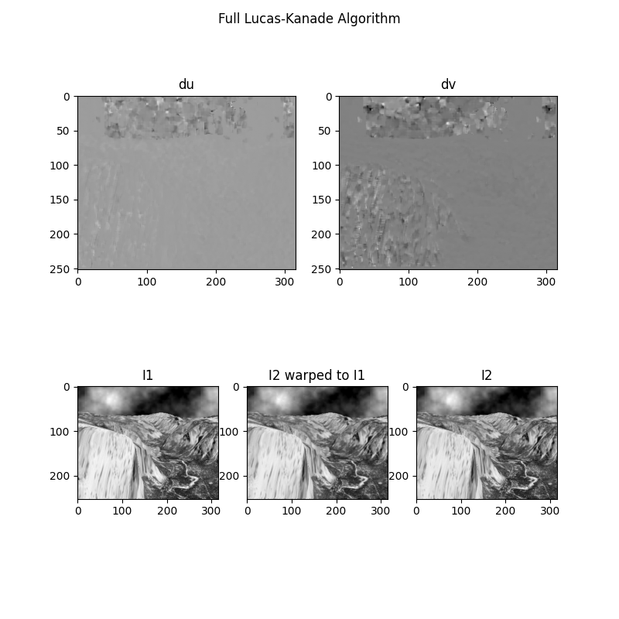
As we can see, the new results demonstrate a significantly improved motion estimation compared to the single step version. The velocity maps ($du$ and $dv$) are much smoother and describe in much cleaner and coherent way the global motion field across the mountain structures and water regions. Looking at I2 warped to I1, the severe distortion, tearing artifacts, and black and white noisy spots that plagued the sky and textured borders in the one step process are completely resolved. The warped frame $I_{2}$ matches the target frame $I_{1}$ almost perfectly, validating that multi-step iterative updates accurately alignment the image structures.
The new gif output looks much better than the single-step version because the multi-resolution image pyramid overcomes the displacement limitations of the LK algorithm. By downsampling the images to higher pyramid levels, large physical frame-to-frame movements are reduced to tiny, sub-pixel shifts at the reduced scale, satisfying the mathematical validity of the first-order Taylor series approximation. The algorithm can then reliably solve for these large motion vectors at a small resolution and propagate them down as starting estimates for lower levels. This iterative warping enables the system to track both large-scale camera translations and fine, high-frequency textural motions without breaking down or producing interpolation artifacts.

