**Bunny's Big Day**

The morning sun peeked through the trees.  
Bunny jumped out of bed with excitement.  
"Today is my big day!" he shouted happily.

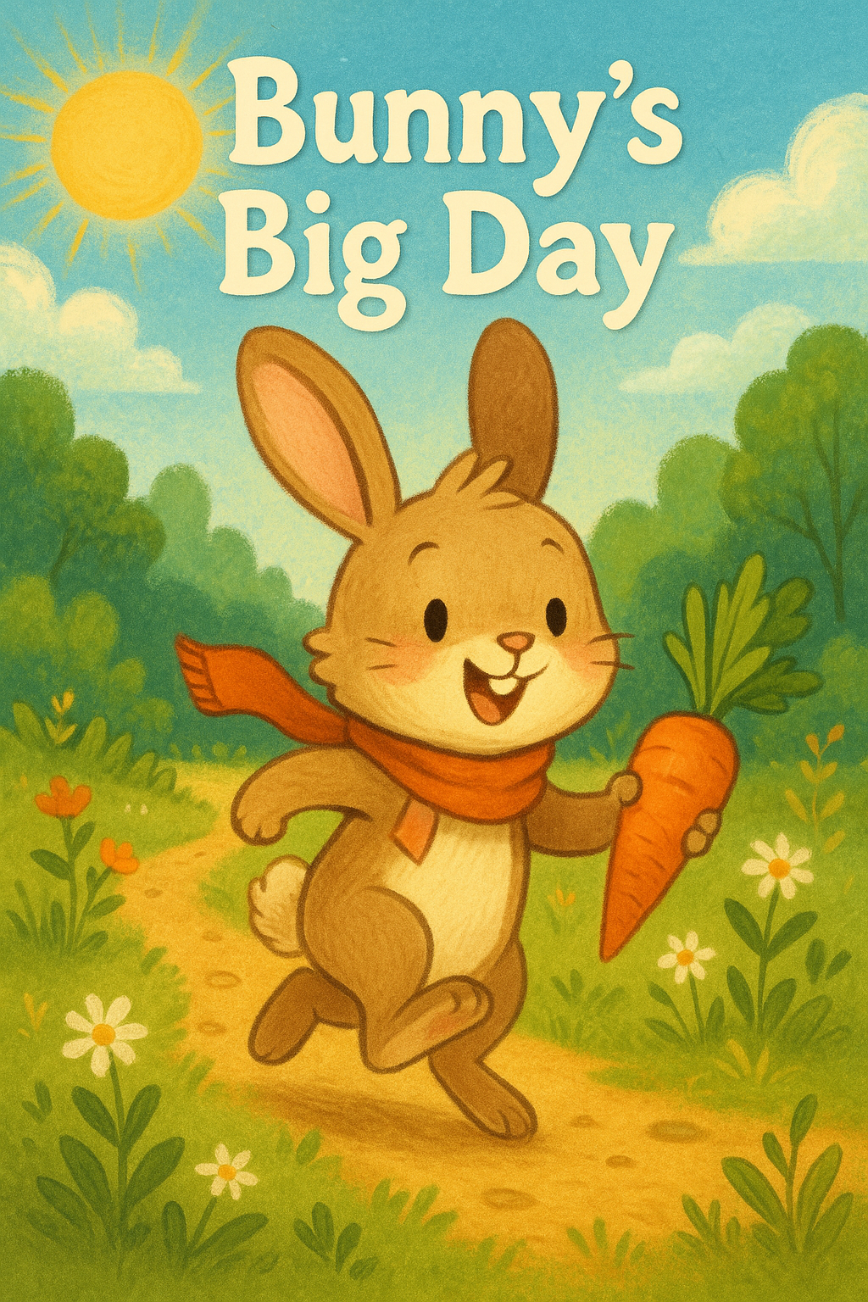He brushed his ears, tied his favorite scarf, and bounced outside.  
On the path, he met his friend Tommy the Turtle.  
"Where are you hopping so fast, Bunny?" asked Tommy.  
"I'm going to find the biggest carrot in the whole forest!" Bunny said proudly.

Bunny hopped past flowers, leaves, and buzzing bees.  
Then he saw it—an enormous carrot sticking out of the ground!  
"That’s the one!" he said, eyes wide.

He pulled... and pulled... and PUUULLLED—  
POP! Out came the carrot, and Bunny tumbled back, giggling.

Later, Bunny and Tommy sat together, munching on the big carrot.  
"This was the best day ever," Bunny whispered with a smile.  
And as the sun slowly set, the sky winked goodnight.