**Milo and the Magic Hat**

Milo was a curious little boy with a big imagination.  
One rainy afternoon, he found an old, dusty hat in the attic.  
It was tall and pointy, with stars that sparkled.

As soon as he put it on—POOF!  
A swirl of colors filled the room.  
"Wow! Is this... a magic hat?" Milo gasped.

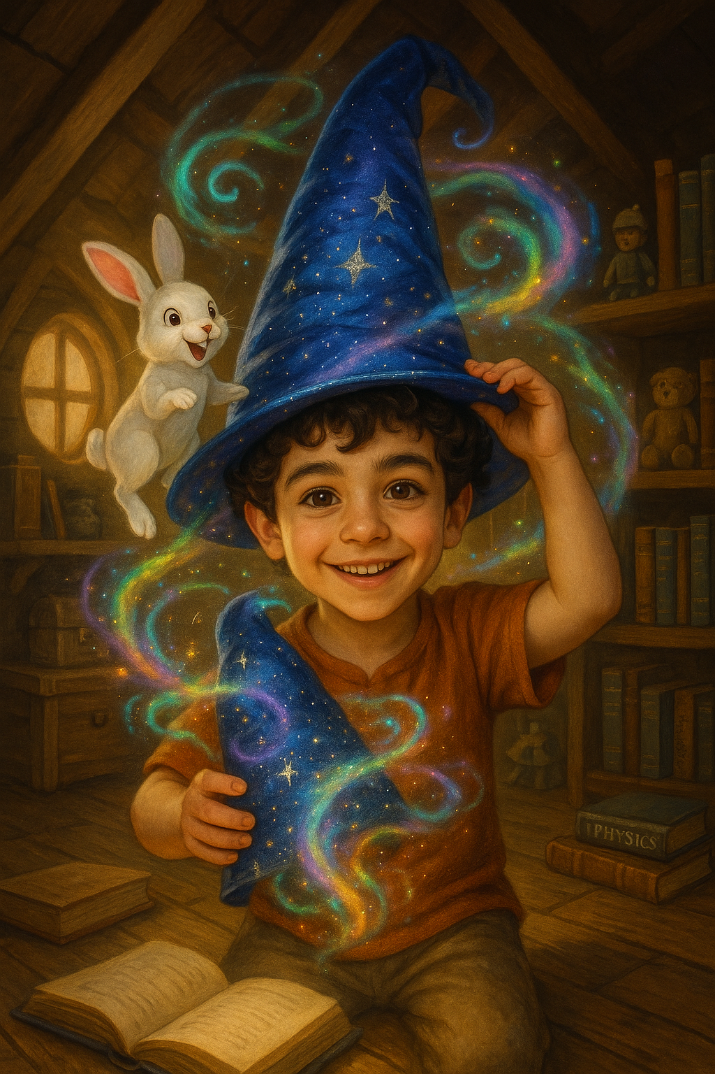Suddenly, a fluffy bunny popped out of the hat!  
"Hello!" the bunny said.  
Milo’s eyes grew wide. "You can talk?!"

"Of course I can!" said the bunny, hopping in circles.  
"Let’s go on an adventure!"

With a swirl and a spin, the hat lifted them into the air.  
They flew over mountains, dipped through clouds, and danced with stars.

When they landed back in Milo’s room, the bunny gave him a wink.  
"Whenever you wear the hat, magic will find you."

Milo smiled and placed the hat gently on the shelf.  
He couldn’t wait for his next adventure.  
But for now—it was bedtime.