**The Island of Whispers**

Nobody knew exactly where the Island of Whispers was.  
Some said it drifted across the sea like a forgotten dream.  
Others claimed they had heard voices from it on quiet nights.

Talia, an 11-year-old girl with curious eyes, had always believed it was real.  
One evening, while walking by the shore, she found a bottle.  
Inside was a small map—and a single word: "Come."

Talia built a small raft and followed the stars.  
For days, the ocean whispered secrets in the wind—until she saw it.  
A quiet island, covered in mist, waiting.

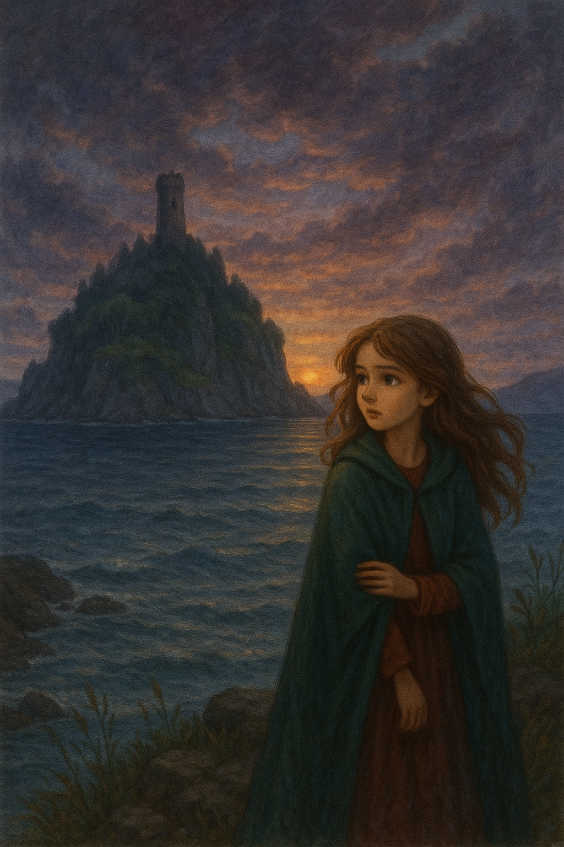As she stepped onto the shore, she heard faint whispers.  
They weren’t scary—just soft voices, like distant memories.  
“Who’s there?” she asked aloud.  
No answer came, but the whispers grew warmer, almost welcoming.

Talia explored the island.  
She found trees with leaves shaped like ears, caves that echoed her thoughts, and a pond that shimmered with voices.  
Each place seemed to carry a story.  
In one tree trunk, she saw carvings: names, drawings, and messages.

This island, she realized, remembered things—people, feelings, even dreams.  
It was a home for forgotten voices.  
But why had it called her?

At the heart of the island stood a stone circle.  
When she entered it, the whispers became clear.  
“Talia... thank you for listening.”

Suddenly, she saw a vision of a girl who looked just like her—  
alone, scared, and silent.  
It was her, from years ago, when she had lost her mother.  
She had buried that sadness deep inside.  
The island had felt it. It had heard her silence.

Tears filled Talia’s eyes—but she smiled.  
“I'm ready to remember,” she whispered.  
She sat by the pond, let the memories flow,  
and spoke to the wind, the trees, and the stars.

When she left the island, it didn’t disappear.  
It stayed in her heart—a place where forgotten feelings could live and be heard.  
From that day on, Talia listened more closely to the world.  
Because sometimes, the quietest things have the most to say.