**Zara's Space Journey**

Zara lived on a small, dusty planet called Luma-7.  
She dreamed of stars, galaxies, and what lay beyond the silver clouds.  
Her people believed it was too dangerous to leave.  
“But how will we ever know what’s out there if we never try?” she asked.

One night, under a sky full of shimmering moons, Zara discovered a hidden ship buried beneath the sand—  
old, broken, and forgotten.  
She spent weeks fixing it, guided only by hope, blueprints, and the stars above.

When the engine roared to life, Zara climbed in with a deep breath.  
She waved goodbye to her quiet planet and blasted into space.

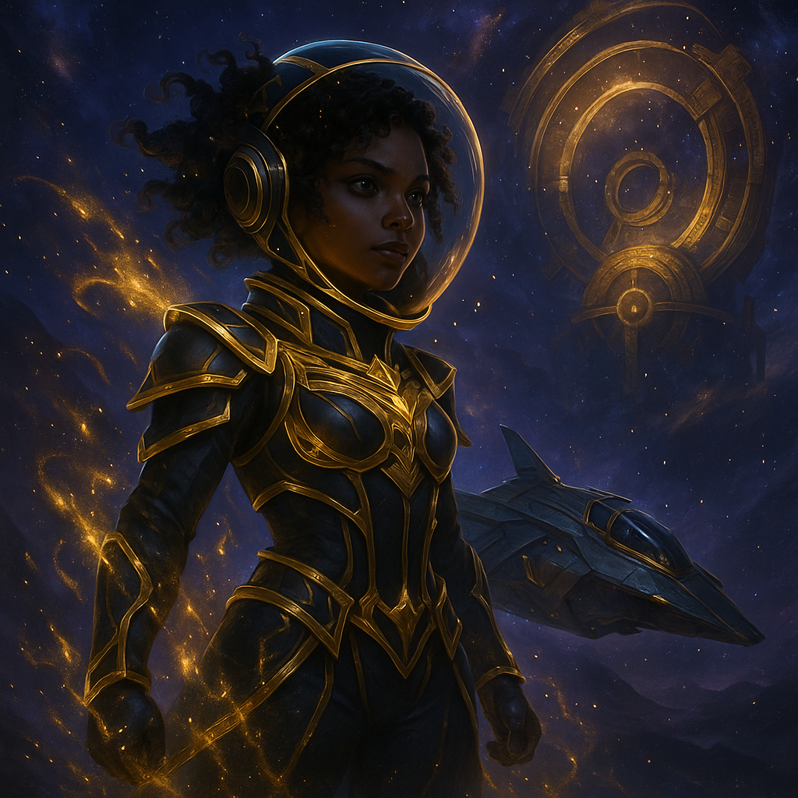At first, it was silence.  
Then—colors, lights, and movement.  
She passed icy comets, glowing nebulae, and spinning asteroid belts.  
Zara felt small but strong, alone but alive.

On the third day, a strange signal blinked on her screen.  
“Unknown Lifeform Detected.”  
She followed it to a floating station surrounded by blue rings.

Inside, she met creatures of light and energy—no words, just feelings.  
They showed her memories of stars being born, of ancient travelers, of galaxies dying and starting again.

Zara listened, learned, and shared her own story.  
She didn’t feel like a visitor. She felt like part of something bigger.

But space is vast—and even brave explorers feel fear.  
When her ship was pulled into a dark gravity field, alarms screamed.  
Zara gripped the controls and remembered what the light-creatures had taught her:  
“Trust the unknown. Use your mind. Use your heart.”

She rerouted the engine, used the black hole’s spin, and launched free—faster than she ever thought possible.

When Zara returned to Luma-7, the people gathered in silence.  
She told them everything. The stars. The creatures. The beauty. The danger. The wonder.

“Were you scared?” a child asked.  
“Yes,” Zara smiled. “But I went anyway.”

From that day on, Luma-7 changed.  
They built observatories, learned the skies, and listened to the stories of the stars.  
And every night, Zara looked up and whispered,  
"There’s always more to discover."