Rename Column Names in Pyspark
df=df.withColumnRenamed("old_column_name","new_column_name") – To rename a column name
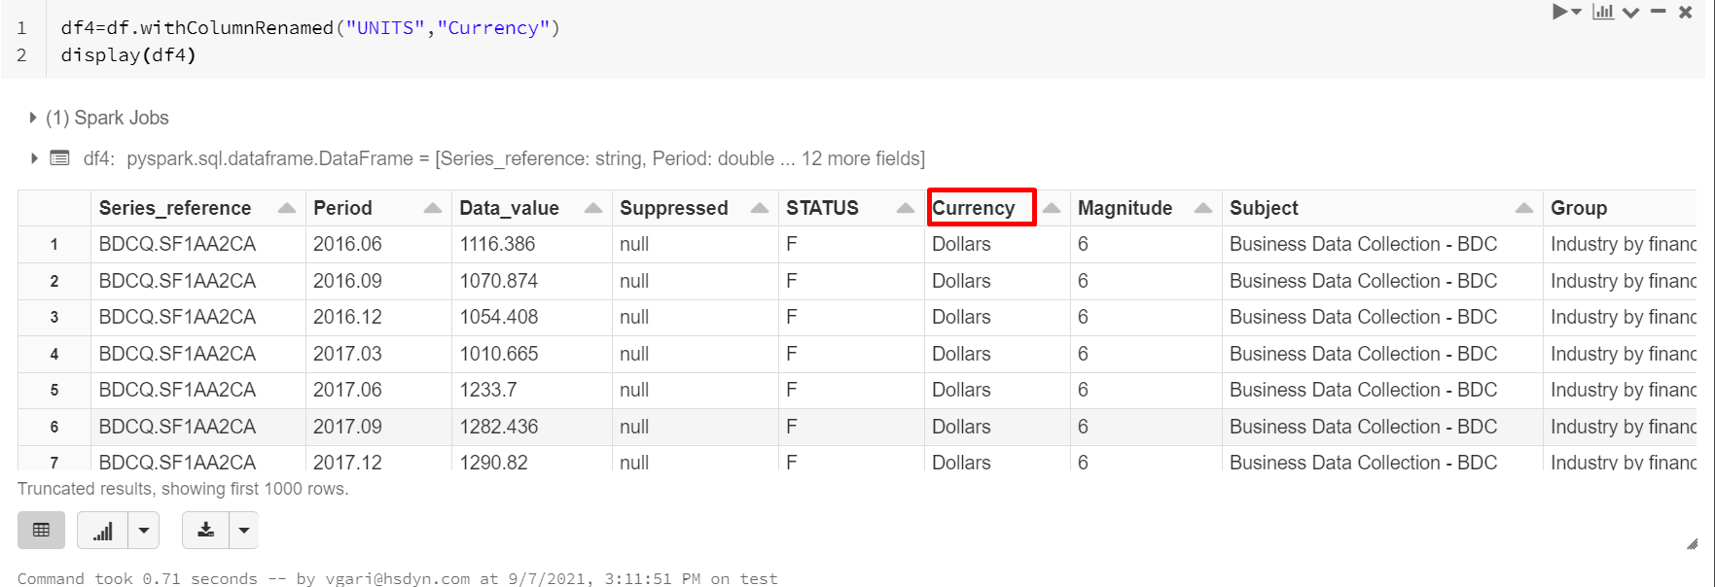

df=df.withColumnRenamed("old_column_name","new_column_name").withColumnRenamed("old_column_name","new_column_name").withColumnRenamed("old_column_name","new_column_name") – To rename multiple column names
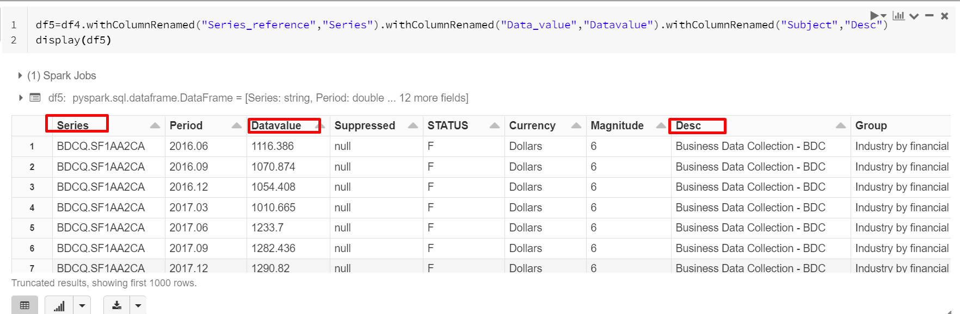

df=df.selectExpr("Data_value as value","UNITS as UNITS1","Period as Time_Period") – This can be used to rename the column but since we have selectExpr, only the selected column will come into dataframes
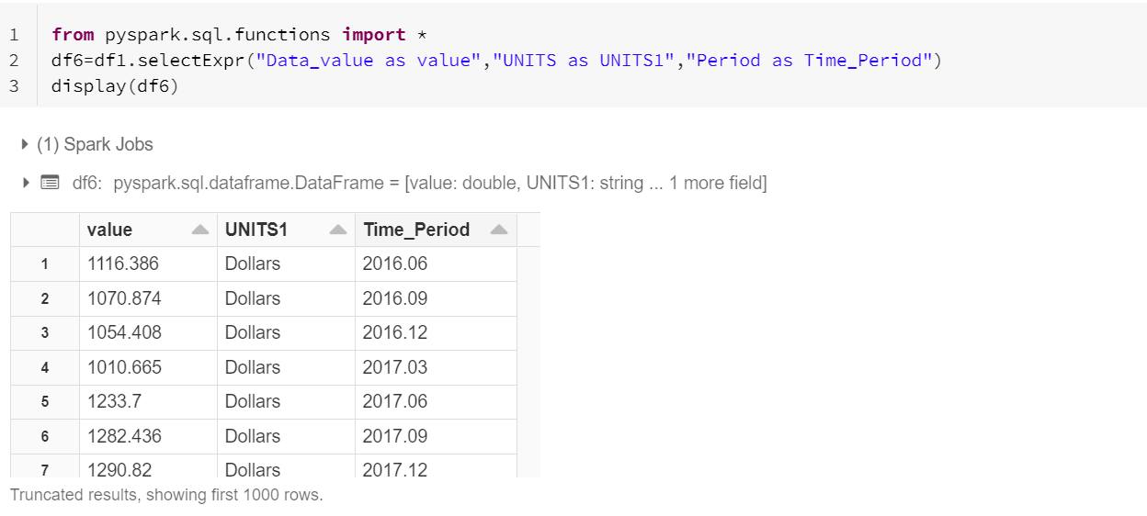

df1=df.select(col("old_col_nm").alias("new_col_nm"),col("old_col_nm2").alias("New_col_nm_2")) – This can be used to rename the column but since we have select(col), only the selected column will come into dataframes
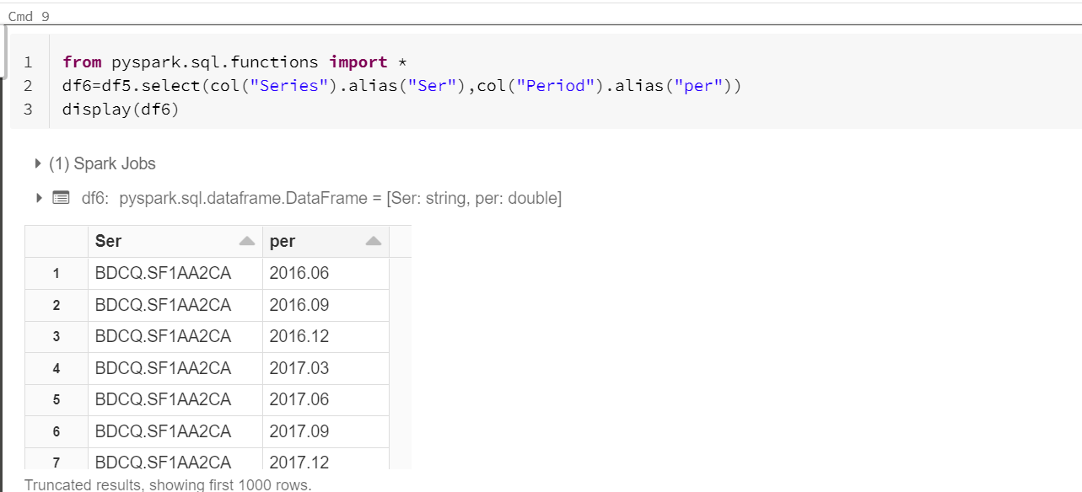

ADD Columns in DataFrames in PySpark:

Below DF8 have 4 columns, now add the new column
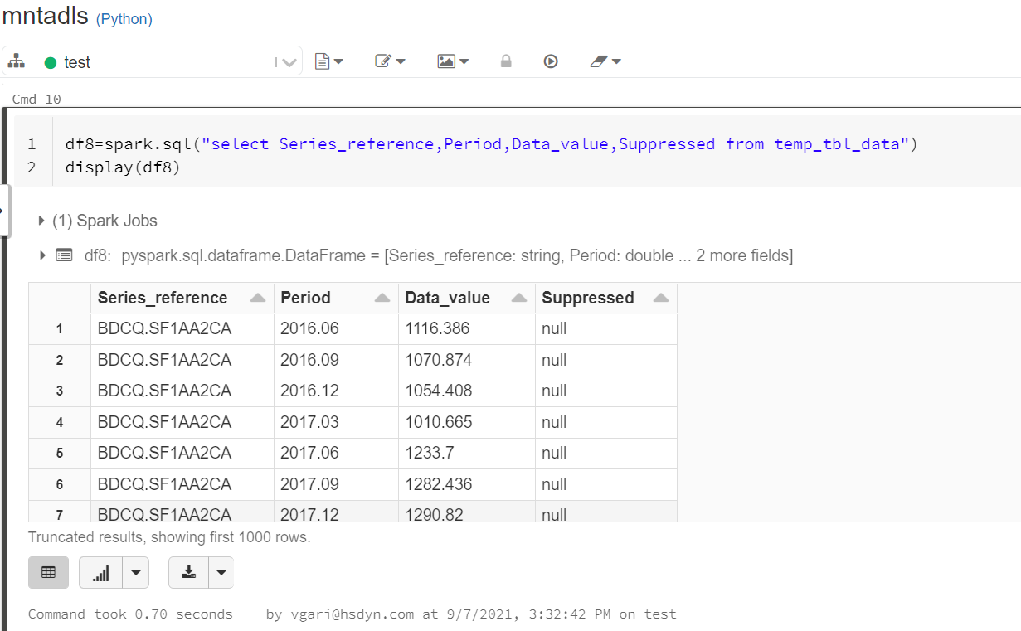
df1=df1.withColumn("new_column_nm",lit("default value")) – For adding current date
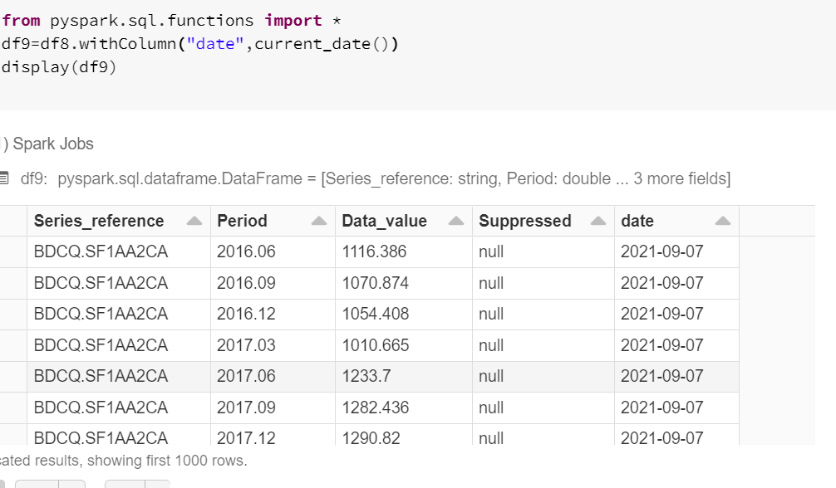

Add new column with default value:
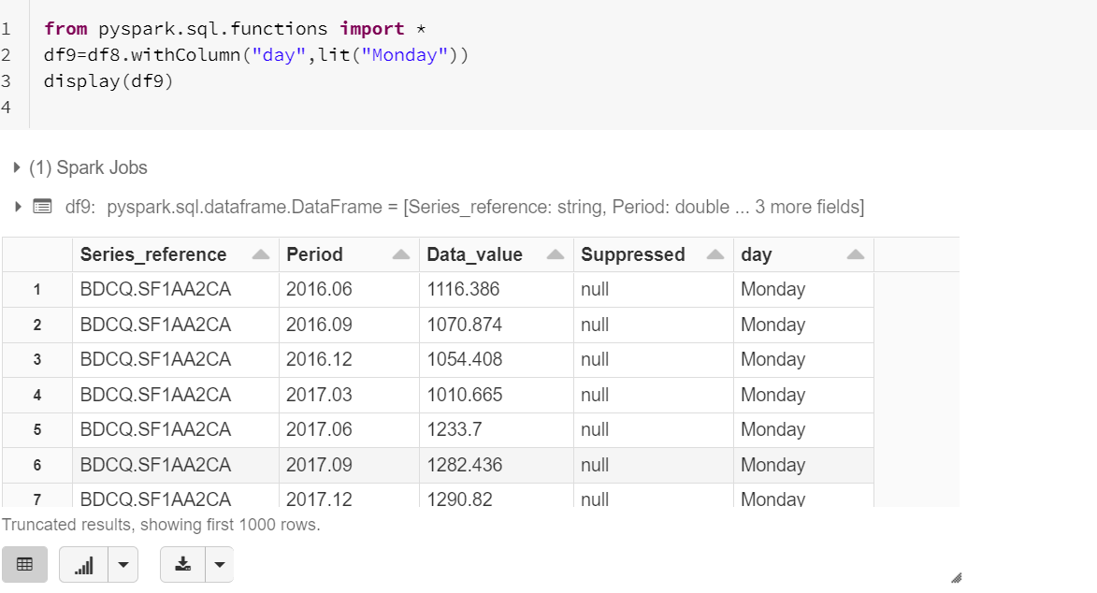
Add a new column with data of another column- Add a new column with Price as of Data_Value Column
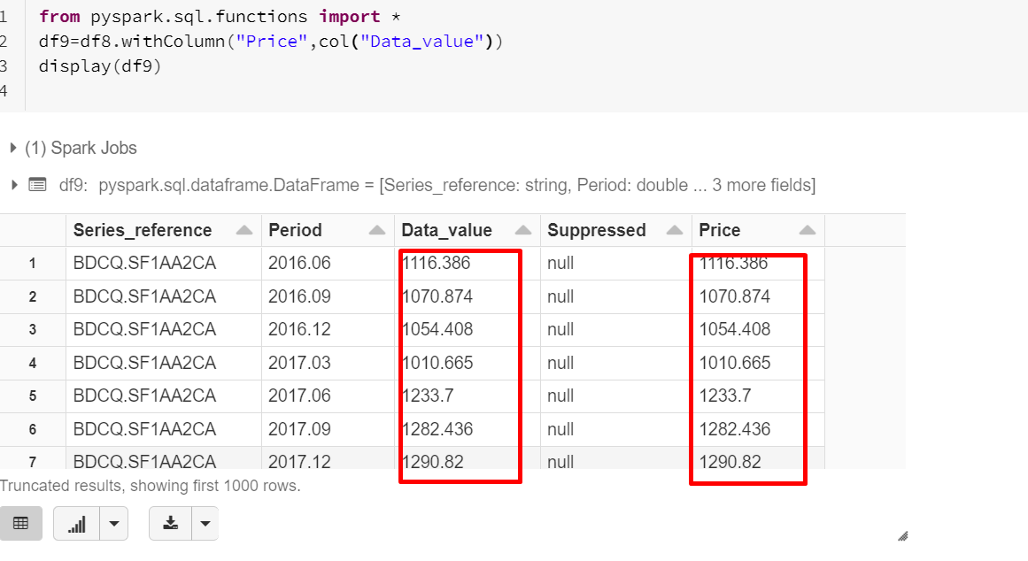

df2=df1.withColumn("sal",col("New_data_value")*10) – for doing column aggregation and get a new column
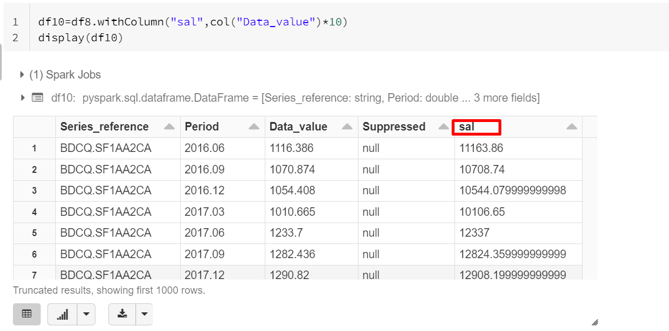
df3=df.select(col("Period"),col("UNITS"),col("Subject"),lit("India").alias("Country")) – We can select required columns and add new columns as well

Filtering Data in PySpark:
df.filter(df.column_nm==value) – similar to where clause in SQL
df.filter(col("Column_nm")==value)
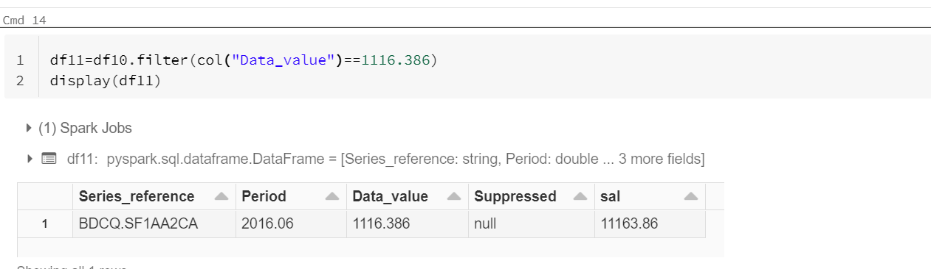

df12=df10.filter((col("Data_value")==1116.386) | (col("Period")==2017.03)) – We can use Boolean functions like AND (&) OR(|) NOT(!=)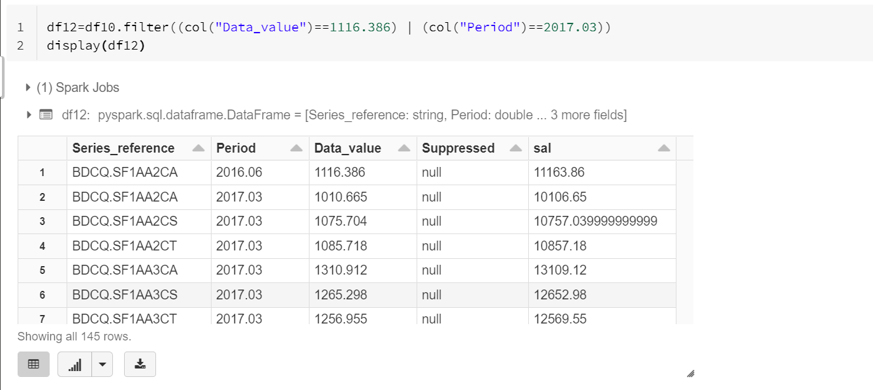
Filter condition with Select - This will filter out as per filter condition and select particular columns as per select statement.
df12=df10.filter((col("Data_value")==1116.386) | (col("Period")==2017.03)).select ("Series_reference")
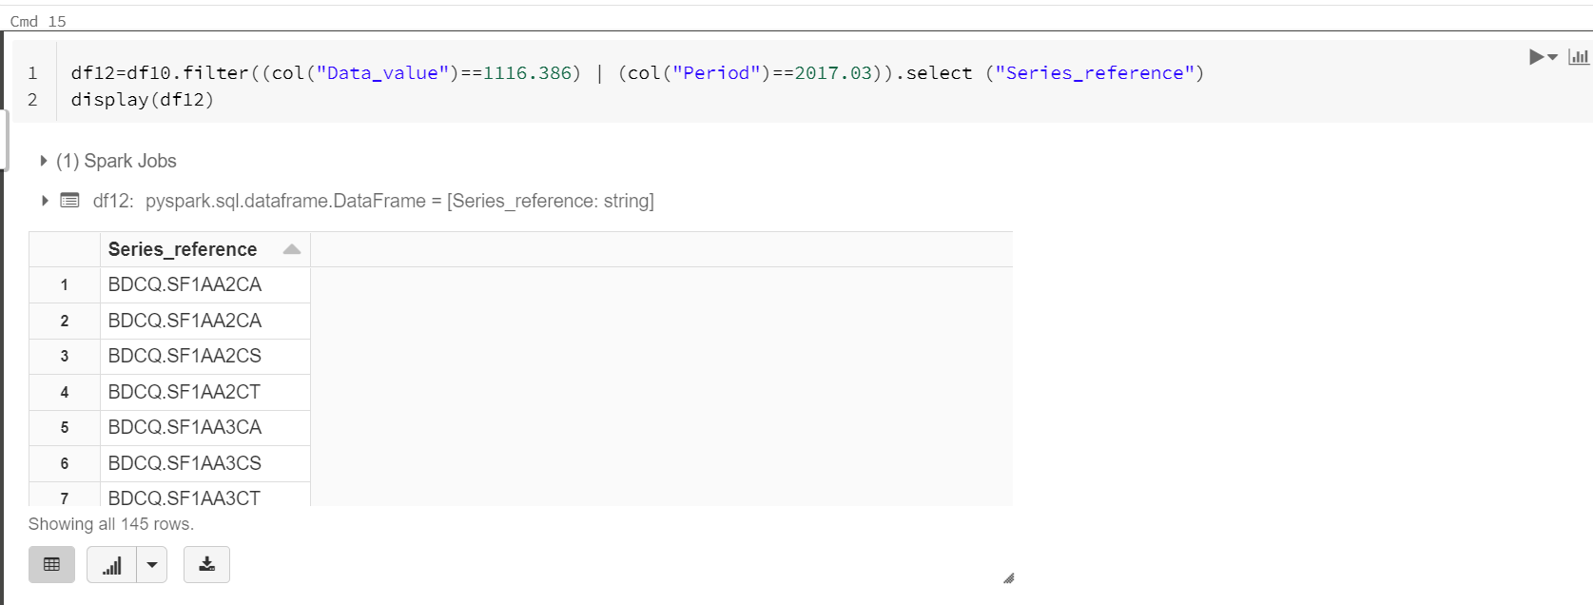

Sorting Data in PySpark:

Default is Ascendiing
df2=df.sort(df.col_nm.desc(),df.col_nm2.asc())
df2=df.orderby(df.col_nm.desc())
df2=df.orderBy(col("col_nm").desc())

Remove Duplicates in PySpark:
df3=df2.distinct()
df4=df.dropDuplicates(["Column_1","Column_2",.."Column_n"])

GroupBy in PySpark:
df5=df4.groupBy('column_1').max('column_2')

Merging Two Dataframes:
df3=df.union(df1) - Merge with duplicates
df3=df.union(df1).distinct() - Merge without duplicates

If Else in PySpark:
df4=df3.withColumn("State_new",when(col("State")=="UP","UttarPradesh").when(col("State")=="TN","Tamilnadu").when(col("State")=="AP","Andhrapradesh").otherwise("Unknown"))

Joins in PySpark:
df.join(df1,df.Emp_ID==df1.Emp_ID,"right").show() – Join two df
df.alias("A").join(df1.alias("B"),col("A.Emp_ID")==col("B.Emp_ID"),"right").show() – Join with alias name
df.alias("A").join(df1.alias("B"),col("A.Emp_ID")==col("B.Emp_ID"),"right").select(col("A.Emp_ID").alias("Emp_ID_A"),col("B.State").alias("State_B")).show() – Join with selecting column
“right” – Right Join
“left” – Left Join
“outer” – Outer Join
“inner” – Inner Join

