

**A**

**PROJECT REPORT**

**FOR**

**SUBJECT: LAB II- PROJECT PHASE II**

**ON**

**“Farmy- A smart website for connecting farmers and agricultural authorities.”**

Submitted in partial fulfillment of the requirement for the award of

**Bachelor of Engineering**

**In**

**Computer Science and Engineering**

**Punyashlok Ahilyadevi Holkar Solapur University**

By

|  |  |
| --- | --- |
| **Mr. Venu Devidas Bura.** | **56** |
| **Mr. Hemant Vasudev Dyavarkonda.** | **57** |
| **Mr. Omsai Gopal Kalekar.** | **58** |
| **Mr. Mahesh Sanjiv Rachha.** | **59** |

Under the Guidance of

**Mr. N. S. Gajjam**



**DEPARTMENT OF COMPUTER SCIENCE AND ENGINEERING**

**WALCHAND INSTITUTE OF TECHNOLOGY**

**SOLAPUR - 413006**

**(2020-2021)**



**Certificate**

This is to certify that the project entitled

**“Farmy- A smart website for connecting farmers and agricultural authorities.”**

Is submitted by

|  |  |
| --- | --- |
| **Mr. Venu Devidas Bura.** | **56** |
| **Mr. Hemant Vasudev Dyavarkonda.** | **57** |
| **Mr. Omsai Gopal Kalekar.** | **58** |
| **Mr. Mahesh Sanjiv Rachha.** | **59** |

**(Prof. Mr. N. S. Gajjam) (Dr. Mrs. A. M. Pujar)**

***Project Guide Head***

**Dept of Computer Sc. & Engg**

**(Dr. S. A. Halkude)**

**Principal**

**DEPARTMENT OF COMPUTER SCIENCE AND ENGINEERING**

**WALCHAND INSTITUTE OF TECHNOLOGY**

**SOLAPUR**

**(2020-2021)**

**Project Approval Sheet**

The Project Entitled

**“Farmy- A smart website for connecting farmers and agricultural authorities.”**

Submitted by

|  |  |
| --- | --- |
| **Mr. Venu Devidas Bura.** | **56** |
| **Mr. Hemant Vasudev Dyavarkonda.** | **57** |
| **Mr. Omsai Gopal Kalekar.** | **58** |
| **Mr. Mahesh Sanjiv Rachha.** | **59** |

“Is hereby approved in partial fulfillment for the degree of

Bachelor of Computer Science and Engineering”

**(Prof. Mr. N. S. Gajjam) (Dr. Mrs. A. M. Pujar)**

***Project Guide Head* Dept of Computer Sc. & Engg.**

(**Dr. S. A. Halkude) *Principle***

**DEPARTMENT OF COMPUTER SCIENCE AND ENGINEERING**

**WALCHAND INSTITUTE OF TECHNOLOGY**

**SOLAPUR - 413006**

**(2020-2021)**

**Acknowledgment**

At the outset, we would like to take this opportunity to express our deep gratitude to our guide **Mr. N. S. Gajjam** of the CSE Department for his guidance and moral support throughout this successful completion of our project.

We heartily thank **Dr. Mrs. A. M. Pujar,** Head of CSE Dept for her moral support and promoting us through completion of our project.

We would also like to thank our Principal **Dr. S. A. Halkude** and all staff members for their whole hearted cooperation in completing this project.

**UNDERTAKING**

We solemnly declare that project work presented in the report titled **“Farmy- A smart website for connecting farmers and agricultural authorities.”** is solely my project work with no significant contribution from any other person except the project guide. Small contribution/help wherever taken has been duly acknowledged and that complete report has been written by the members of the project group.

We understand the zero tolerance policy of the WIT, Solapur and University towards plagiarism. Therefore we as Authors of the above titled report declare that no portion of the report has been plagiarized and any material used as reference is properly referred / cited.

We undertake that if found guilty of any formal plagiarism in the above titled report even after award of the degree, WIT, Solapur and Solapur University reserves the rights to withdraw/revoke the degree granted and that WIT, Solapur and the University has the right to publish our name on the website on which names of students are placed who submitted plagiarized report.

|  |  |  |  |
| --- | --- | --- | --- |
| Name | Exam Number | University PRN Number | Signature |
| Mr. Venu Devidas Bura |  | 2017032500248741 |  |
| Mr. Hemant Vasudev Dyavarkonda. |  | 2017032500247351 |  |
| Mr. Omsai Gopal Kalekar. |  | 2017032500248717 |  |
| Mr. Mahesh Sanjiv Rachha. |  | 2018032500235946 |  |

Date: / / 2021

**Abstract**

In India, Most of the farmer's face issues regarding crop, weed, pest damage, disease damage, nutrient deficiency ,etc. but they have no proper guidance about how to solve them and keep their farm on the track. Apart from this, the indian farmers do not have any knowledge about the amendment bills issued by indian government and specially, the farmers living in villages do not have any idea about what’s going on in the farming sector and market.Also, Farming living in rural areas have no idea of weather conditions of their native location where they grow crops.

So, Solution to the problem mentioned above is, Firstly to develop a smart and intelligent responsive website for solving all the issues of farmer’s by connecting them to their local agricultural officer.Secondly, proving them the information about the latest or current news feeds and amendment bills on farming.Lastly, alerting them about their native locations weather conditions using the same platform from which they are expecting there issues to be solved.

Hence, a Smart web application named **“Farmy”** has been designed in such a way that it can fulfill the needs of the farmers. It has many features which can be used in different environments and scenarios. For instance, Farmers had to visit agricultural offices if they had any issues which would cost their time and money,so this web application will help farmers to connect them to the agricultural officers from their remote places.The chatbot is provided for more usability purposes which perform certain tasks . Notifications will provide the status of their queries and keep them updated.

**Index**

|  |  |  |  |
| --- | --- | --- | --- |
| **Sr. No.** | **Title** | | **Page No.** |
| **1** | **Introduction** | |  |
|  | 1.1 | Introduction | **08** |
|  | 1.2 | Problem Statement and Objective | **08** |
| **2** | **Background** | | **10** |
| **3** | **Proposed Solution** | |  |
|  | 3.1 | Solution | **11** |
|  | 3.2 | Advantages of proposed system | **11** |
| **4** | **Working Environment** | |  |
|  | 4.1 | Hardware Requirements | **13** |
|  | 4.2 | Software Requirements | **13** |
| **5** | **Methodology** | |  |
|  | 5.1 | System Architecture | **14** |
|  | 5.2 | Workflow | **15** |
| **6** | **Implementation** | |  |
|  | 6.1 | Code Snippet | **17** |
|  | 6.2 | Screenshots & Results | **18** |
| **7** | **Flow diagrams** | |  |
|  | 7.1 | Data Flow Diagrams | **19** |
|  | 7.2 | Sequential UML Diagram | **20** |
| **8** | **Future Work** | | **21** |
| **9** | **Conclusion** | | **22** |
| **10** | **References** | | **23** |

**Chapter 1**

**INTRODUCTION**

**1.1 Introduction:**

In Today’s Century, mobile devices are used by everyone, including rural farmers in India. Mobile technology is increasingly being evolved in the agricultural space as a measure to assist farmers in decision making. Most of the farmer's in India face issues regarding crop, weed, pest damage, disease damage, nutrient deficiency ,etc. but they have no proper guidance to solve and keep their farm on the track. So with the aim to guide and help farmers on these issues a platform named **“Farmy”** is introduced. This platform will solve the issues of farmers by connecting them with agricultural local officers. This platform will allow farmers to ask their questions and queries related to farming. The solution to questions asked by farmers is given by local agriculture authorities within a fraction of time in the form of text messages. Once a Farmer gets a reply on his question the system will notify or alert the farmer about the reply received through SMTP Email notification.

**1.2 Problem Statement and Objective:**

**1.2.1 Problem Statement:**

Develop a platform to connect farmers and agriculture officers to solve farmer's issues regarding crop, weed, pest damage, disease damage, nutrient deficiency etc. Questions can be asked by farmers (internet users) using texts, texts with images and can be answered, edited by agriculture officers/departments. Farmers (users) should be able to search, view questions that have been raised and their answers. Questions raised by farmers should get notified when it has been answered.

**1.2.2 Objectives:**

1. To resolve Queries of farmers by connecting them to agricultural authorities.
2. To make farmers aware about the latest feeds related to farming.
3. To Inform farmers about the weather Forecast.
4. MiddleMan Elimination.
5. To provide a chatbot for a smooth interface and getting ideas about our platform.

**Chapter 2**

**BACKGROUND**

* All the Apps and websites related to farmers and farming has certain limitations like ,

1) We can ask questions on limited crops only.

2) Not user-friendly UI.

3) As apps are mobile applications, we can not use them on a desktop,laptops etc.

4) The video question facility is unavailable.

so,we rectified all these limitations by providing proper solutions over them and added some extra features.

* Mobile devices are used by everyone, including rural farmers in India. Mobile technology is massively being evolved in the agricultural space as a measure to assist farmers in making decisions.
* Over the last period of time farmers have to visit the agriculture office if they face any of the issues.
* Keeping an eye on the current situation due to this covid-19 strain, Travelling was a major issue for farmers. If a problem persists then travelling all the time is not safe and efficient for farmers to find solutions to their issues. A platform is to be developed where they can directly ask authorities to solve their issues from remote locations without travelling anywhere, once the issue is solved farmers are notified with the help of Email or SMS.
* Government issues bills on farming every quarter of the year,but farmers are unaware about what that bill is about,so to make them aware about bills the “Amendment bills” facility is provided.

**Chapter 3**

**PROPOSED SOLUTION**

**3.1 Solution:**

The solution to the problem statement listed above is to “Develop an advanced responsive website which will connect farmers and local agricultural authorities together,so that each and every issue of farmers will get solved within a shorter amount of time.” and for making them aware about current trends,bills and news we’ll provide a separate section on the website so that they can read those and keep themselves updated. Talking about weather conditions we’ll notify them if bad weather is approaching their native location plus they do have the privilege to check the current and next 5 days weather of any of the locations.

**3.2 Advantages of the proposed system:**

1. **Fast and Assured replies:**

As soon as you put your issue on the platform the issue will be transferred to your local agricultural authorities dashboard,so that he/she will answer it. Your issue will be solved on the basis of “**First Come & First Serve**” manner.

1. **Email notification:**

Every farmer will receive Email notification through SMTP (simple mail transfer protocol) wherever the agricultural authority replies to their question or while resetting password farmers will receive an OTP on email.

1. **Mobile responsiveness:**

The entire project is built in such a way that it will work on any of the compatible devices such as mobiles, desktops, laptops or tablets.

1. **Innoxious:**

While farmers are putting up issues on the platform and agricultural authority answering those issues, both issues and solutions will be passed through the toxic comment classifier to avoid toxicity and to maintain positivity on the platform.

1. **Secure:**

an OTP will be provided to you if you are resetting your password to re verify that the particular account belongs to you.

**Chapter 4**

**WORKING ENVIRONMENT**

**4.1 Hardware Requirements:**

In this project we don’t need any specialized hardware. But we just need a good configuration development laptop consisting of 8GB RAM and Intel Core processor running on Windows or Apple Mac.

**4.2 Software Requirements:**

The software and the technologies used in this project are as follows:

**A. Python:**

* **Django Web Framework**
* **Chatter BOT Library**

**B. Web Development Technologies:**

* **HTML5**
* **CSS3**
* **BOOTSTRAP**
* **JAVASCRIPT**
* **JQUERY**
* **AJAX**

**C. Jupyter Notebook:**

**D. Sublime Text Editor**

**Chapter 4**

**METHODOLOGY**

**5.1 System Architecture:**

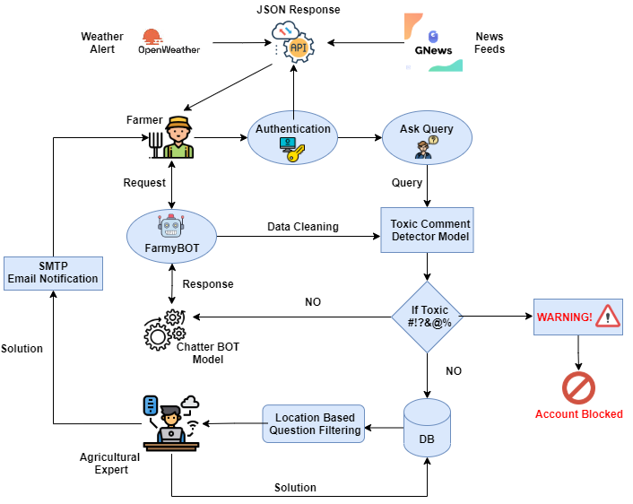

**Fig1.System Architecture.**

The above system architecture consist of three components or modules which

are,

1. Farmer or Normal user
2. Agricultural Expert
3. Admin

All three components are related to each other in such a way that if any of the above moves out then the entire system will fail.

As soon as the farmer puts his issue on the platform the entered issue will be passed through the toxic comment classifier model.Then, the classifier will predict the toxic percentage associated with the entered issue. If the predicted percentage is less than 0.70 ~ 70% then the issue will be carried forward to the local authority for getting a solution. Apart from getting issues solved farmers will also get updates on latest news related to farming, current weather, weather of next 5 days, warning alert if weather is too bad for farming.

The agricultural officers will come into picture as soon as the toxic comment classifier indicates that the entered issue is non toxic. The local authorities dashboard is updated & the latest issue of the farmer is displayed on top. All issues are solved in the “first come first serve” manner. Authority has poverty to delete the question from the platform if it seems unorthodox.

Admin will be interacting and managing the website whenever and wherever the bug comes out. The Admin will Manage website Infrastructure , Monitor Performance, Provides technical Support, Create and update web pages, Fixe bugs and issues everyday.

**5.2 Workflow:**

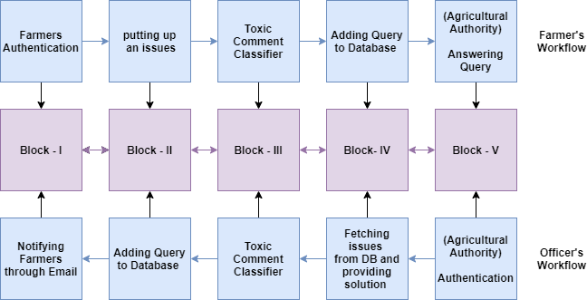

**Fig2. workflow diagram.**

The workflow of the proposed system follows the below steps:

**A. Forward Flow: (Farmer To Officer)**

**1. BLOCK-I:** Authenticating a farmer.

**2. BLOCK-II:**Putting up an issue on the platform.

**3. BLOCK-III:** Passing issues through the toxic comment classifier.

**4. BLOCK-IV:** Adding issue to database.

**5. BLOCK-V:** getting a solution from a local officer.

**B. Backward Flow: ( Officer To Farmer)**

**1. BLOCK-I:** Authenticating an agricultural officer.

**2. BLOCK-II:** Fetching issues from the database and providing solutions**.**

**3. BLOCK-III:** Passing solution through the toxic comment classifier.

**4. BLOCK-IV:** Adding solution to database.

**5. BLOCK-V:** Notifying farmers about solutions through Email.

**Chapter 6**

**IMPLEMENTATION**

**6.1Code Snippet:**

You can find the entire code on the link given below,

//github link

**6.2 Screen shots & Results:**

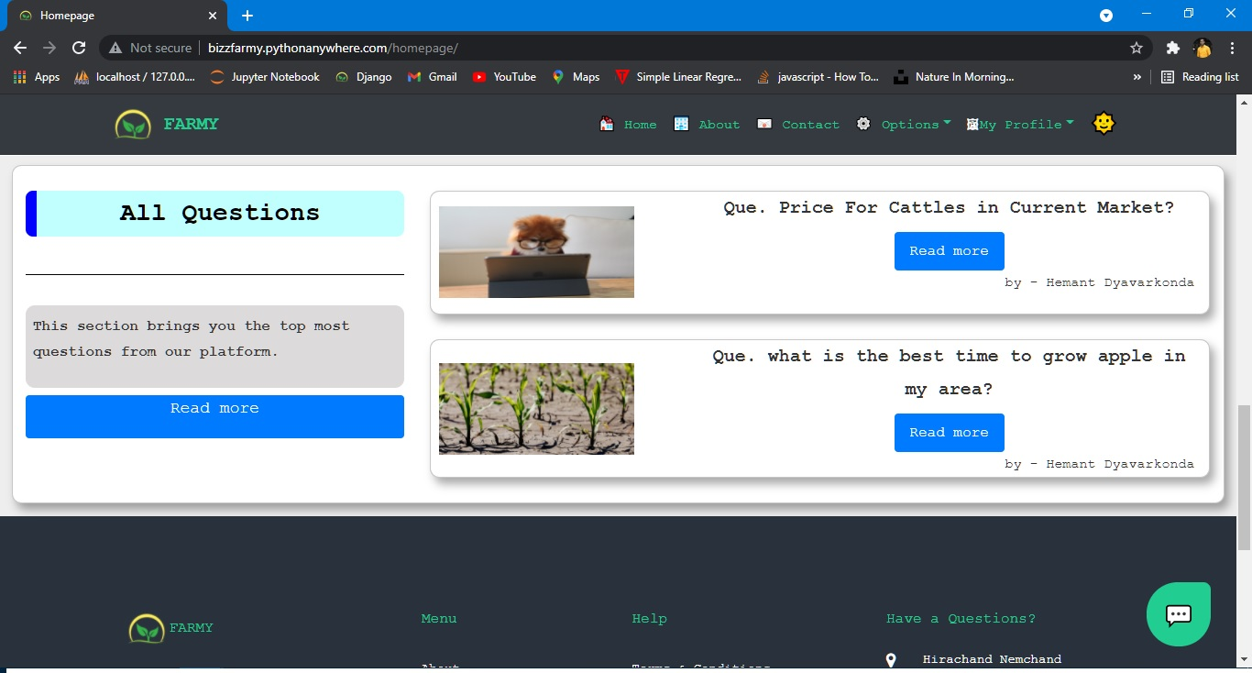

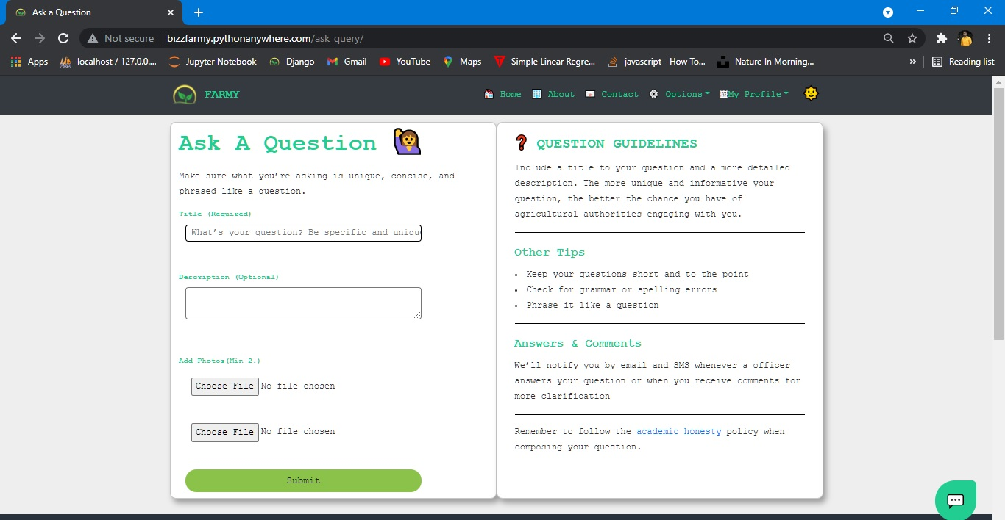

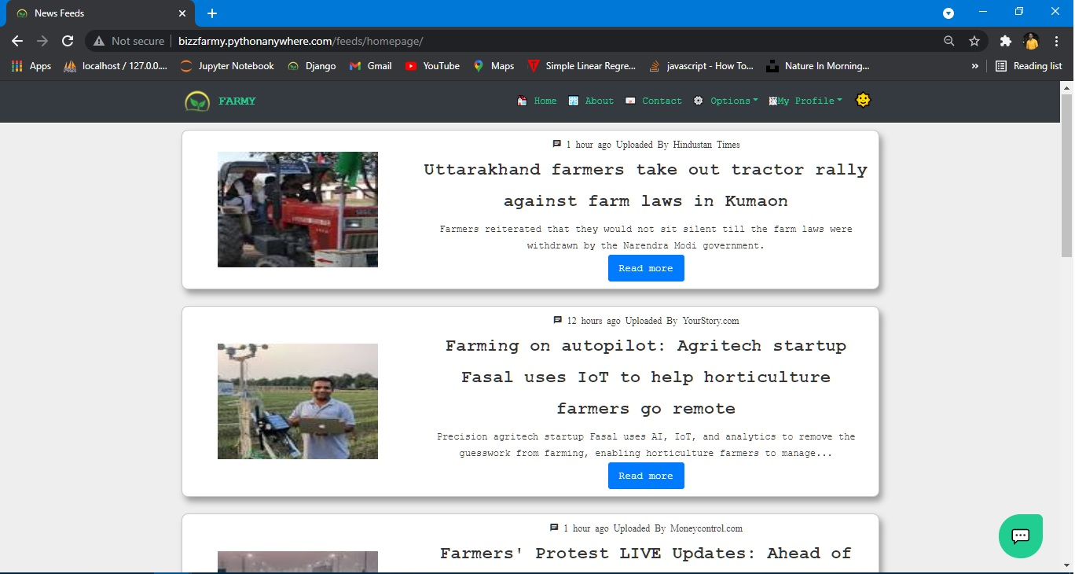

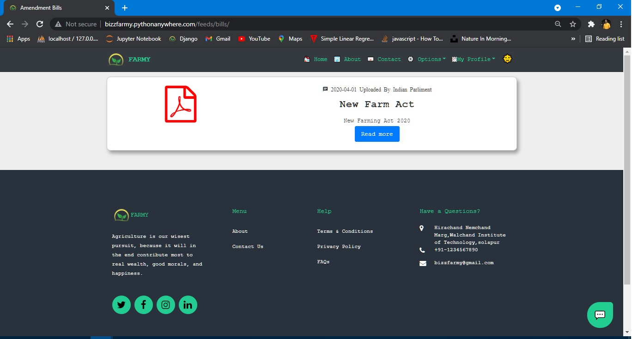

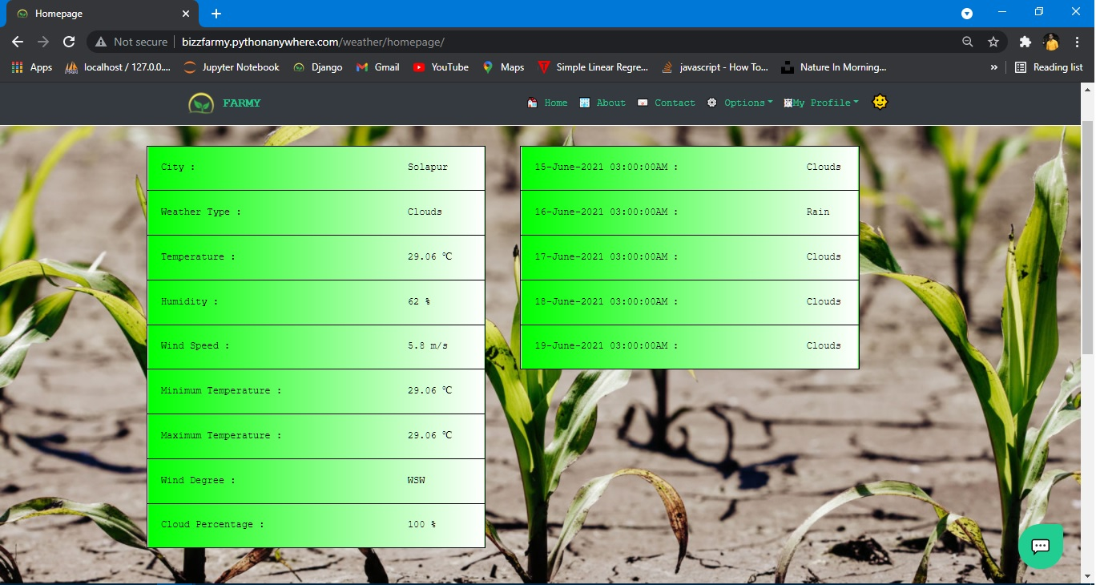

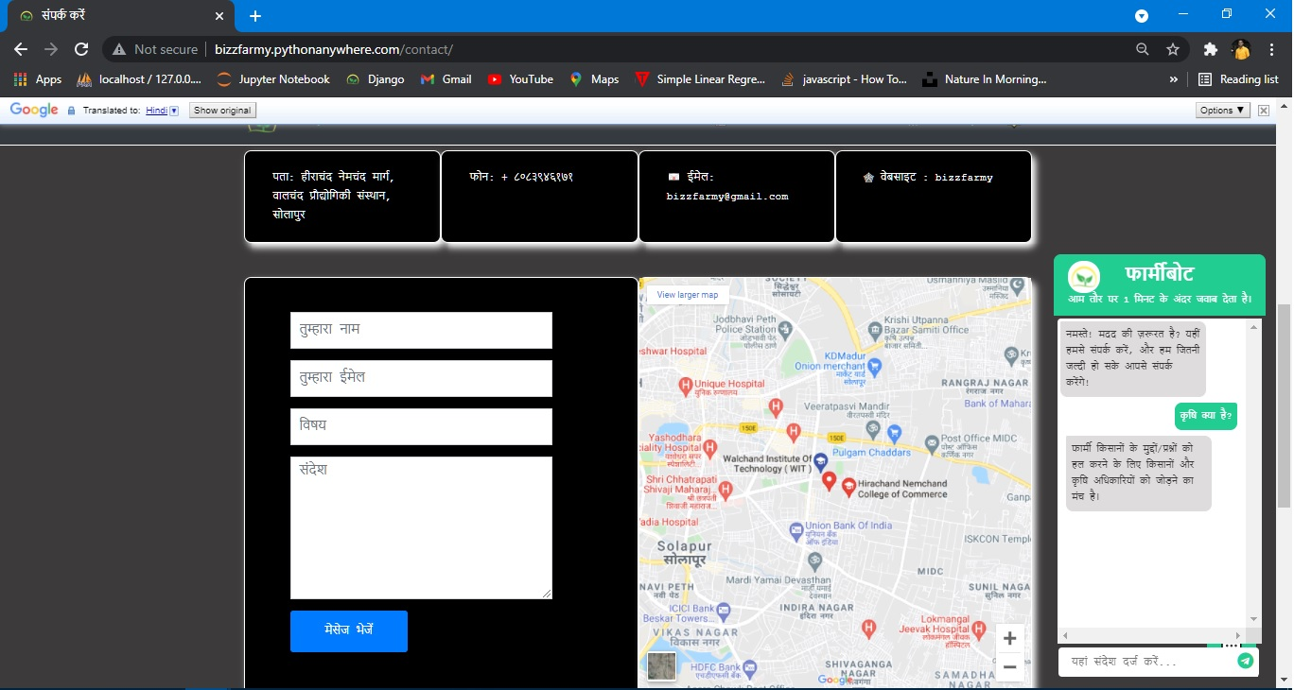

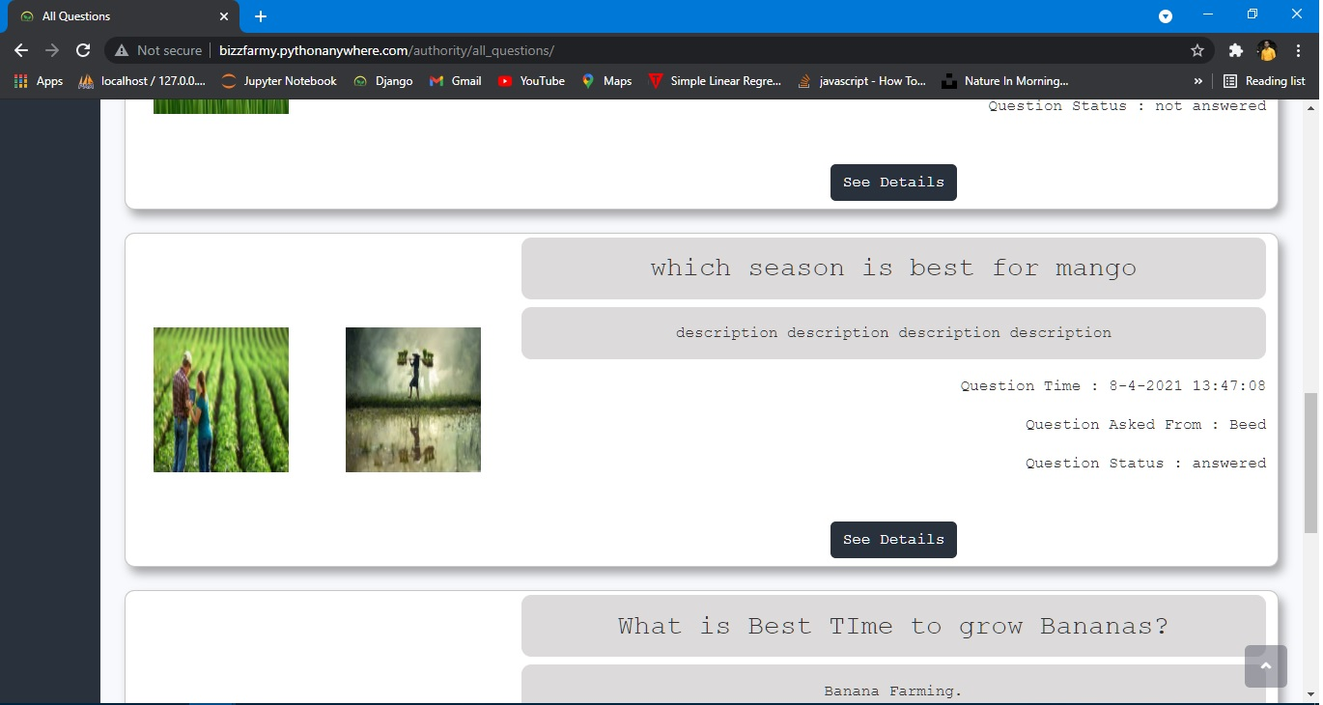

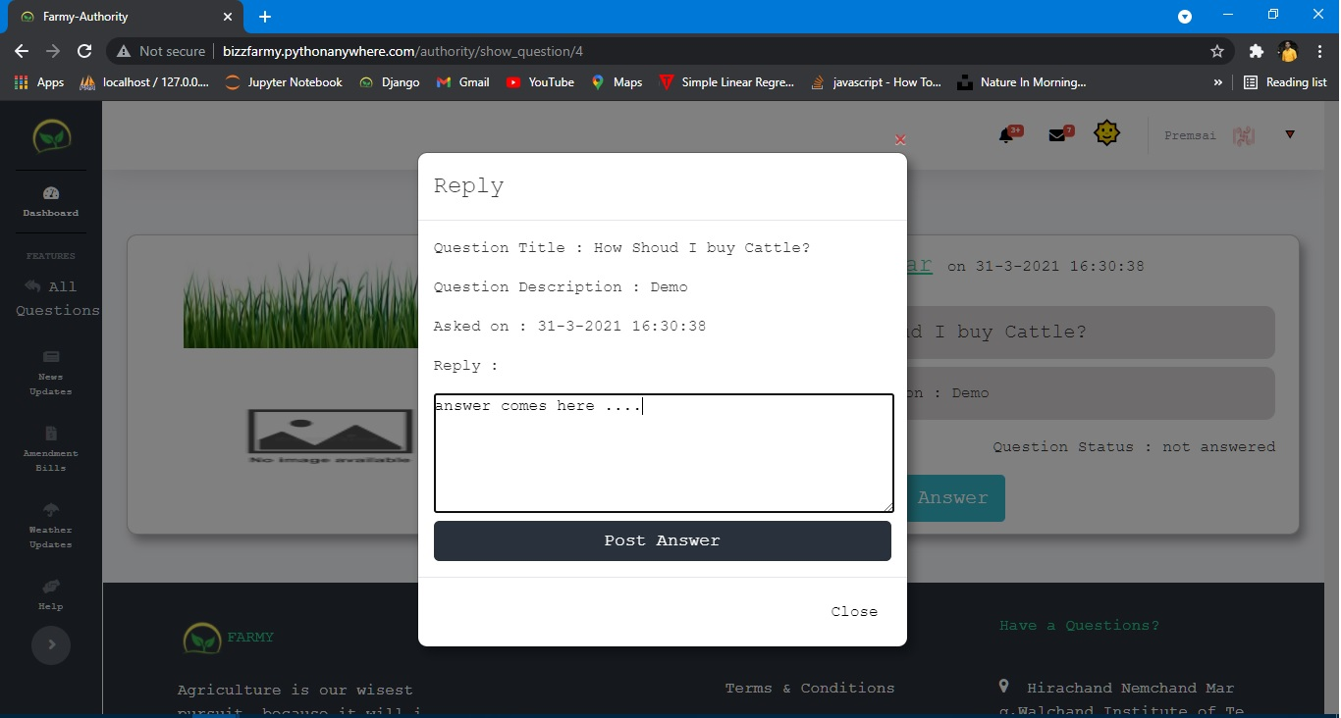

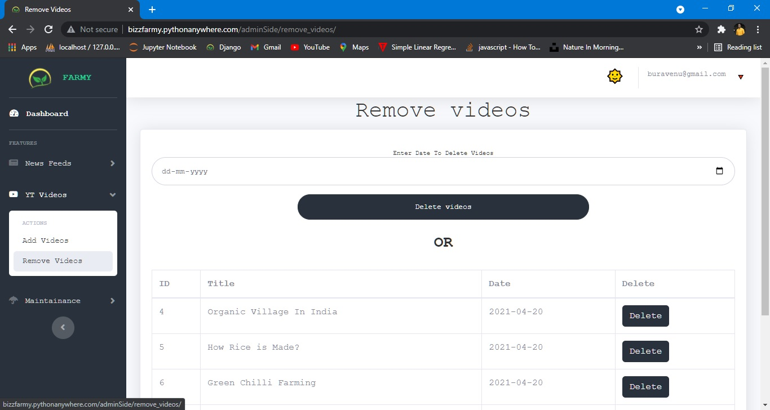

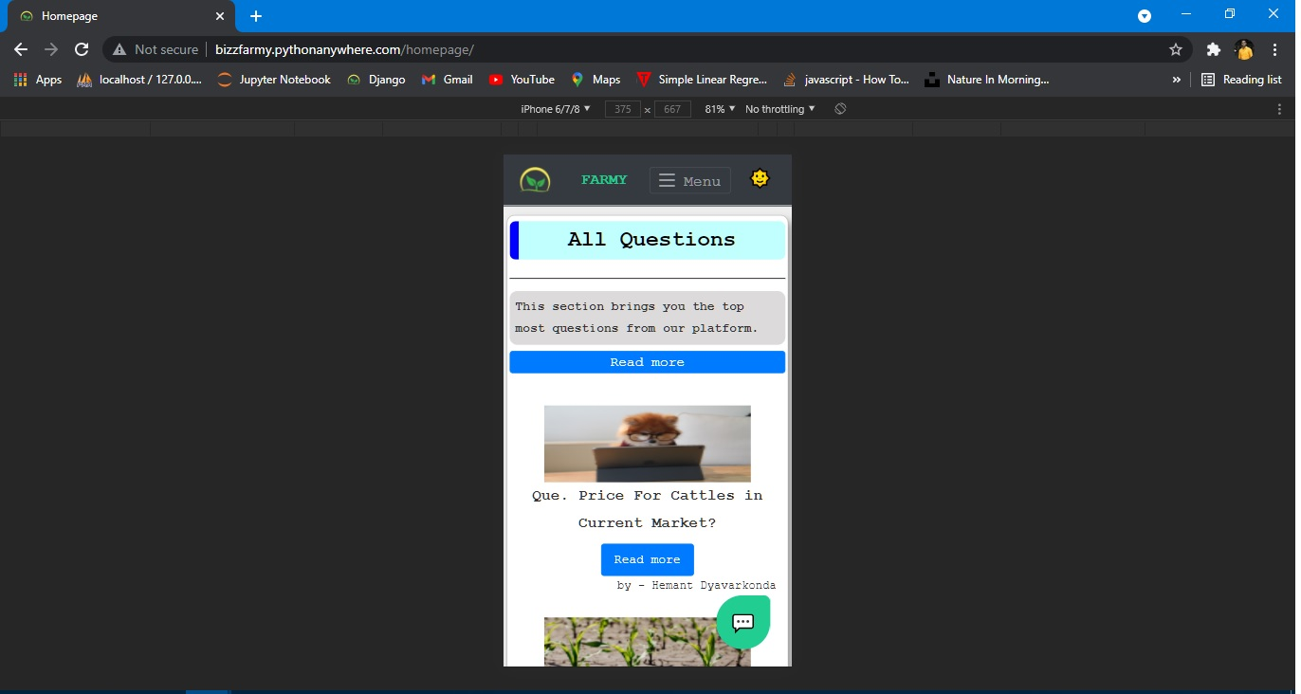

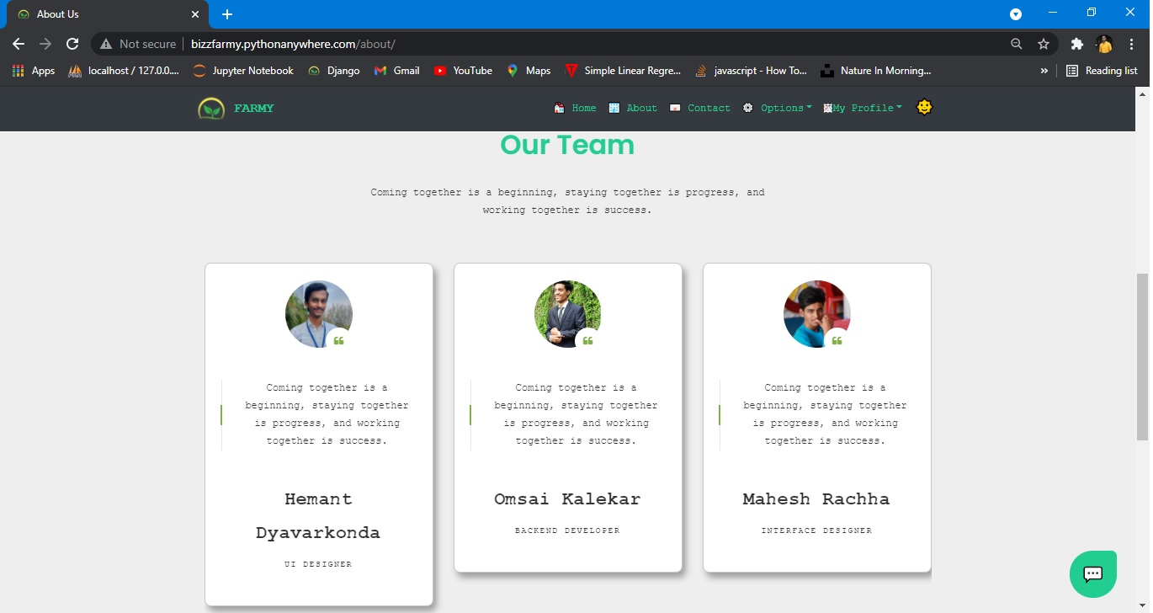

**Chapter 7**

**FLOW DIAGRAMS**

**7.1 Data flow diagrams:**

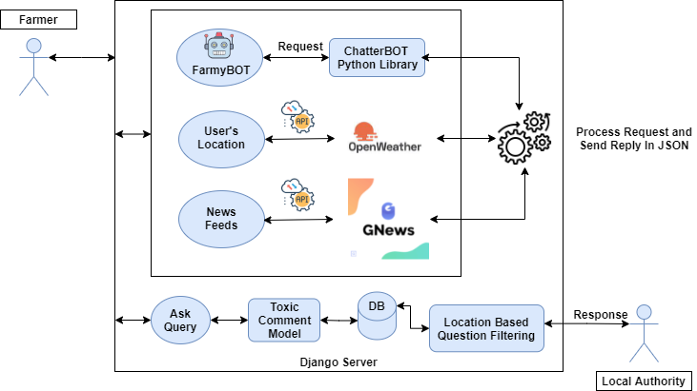

**Fig.3 Data flow Diagram.**

**7.2 Sequential UML Diagrams:**

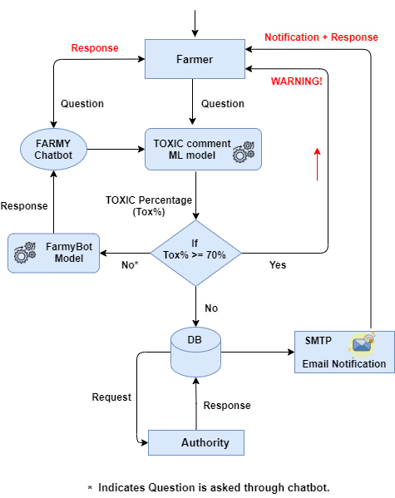

**Fig.4 Sequence Diagram.**

**Chapter 8**

**FUTURE WORK**

We Can add many New Features to help and attract farmers towards this platform like,

1. Convert website to mobile Application.

2. Voice Based Question Answering Scheme.

3. Can provide a video tour of the project.

4. Can Add E-marketing Features.

5. Search option for finding questions.

6. More attractive UI.

**Chapter 9**

**CONCLUSION**

Smart web application named **“Farmy”** has designed such a way that it can fulfill the needs of the farmers.It has many features which can be used in different environments and scenarios. For instance, Farmers had to visit agricultural offices if they had any issues which would cost their time and money,so this web application will help farmers to connect them to the agricultural officers from their remote places.The chatbot is provided for more usability purposes which perform certain tasks.Notifications will provide the status of their queries and keep them updated.

**Chapter 10**

**REFERENCES**

[1] Mahendra Dev, S. (2014). Small farmers in India: Challenges and opportunities.

[2] Reddy, S. K. Farmer Producers Organizations: An initiative to eliminate middlemen. INDiAN FARmER, 223.

[3] Ozoh, P., MO, O., & Adigun, A. A. (2019). Identification and Classification of Toxic Comments on Social Media using Machine Learning Techniques. International Journal of Research and Innovation in Applied Science (IJRIAS).

[4] Jackson, W. (2019). Watch Face Weather Design: Using Weather APIs. In SmartWatch Design Fundamentals (pp. 345-383). Apress, Berkeley, CA.

[5] A. M. Rahman, A. A. Mamun and A. Islam, "Programming challenges of chatbot: Current and future prospective," 2017 IEEE Region 10 Humanitarian Technology Conference (R10-HTC), Dhaka, 2017, pp. 75-78, doi: 10.1109/R10-HTC.2017.8288910.

[6] Plekhanova, J.. Evaluating web development frameworks: Django, Ruby on Rails and CakePHP. Institute for Business and Information Technology.

[7] Das, A. S., Datar, M., Garg, A., & Rajaram, S. (2007, May). Google news personalization: scalable online collaborative filtering. In Proceedings of the 16th international conference on World Wide Web (pp. 271-280).

[8] Kumar, P., Sharma, M., Rawat, S., & Choudhury, T. (2018, November). Designing and developing a chatbot using machine learning. In 2018 International Conference on System Modeling & Advancement in Research Trends (SMART) (pp. 87-91). IEEE.

[9] Frain, B. (2012). Responsive web design with HTML5 and CSS3. Packt Publishing Ltd.

[10] Kim, B. (2013). Responsive web design, discoverability, and mobile challenge. Library technology reports, 49(6), 29-39.

[11] Zaheri, S., Leath, J., & Stroud, D. (2020). Toxic comment classification. SMU Data Science Review, 3(1), 13.

T