**Studying food wastage behaviour of college students and reasons leading to this behaviour.**

Om Vaknalli (18376)

______________________________________________________________________________

**Introduction**

Food wastage is a big concern in today’s world from an economic, environmental and social justice point of view. Tonnes of kgs of food is wasted every year due to gaps at various stages of the food supply chain. However, the most compelling or somewhat bewildering reason for food wastage is people throwing it away. Apart from the mess, healthy food is often not in reach in a hostel. Here too, food wastage is observed, often more than anywhere else. Most behaviours of organisms are ultimately driven by economics, and the payoff decides whether a particular behaviour is exhibited or not. Food wastage then seems to be a contrarian ideology. Students ideally should not be wasting a source of energy, especially something that they have paid for. We try to hypothesise here the reasons behind this behaviour and how this can be a positive payoff. Through anecdotal information, most students wasted food because they did not like the taste. Here we check whether this is the real reason and attempt to validate other possible hypotheses. We have tried to look at regional bias, monetary costs and oversight as the possible reasons.

**Questions and Hypotheses**

Anecdotal information indicated that most people waste food due to its bad quality (lack of taste, uncooked nature, etc.). In college mess, the same menu is repeated each week. Volunteers who say they waste due to bad quality food must have had the same food last week. If that is the case, that specific dish can be taken in lesser quantities or not in the subsequent meals.

We predicted that if a dish is regional for the volunteer, there may be a greater expectation and thus more wastage. We formed a *second* hypothesis that the source of money (cost) defines whether students will waste food or not. We asked a question regarding wastage habits at the canteen/restaurant. A *third* hypothesis suggests oversight is the deciding parameter while wasting food. A subsidiary hypothesis was also formulated regarding any gender biases towards food wastage. We also asked their opinion on the other messes and whether they think food wastage is lesser than their mess.

**Methods**

We formed a questionnaire to collect data from individuals regarding their wastage patterns. Two categories of questions were created, one to be answered after every meal for seven meals, and the rest to be answered just once after completing the first set. Questions were sent out via google forms on Whatsapp groups. To encourage honest answers, the data was collected while keeping the volunteers anonymous. We asked the volunteers to pick a nickname and use it to identify themselves every time they filled the form. We calculated the chi-square value to find the significance of data for a hypothesis. For the sake of simplicity, we assume that food quality is consistent.

We attempted to reduce the throw-away of food by introducing a supernormal stimulus in the existing system. A series of photographs of food items were made accessible to the participants a few minutes before one of the meals. The photographs consisted of more attractive pictures of the items served in the meal. We expected that this stimulus would lead to lower wastage.

**Data and Statistical Analysis**

Link to data sheets : [General Information](https://docs.google.com/spreadsheets/d/1RE39Rbg82err9hIoq0r4dpV6oFtgzP4gmCfFn-_xSho/edit?usp=sharing) [7 Meal Survey](https://docs.google.com/spreadsheets/d/1CkVRjkwKIA7_hgNIEGn2y-9cfLZO-ctiRaR2fingHS0/edit?usp=sharing)

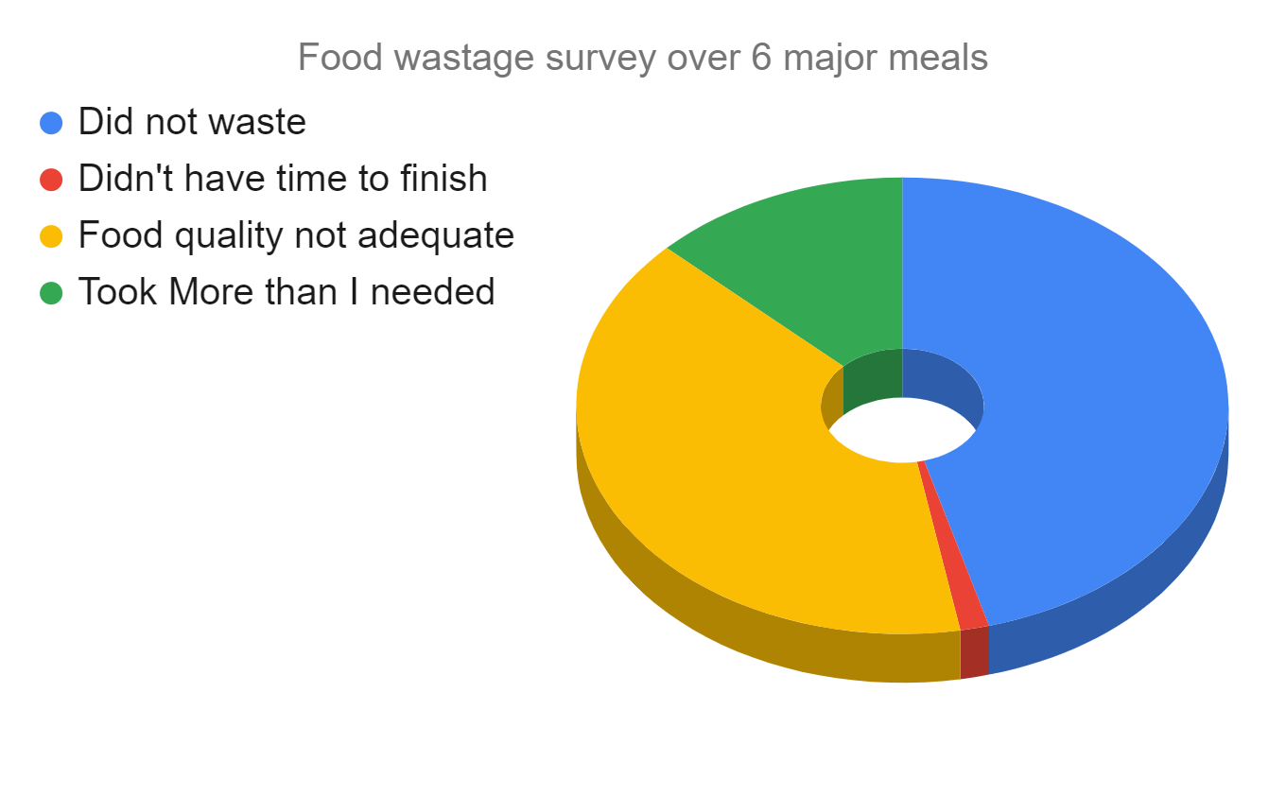

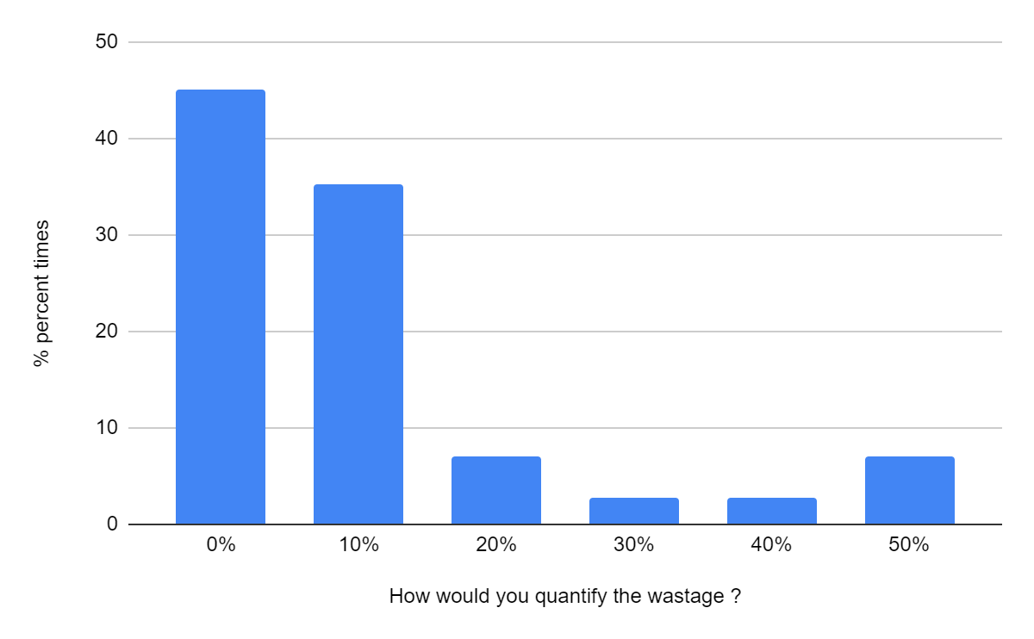

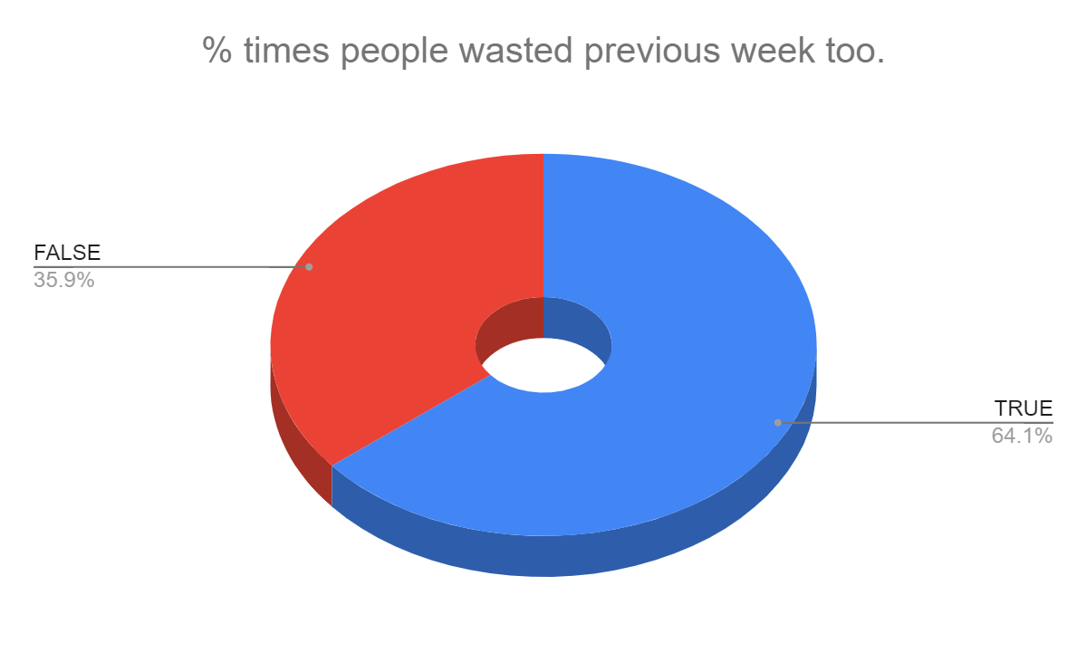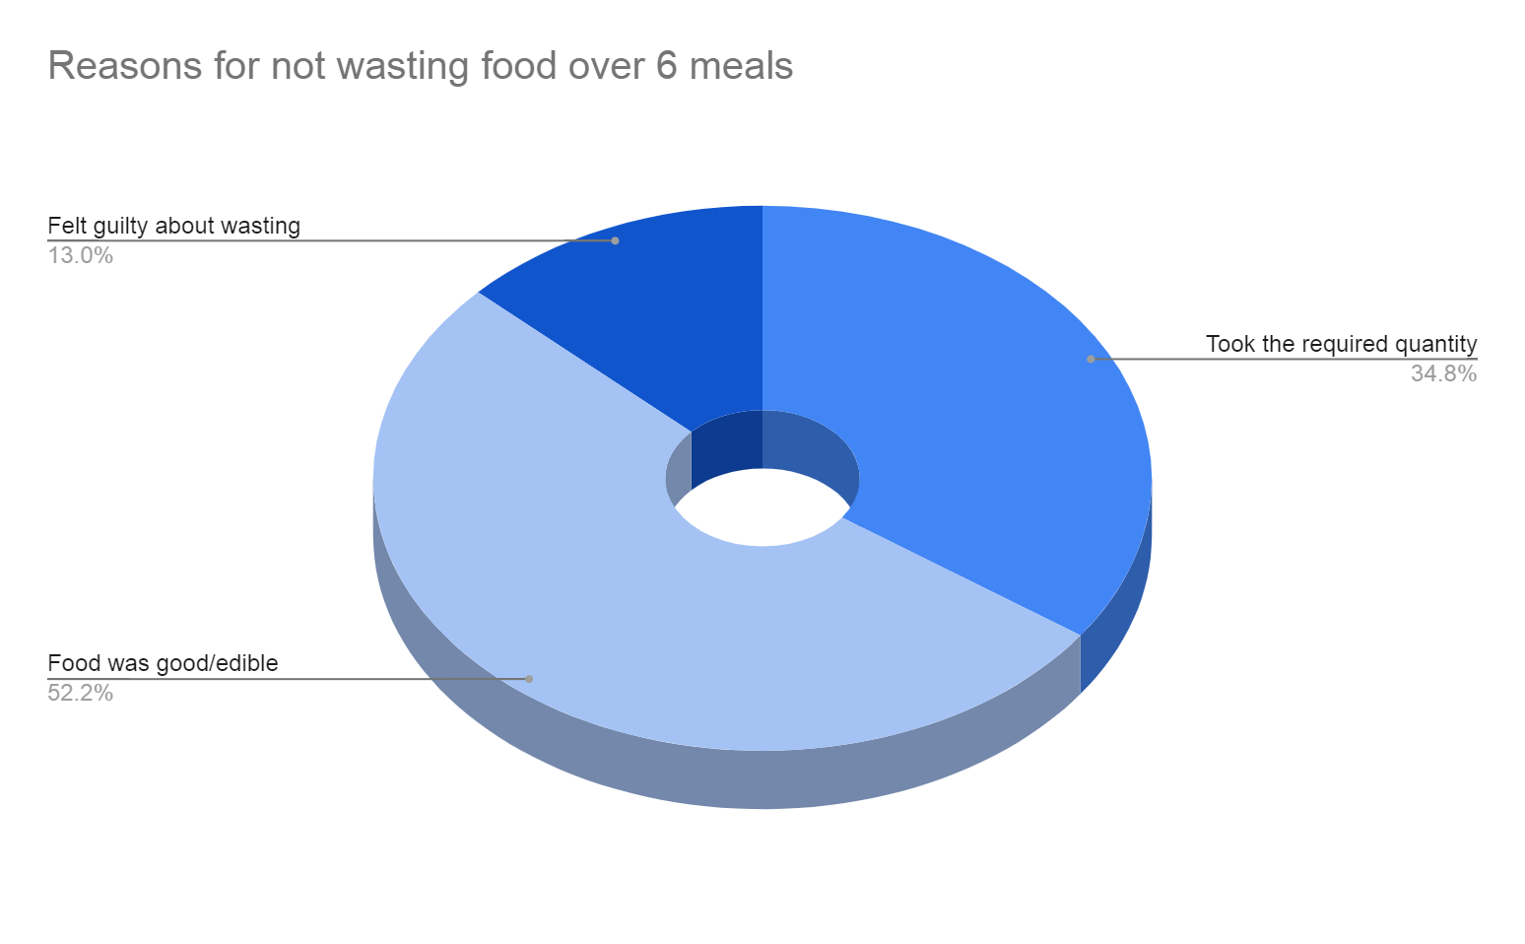

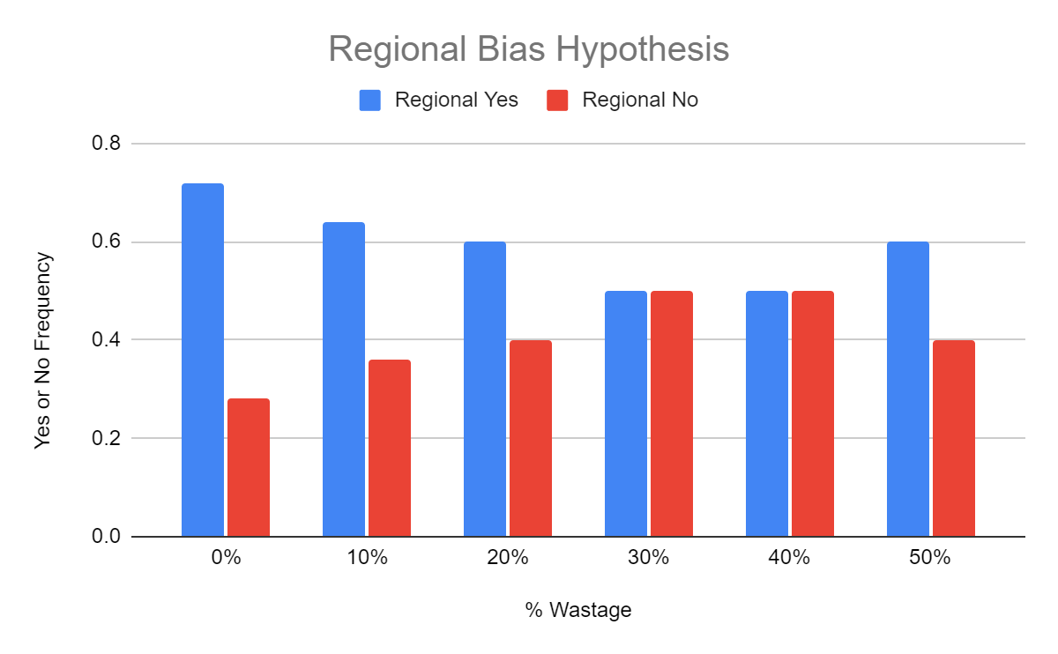

One way Chi-Square table to reject null hypothesis for regional bias

|  |  |  |
| --- | --- | --- |
| ----- | wastage | no wastage |
| regional | 24 | 23 |

Sample size for wastage: 39 Degrees of freedom: 1

Sample size for no wastage: 32 Chi-Square value (𝞆2) ~ 4.101

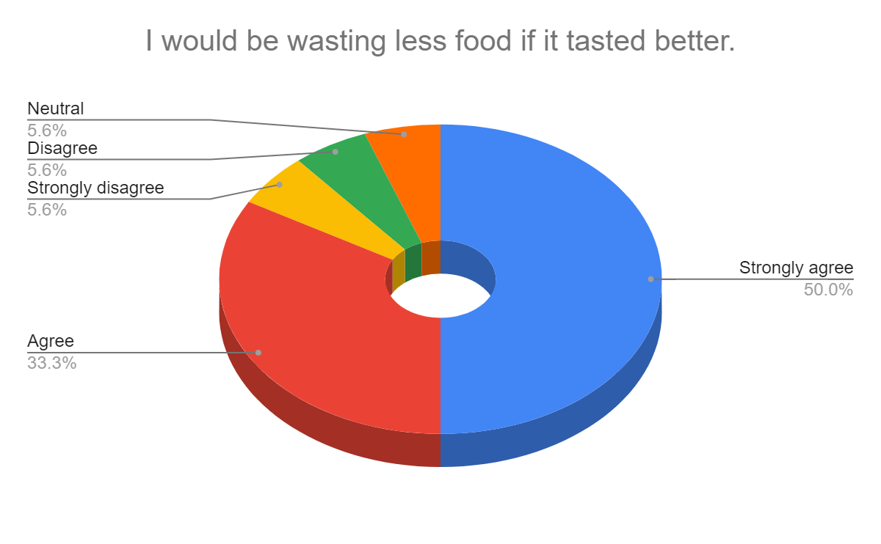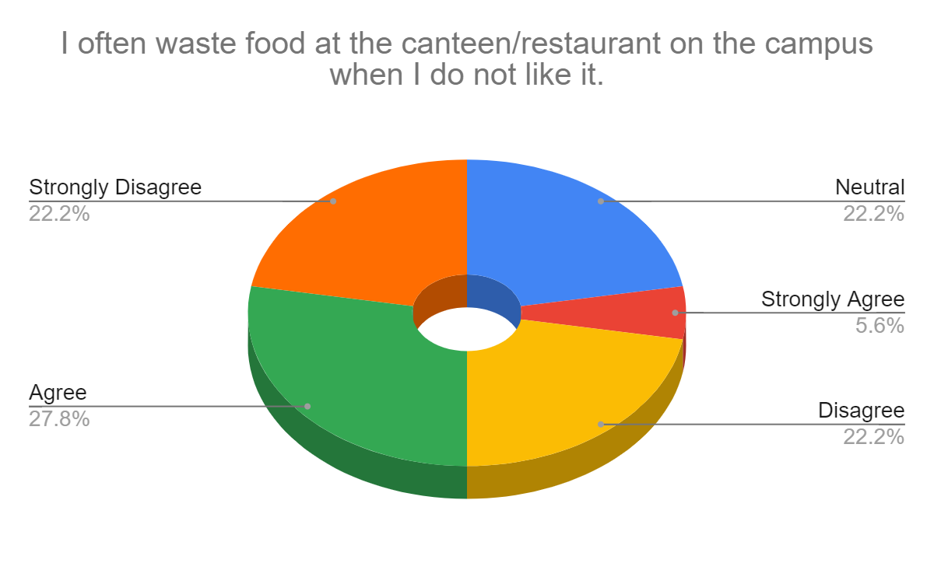

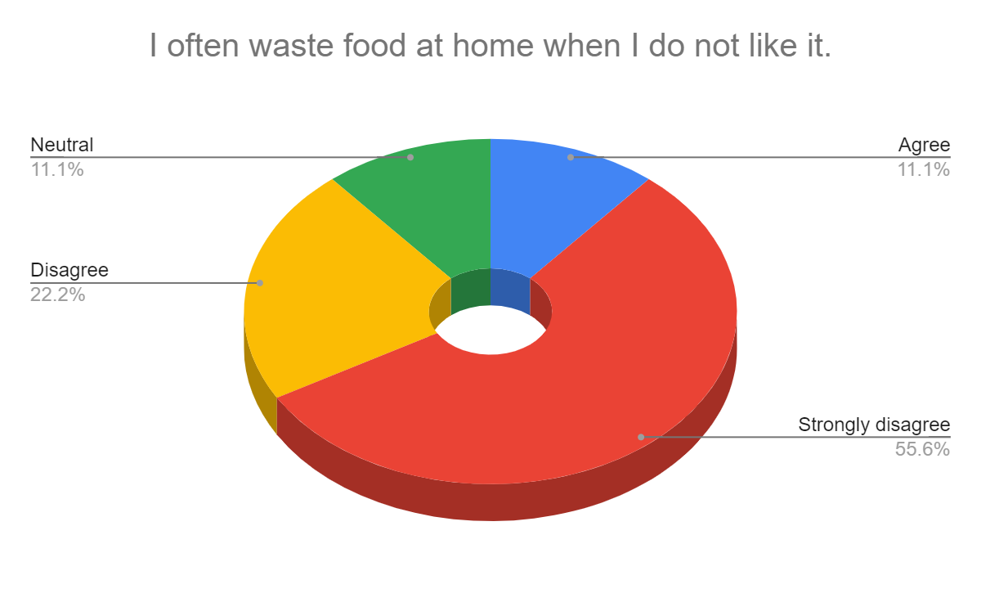

**Results and Conclusion**

As anecdotal evidence suggested, most people feel they waste food because of bad quality. When the question was asked regarding the previous week wastage, 64% of people who wasted this week also wasted in the previous week. This contradicts the perceived reason. If the taste is the reason, it should take a week or two to know the taste. There should ideally be little to no wastage after that. Thus, there has to be a different reason for the behaviour of food wastage.

The first hypothesis was that food wastage is due to a regional bias while eating. This hypothesis works in combination with taste. When a person perceives a certain dish as a staple, there will be a biased expectation, leading to a significant wastage. Our analysis based on the Chi-Square value suggested that this hypothesis turns out to be accurate at a significance level of 5% when overall wastage is considered. Sample size falls short if significance was calculated considering separate categories based on the quantity of food wasted.

The second hypothesis links wastage to monetary costs. As mess fee payments come through parents, the cost perceived by a student is lesser. Contrary to that, when eating at canteens or restaurants, money comes from allowance granted by parents. We asked whether volunteers often waste food at canteens too. The results, in this case, are too scattered. We conclude here that the question formation should have been different. Since this is a behaviour study, it would have been better to study whether people think more profusely (more than they do while serving in a mess) about taste before buying anything at the canteen.

The third hypothesis was regarding oversight. Wasting food in a mess has no direct or immediate consequences on the students. Students are supposed to finish what they take (or are served) at home. Thus a greater thought is given before wasting anything. More than 80% of the students disagree with wasting food at home, even with a bad taste. This hypothesis requires more study to pinpoint the reasons for lesser wastage at home. Wastage patterns can change according to the age group of the sample size (nearly the same here) and family structure at home.

The hypotheses on gender biases and supernormal stimuli stood inconclusive due to a lack of substantial and coherent data.

Human behaviour is a complex topic. It requires a profound understanding of various factors affecting a single behaviour. We performed our data collection exercise in a controlled environment. Reasons for wastage here cannot be generalised elsewhere. This project is oversimplifying a very complex issue. Apart from the three suggested hypotheses, there can be several other reasons for food wastage in a college mess. Our data is also subject to errors due to irregular updates by volunteers, misinformed answers, smaller sample sizes, smaller temporal scale of data observations and preconceived biases due to familiarity between surveyors and surveyees.

In conclusion, we would like to say that the behaviour of wasting food is likely affected by all three reasons suggested and more. To study the real-world impact of our hypotheses, we can hire special cooks for regional dishes, change the fee collection system and deploy carrots and sticks as an oversight. A more extensive study, a better line of questioning, and more efficient ways of data collection can be the prospects of this project.

**References**

Preliminary Study Reference [[1](https://www.researchgate.net/publication/314262608_Assessment_of_Food_Wastage_in_Hostel_Messes_A_Case_of_NDRI_Karnal)]

Chi-Square Calculation Reference [[2](https://www2.palomar.edu/users/rmorrissette/lectures/stats/chisquare/chisquare.htm)]

Supernormal Stimulus Experiment Reference [[3](https://pubmed.ncbi.nlm.nih.gov/22240720/)]