ADVANCED CODING 2



6/12/2024

TASK 1

# D.Omsri

# CSEAIML

VU21CSEN0300006

1. Write a C program to calculate sum of digits of a number.

CODE

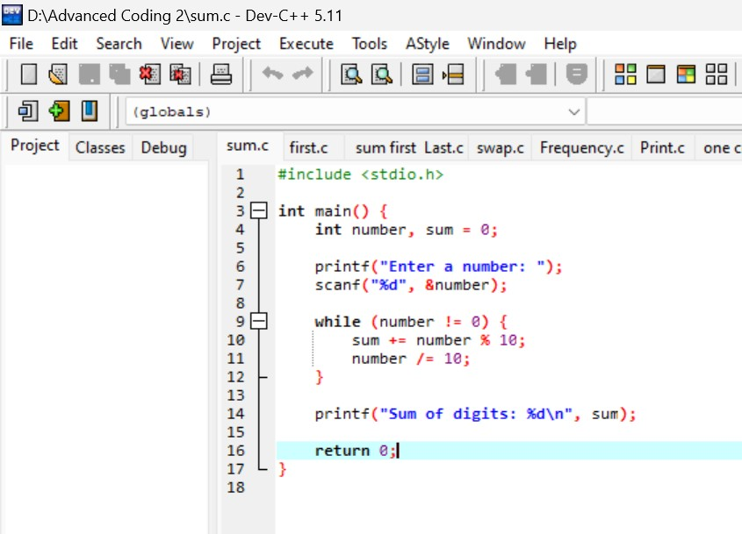

OUTPUT

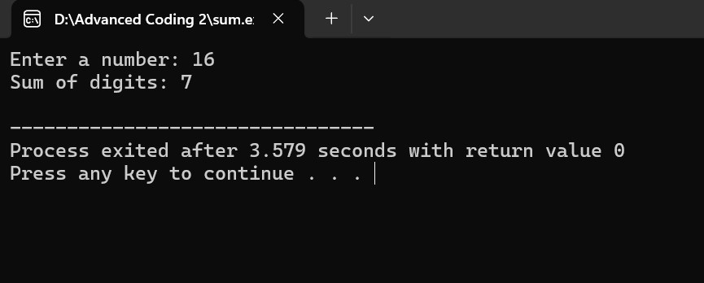

1. Write a C program to find first and last digit of a number.

CODE

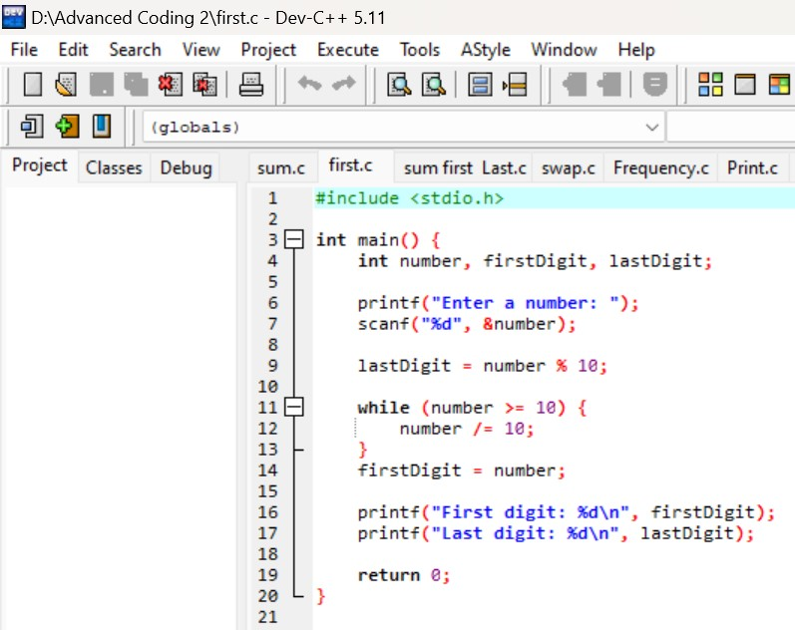

OUTPUT

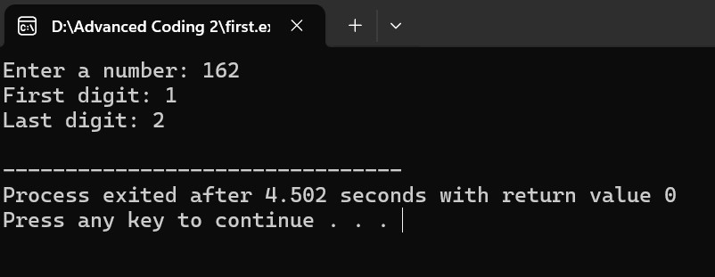

1. Write a C program to find sum of first and last digit of a number.

CODE

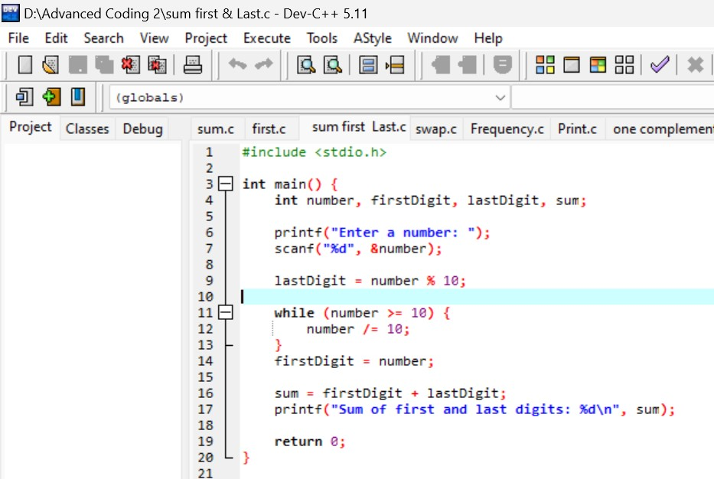

OUTPUT

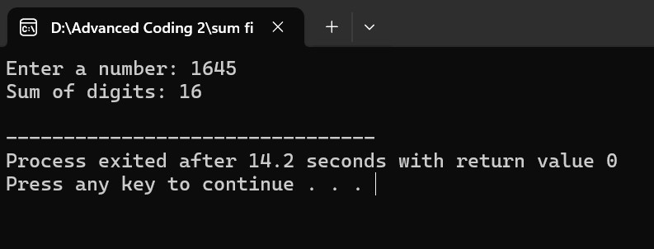

1. Write a C program to swap first and last digits of a number

CODE

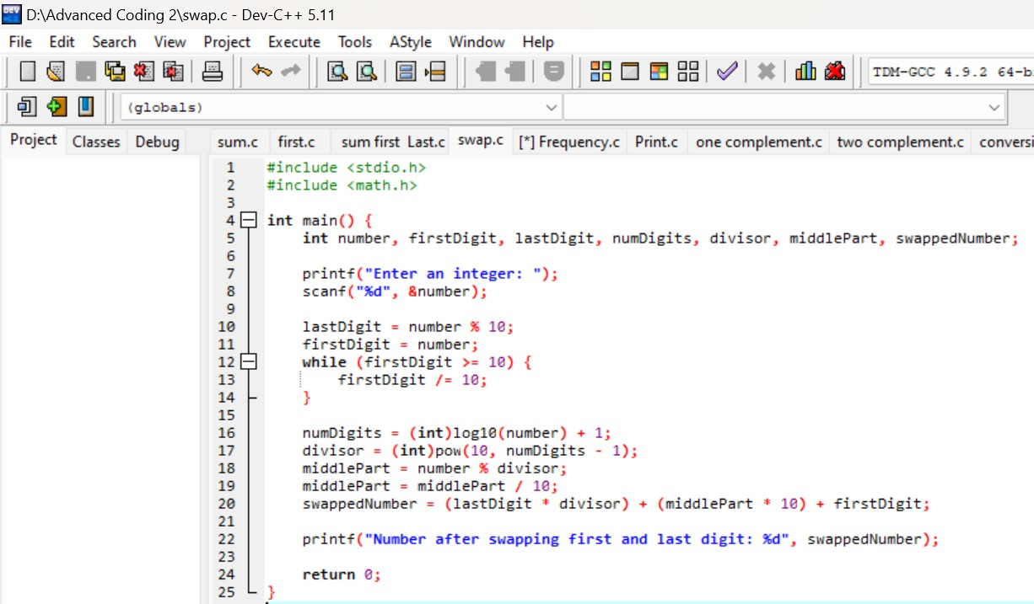

OUTPUT

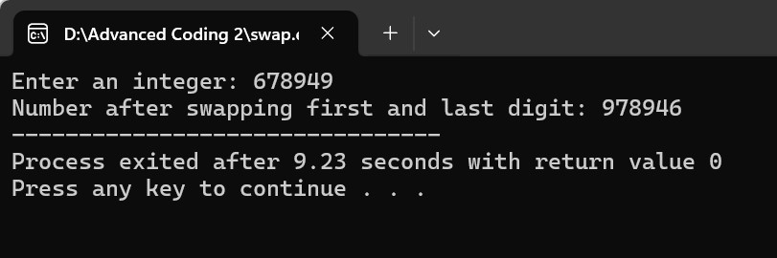

1. Write a C program to find frequency of each digit in a given integer.

CODE

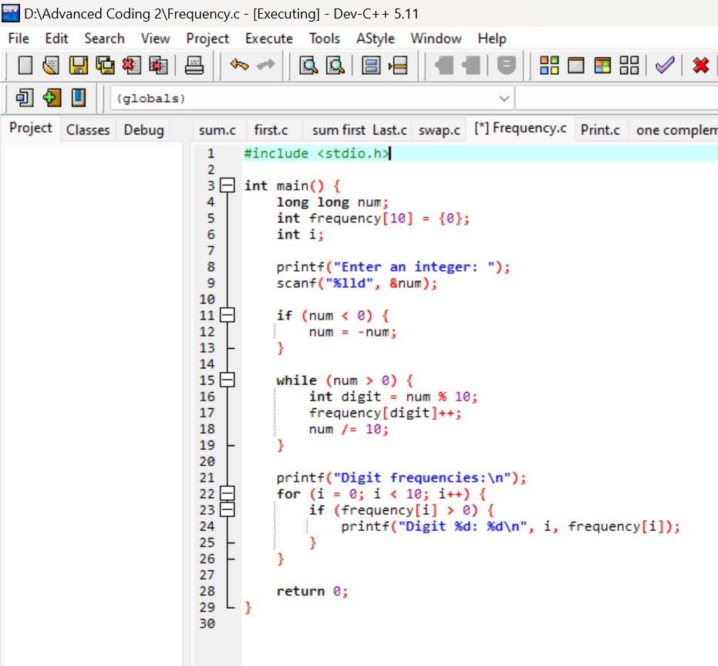

OUTPUT

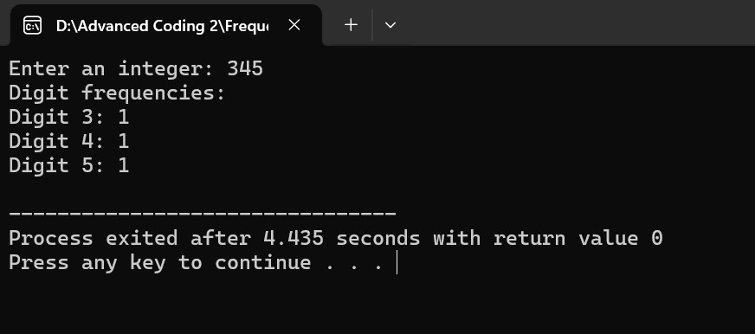

1. Write a C program to enter a number and print it in words CODE

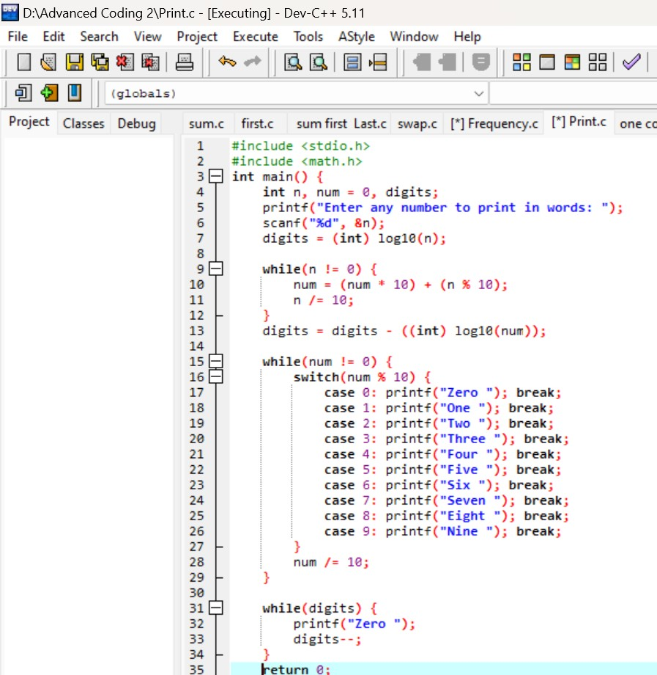

OUTPUT

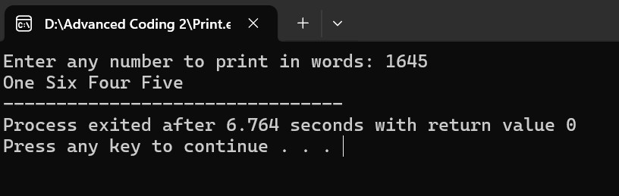

1. Write a C program to find one’s complement of a binary number.

CODE

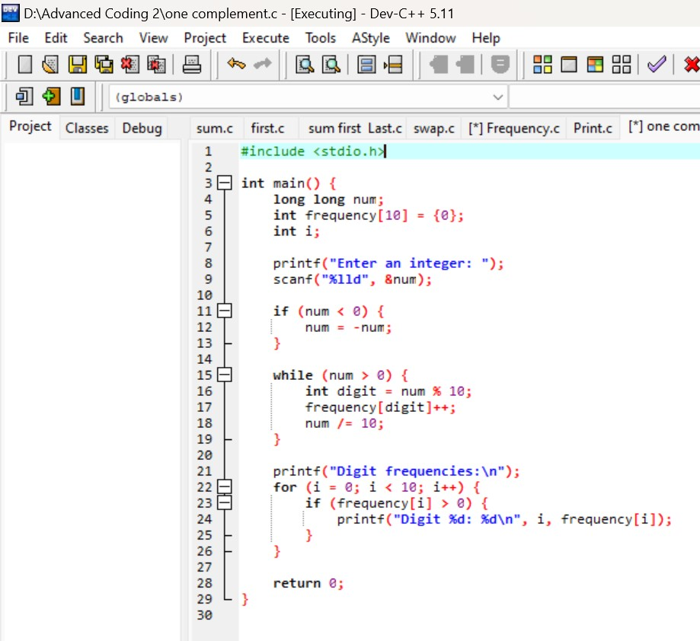

OUTPUT

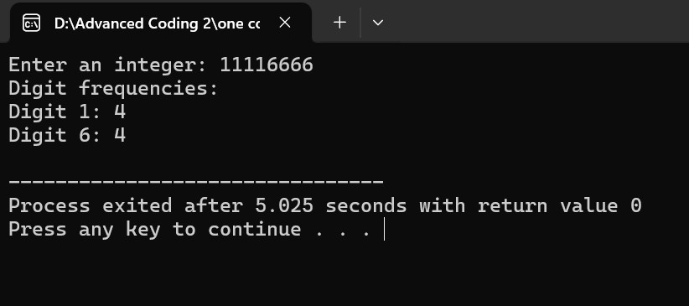

1. Write a C program to find two’s complement of a binary number. CODE

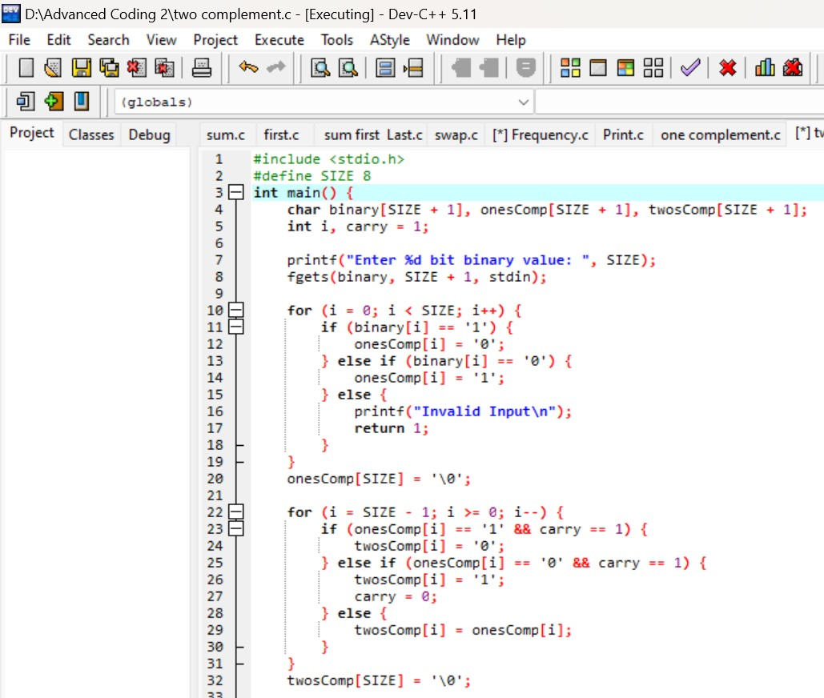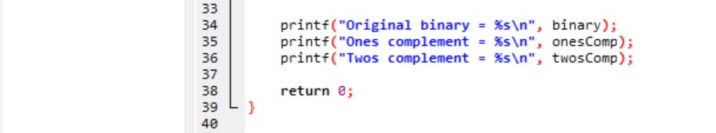

OUTPUT

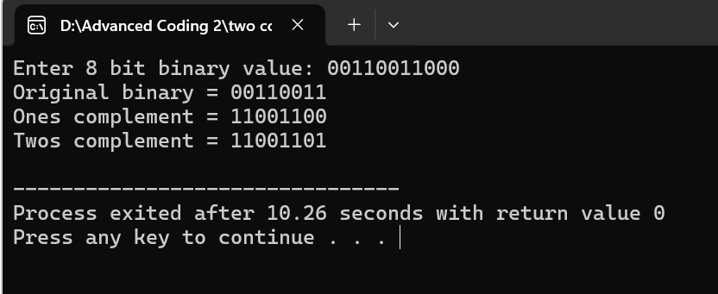

1. Write a C program to convert Decimal to Hexadecimal number system

CODE

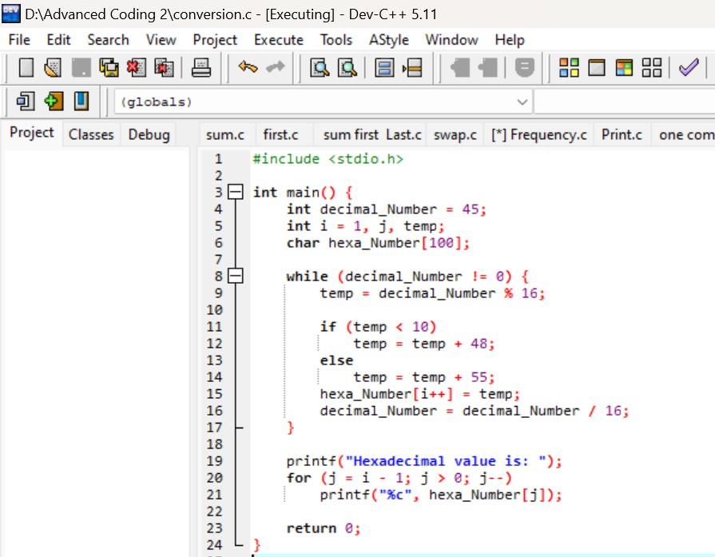

OUTPUT

