Software Engineering Laboratory

Semester | T.E. Semester VI — Computer Engineering
Subject | Software Engineering
Subject In-charge | [Subject In-charge Name]
Laboratory | [Lab Room]

Student Name | 1. Omsri [Last Name]
Roll Number | 1. [Roll Number]
Grade and Subject
Teacher's Signature

Experiment  Number | [XX]
Experiment  Title | Creation of Activity and Swimlane Diagram — SalesSense Retail Forecasting Platform
CO Mapped | [CO#]
Resources /  Apparatus  Required | Hardware: Laptop  Software: Visual Studio Code, GitHub, UML Diagram Tool / PlantUML, Python (matplotlib)
Description | The objective of this experiment is to construct an Activity and Swimlane Diagram for the SalesSense Retail Demand Forecasting Platform. While a standard activity diagram depicts the operational workflow and conditional execution paths of a system, a swimlane diagram visually partitions those activities across responsible entities to highlight the functional boundaries between components.  SalesSense uses a three-tier architecture comprising a React frontend, a FastAPI/MongoDB backend, and a forecasting engine built on LSTM, Prophet, and SARIMA models. The swimlane diagram categorizes system workflows across four functional lanes:  - User / Retail Manager: Selects the store, product, and forecast horizon; views the resulting dashboard and exports reports.  - React Frontend: Sends the forecast request over the REST API, renders forecast charts and KPI cards once results return.  - FastAPI Backend: Validates incoming requests, fetches historical sales data from MongoDB, triggers the forecasting job, then stores and returns results.  - Forecasting Engine (LSTM / Prophet / SARIMA): Preprocesses and cleans the time-series data, runs the candidate models, checks forecast accuracy, retrains or tunes hyperparameters when accuracy is insufficient, and returns the final forecast with error metrics.  Key Activities Identified  - Request Configuration: Capture store, product, and forecast-horizon selections from the user.  - Data Retrieval: Fetch and validate historical sales records from MongoDB.  - Model Execution & Selection: Run LSTM, Prophet, and SARIMA models and evaluate forecast accuracy.  - Retraining Loop: Tune hyperparameters and re-run models when accuracy falls below threshold.  - Result Delivery: Persist results, stream them back to the frontend, and render charts and KPIs for the user.
File Structure  and Overview | SalesSense/  ├── backend/ FastAPI service — REST routes, request validation, MongoDB access  ├── forecasting/ LSTM, Prophet, and SARIMA model implementations & selection logic  ├── data/ Historical sales datasets and processed time-series data  ├── frontend/ React dashboard — forecast charts, KPI cards, request forms  ├── reports/ Exported forecast reports and accuracy metrics  └── README.md Project overview, setup, and execution guide  Overview of Key Architectural Components  - Frontend (frontend/): React application presenting forecast inputs, interactive charts, and KPI dashboards.  - Backend API Gateway (backend/): FastAPI service handling REST requests, orchestrating the forecasting job, and persisting data to MongoDB.  - Forecasting Engine (forecasting/): Trains and evaluates LSTM, Prophet, and SARIMA models, selecting the best-performing forecast.  - Data Layer (data/): Stores raw and processed historical sales data used for training and inference.
Output
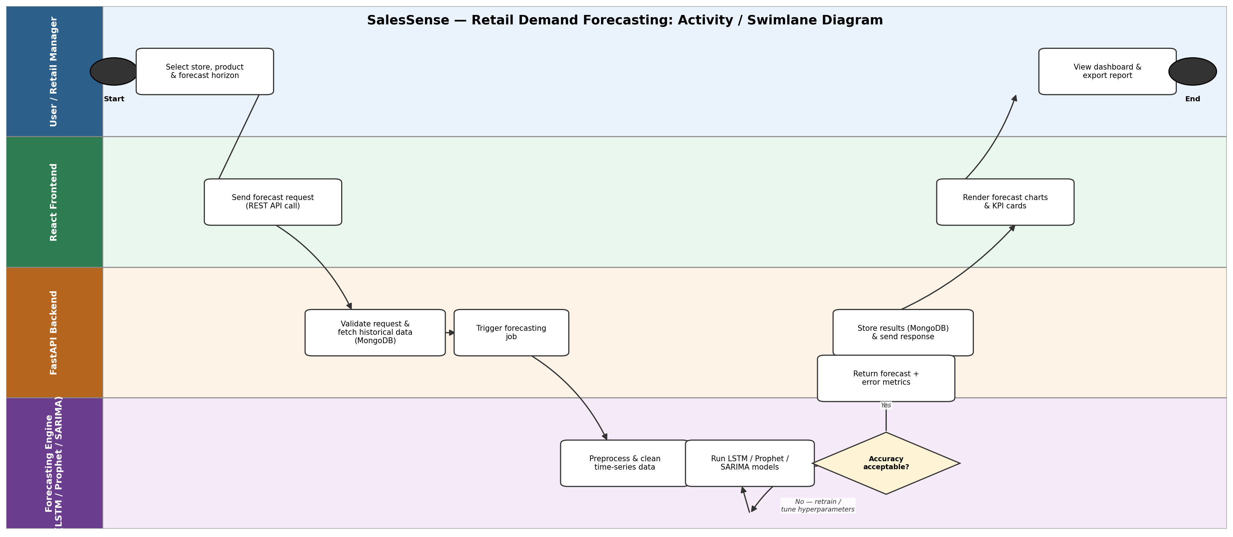
Conclusion: | The Activity and Swimlane Diagram for the SalesSense Retail Demand Forecasting Platform was successfully created. The diagram illustrates the operational workflow across system partitions, clearly delineating responsibilities between the React presentation frontend, the FastAPI serving backend, and the LSTM/Prophet/SARIMA forecasting engine. By modeling the request flow alongside model execution, accuracy evaluation, and the retraining loop, this experiment provides a visual foundation for implementing and validating the decoupled architecture of the system.

