Software Engineering Laboratory

Semester | T.E. Semester VI — Computer Engineering
Subject | Software Engineering
Subject In-charge | [Subject In-charge Name]
Laboratory | [Lab Room]

Student Name | Omsri [Last Name] + 3 teammates
Roll Number | [Roll Number]
Grade and Subject
Teacher's Signature

Experiment  Number | [07]
Experiment  Title | Work Breakdown Structure and Gantt Timeline Chart
CO Mapped | [CO#]
Resources /  Apparatus  Required | Hardware: Laptop/Desktop  Software: draw.io / Python (matplotlib)
Description | Project Title: SalesSense  SalesSense is an AI-powered retail demand forecasting platform that helps retailers decide how much stock to order and when. Users select a store, product, and forecast horizon, and the platform runs three complementary forecasting models — SARIMA, Prophet, and LSTM — backtests them against real historical sales data (FreshRetailNet-50K), and surfaces only the best-performing forecast as the primary result, with the full model comparison available as a secondary view. The platform supports data ingestion, accuracy tracking, stock/reorder recommendations, and exportable reports. The project is built by a 4-member team with dedicated ownership of Data & Pipeline, Backend & API, Modeling, and Frontend Integration.
Output (where applicable)
Work Breakdown Structure:
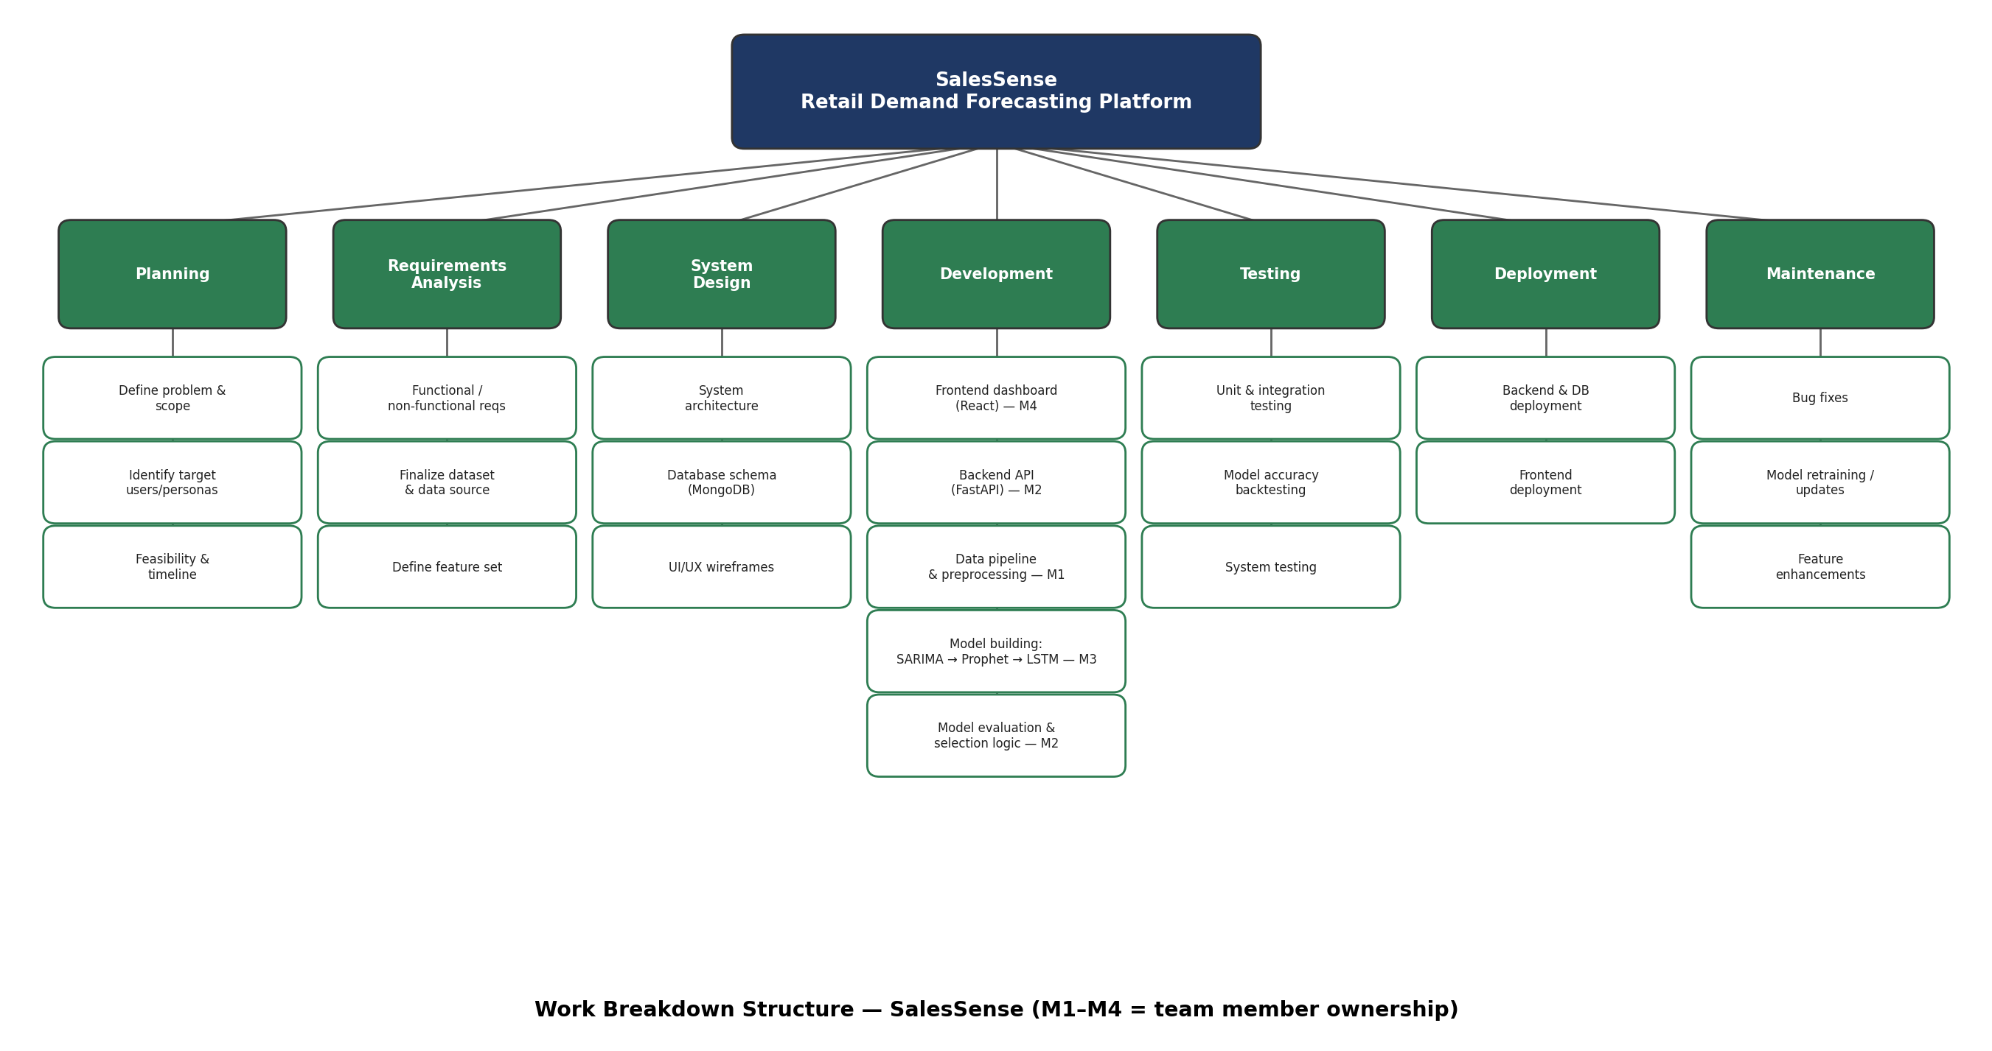

Gantt Timeline Chart:
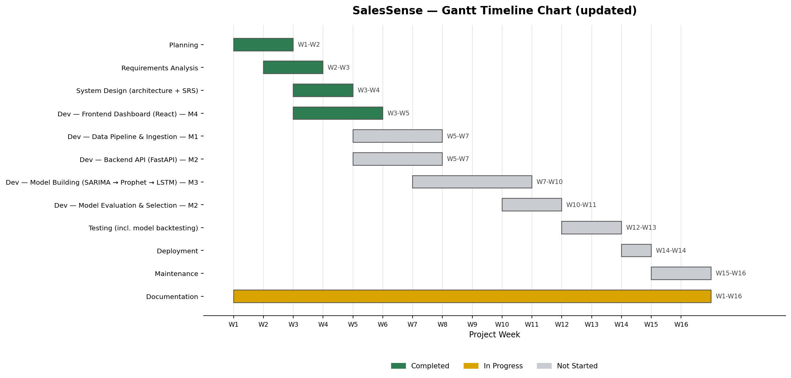

SalesSense Project Progress Timeline (updated)
This timeline reflects the project's actual current state, spanning Week 1 to Week 16.
- Completed: Planning, requirements analysis, system design (architecture doc + SRS), and the frontend dashboard shell (still on dummy data).
- In Progress: Documentation — README, CONTRIBUTING, AI usage guidelines, architecture plan, and SRS are drafted and will continue to evolve alongside implementation.
- Not Started: Data pipeline & ingestion (M1), backend API (M2), model building — SARIMA/Prophet/LSTM (M3), model evaluation & selection (M2), testing, deployment, and maintenance.
- Team: 4 members, each owning one layer — Data & Pipeline, Backend & API, Modeling, and Frontend Integration — so implementation can proceed in parallel rather than sequentially.

Overall: Planning and design are essentially complete — dataset, architecture, and requirements are all locked, and the team structure is defined. What remains is real implementation: data ingestion, model training, backend wiring, and connecting the frontend to live data instead of mocks.
Conclusion: | The updated SalesSense WBS and Gantt chart reflect the project's real progress: planning, requirements, and system design are complete, and a 4-member team now owns clearly separated implementation tracks. Keeping this document synced with actual status — rather than the plan as it looked weeks ago — is what makes it useful for tracking real progress rather than just an initial estimate.

