1.First upon open the excel blank workbook

2.Go to data->get data->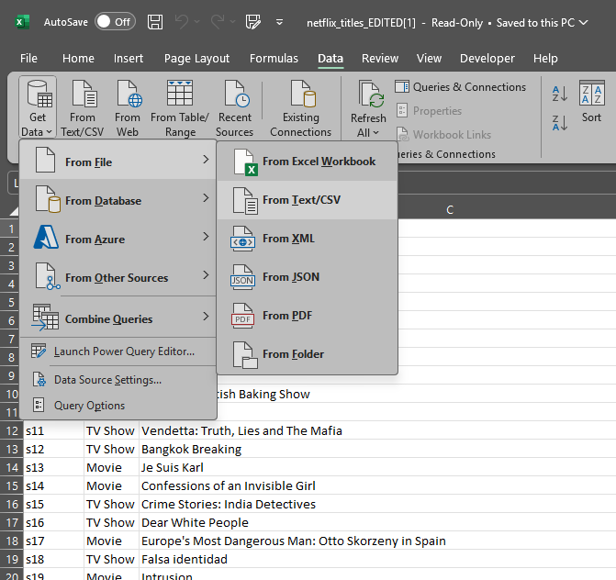

3.then transform the data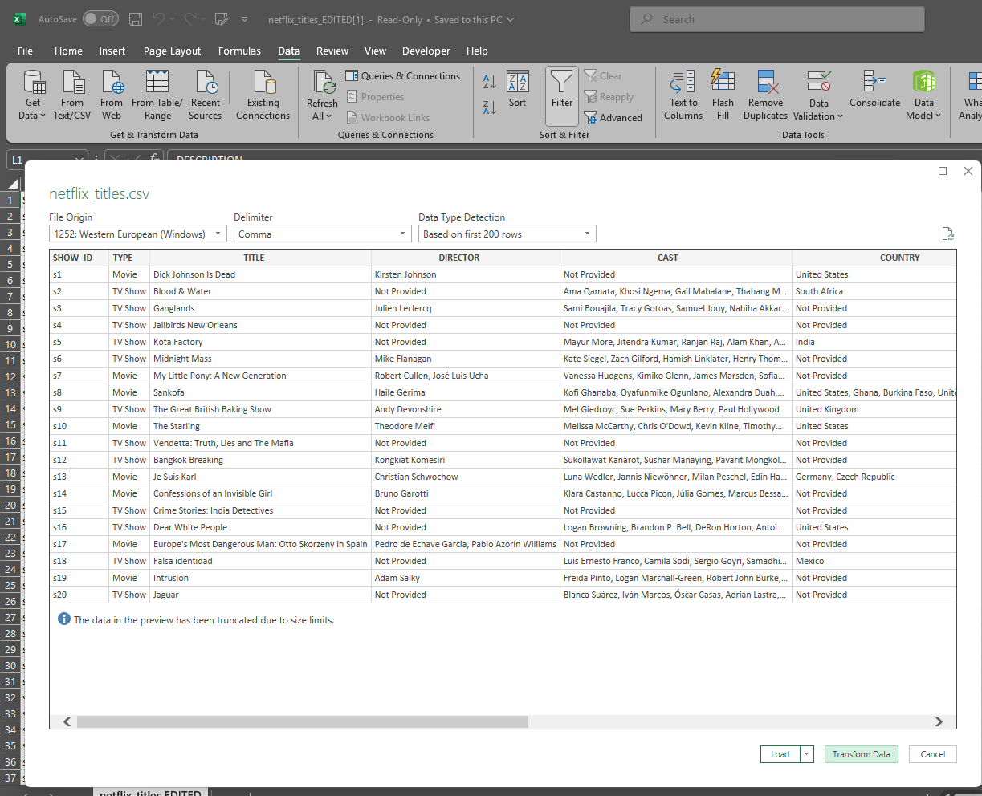

4. here we format cell according to our needed ,Then click close & load