Haunted Creature Registry Ghost Hunt
MAD 4360 Activity 11 | Undergraduate track | October 29 2026
Om Swaroop Reddy Udumula
Individual submission with no teammates
Repository: https://github.com/Omswaroopreddyudumula/haunted-creature-registry-activity-11
The registry extends the existing Activity 10 Snack Club signup form into a Welcome Foyer, Signup Lab, and Celebration Ballroom. The undergraduate shared build is complete; the checks below record observed behavior, and the next pages answer Pumpkin Patch prompts 2 and 4.

Full flow test record
Case | Observed result | Evidence
Empty fields and whitespace | All original required errors, plus creature and date errors. | Widget test; image 02
Each creature choice | Ghost, Bat, Black Cat, Pumpkin Spirit, Witch each reach the correct personalized confirmation. | Five widget tests
Malformed email and short password | Missing @ and 12345 rejected under the correct fields. | Widget test
Password eye toggle | Letters and dots alternate; validation remains active. | Widget test; Android assertions
Date picker | 1920 lower bound and today accepted; tomorrow rejected; empty date blocks submission. | Two widget tests; image 05
Back from Lab | Returns to Foyer; reopening creates empty fields and default visibility. | Widget and Android tests
Back from Ballroom | Returns to Foyer without recovering the submitted Lab. Foyer button also works. | Widget tests; Android Back dispatch
Double submission | Disabled button during two-second delay; only one Success screen. | Five widget tests; image 06
Confetti and reentry | Nonlooping controller starts on arrival; leaving and returning produces no exception. | Controller inspection; Android flow
Small screen and async exit | No overflow at 360 by 640 with keyboard inset; leaving mid-load causes no late navigation. | Widget tests
Verification: 12 widget tests passed; one Android integration test passed; analysis reported no issues. Environment: Flutter 3.47.2, Dart 3.13.2, Android emulator API 37 arm64. Raw logs are in the repository evidence folder. These checks do not claim physical-device testing or a live course demo.

Prompt 2 The Poltergeist Field
In the Android rotation run, Mina Moon, the visible password setting, birth date 1/1/2008, and Black Cat all survived portrait-to-landscape rotation, and the test confirmed that SignupScreen kept the identical State object. The name and password text live in TextEditingControllers; _obscurePassword, _birthDate, and _selectedCreatureType live in the same State, with the date controller mirroring the chosen date. The landscape screenshot below shows the retained name and visible password, while the integration assertions also check the date and creature values that sit farther down the scrollable form. No value disappeared in this run, so no rotation fix was justified; if one did disappear because it was created inside build(), the smallest fix would be to move it into the existing State and initialize it once. Popping or replacing the Lab is different: dispose() releases its controllers, and reopening creates a new empty form, as the final Android assertions verify.
Value | Owner in signup_screen.dart | Observed lifetime
Name and password text | _nameController and _passwordController | Retained on rotation; cleared on a new Lab
Password visibility | _obscurePassword | False after rotation; true in new Lab
Birth date | _birthDate and _dateController | 1/1/2008 after rotation; empty in new Lab
Creature | _selectedCreatureType | Black Cat after rotation; no choice in new Lab

Actual Android landscape capture
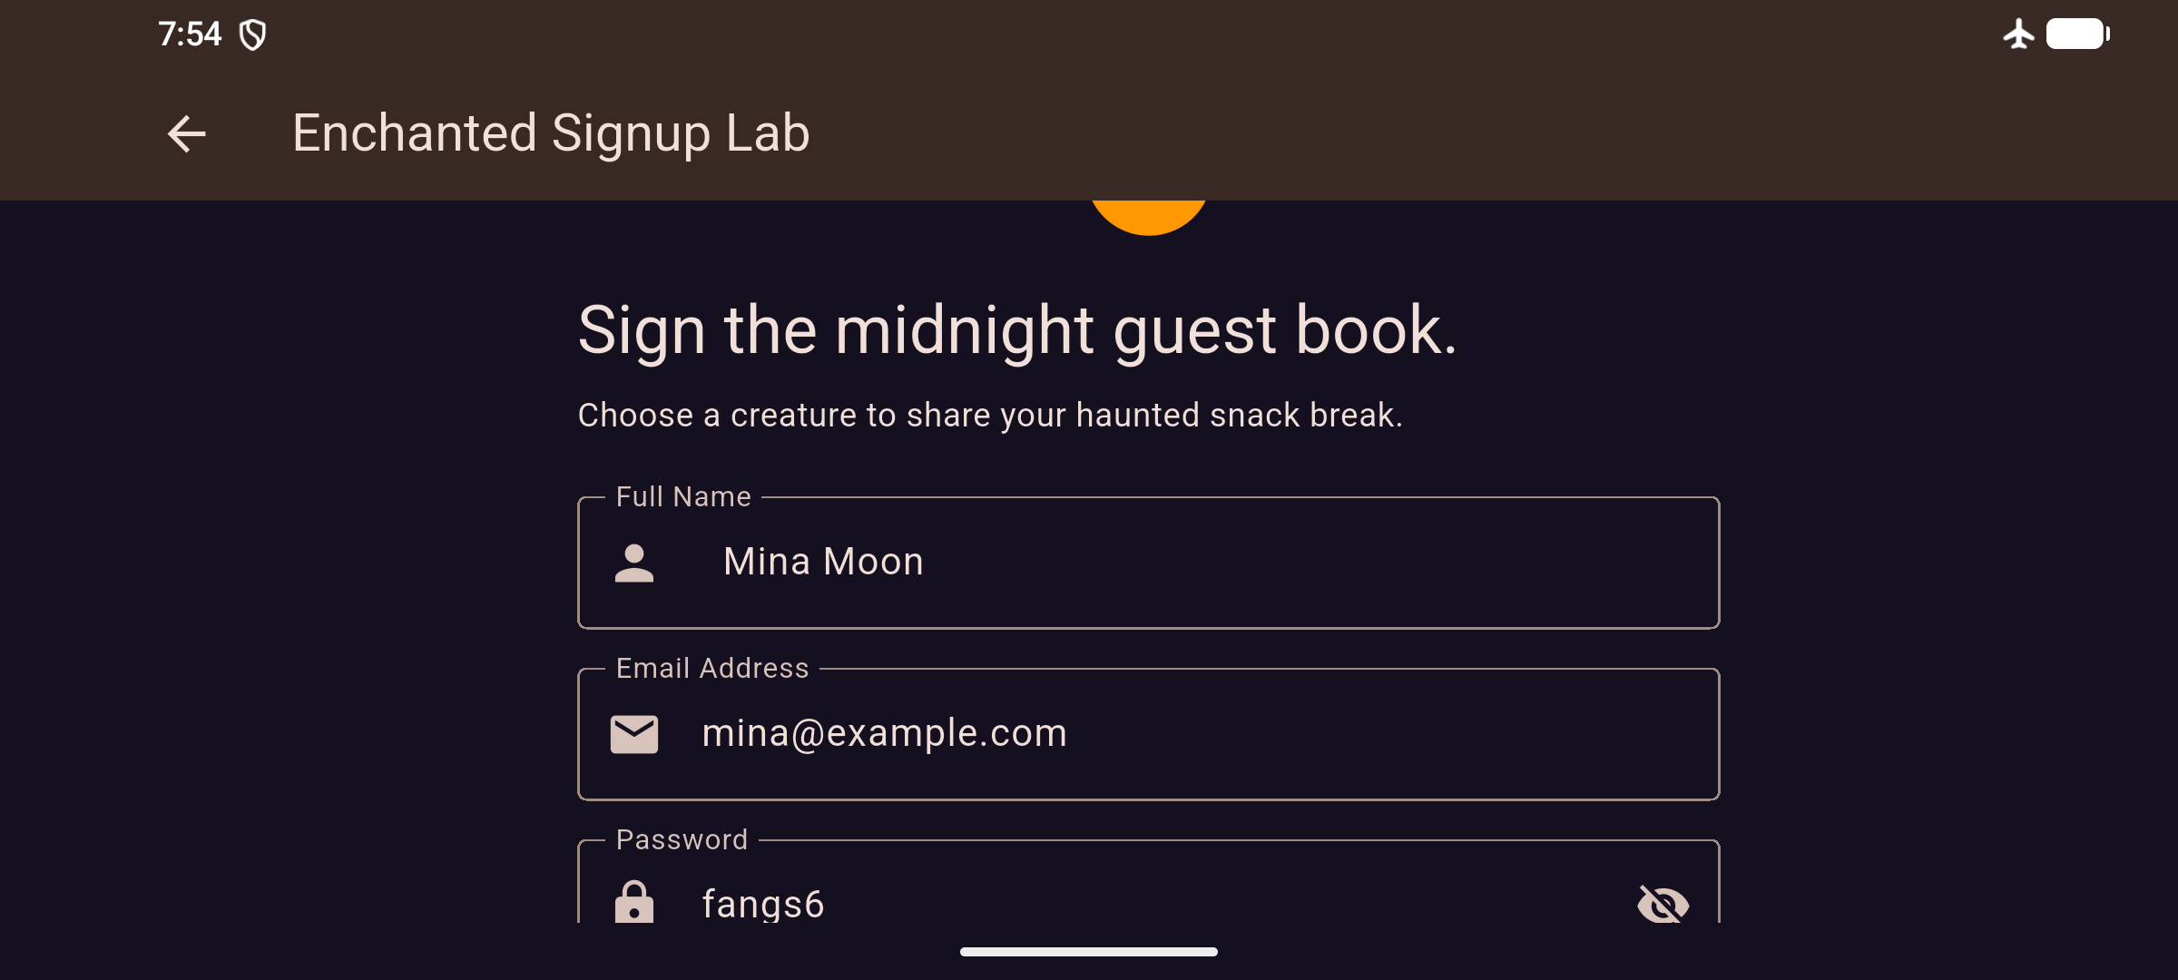
Image 04. Real emulator display after a landscape orientation request. The test checks that width exceeds height and verifies all four values. The screenshots use fictional test input.
final stateBefore = t.state(find.byType(SignupScreen));
// Request landscape, wait for Android, and rebuild.
expect(identical(stateBefore, t.state(find.byType(SignupScreen))), isTrue);
// Assert name, visibility, date text, creature, and landscape dimensions.
Trace: integration_test/app_test.dart contains the rotation and reset assertions; signup_screen.dart owns the four values and disposes the text controllers. The first emulator attempt stayed in portrait because of a pre-existing tablet display override; the successful capture followed a reset to the phone configuration.

Screens from the tested app
These are Android display captures from the integration flow. They show validation before any input, the loading state after valid input, and the personalized Black Cat confirmation after replacement navigation.
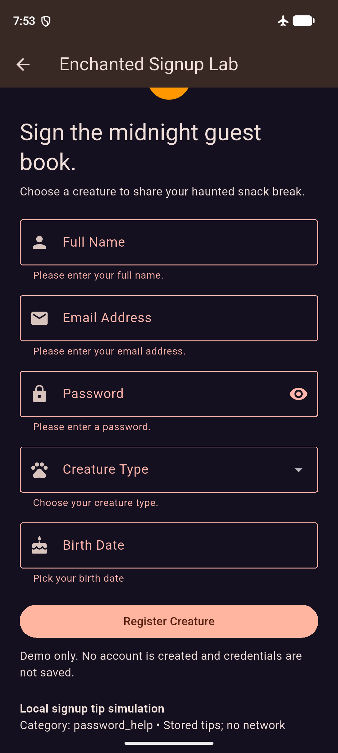  Empty form validation | 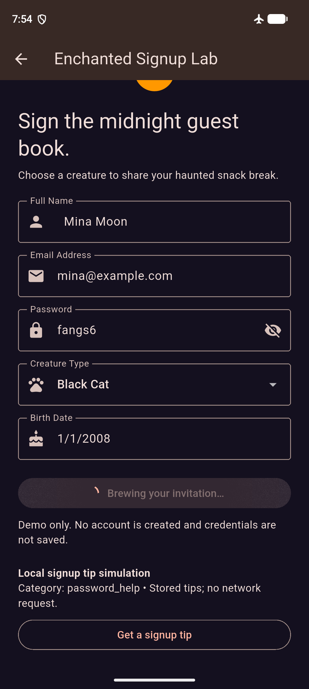  Disabled loading button | 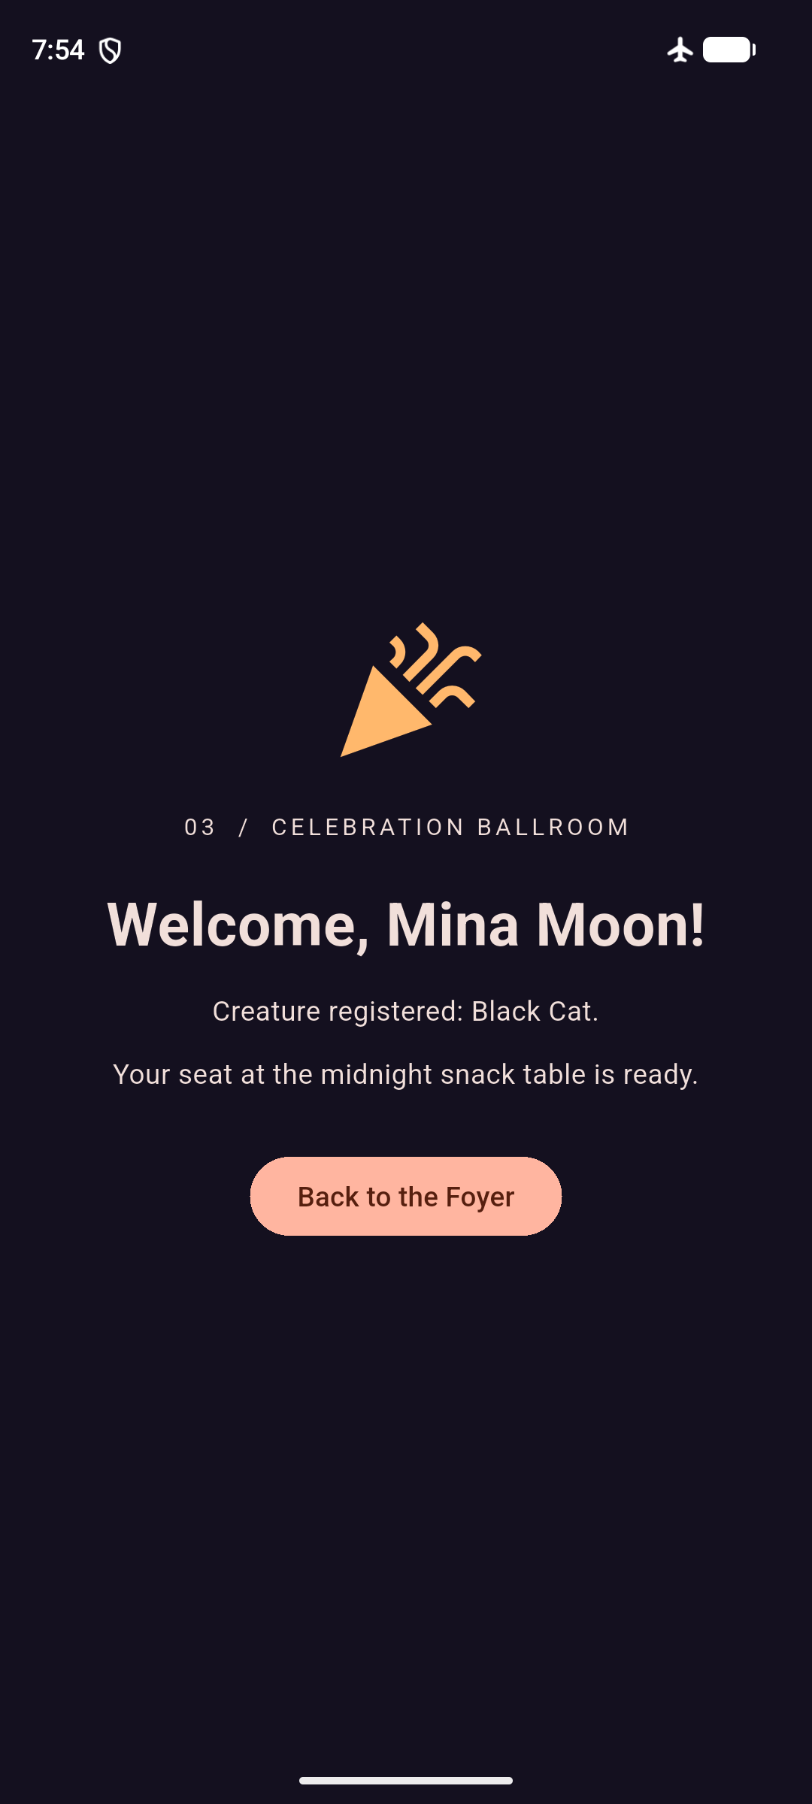  Personalized confirmation
Image 02 shows all five required-field errors. Image 06 shows Mina Moon, Black Cat, 1/1/2008, and a disabled registration button with a spinner. Image 07 shows the name and selected creature received by SuccessScreen. A still image alone does not establish the animation count; that behavior is supported by the controller setup and the completed navigation tests.

Navigation trace
Welcome -- push --> [Welcome, Signup]
Valid form -- pushReplacement --> [Welcome, Success]
Back or Back to the Foyer --> [Welcome]
The Lab is removed after submission, so Back cannot expose a filled form for accidental resubmission. The Success screen owns its three-second confetti controller, starts it in initState(), disables looping, and disposes it on exit. The original Activity 10 name, email, and password validators remain in the refactored Lab.

One verified layout fix
A 360-pixel-wide test initially reported a 6.1-pixel horizontal overflow. Setting isExpanded: true on the creature dropdown kept it within the available field width, and the same test passed with a simulated 280-pixel keyboard inset. This test also enters tomorrow in the date dialog and observes its out-of-range error.

Prompt 4 The Twin Mansions
For a controlled merge scenario, I predicted the exact first diagnostic "Error: No named parameter with the name 'name'." before building a caller that used SuccessScreen(name: 'Mina Moon') against this project's required userName and creatureType constructor. The debug bundle build produced that diagnostic and pointed to the canonical constructor with "Found this candidate, but the arguments don't match.", matching the prediction. Replacing the call with SuccessScreen(userName: 'Mina Moon', creatureType: 'Black Cat') allowed the bundle build to finish successfully. The naming rule is to define SuccessScreen only in lib/screens/success_screen.dart and require every caller to use its userName and creatureType parameters. This was a deliberate contract-mismatch experiment in an individual project, rather than a claim that a teammate merge occurred.

Prediction recorded before building
Predicted first compiler diagnostic:
Error: No named parameter with the name 'name'.

Observed compiler output
../../work/constructor_probe.dart:3:61: Error: No named parameter with the name 'name'.
void main() => runApp(const MaterialApp(home: SuccessScreen(name: 'Mina Moon')));
^^^^
lib/screens/success_screen.dart:5:9: Context: Found this candidate, but the arguments don't match.

Corrected constructor call
SuccessScreen(userName: 'Mina Moon', creatureType: 'Black Cat')
The broken and corrected caller fixtures, timestamped prediction, and raw build output are in evidence/constructor/. The fixtures end in .dart.txt so the normal project does not compile the deliberately broken example. The corrected build exited successfully; the final app also passed static analysis and its tests.

Delivery and verification limits
The delivery includes the public repository, complete Android Flutter source, this Word document, and a release-mode APK. The APK uses the Android project's debug signing key for classroom installation. The source is an Android project; other platforms and physical-device behavior were not verified. One contributor completed the work, so no group participation, teammate history, or live demonstration is represented as completed.
Read the project README for the route stack, state lifetime, controller disposal, full expected-versus-observed table, build commands, and bug record. Course upload and any live explanation are separate steps.

