

Design Guide

Star Security Services
Faculty Name | Miss. Wajiha Siddiqui
Batch Coordinator Name | Miss Maham Haider
Batch Code | 2308B1
Group | B

Enrollment No. | Student Name
Student1503124 | OMYMAH
Student1500557 | AHMED RAZA
Student1499166 | MUHAMMAD AFFAN VOHRA
Student1497938 | SYED ZAIN UL ABIDEEN
Student1501335 | SYED AUN ALAM

ACKNOWLEDGEMENT
We express our sincere gratitude to our faculty “--Miss Wajiha Siddiqui--" and our coordinator for their amazing support and guidance, continuous encouragement and supervision throughout the course of the present work. It’s of no doubt that we have been very fortunate to work under such a supportive and cooperative teacher/coordinator and last but not the least we are extremely grateful to the whole faculty and administration of Aptech, for providing us all the facilities that were mandatory, without which this project could not be a success.

SYNOPSIS
Introduction: Star Security Services is a premier security solutions provider committed to delivering top-tier protection and safety solutions. With a highly trained and professional team, we cater to a diverse range of security needs, ensuring peace of mind for individuals, businesses, and institutions.
Vision: To be a trusted leader in the security industry, setting new benchmarks in safety, reliability, and customer satisfaction through innovation and excellence.
Mission: Our mission is to provide superior security services tailored to our clients' unique needs. We strive to uphold the highest standards of integrity, professionalism, and efficiency, ensuring the safety of people, property, and assets.
Services Offered:
Corporate Security – Ensuring safety in corporate offices, IT parks, and business establishments.
Residential Security – Protection services for gated communities, apartments, and individual residences.
Event Security – Specialized security management for concerts, conferences, and private events.
Industrial Security – Guarding factories, warehouses, and industrial complexes.
VIP Protection – Personal bodyguard and escort services for high-profile individuals.
Surveillance & Monitoring – Advanced CCTV surveillance and monitoring solutions.
Emergency Response Services – Rapid action response teams for crisis situations.

PROBLEM Statement

The problem statement is attached separately in a file “StarSecurityServices.doc”
Standards plan:
Every code block must have comments.
The logic of the program needs to be explained. Proper documentation should be
maintained.
Complete Project Report along with synopsis, code and documentation should be
prepared.
Documentation:
No project is complete without documentation. In fact, it is one of the most
important activities during the development of a project. The documentation of an
ideal project will be in the form of a project report comprising of the following
documents:

- Certificate of Completion.
- Table of Contents.
- Problem Definition.
- Customer Requirement Specification.
- Project Plan.
- E-R Diagrams.
- Algorithms.
- GUI Standards Document.
- Interface Design Document.
- Task Sheet.
- Project Review and Monitoring Report.
- Unit Testing Check List.
- Final Check List.

CUSTOMER REQUIREMENT SPECIFICATIONS (CRS)

Hardware

Hardware/ Software Requirements

A minimum computer system that will help you access all the tools in the
courses is a Pentium 166 or better

128 Megabytes of RAM or better

- Software
- Visual Studio .Net / ASP
- IIS server
- .Net Framework
- Java Virtual Machine/ J2EE server
- Notepad/Java editor
- j2sdk1.4.1_02 (or later).
- EJB Dev Kit
- Java enabled web server
- JSP / Servlets Dev. Kit

SCOPE OF THE WORK
1. Objectives Star Security Services aims to provide comprehensive security solutions tailored to meet the specific needs of individuals, businesses, and institutions. The key objectives include:
- Ensuring the safety and security of clients through highly trained personnel and advanced surveillance technologies.
- Providing round-the-clock monitoring and rapid response to security threats.
- Implementing state-of-the-art security infrastructure to enhance protection measures.
- Offering customized security solutions for different sectors, including corporate, residential, and industrial.
- Maintaining high ethical and professional standards to foster trust and reliability.
2. Limitations While Star Security Services strives for excellence, certain limitations must be considered:
- Dependence on external factors such as weather conditions, power supply, and network connectivity for surveillance operations.
- Regulatory and legal constraints that may vary across different jurisdictions.
- The effectiveness of security measures is subject to compliance by clients with safety protocols.
- Potential delays in response time due to unforeseen circumstances such as traffic conditions or natural disasters.
- Limited control over third-party systems that may be integrated into security solutions.

SCREENSHOTS


User Index

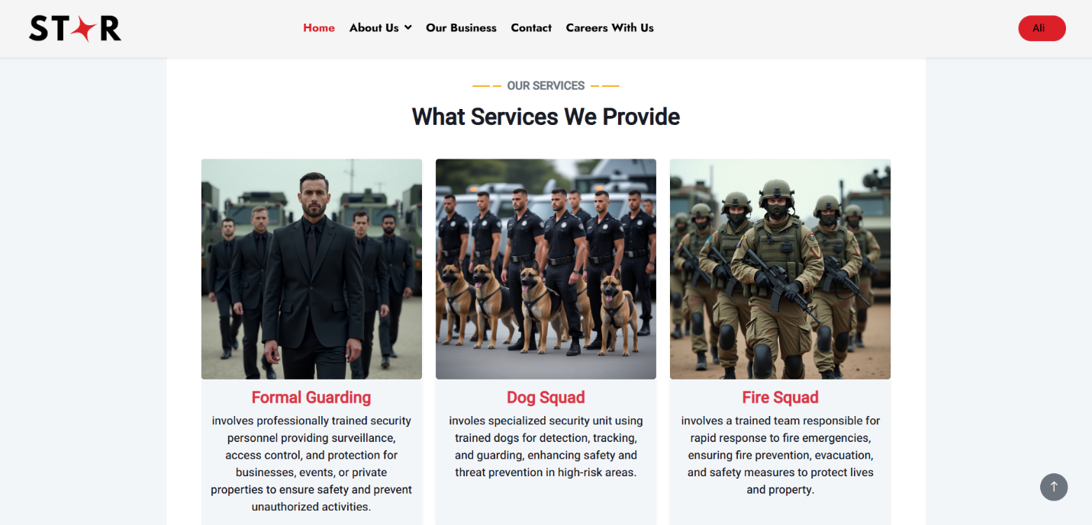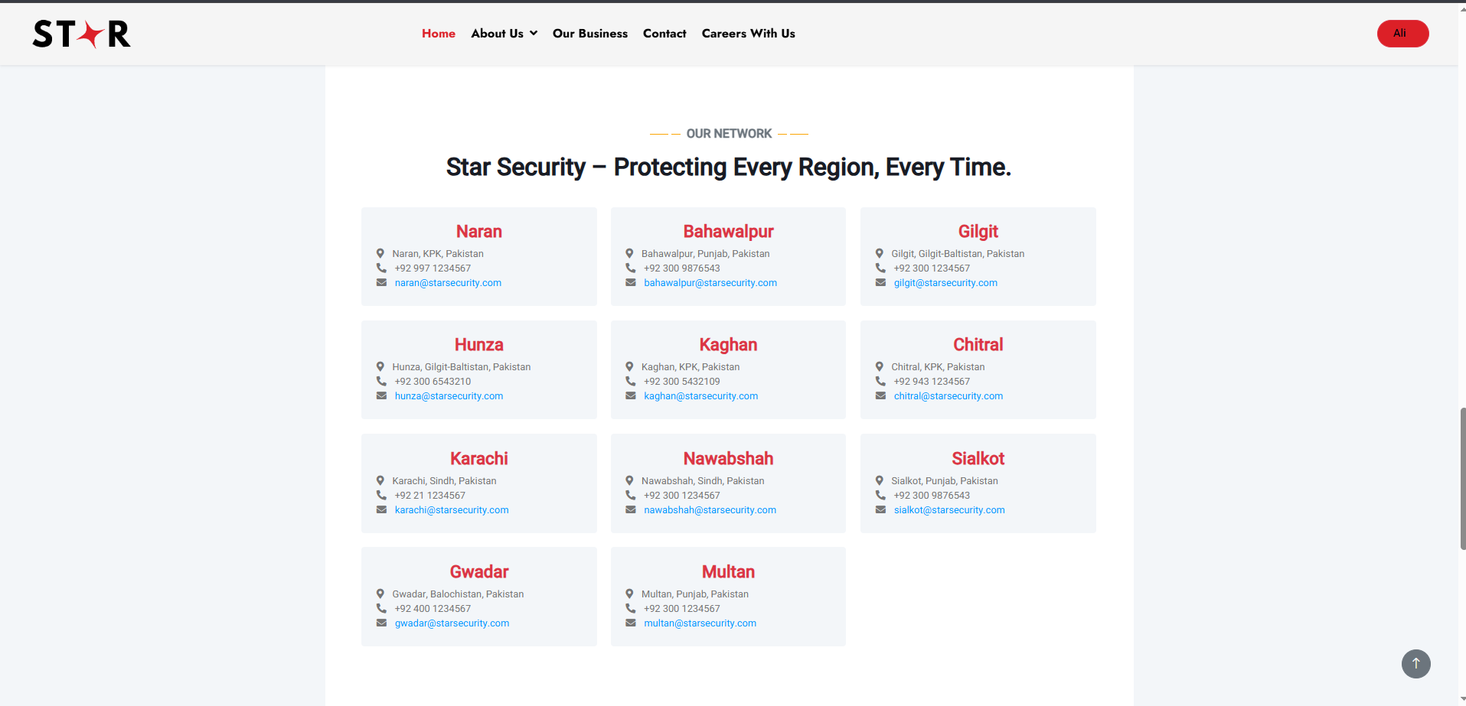

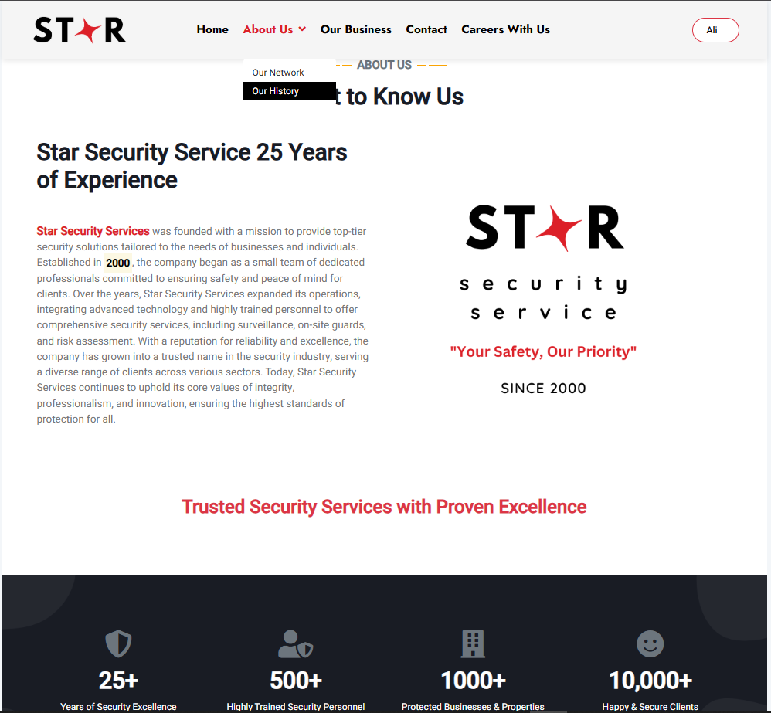
About Us

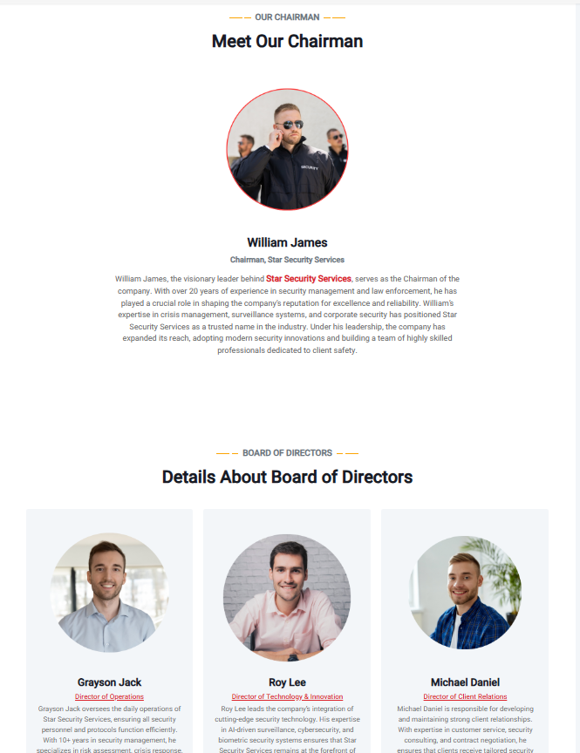

Our Network
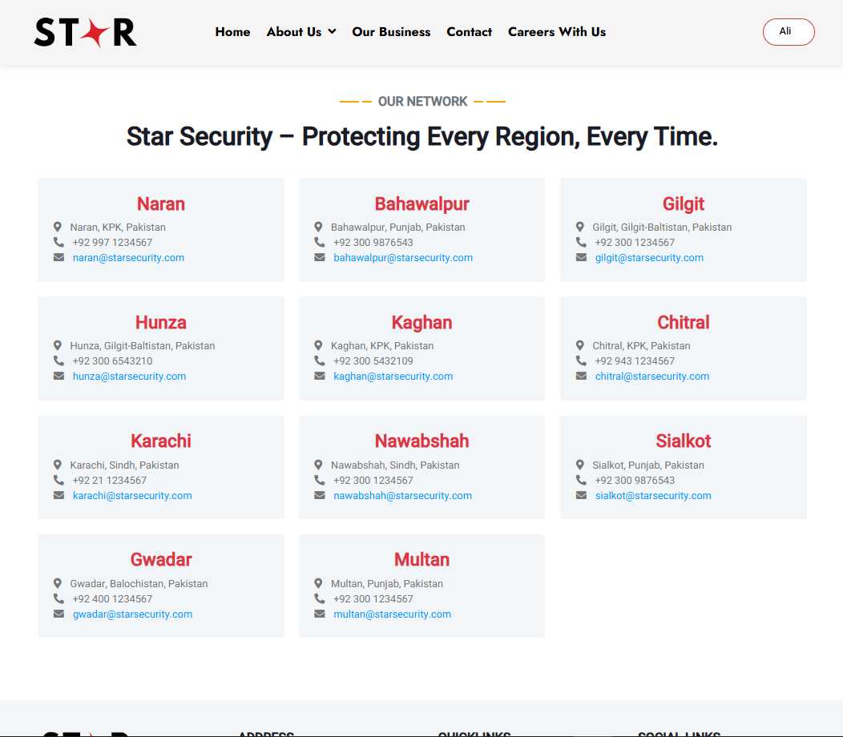

Our Business
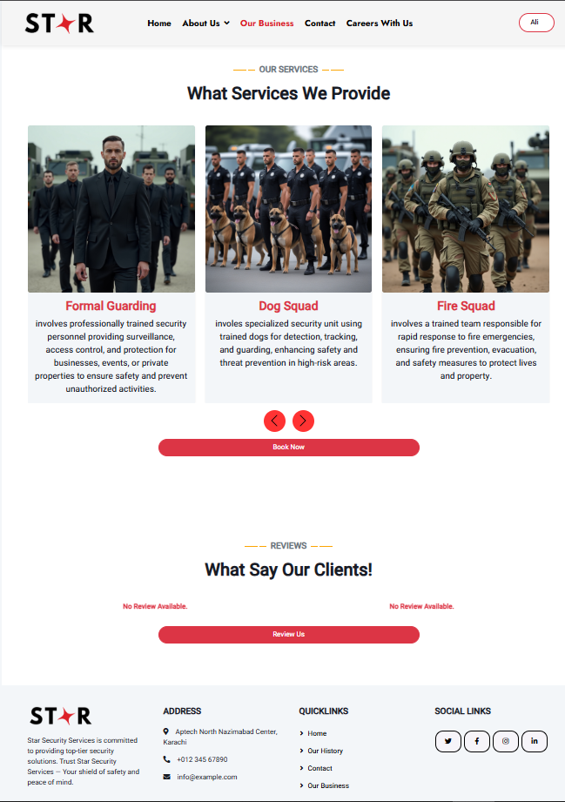

Contact Us
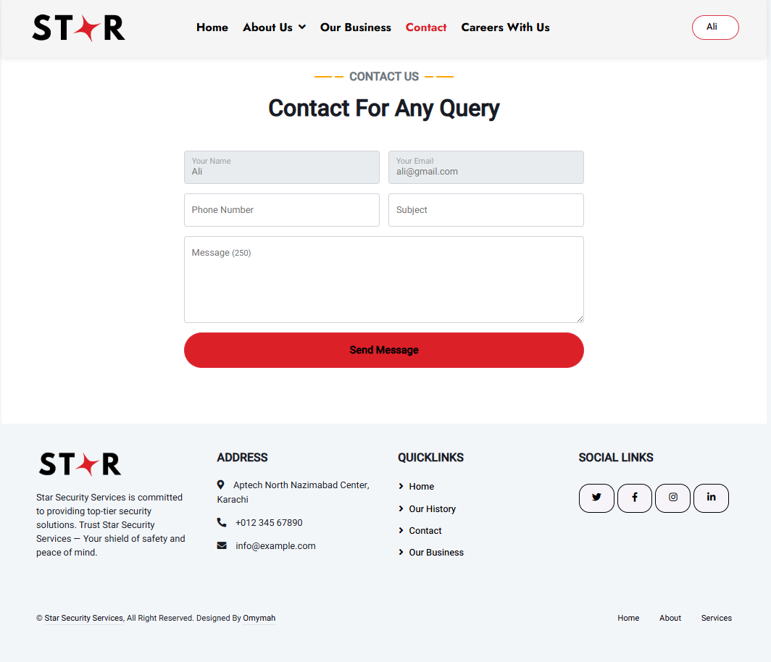

Career With Us
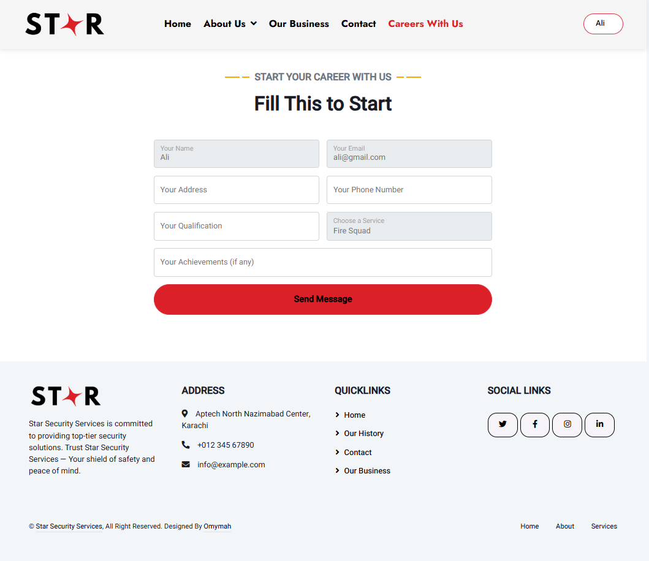

User Booking
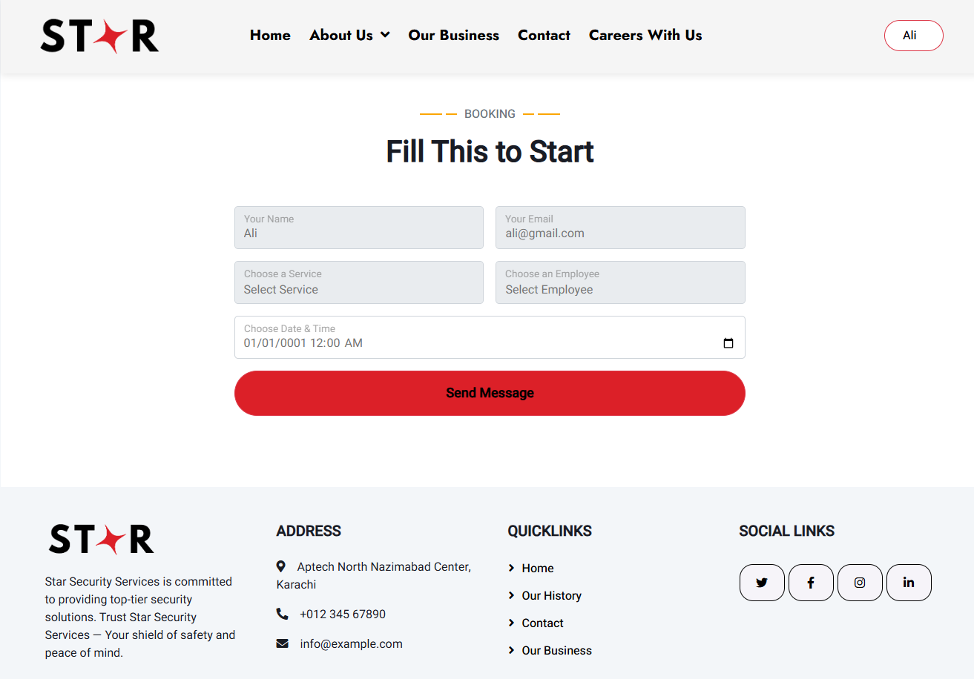

Employee Profile
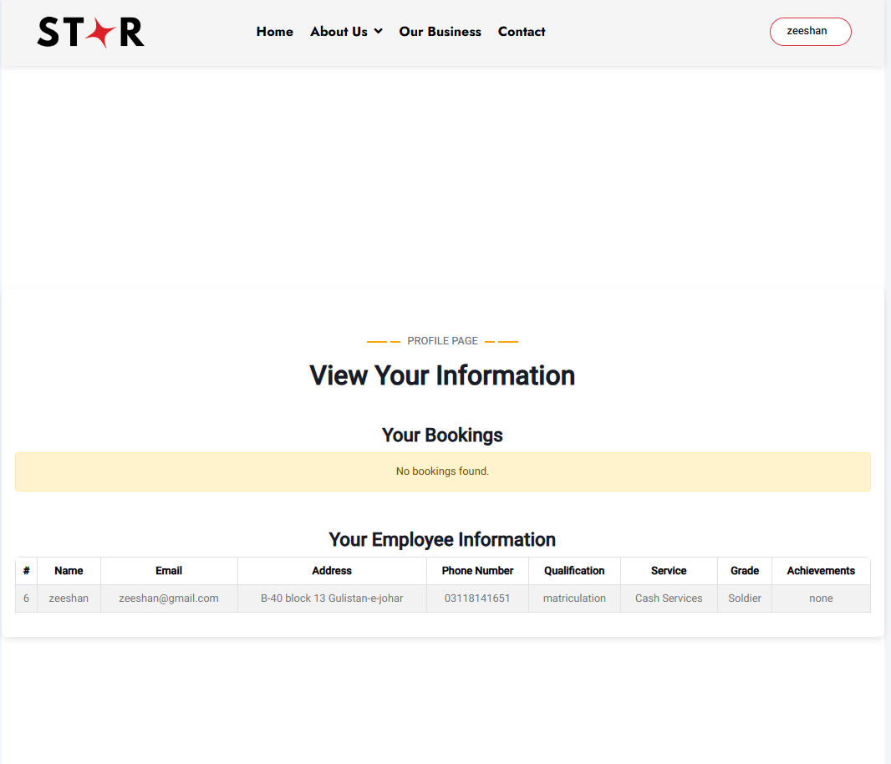
User Profile
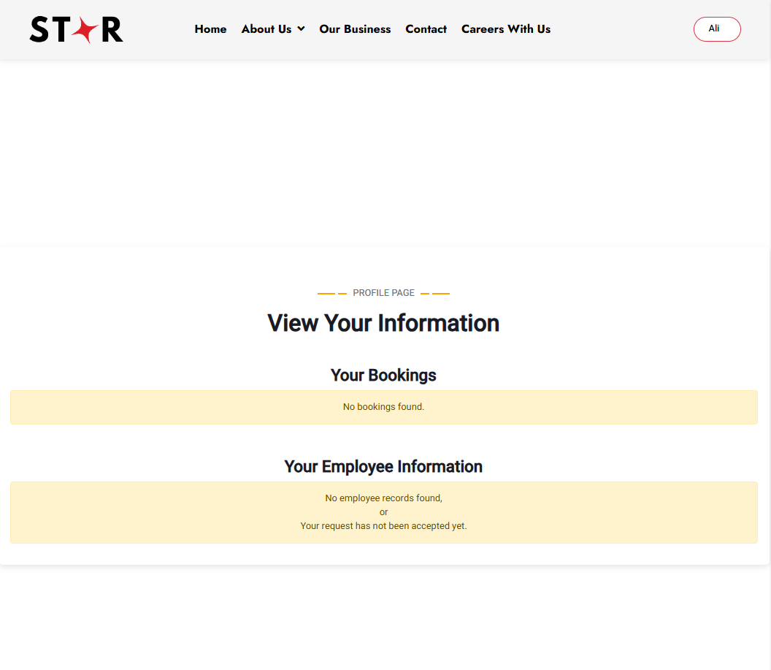

Admin Dashboard
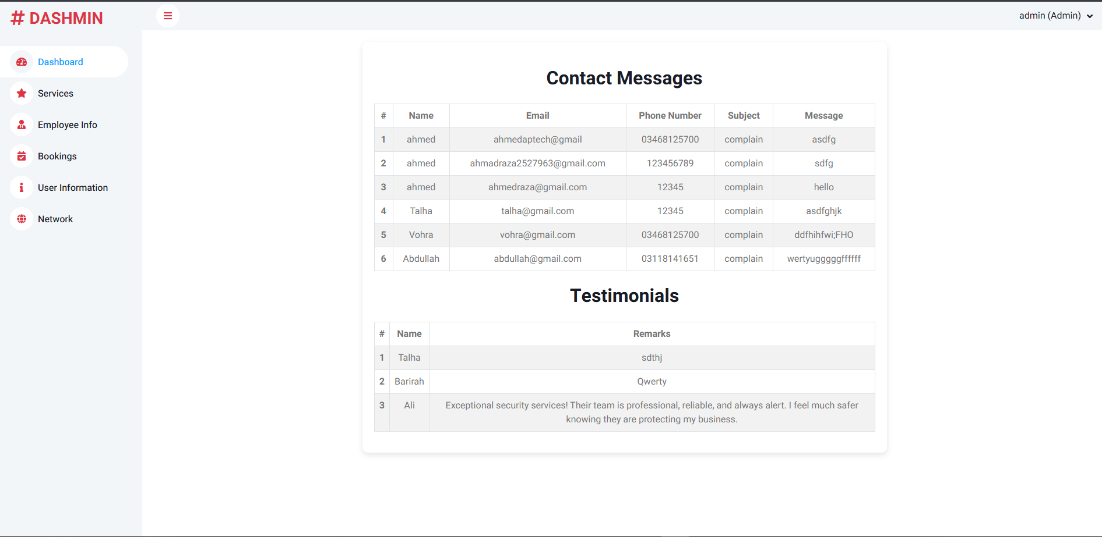
Admin Services
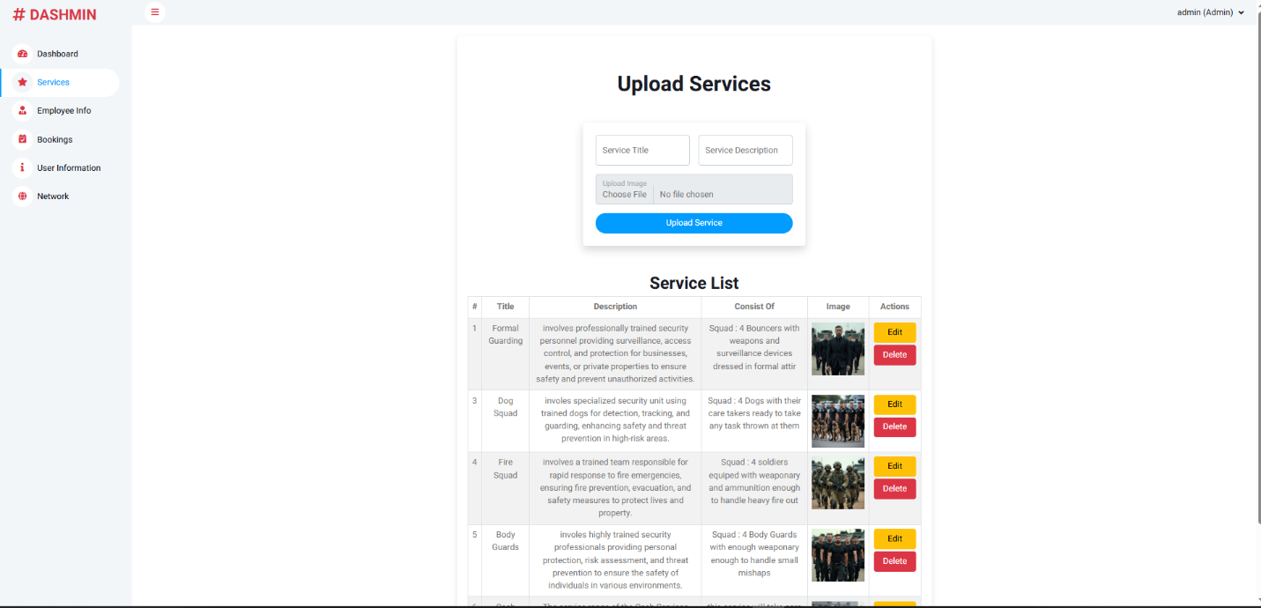

Admin Employee Info
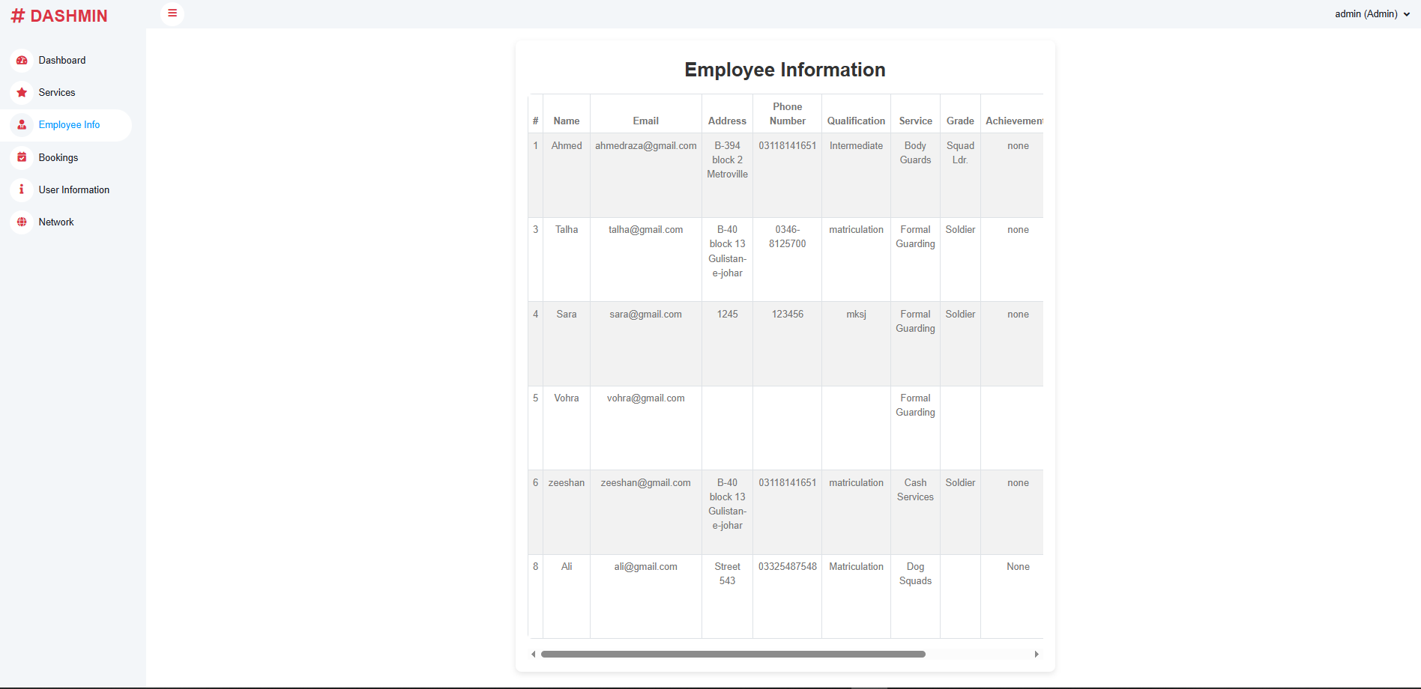
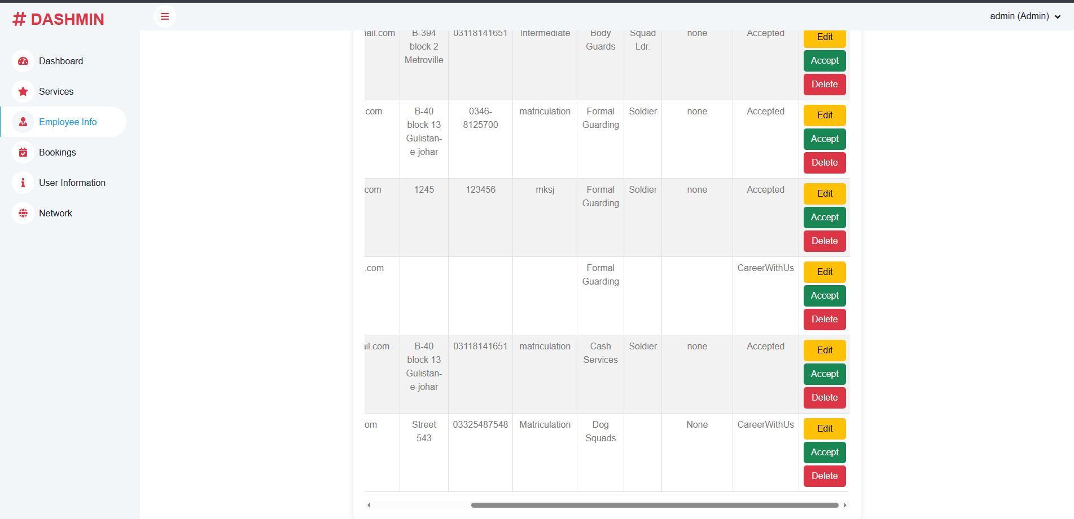

Admin Booking
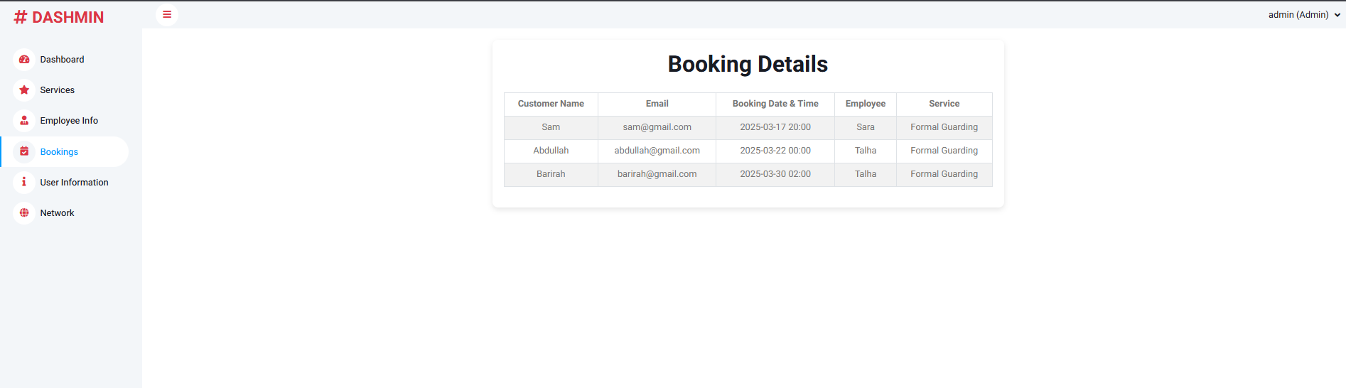
Admin User Info
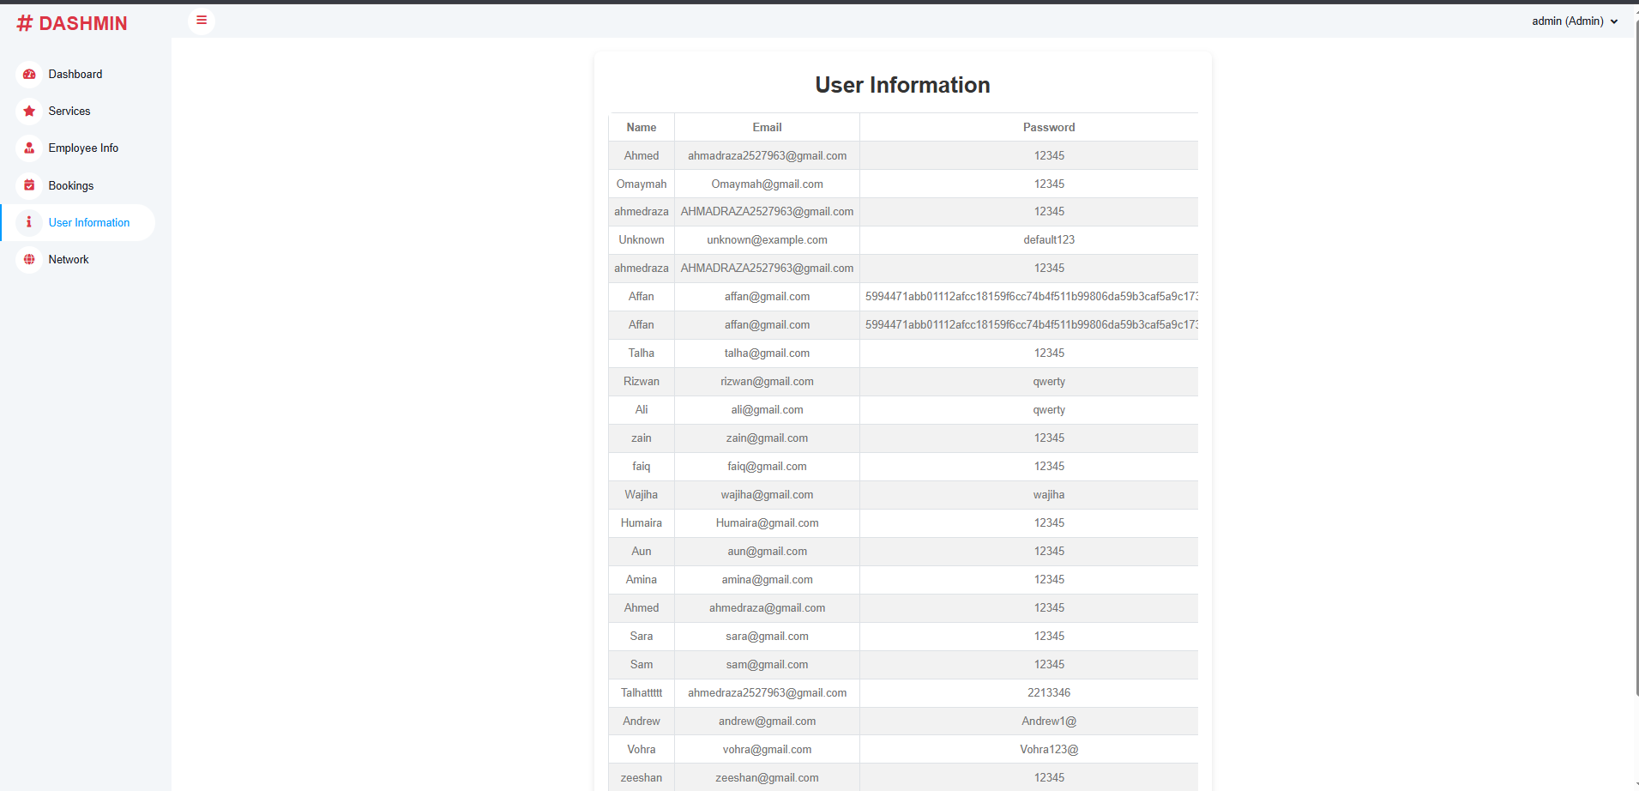

Admin Network
