

User Guide

Star Security Services

Faculty Name | Miss. Wajiha Siddiqui
Batch Coordinator Name | Miss. Maham Haider
Batch Code | 2308B1
Group | B

Enrollment No. | Student Name
Student1503124 | OMYMAH
Student1500557 | AHMED RAZA
Student1499166 | MUHAMMAD AFFAN VOHRA
Student1497938 | SYED ZAIN UL ABIDEEN
Student1501335 | SYED AUN ALAM
INTRODUCTION
The thirst for learning, upgrading technical skills and applying the concepts in real life environment at a fast pace is what the industry demands from IT professionals today. However busy work schedules, far-flung locations, and unavailability of convenient time-slots pose as major barriers when it comes to applying the concepts into realism. And hence the need to look out for alternative means of implementation in the form of laddered approach. The above truly pose as constraints especially for our students too! With their busy schedules, it is indeed difficult for our students to keep up with the genuine and constant need for integrated application which can be seen live especially so in the field of IT education where technology can change on the spur of a moment. Well, technology does come to our rescue at such times!! Keeping the above in mind and in tune with our constant endeavour to use Technology in our training model, we at Aptech have thought of revolutionizing the way our students learn and implement the concepts using tools themselves by providing a live and synchronous eProject learning environment!
So what is this eProject?
eProject is a step by step learning environment that closely simulates the classroom and Lab based learning environment into actual implementation. It is a project implementation at your fingertips!! An electronic, live juncture on the machine that
allows you to
o Practice step by step i.e. laddered approach.
o Build a larger more robust application.
o Usage of certain utilities in applications designed by user.
o Single program to unified code leading to a complete application.
o Learn implementation of concepts in a phased manner.
o Enhance skills and add value.
o Work on real life projects.
o Give a real life scenario and help to create applications more complicated and
useful.
o Mentoring through email support.

The students at the Centre are expected to complete this eProject and send complete
documentation with source code within the time allotted to eProjects Team
Looking forward to a positive response from your end!!
SCREENSHOTS

User Index

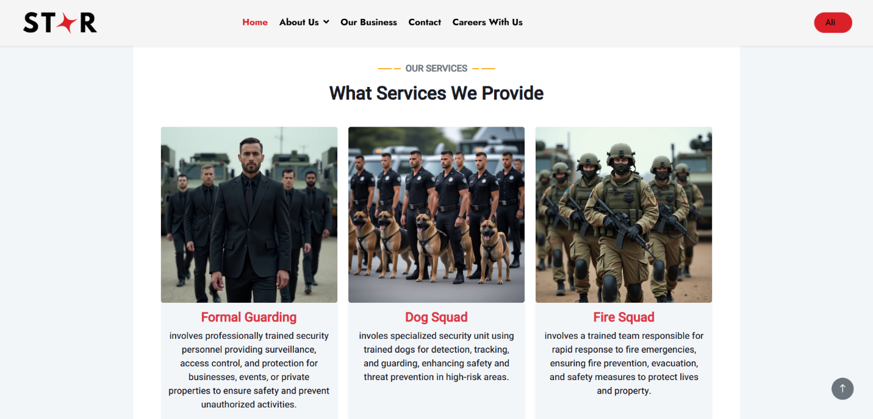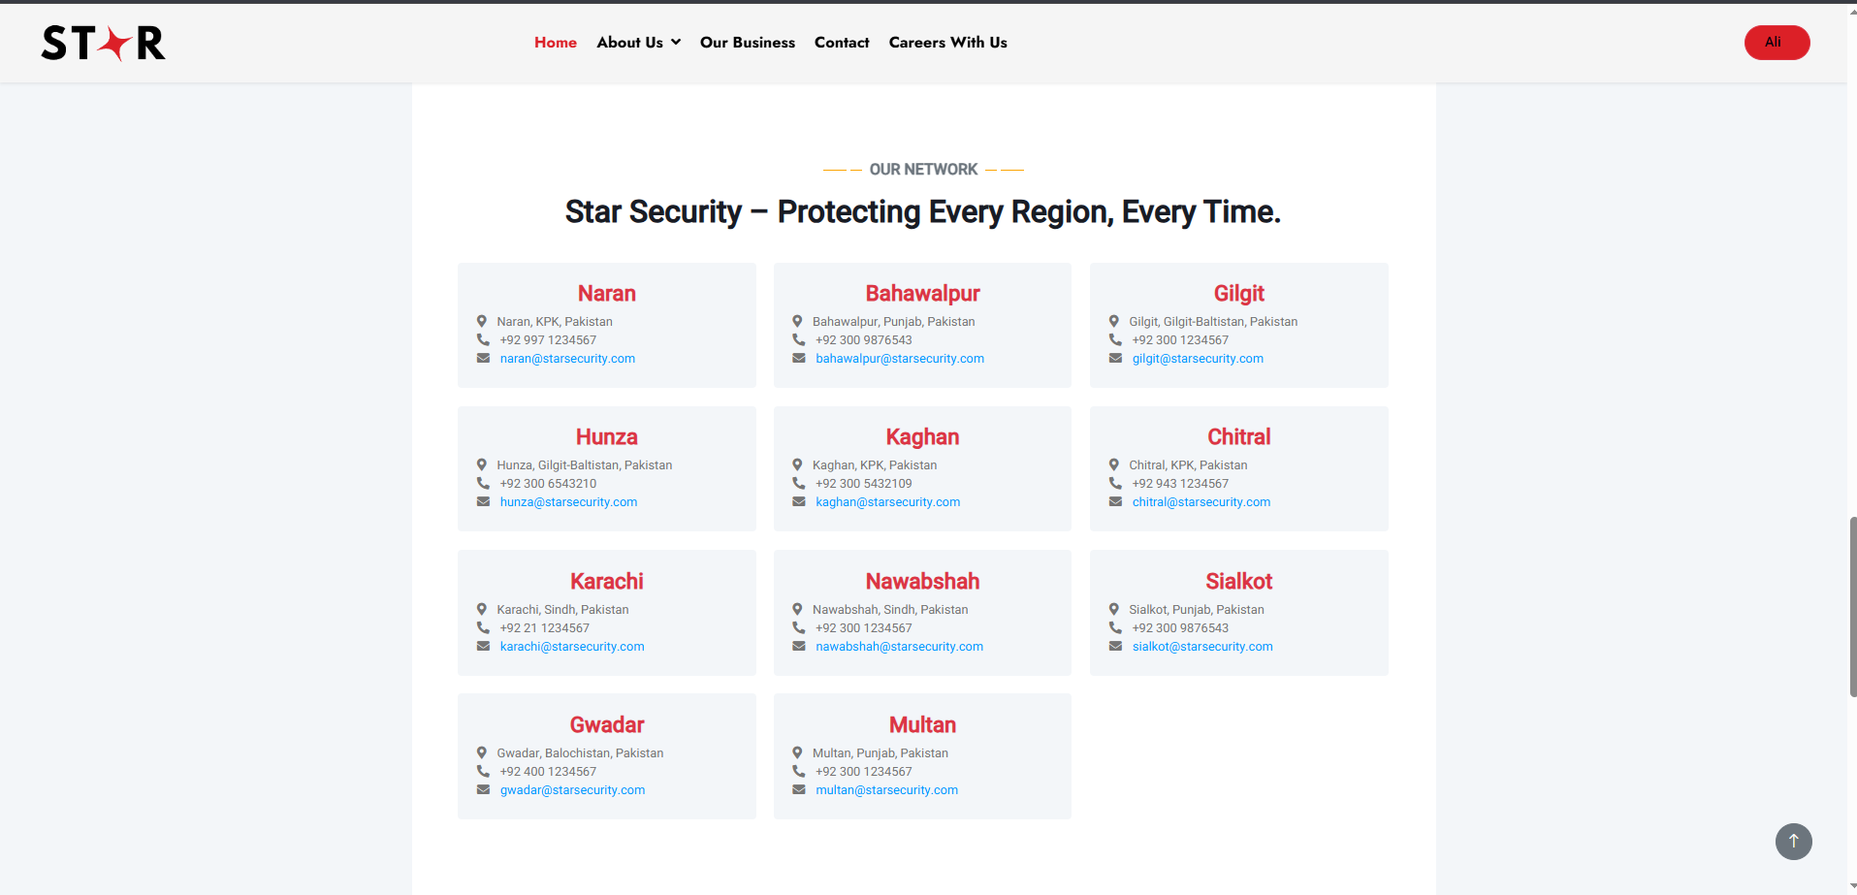

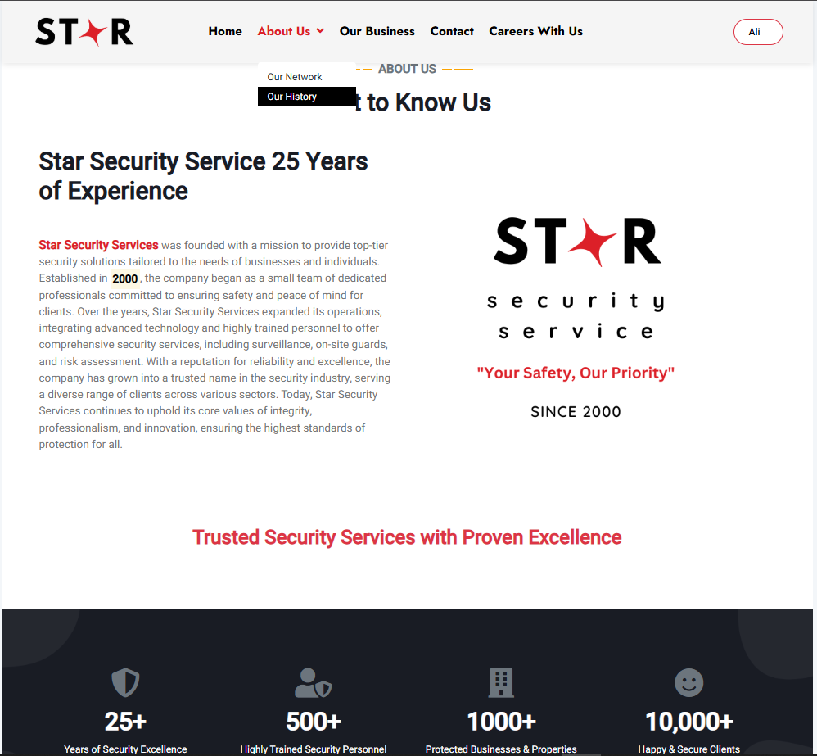
About Us



Our Network
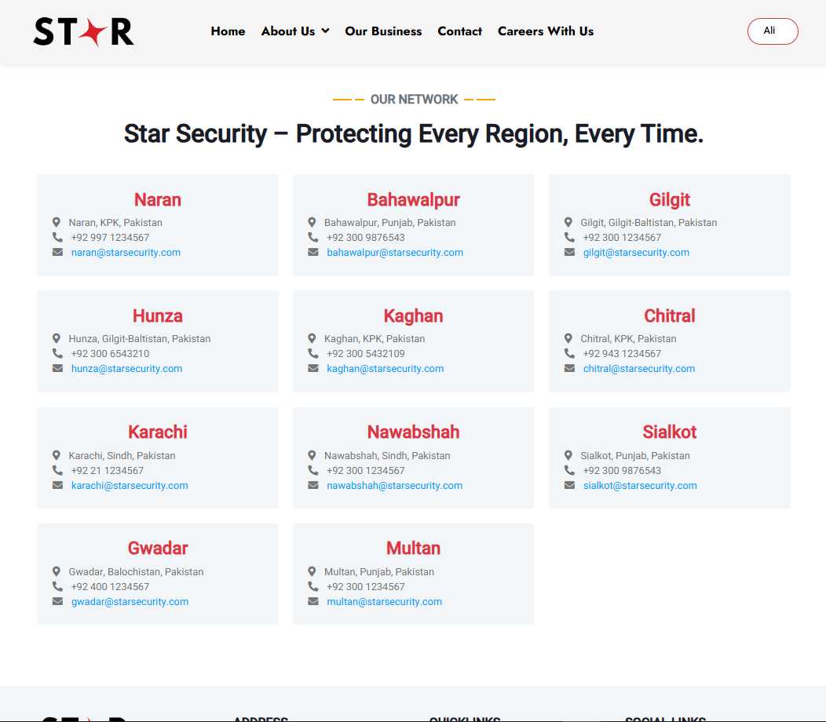

Our Business
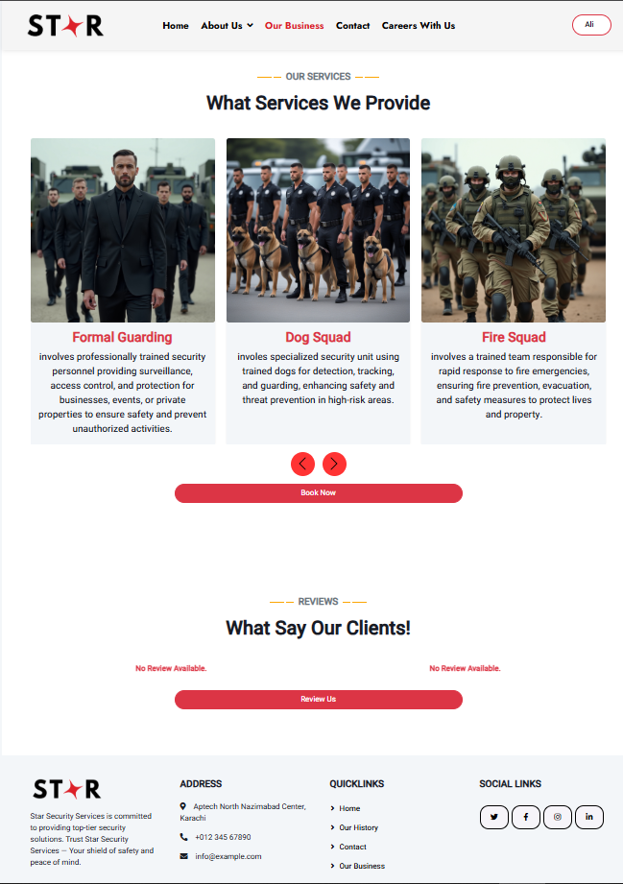

Contact Us
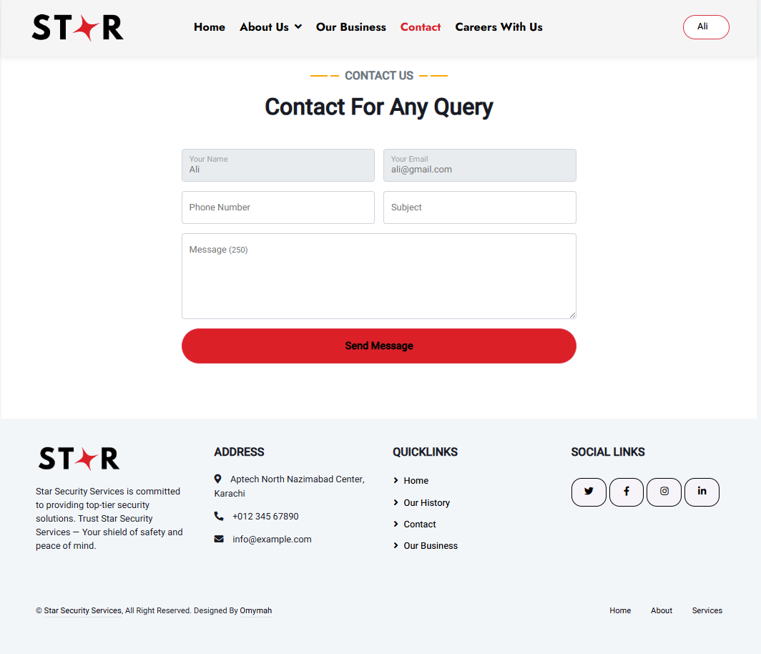

Career With Us
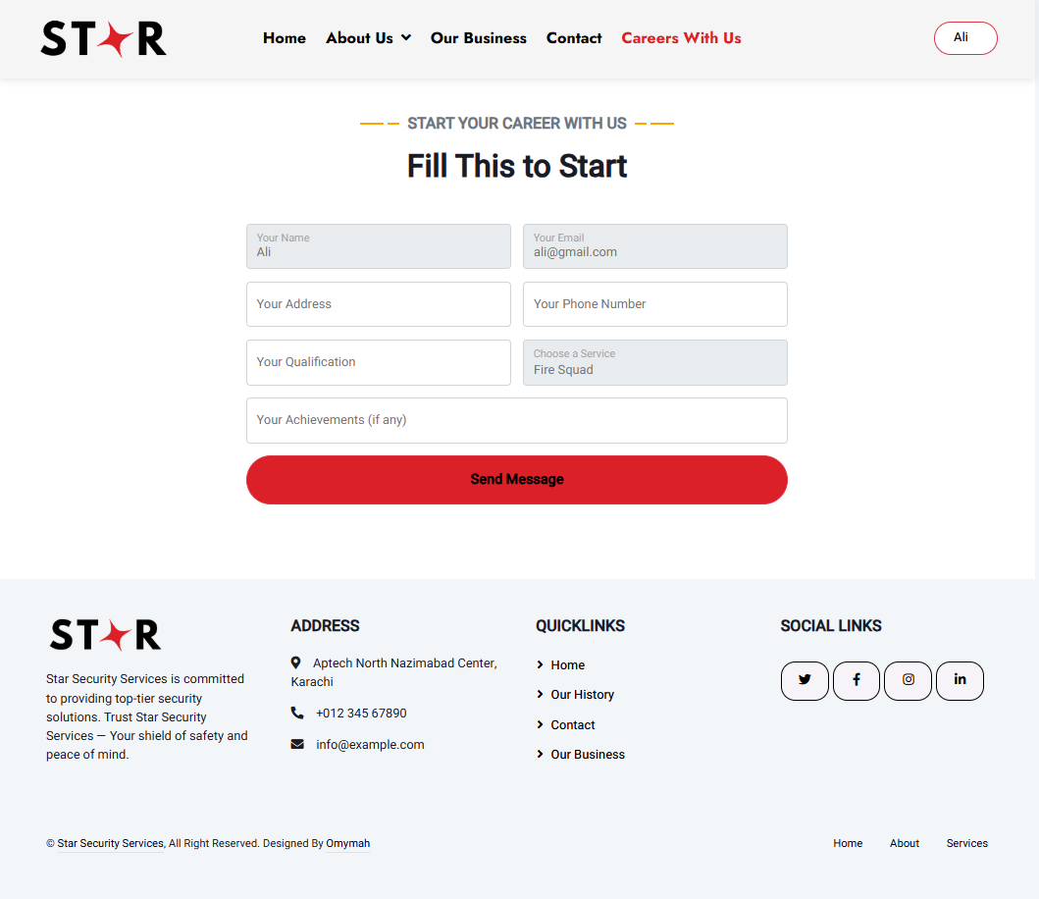

User Booking
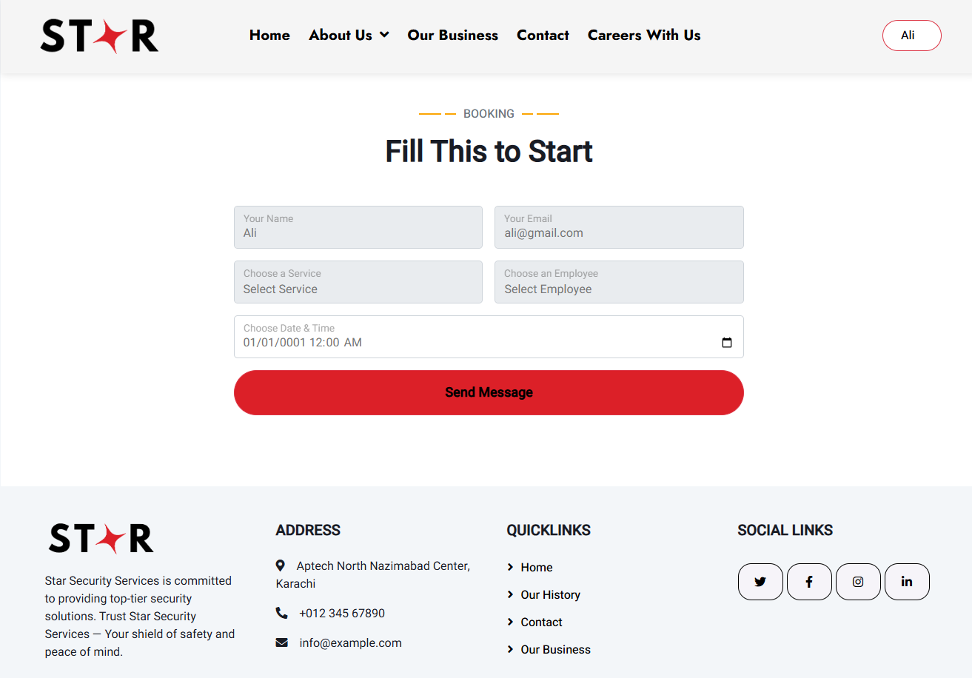

Employee Profile
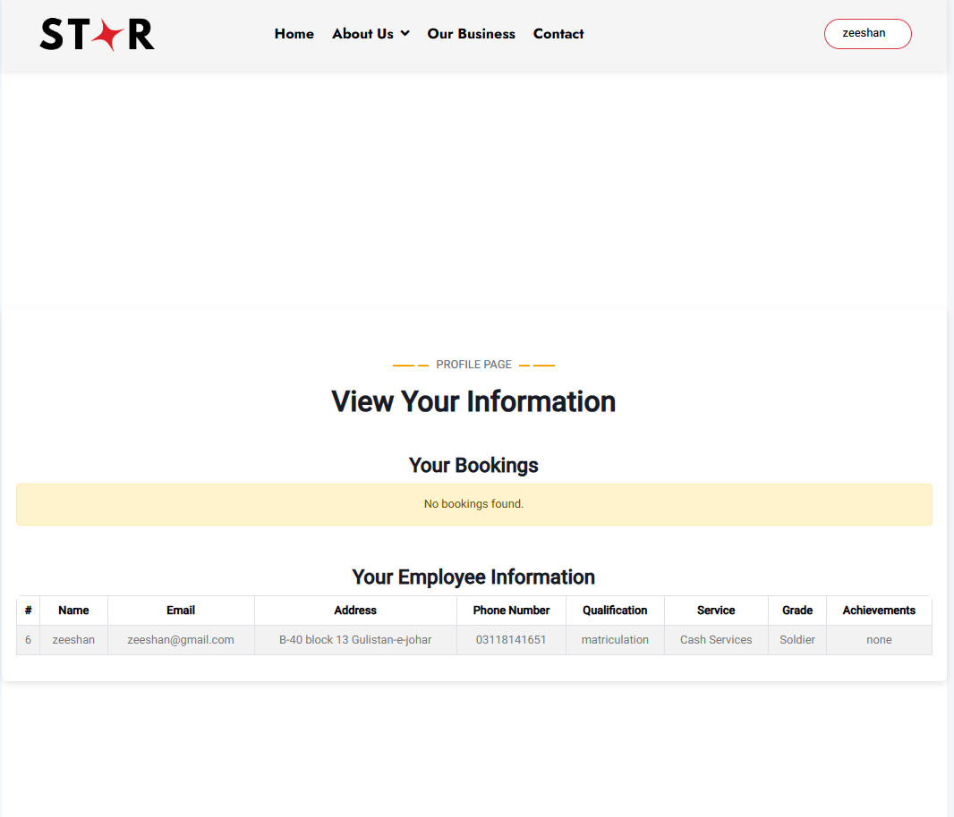
User Profile
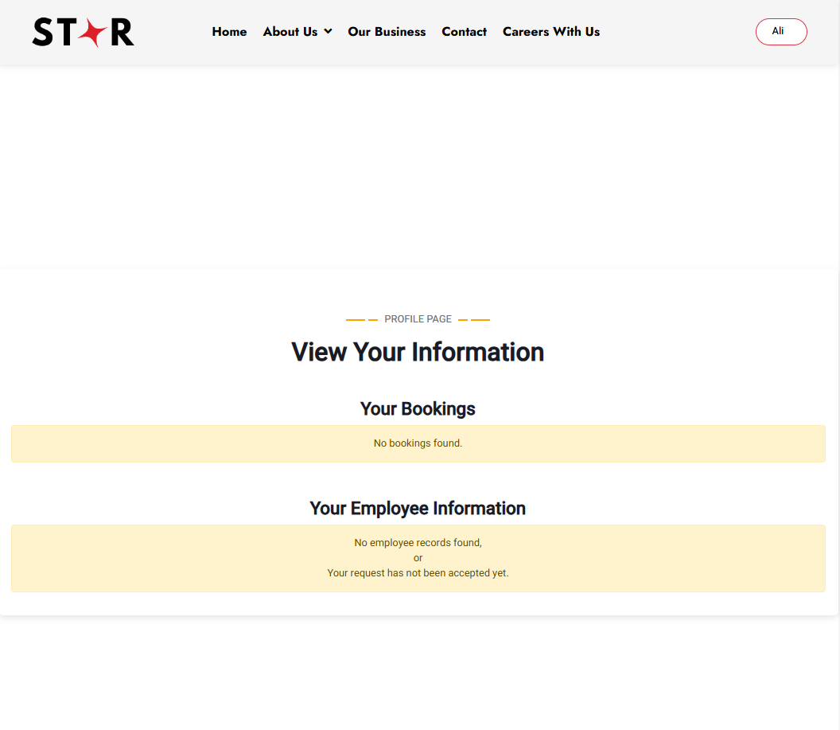

Admin Dashboard
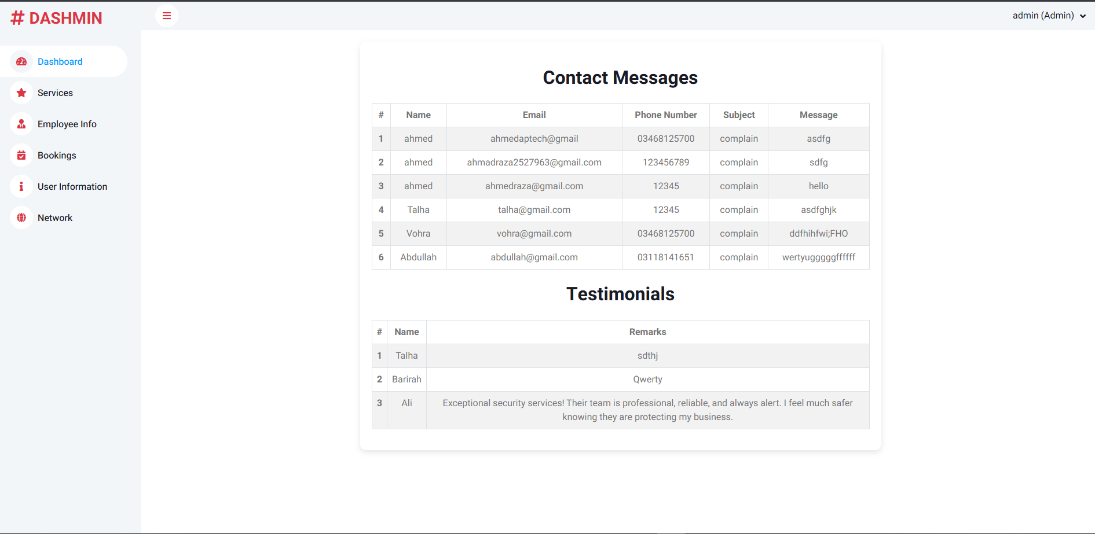
Admin Services
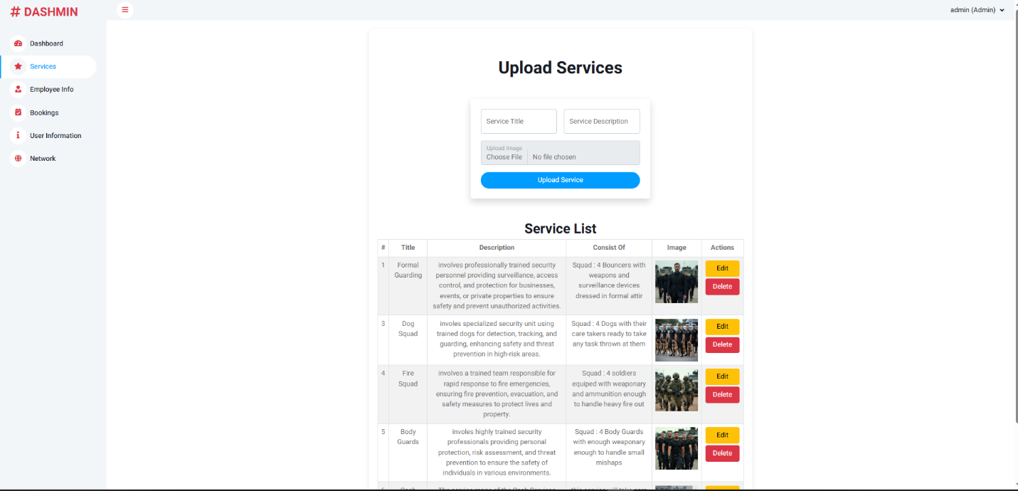

Admin Employee Info
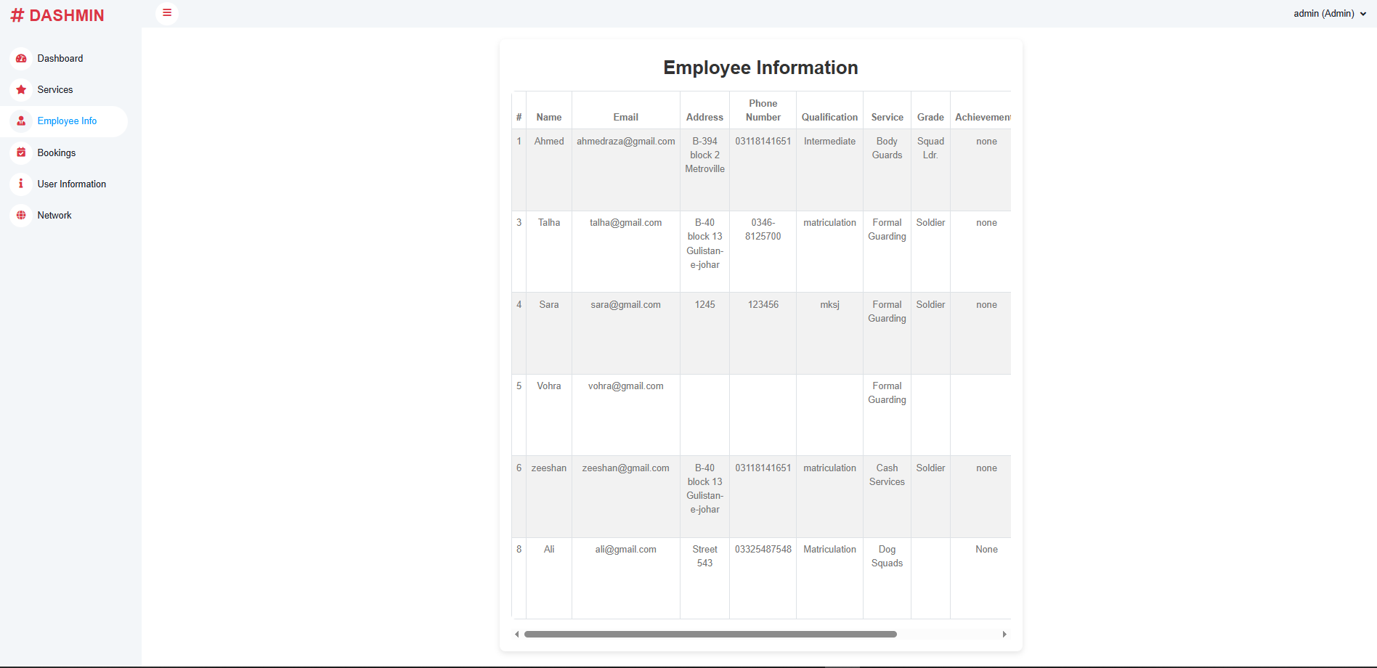
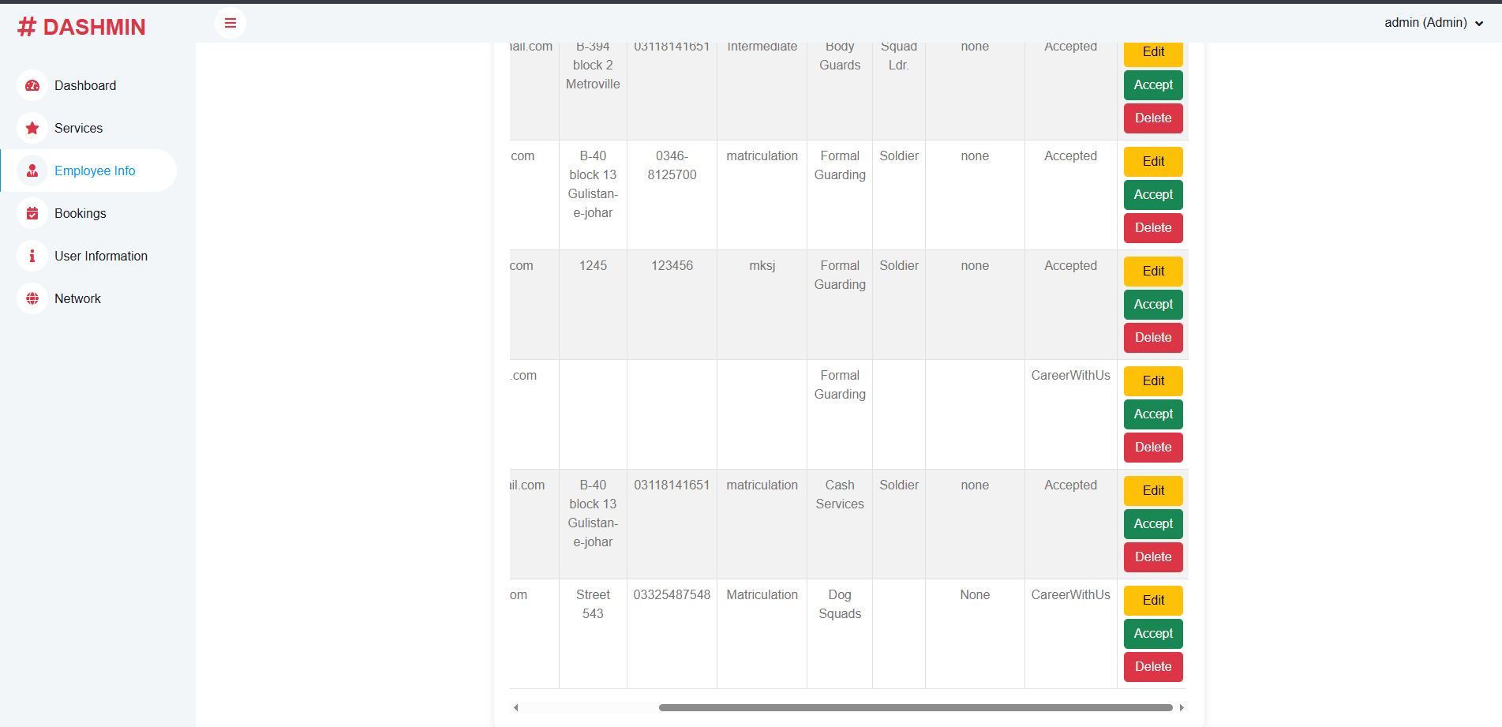

Admin Booking
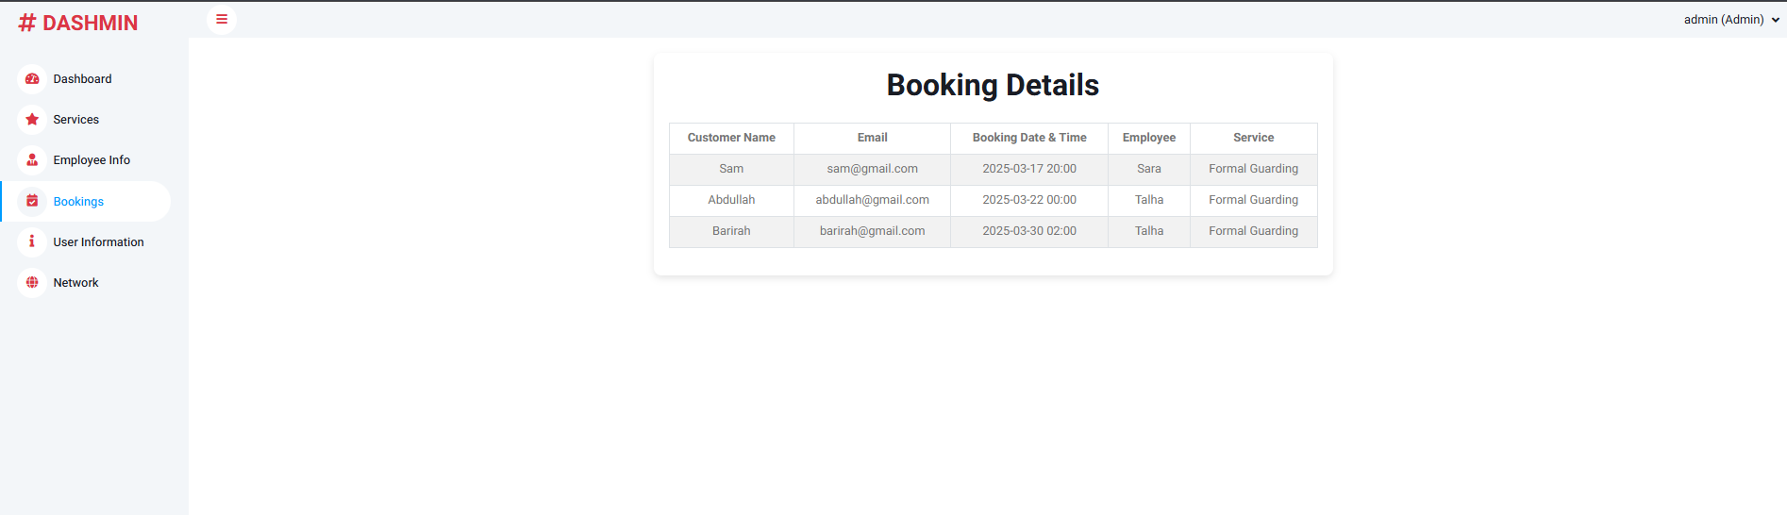
Admin User Info
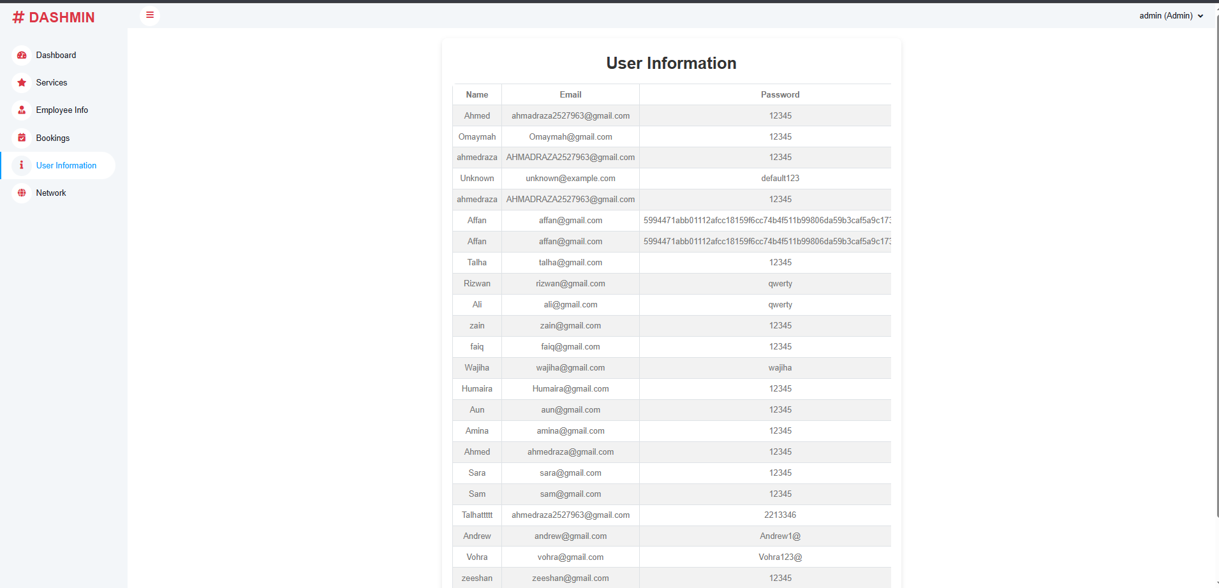

Admin Network
