# Emma! V1.1 Prototype Build Data Analysis

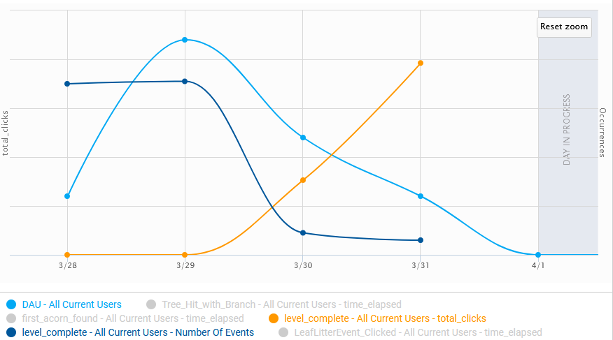

Figure 1 Dau vs. Level Completion rate vs. total clicks (average/day)

As shown in the figure above, the level completion rate and the number of players decrease day by day, while the number of clicks used by players to complete the level rises. This shows that the update makes the game more challenging. This phenomenon was expected, the development team made updates that increase the difficulty of the game.

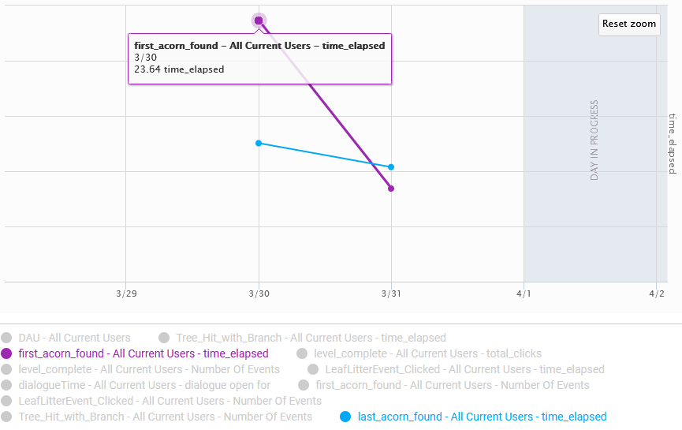

Figure 2 First collectable found time vs. last collectable found time (average/day)

This prototype contains one level. The player must find all collectables (acorns) to clear the level. From the information shown in the figure above, it can be seen that the time it takes the player to find the last collectable is too short, sometimes even shorter than the time it takes to collect the first collectable. This suggests that the project may have one of these problems:

1. There is a bug that creates a shortcut in the level to let players pass the level fast

2. The code transmitted the wrong data/ dispatched the event at the wrong time

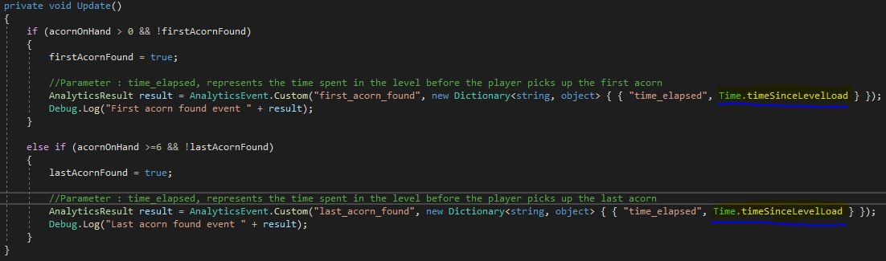

Figure 3 bug location

The dev team reacted to the false data quickly and located the bug. As shown in the screenshot, when the player finds a collectable, the time parameter transmitted by the event is counted from the beginning of the current scene, rather than using the universal timer. Therefore, the two sets of data obtained are neither accurate.

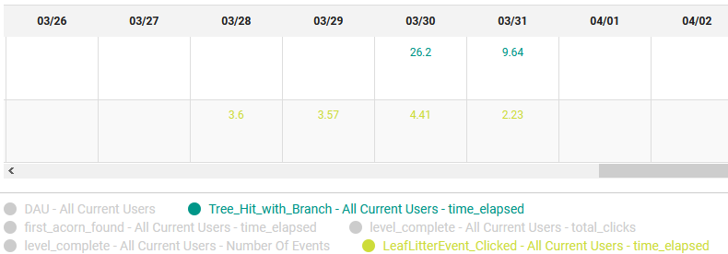

Figure 4 Tree Puzzle figure-out time vs. Leaf Puzzle figure-out time (average/day)

There are two puzzles in this prototype. The player must unlock both of them to complete the quest and pass the level. The "leaf pile puzzle" is relatively simple, and most players found the solution in less than five seconds. The "tree & branch" puzzle is designed to be difficult. According to the data, the dev team thinks that both puzzle's difficulty should be increased, especially the "leaf pile puzzle".

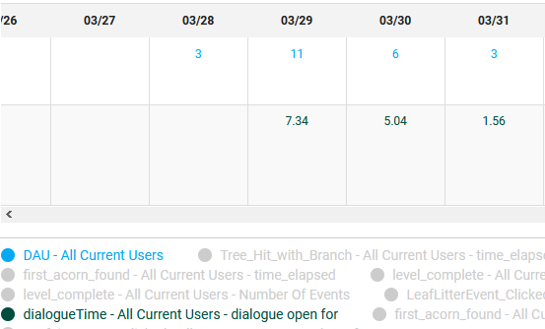

Figure 5 DAU vs. Dialogue open time (average/day)

The duration of the player's conversation with the NPC (Acorner) is recorded. According to effective data, the number of active users per day is proportional to the length of the conversation. Some players replayed the game and skipped the dialogue. The dev team plans to extend the dialogue a little according to the data.

# Working with Data – Serialization

When there are multiple scenes in the game and the player is supposed to jump between the scenes, it becomes necessary to transfer data between scenes. To do this, the current scene data must be serialized and stored before it is destroyed. The scene will be reconstructed it from the previously stored data when the player returns to the scene. Some objects in Unity cannot be directly serialized, such as gameobject, transform. The data in these objects have to be recorded manually, as shown below.

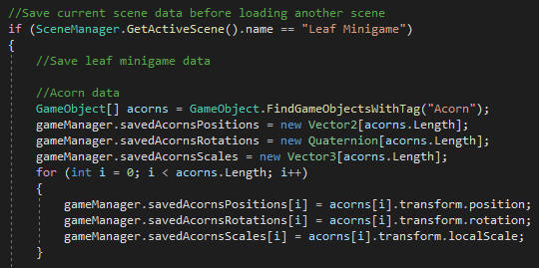

Figure 6 Scene storing process (Located in script "LoadSceneOnClick")

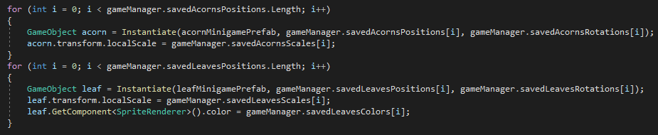

Figure 7 Scene rebuilding process (Located in script "SceneRestorer")