VSync Off:

Inside Unity’s Quality Settings, there’s an option called VSync Count. Setting this to Don’t Sync lowers the overall CPU usage of the game. The CPU Usage is lowered from about 14 average to 6 average. These screenshots help show the comparison. Vsync syncs your graphic card image output rate with your display's refresh rate. With VSync off, the game starts drawing the next frame without finishing the previous one, and can create tears on the screen. This is more so an issue in AAA games, and VSync off doesn’t affect our game.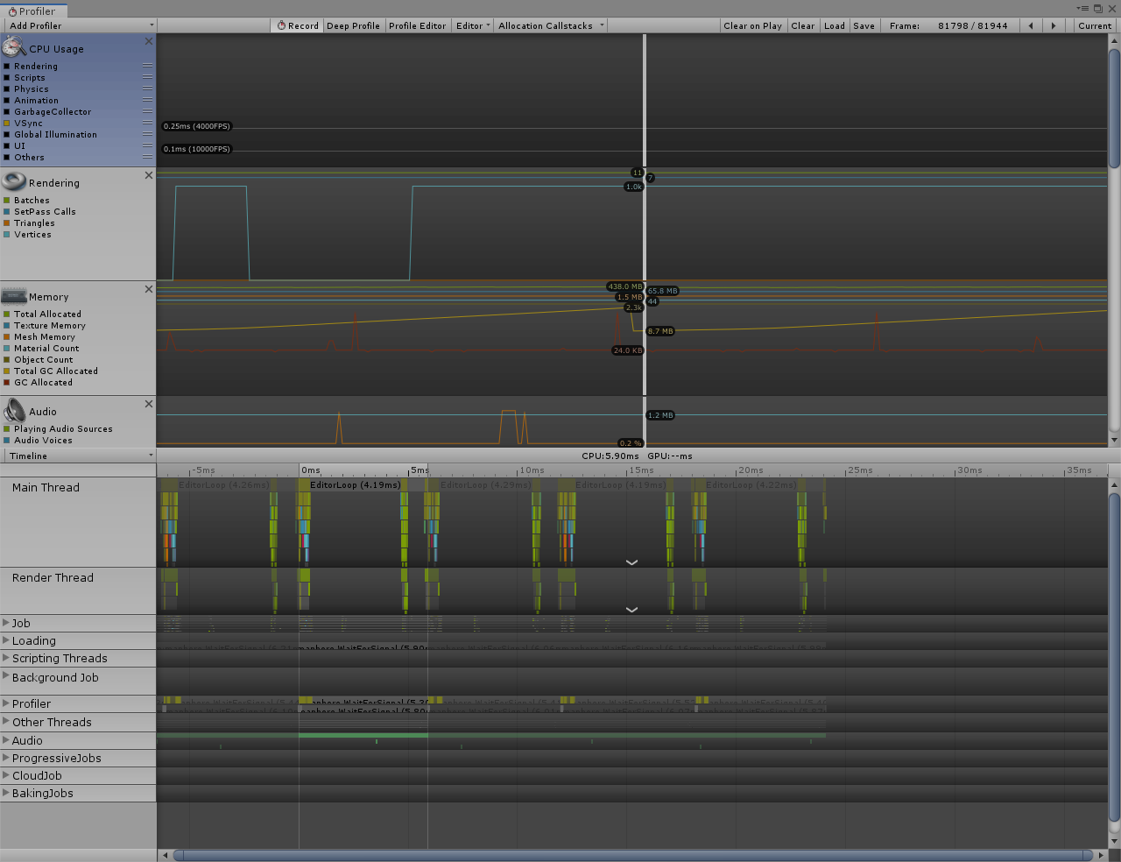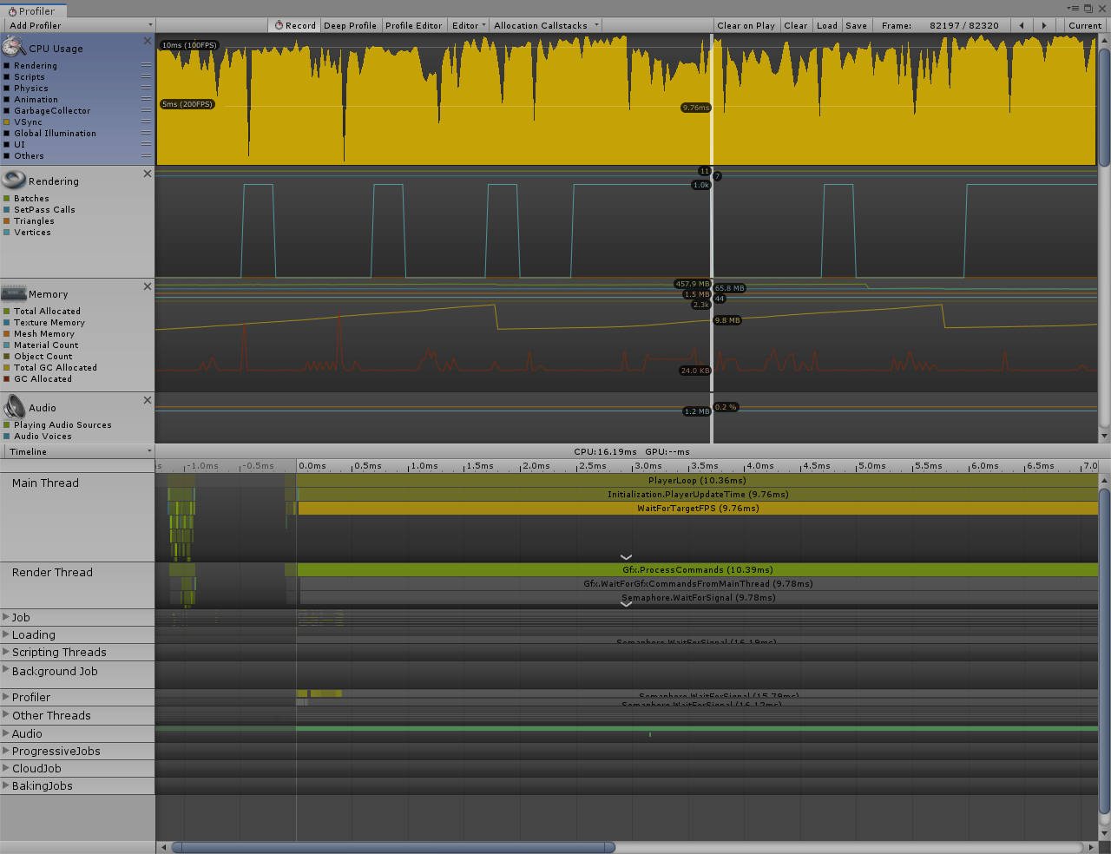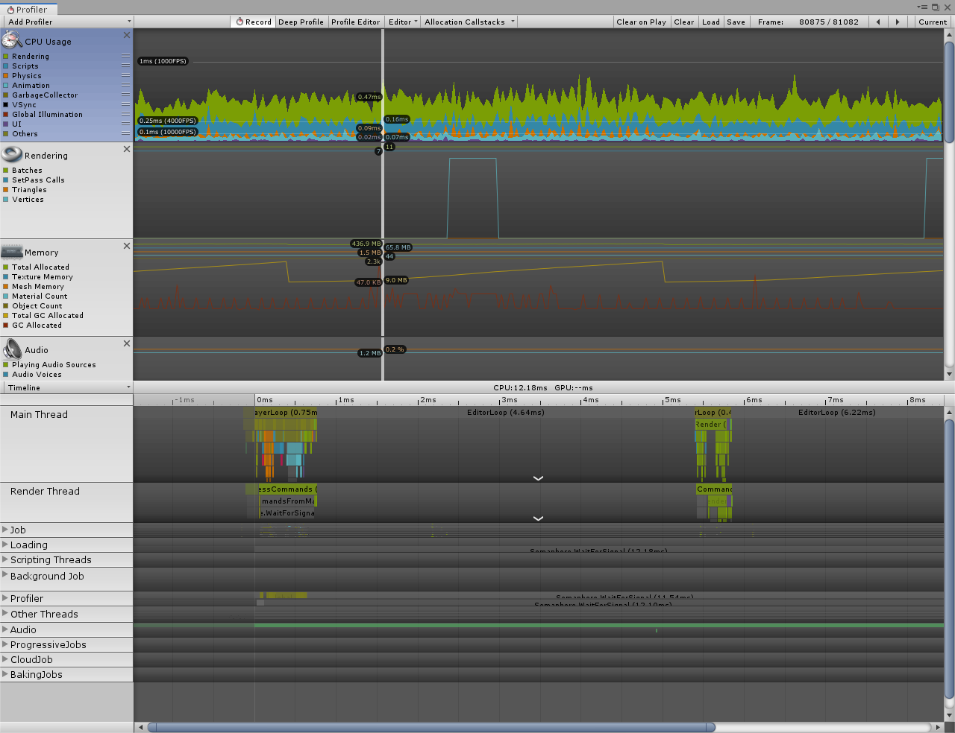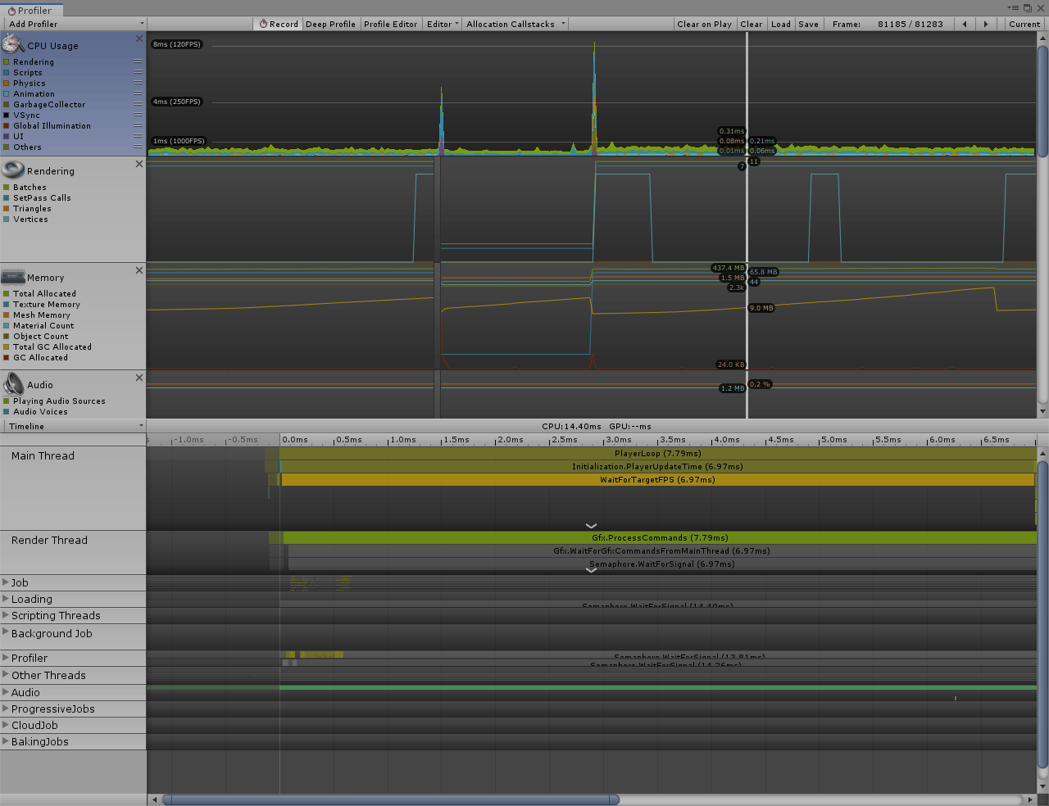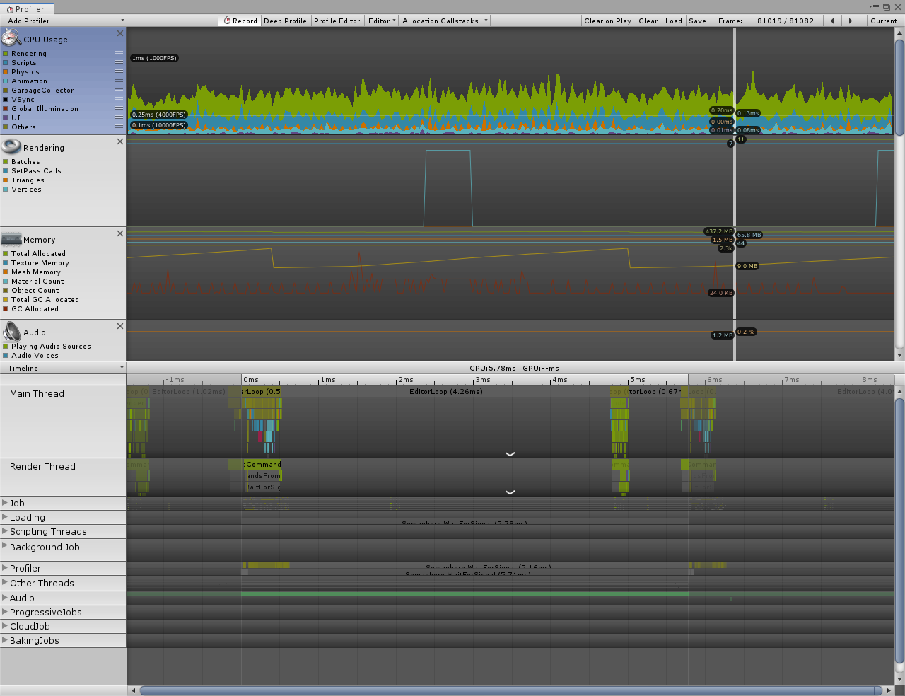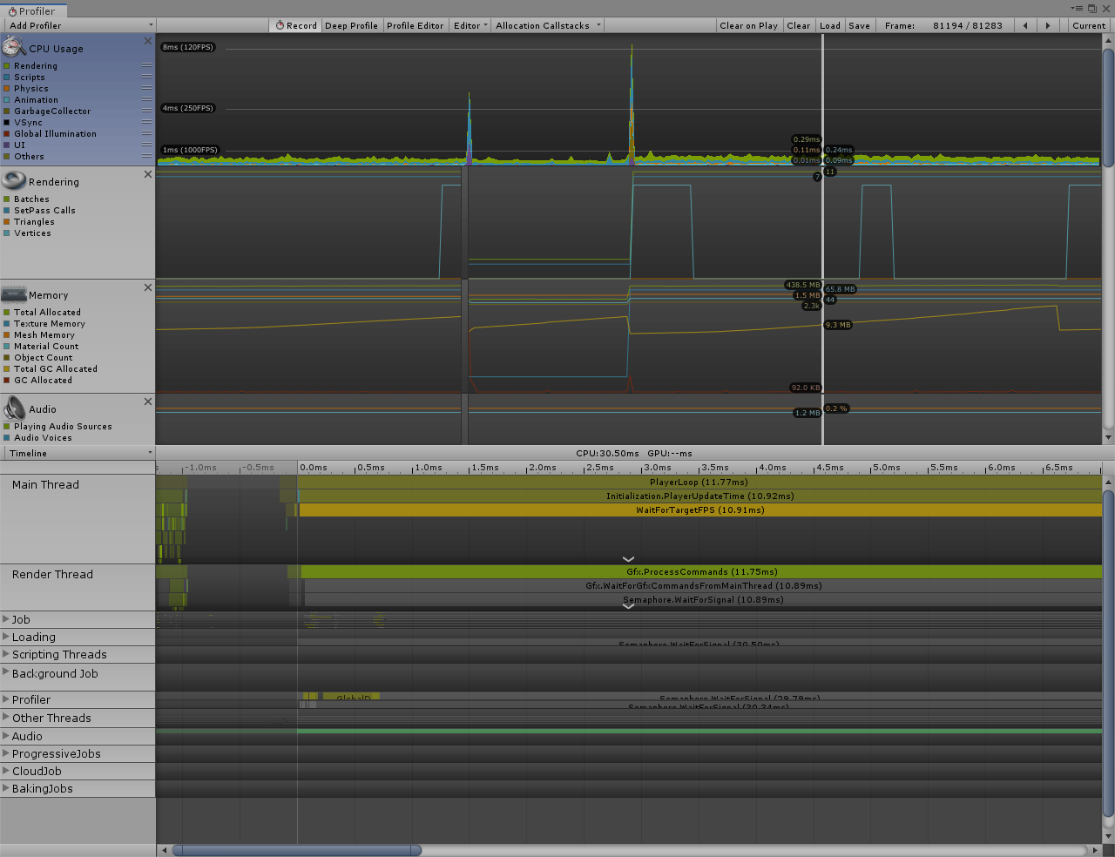

Hit tree with branch, nothing set to static yet

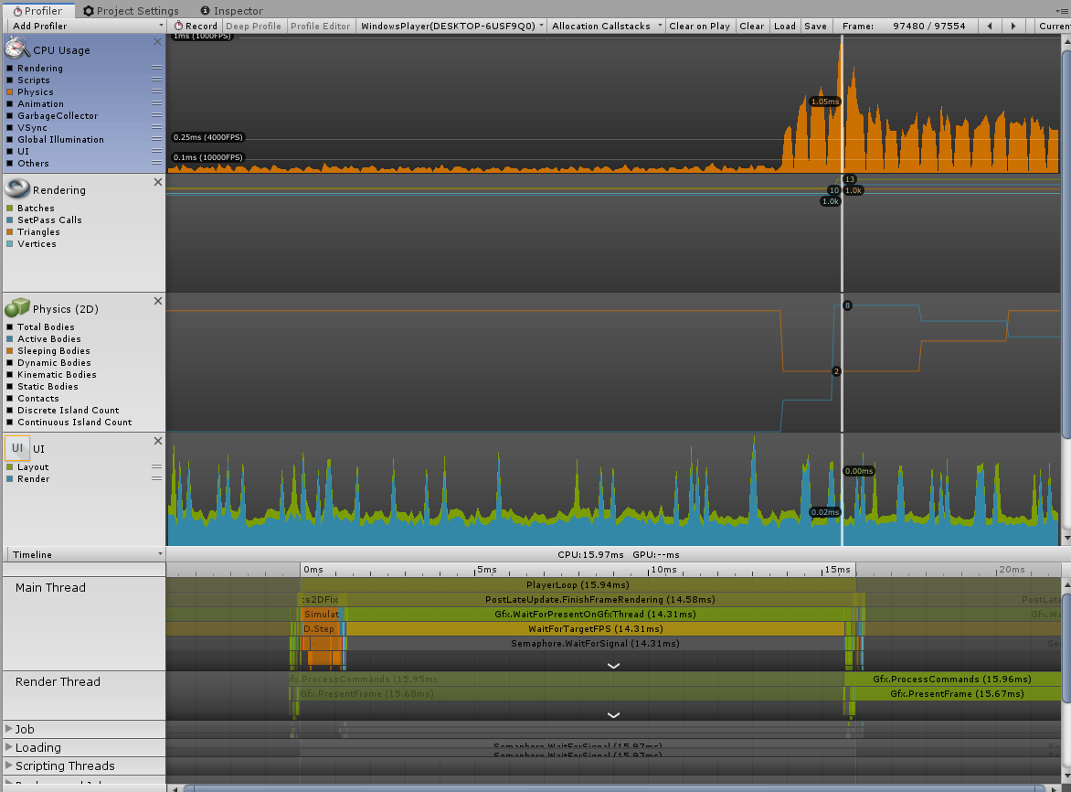

Hit tree with branch, acorns falling/fell, everything now set to static:

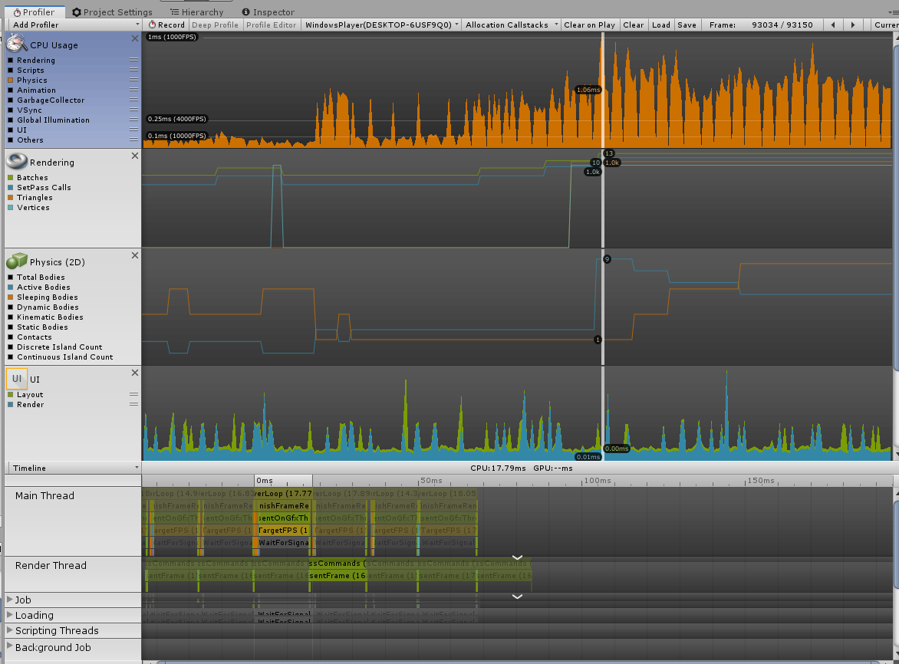

Before dialogue manager changes (idling with dialogue box open):

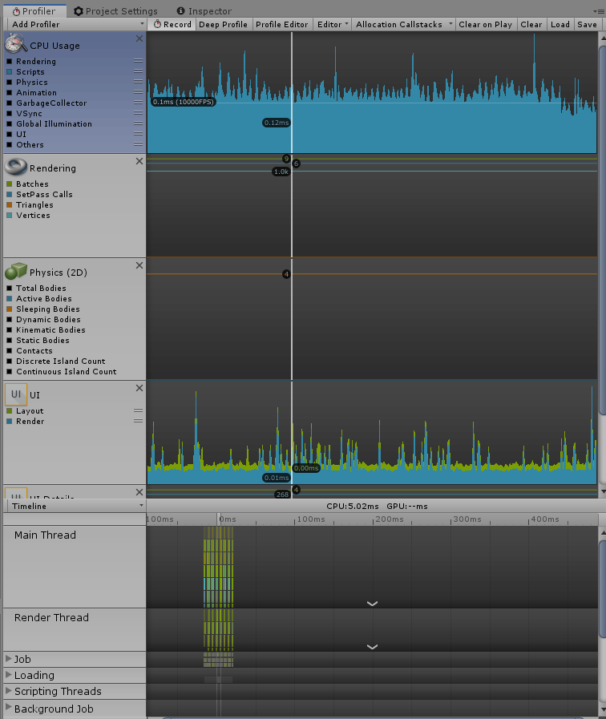

After Dialogue manager changes (idling with dialogue box open):

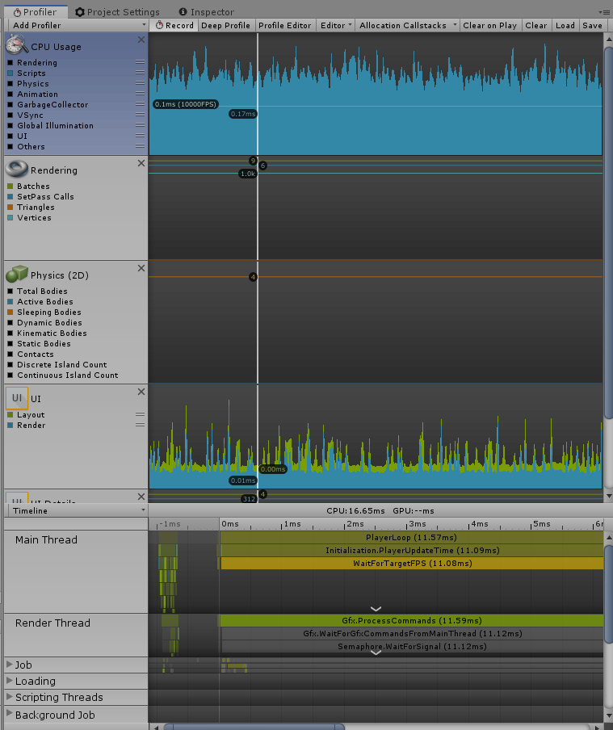

Acorn(dynamic rigidbody) polygon collider without optimization performance: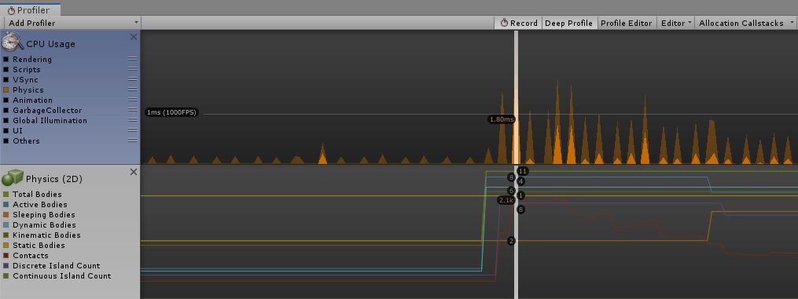

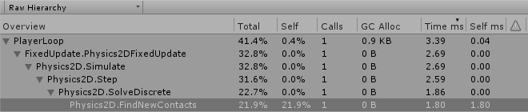

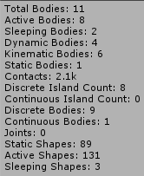

Acorn(dynamic rigidbody) polygon collider after optimization performance:

