<https://github.com/OnCodeDeny/Emma-Unity>

<https://trello.com/b/rHzeUpUb/emmaprojectboard>

<https://docs.google.com/document/d/1Y57_7kmuxd7y8SpX1nBzsnZeF6O70XBC9sQykMAQ_2E/edit?usp=sharing>

Emma! Game Data Project Technical Report

# Folder Structure

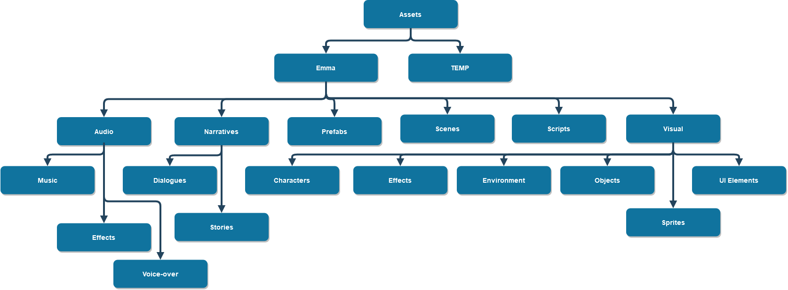

Figure Emma! Folder Structure

Fully constructed folder structure is built to make sure assets are all easily managed, also ensures that team members know where to put a new file. A TEMP folder is created for temporary use, since developers may put temporary files for testing purpose.

# Code & Documentation



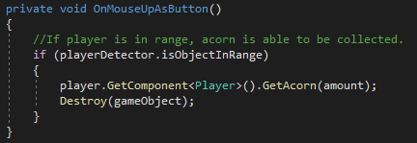

Figure Provide variable for future use

When applicable, avoided hard coding the value, variables were made for future use. In the example above, an int variable amount is used instead of just putting the number 1 there. In the future, if a decision is made that each acorn on the screen represents 10 acorns in value, developers can change the amount to 10.

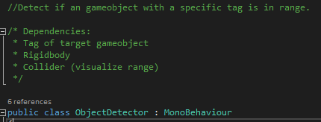

Figure Component instruction

For the component/class ObjectDetector, simple instruction is provided for other developers since this is a tool made for other developers to use in the future.

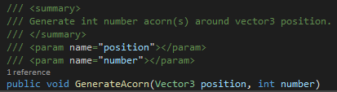

Figure Method instruction

For method GenerateAcorn, instruction is provided for other developers since other developers may use this method in the future.

# Version Control

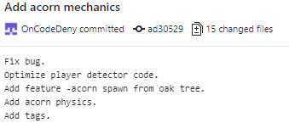

Figure Git Commit

Git commits used best practices, present tense, short title and detailed descriptions. Features development were done in a separate branch Felix-Features and then merged into master.

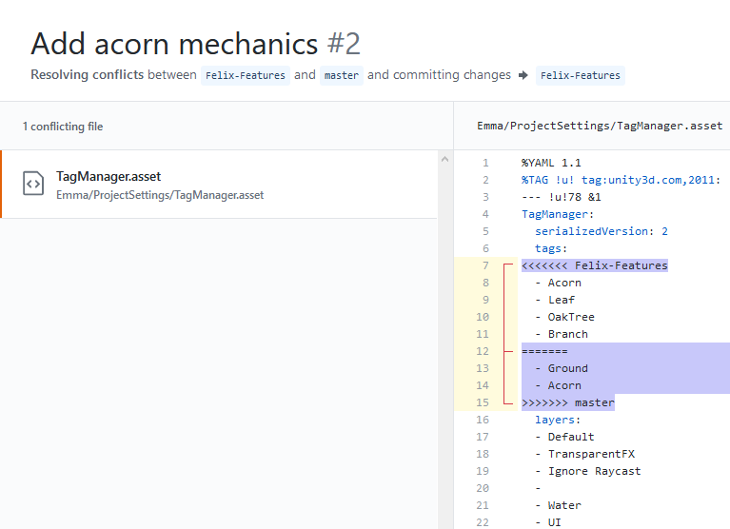

Figure Conflict between Felix-Features and master

A conflict was created when merging Felix-Features to master.

The conflict was solved by deleting the highlighted blocks above, keeping tags in Felix-Features.

# Project Management

Trello was used to manage the project progress. The team is developing a ***Minimum Viable Prototype*** at the current stage, a rough schedule with roles assigned and an asset checklist were put on Trello board for task tracking.

# Working with Data

In the current stage of development, no data were being stored in the file system, only in system memory, data lose when the program closes. In the future, the development team plans to create a save system that records all important game data (player position, items in the inventory, etc.) in a hub(manager) to 1 JSON file.