Version Control Assignment #1

Technical Report

*This technical report is written in a log form to better convey the work progress and requirements fulfilled. Only key processes are recorded in this report.*

VC Platform & Software: Git Bash, Git GUI, GitHub Desktop, GitHub Web.

About the Project:

This assignment project is built on a base FPS game project:

FPS Microgame

Source Page: <https://learn.unity.com/project/fps-template>

Tasks& Goals:

|  |  |
| --- | --- |
| Branch\Task Name | Goal |
| PlayerController_Sprint | Create player character sprint animation, implement restrictions (disable shoot, disable aim) |
| PlayerController_DoubleJump | Create double jump function for player character. |
| NoCooldownBooster | Create a pickup item that continuously charges all player weapons in a few seconds. (no weapon heating, infinite bullets) |
| Weapon_Rifle | Create a set of properties for a new weapon type called rifle. |
| Weapon_SniperRifle | Create a set of properties for a new weapon type called sniper rifle. |
| BugFix | Fix existing bugs, merging conflicts, **potential** bugs. This may include some code optimization. |

1. The repository “fpsBOIS” was created on GitHub Web, cloned on GitHub desktop, the base FPS Mircrogame project was pushed to master, committed as ORIGINAL.

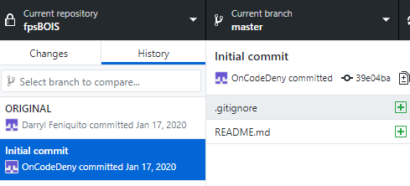

Branch NoCooldownBooster added to the repo, this branch is used to work on a single task: Making a pickup item that prevents play weapon overheating.

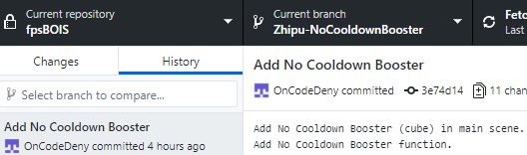

Final commit in this branch was done after testing.

Due to that one commit in the branch has broken work (for temporary backup purpose), in the pull request the setting was set to Squash and merge.

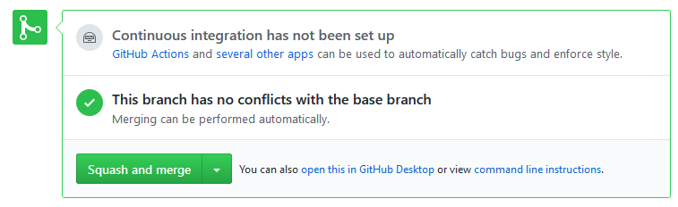

Merged and pulled updated master branch from web server, tested master branch, no issue appeared. Proceeded to deletion on both remote and local.

1. Binary Conflicts:

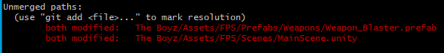

Merging conflicts were created. When merging master into PlayerController-Sprint branch for testing, conflicts were created.

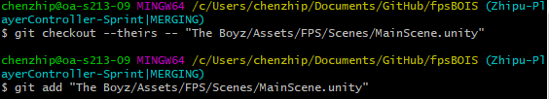

Conflicts resolved by picking the file in master/remote branch using git checkout and git add.

1. Non-binary Conflicts:

Project broke after merging master into local branch PlayerController-Sprint.

Code conflict showed that the same scripts had been modified on 2 branches. However, it was not detected by Git. Thus, the conflict had to be solved manually by taking the useful code blocks from each branch’s script and combining them into one. This required rebranching from master.

1. 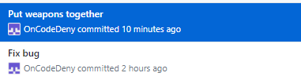

On master, artists’ work and programmers’ work were combined, bugs were fixed.