

## Tribhuvan University

**Faculty of Humanities and Social Sciences**

COMPLAINT MANAGEMENT SYSTEM

# A PROJECT REPORT

## Submitted to: Department of Computer Application

**Prime College**

***In partial fulfillment of the requirements for the Bachelors in Computer Application***

Submitted by Pramila Shrestha (184100477)



## Tribhuvan University

**Faculty of Humanities and Social Sciences**

COMPLAINT MANAGEMENT SYSTEM

# A PROJECT REPORT

## Submitted to: Department of Computer Application

**Prime College**

***In partial fulfillment of the requirements for the Bachelors in Computer Application***

Submitted by Pramila Shrestha (184100477)



## Tribhuvan University

**Faculty of Humanities and Social Science Prime College**

## Supervisor’s Recommendation

I hereby recommend that this project prepared under my supervision by Pramila Shrestha entitled “**Complaint Management System**” in partial fulfillment of the requirements for the degree of Bachelor of Computer Application is recommended for the final evaluation

**Er. Rolisha Sthapit SUPERVISOR**

**BCA Coordinator Prime College**



## Tribhuvan University

**Faculty of Humanities and Social Sciences Prime College**

## LETTER OF APPROVAL

This is to certify that this project prepared by Pramila Shrestha entitled **“Complaint Management System”** in partial fulfillment of the requirements for the degree of Bachelor in Computer Application has been evaluated. In our opinion it is satisfactory in the scope and quality as a project for the required degree.

|  |  |
| --- | --- |
| Er. Rolisha Sthapit Supervisor  Prime College, Khusibun | Er. Rolisha Sthapit BCA Co-Ordinator BCA Department  Prime College, Khusibun |
|  | **Nawaraj Paudel External Examiner** |

# ABSTRACT

The complaint management system is designed to bridge the gap between government officials and ordinary people working at the same time. The system helps users to login to the system by filling out the registration form and then by using the registered username and password one can access the system. Once the user is logged in to the system, he/she will be able to lodge the complaint by filling out the complaint form. They will be able to list out their user history and can also check the status of their current complaints if they are in process or have been solved. The system is developed using HTML and CSS in the front-end and PHP and MySQL in the back-end

On the other hand, only few people will be given the admin credentials using that one can access the admin dashboard where they can see all of the lodged complaints from the user. They will be able to process the complaints, close and also delete the complaints if necessary. Once the admin processes the complaints, users will be able to see in their own profile that their complaints are in process and will be taken actions accordingly.

Hence, this system is capable of managing the complaints lodged by the users as per the nature of complaints and hopefully will be of use in the current scenario of our country.

*Keywords: Complaint, Admin, HTML, MySQL*

# ACKNOWLEDGEMENT

For the partial fulfilment of the project in this semester I would like to express my sincere gratitude to everyone who has directly and indirectly helped me to develop this project. There were times when I thought that this project was too difficult or may be not possible but I am really thankful to my supervisor **Er. Rolisha Sthapit** who continuously inspired me to give my best and perform the project to complete it. I could barely do anything without the help of **Shravan sir** who hashelped me throughout and find and reconcile my mistakes.

I would also like to include the continuous support of my classmates who were always inspiring me to continue with the project and reminded me of the competition every time. I have also taken help from the seniors of Prime college so I would like to acknowledge them and really thank them from the bottom of my heart. It is because of all of you that I did not stop and give my best that has today brought the project here today.

In the end, I would also like to thank the Tribhuvan University for giving me this opportunity via the course of Computer Application to help me understand the project ethics at this early stage and helped me to evaluate my knowledge and expand it a little more.

Pramila Shrestha

# TABLE OF CONTENTS

SUPERVISOR’S RECOMMENDATION iii

CERTIFICATE OF APPROVAL iv

ABSTRACT. v

ACKNOWLEDGEMENT. vi

TABLE OF CONTENTS vii

LIST OF ABBREVIATIONS ix

LIST OF FIGURES x

LIST OF TABLES. xi

CHAPTER 1: INTRODUCTION. 1

* 1. Introduction 1
  2. Problem Statement 2
  3. Objectives. 2
  4. Scope and limitation 2
     1. Scope 2
     2. Limitation 2
  5. Development Methodology. 3
  6. Report Origination 5

CHAPTER 2: REQUIREMENT STUDY AND FEASIBILITY ANALYSIS 6

* 1. Background Study. 6
  2. Literature Review 7

CHAPTER 3: SYSTEM DESIGN 8

* 1. System Analysis 8
     1. Requirement Analysis 8
        1. Functional Requirement. 8
        2. Non-Functional Requirement 9
     2. Feasibility Analysis. 10
        1. Technical feasibility 10
        2. Operational feasibility 10
        3. Economic feasibility. 11
        4. Schedule feasibility. 11

3.1.3. Data Modeling 12

3.1.4 Process Modeling 13

* 1. System Design. 14
     1. Architectural Design. 15
     2. Database Schema Design 16
     3. Interface Design 17
     4. Physical DFD… 19

CHAPTER 4: SYSTEM IMPLEMENTATION AND TEST 20

* 1. Implementation Overview. 20
     1. Tools Used. 19
     2. Implementation Details of Modules. 21
  2. Testing. 21
     1. Test Cases for Unit Testing. 22
     2. Test Cases for System Testing. 27

CHAPTER 5: CONCLUSION AND RECOMMENDATION 30

* 1. Lesson Learnt / Outcome 30
  2. Conclusion… 30
  3. Future Recommendations… 31

REFERENCES/BIBLIOGRAPHY 32

# LIST OF ABBREVIATIONS

CSS- Cascading Style sheets DFD- Data Flow Diagram

ERD- Entity Relationship diagram HTML- Hypertext Markup Language JS- JavaScript

PHP- Hypertext Preprocessor SQL- Structured Query Language

# LIST OF TABLES

Table 4. 1 User registration. 21

Table 4. 2 User logins. 22

Table 4. 3 Edit User 23

Table 4. 4 Lodge Complaint 24

Table 4. 5 User interfaces. 25

Table 4. 6 Admin interfaces… 26

# LIST OF FIGURES

Figure 1.1 Waterfall model… 18

Figure 3.1 Use Case Diagram 6

Figure 3.2 Schedule Gantt Chart. 9

Figure 3.3 ER Diagram. 10

Figure 3.4 Context Level Diagram 11

Figure 3.5 Architectural Design. 13

Figure 3.6 Schema Design. 14

Figure 3.7 Interface Design. 15

Figure 3.8 UI Interface 16

Figure 3.9 Physical DFD 17

# CHAPTER 1 INTRODUCTION

## Introduction

With the evolving technology, despite the fact that the world has evolved and has been enormously technological, the hidden fact of our country is that we have not yet been able to implement the technology as the world has and are quite behind in this matter. The government officer and their protocols are still dependent on the handwritten reports and it has not been digitized even though the government is wanting to make everything digital. This project is a web-based application to make an initial step to something that we lack and are in need of. The application accepts inputs from users i.e., the complaint or any sorts of crime they have witnessed or faced and the data will be stored in the database. Anyone can register and login to the system and complain about the problem that they have been facing and the concerned authorities will help to sort them out as soon as possible. Once the accessed admin logs in to the system, he/she will abstract the recent complaint and will take actions accordingly. The system will enhance the working mechanism of this system and will also enforce both the people and the authorities to work hand in hand to solve any sorts of problems.

This project is a community service-based problem solver regarding the current scenario of increasing crimes in our country. It has been developed using HTML, CSS and JavaScript at front end and PHP and MySQL for the backend programming. It will save the time and effort of people and the complaints could be managed properly in the database. It will also encourage everyone to move a step closer to technology and digitalization which will make our life easier and comfortable. This web application has used php, html and bootstrap and will provide a transparent medium through which the users can register their complaints, search complaints, view existing complaints and confirm the rectification of the issue. This project will help the public in knowing their place details and getting their problems solved online without going to the officer regularly until the problem is solved.

## Problem Statement

In this country, most of the people do not have the courage to face the police even though they have witnessed any type of crime or have been a victim of certain criminal activities as they have to go through a lot of questionnaires via their own family members, society and the police department itself. People do not have any particular department to complain about the problem or the inequality they are facing so this project is the mediator between people and the concerned authorities to eliminate the gap between them and have the organized way of telling things.

People have bad experiences with the government officers and are facing problems to complete any work that is related to the government. Even with private organizations they have fostered so much that not everyone is reliable and many times innocent people get into their trap and they have nowhere to go and complain about it. So, this will be the platform for people to openly express what problem they have been through and with the high implementation of the system the situation will be better one day.

## Objectives

* To manage the record of online complaints
* To create an online portal via which the complaints of the public can be addressed.

## Scope and Limitation

**Scope:**

* It can be used by any government firms or private organizations
* This web app aims to reach citizen and various departments of the government of Nepal replacing paper-based complaint management system.

**Limitations:**

* Difficult to identify whether the registered complaint is fake or not.
* Images cannot be uploaded as evidence of the complaint

## Development Methodology

A software development methodology or system development methodology is a framework that is used to structure, plan and control the process of developing a system. There are different models or methods used or followed during software development life cycle (SDLC) processes such as the waterfall model, prototyping model, spiral model and others based on the nature or objective of the software.

As maximum requirements for the project were discussed and finalized before starting working on the project and one stage would come after the completion of the previous steps, the author decided to use the waterfall model for the completion of the project.

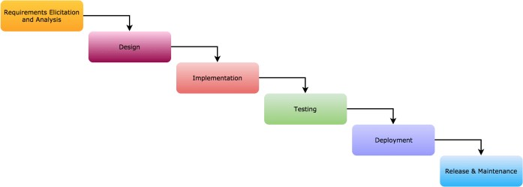

**Figure 1.1 Waterfall model**

**Analysis**: This phase includes the gathering of all the requirements of the system. For this, some research was done and some useful insights were pointed out so that the requirements, the functions, and the objectives of the system were well known.

**Design**: It includes the study and designing of the requirements gathered in the analysis phase for the system development. Thus, the formed design was then converted into use case-diagram, data modeling -diagram, interface design where each diagram depicted the design in their unique representation.

**Implementation**: This phase includes the implementation of the design done for system development in the previous phase. The features of the system were developed one at a time and then all the features were integrated to form a complete system in the next phase. All the modules were developed using html, CSS and JavaScript for the front end and PHP and SQL for the backend programming.

**Testing**: The main objective of this phase is to see if the system is functioning as intended or not. This phase includes unit testing as well as system testing under various test case scenarios. In unit testing, each unit is tested one by one whereas in system testing the system as a whole is tested.

**Maintenance**: The errors were debugged, and solved then the completed version of the system was delivered to the concerned parties.

## Report Organization

The report starts with the introduction of the public complaint with problem statements and objectives of the project. Chapter 2 analyses the existing system. Chapter 3 discusses the data modeling and process modeling techniques used to give the information about the system requirement and feasibility study. The system design can be database schema design, interface design and process design. Chapter 4 explains about the tools that are used on our project’s front end, back end and purpose of it. The modules used are also explained. The testing is also explained in this part. Chapter 5 discusses the conclusion of how the project is accomplished, its findings and many more. We also discuss the recommendation for future enhancements of the project. In conclusion, this chapter overview’s purpose of doing this project including its scopes and objectives.

# CHAPTER 2

**BACKGROUND STUDY AND LITERATURE REVIEW**

## Background study

The planned application “Complaint Management System” provides a subject with an interactive interface to just about communicate with the involved civic agencies regarding environmental problems while not having to go to them physically on site

In the context of Nepal there is no system as such that actually works as an application which allows people to complain about any sorts of activities digitally however there are many existing systems as such in other countries. Many researchers have researched the importance of a complaint management system.

Before developing the project, we have developed a direct interview to students in college and people around us and conducted a questionnaire where there were responses like we need to work on a project like this and it will be helpful to both the concerned authorities and the people.

## Literature Review

In the current situation a file-based system is in use which needs a private visit to the workplace and registering complaints on paper, that is incredibly time consuming and conjointly needs loads of manpower. We’ve done a survey on our project; thus, we tend to determine Hello Sarkar, a political candidate portal of the government underneath the workplace of the Prime Minister and Council of Ministers to receive public complaints. Generally, Hello Sarkar has launched a center where a public will report their issues to the govt by dialing 1111 through a center, however it provides a ton of drawbacks in registering complaints [1].

“SMART COMPLAINT” app was introduced in the Republic of India to produce a platform to address grievances easily. Thus, good grievances reduced people’s efforts. grievance Lodger will share location mistreatment GPS. This app deals with the internal process of complaints. The main purpose of this method is to assist the general public in knowing their place details and obtaining their issues solved on-line while not aiming to go to the workplace frequently till the matter is solved [2].

“CLEAN KTM '' app was launched by cabinet minister Leela Mani Paudyal throughout the one hundredth week of the fresh Bagmati Campaign. This application has been backed by the Kathmandu Metropolitan town Office. The app is aimed for people that need to contribute to creating a national capital Metropolitan town cleaner. One will do thus by sending a report which may be viewed by the municipality workplace that successively will be wont to send pickup trucks to select the individual waste [3]. “

NAGARPALIKA/GAUPALIKA” is a demo app designed for any Municipality or Rural Municipality of Nepal. This app principally aims to produce necessary data to its citizens quickly and easily and conjointly enable the voters to register suggestions or complaints.

# CHAPTER 3 SYSTEM ANALYSIS AND DESIGN

## System Analysis

System analysis is a process of gathering and interpreting facts, diagnosing problems and the information about the Complaint Management System to recommend improvements on the system. It is a problem-solving activity that requires intensive communication between the system users and system developers. It is an important phase of any system development process.

## Requirement Analysis

1. **Functional Requirement**

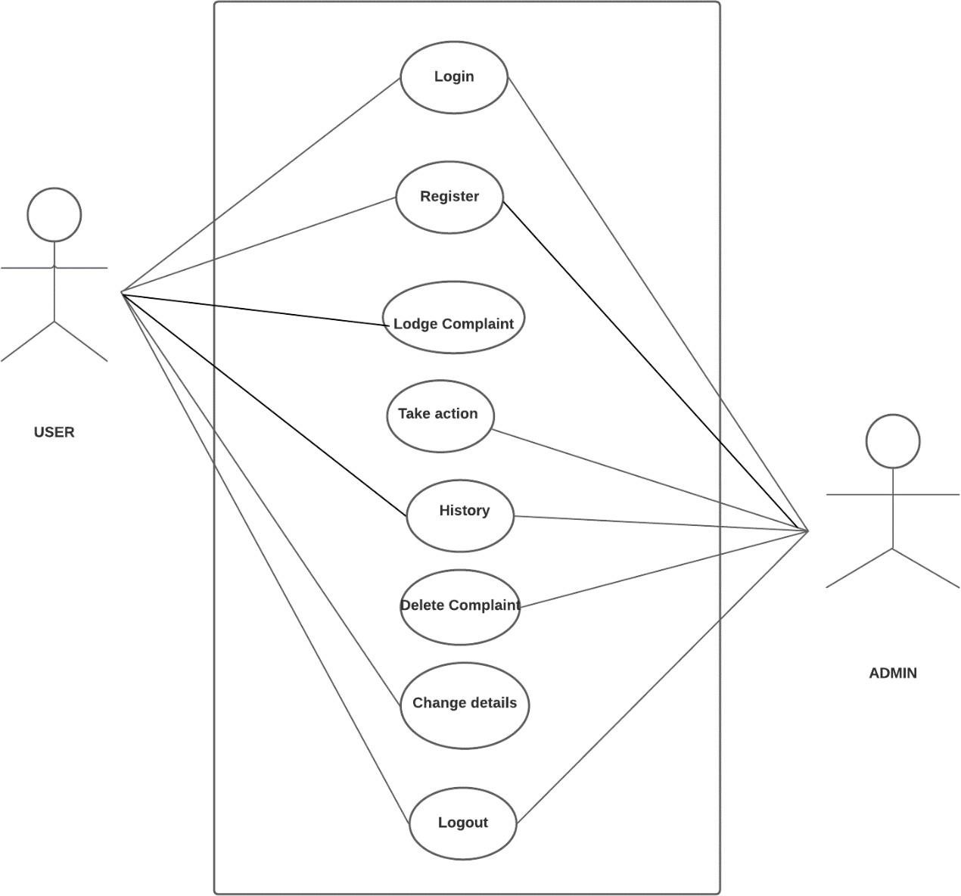

**Figure 3. 1.Use Case Diagram**

1. **User Registration**: Registration is open to all the visitors to the Complaint Management System. Users can register to the online system by filling up the form and entering the correct details.
2. **User Login** (general user/admin): User can login with username and password. User then selects appropriate login credentials to access their profile.
3. **Lodge Complaint:** General users can add complaints by entering caption, detailed information and select complaint category. General users can view their complaint history and their details.
4. **Take action:** Admin panels will be able to take action to the lodged complaints according to the nature of complaints and forward it to the departments.
5. **Delete Complaints:** Admin can also delete or close the complaints in case of necessity.
6. **Complaint status:** Under consideration, completed or rejected status could be added by department user to the complaint added by general user. Complaint status can be viewed by all users
7. **Log out:** User can log out of the system after finishing using the web application

## Non-functional Requirement

1. **User Friendly:** User Friendly is self-explanatory. When something is user friendly then it is easy to access and work with it. Complaint Management system is user friendly. Person having basic knowledge and skills of computers can also easily use the web application.
2. **Simple and easy to use:** Complaint Management system uses a simple design as well as simple language on the content to improve the user friendliness of the web application
3. **Easy Access:** Complaint Management system is a web application. It can be accessed anytime from anywhere with the help of internet connection.
4. **Responsive:** Complaint Management system is responsive. This nature could prove to be extremely beneficial to people living in areas with limited access to computers.

## Feasibility analysis

After doing the project ‘Complaint Management System’, study and analyzing all the existing or required functionalities of the system, the next task is to do the feasibility study for the project. Feasibility study includes consideration of all the possible ways to provide a solution to the given problem. The proposed solution should satisfy all the user requirements and should be flexible enough so that future changes can be easily done based on the future upcoming requirements.

## Economic Feasibility

This is a very important aspect to be considered while developing a project. The author decided the technology based on the minimum possible cost factor.

* All hardware and software cost has to be borne by the organization.
* We have estimated that the benefits the organization is going to receive from the proposed system will surely overcome the initial costs and the later on running cost for the system.
* Also, we have estimated that the cost of the development of this system will be minimum which will benefits both users and developers

## Technical Feasibility

It is an evaluation of the hardware and software and how it meets the needs of the proposed system. This includes the study of function, performance and constraints that may affect the ability to achieve an acceptable system. For this feasibility study, we studied complete functionality to be provided in the system, and checked if everything was possible using different types of frontend and backend platforms.

**Software requirements:** The system is compatible with laptops. The system itself is platform independent and it can be run on any operating system if the required libraries and the system is available.

**Hardware requirements:** This project was developed and ran on Intel Core i5:5th generation. Although the system runs fine on i3 processors, for smooth implementation. The proposed hardware and software requirements are feasible for almost all processors and aren't too expensive. Therefore, the project is technically. feasible

## Operational Feasibility

Operational feasibility is the measure of how well the project will support the customer and the service provider during the operational phase. No doubt the proposed system is fully GUI based that is very user friendly and all inputs to be taken all self-explanatory. Besides, proper training has been conducted to let the users know the essence of the system so that they feel comfortable with the new system. As far our study is concerned the clients are comfortable and happy as the system has cut down their loads and doing.

## Schedule Feasibility

This is one of the most important feasibility analyses as it helps an organization to estimate how much time the organization will take to complete the project and how much of it is on track to a given schedule**.**

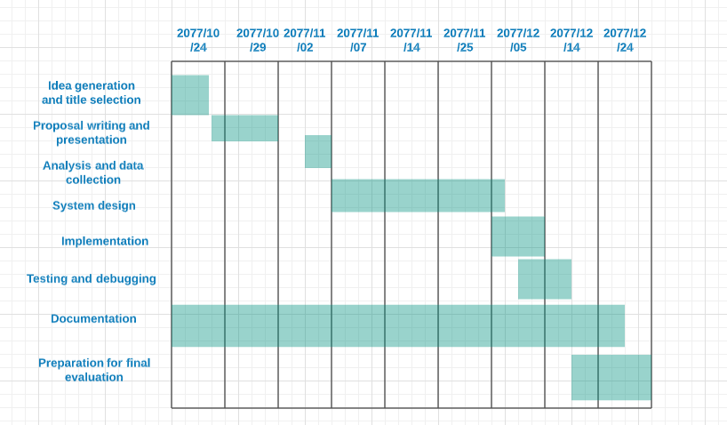

**Figure 3.2 Gantt Chart**

## Data Modeling

A data model is a mechanism that provides this abstraction for database application. Data modeling is used for representing entities and their relationship in the database. E-R (Entity Relationship) Model can be referred to as a Data Model. E-R Model is a popular high level conceptual data model. This model and its variations are frequently used for the conceptual design of database application and many database design tools employ its concept.

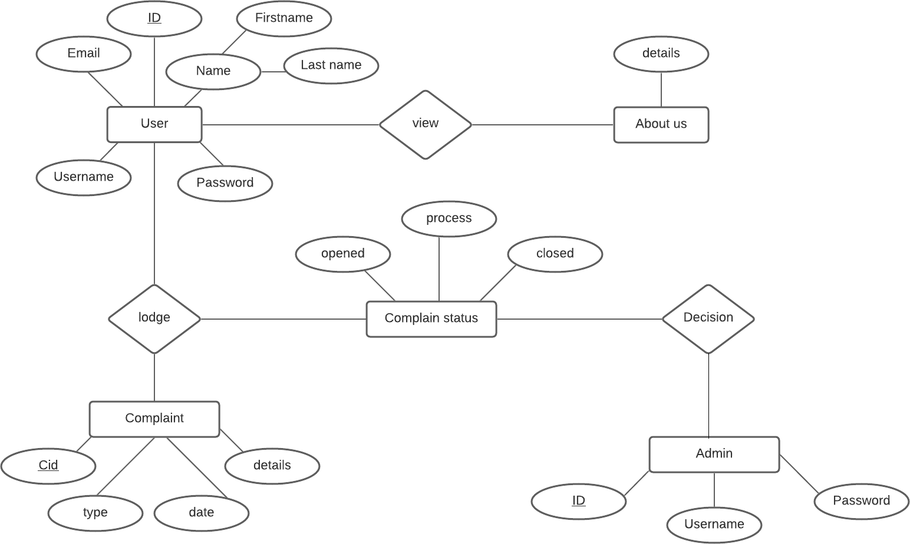

**Figure 3.3 ER Diagram**

# Process Modeling

A **DFD** can be referred to as a Process Model. A **data-flow diagram** (**DFD**) is a graphical representation of the "flow" of data through an information system A **data flow diagram** (DFD) is a significant modeling technique for analyzing and constructing information processes illustrates this flow of information in a process based on the inputs and outputs.

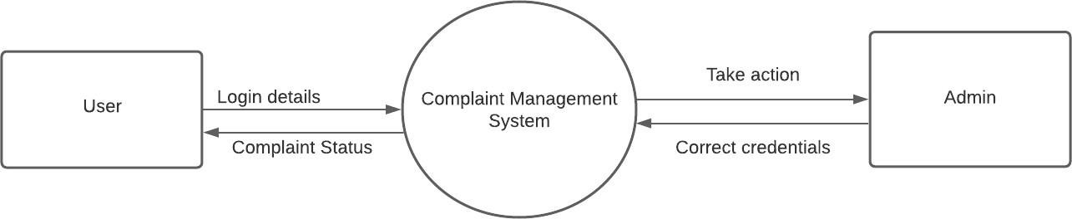

**Figure 3.4 Context level diagram**

The Data Flow Diagram Level 0 shows the most basic relationship between user, admin and department. With the online portal, we are able to address and solve citizen complaints

# System Design

System Architecture is a framework that incorporates the interactions and relationships between application components such as databases, middleware systems, and user interfaces. The common concept of System Architecture of Web Application is in line with the idea of a browser user who triggers an application which is capable of running in multiple websites. The components of Complaint management system can be grouped as

User interface components User interface application components are not relevant to the structural development of the application and are more user experience/ interface oriented. They refer to web pages displaying dashboards, logs, notifications, profiles and more.

Structural components:

**Client tire**: The web browser or client is the interface interpretation of a web app functionality with which the user interacts. Content delivered to the client is developed using HTML, JavaScript, CSS. In general, the web browser or client manages how end users interact with the application.

**Web tire**: The web application server manages business logic and data persistence and is built using PHP. It comprises a centralized hub to support multi-layer applications. XAMPP is used which is completely free, easy to install Apache distribution containing PHP.

**Database tire**: The database server provides and stores relevant data for the application. Furthermore, it may also supply the business logic and other information that is managed by the web application server

## Architectural Design

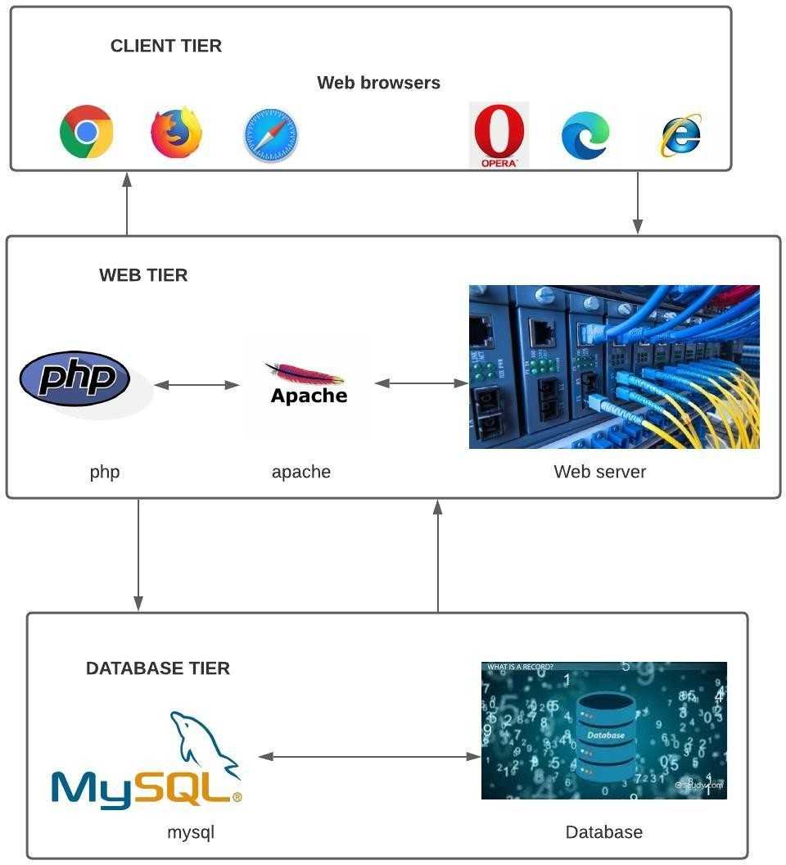

**Figure 3. 5 System Architecture**

## Database Schema Design

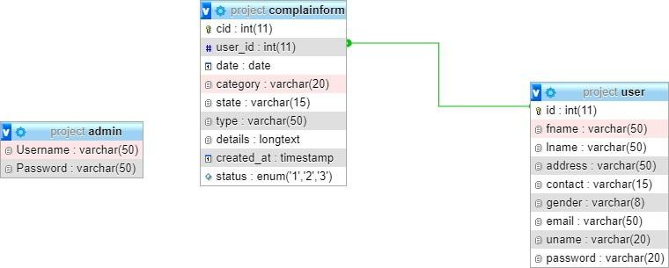

**Figure 3.6 Database Schema design**

## Interface Design (UI Interface / Interface Structure Diagrams)

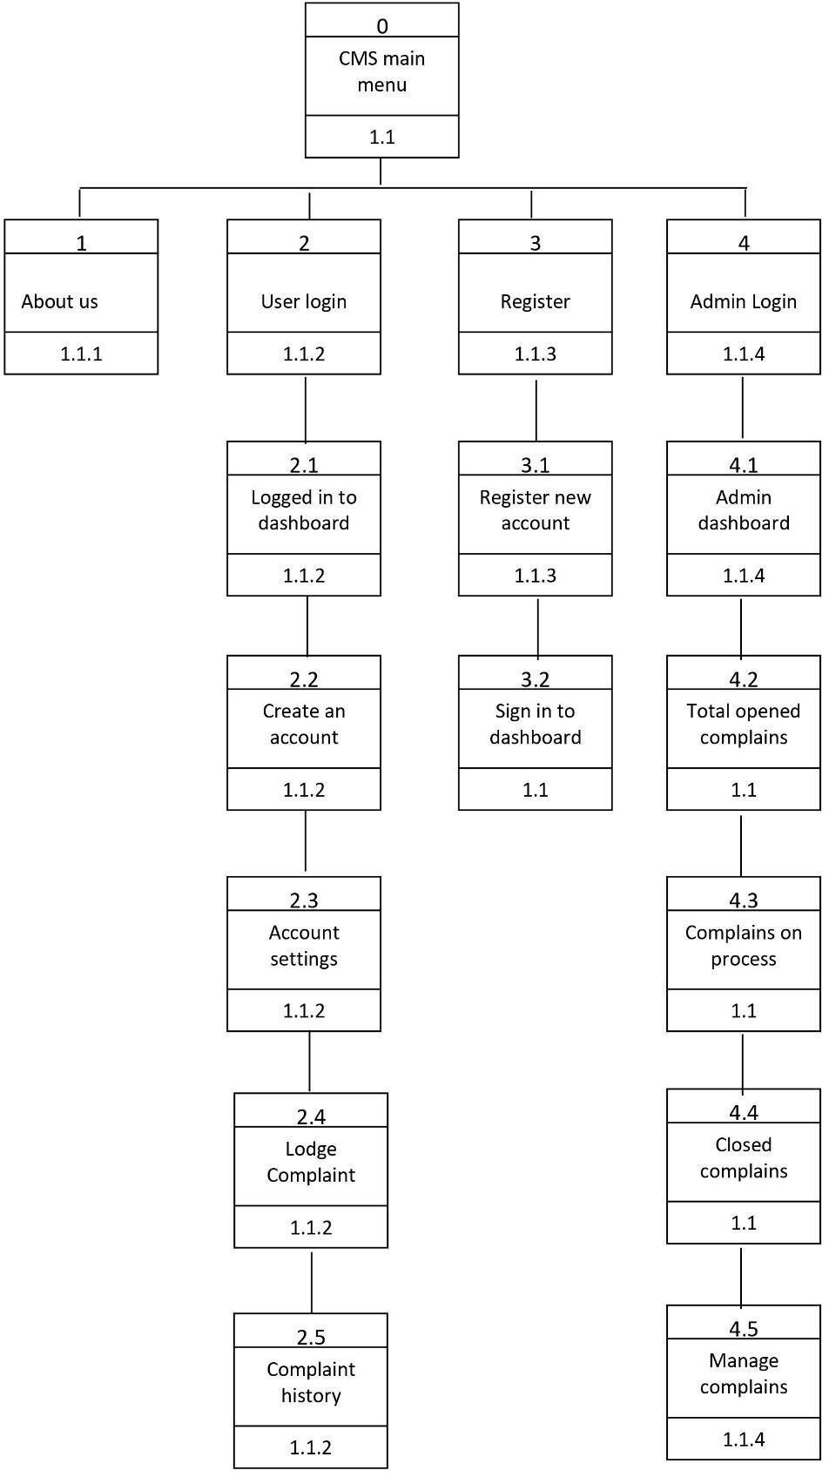

**Figure 3. 7 Interface design**

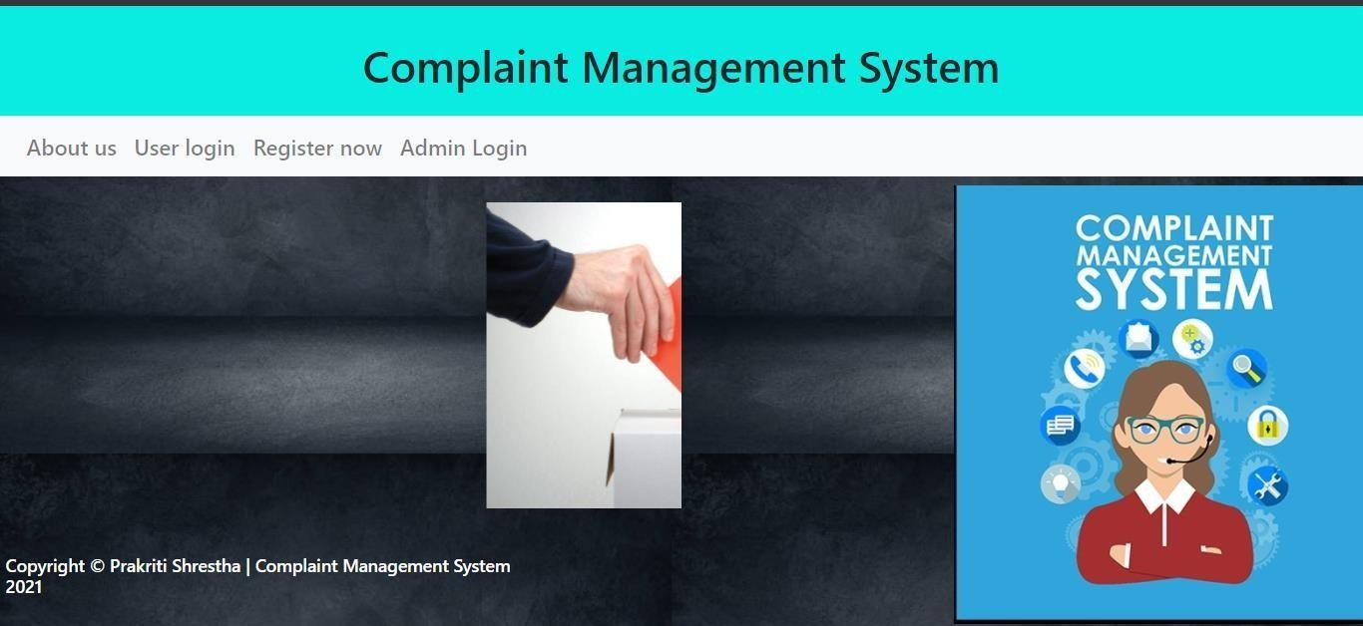

**Figure 3.8 UI Interface**

## Physical DFD

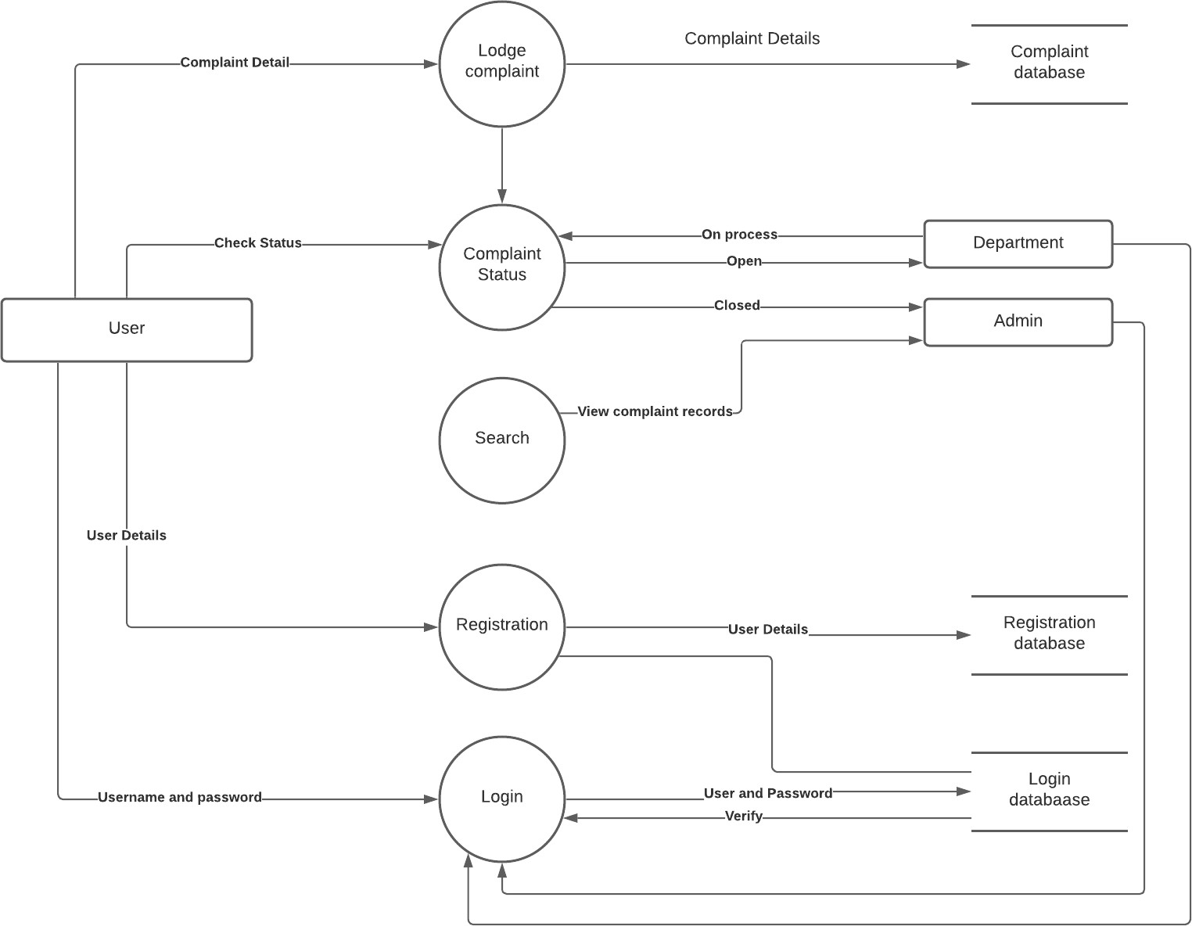

**Figure 3.9 Physical DFD**

# Chapter 4 Implementation and Testing

## Implementation

* + 1. **Tools Used (CASE tools, Programming languages, Database platforms)**
       1. **Front End Tools**

**HTML**: HTML is used to design the frontend views of this system.

**CSS**: CSS is used for describing the presentation of the front-page including colors, layout, and fonts of the system.

**JavaScript**: JavaScript web framework is one of the best ways to stack backend and frontend frameworks and has been used for the same in the project

* + - 1. **Back End Tool**

**PHP**: The PHP Hypertext Preprocessor (PHP) is a programming language used to create dynamic content that interacts with databases. It has helped to send and get requests and data from and to databases like MySQL in the project and is used for developing web-based software applications.

**MYSQL**: MySQL is an open-source relational database management system (RDBMS). We have used MySQL to store and retrieve data.

## Implementation Details of Modules (Description of procedures/functions)

There are different module descriptions. They are described below:

**Registration Module:** This module is dedicated to register all the complaints from the customers whenever they come to complaint. The process of this module is divided into two sub processes in which one registers the complete details of the customer who wants to submit the complaint, other registers the complete details of the compliant

**Monitoring Module:** This module is dedicated to monitoring the complaints by searching the complaints and updating the status of complaints at any time. The process of this module is divided into two sub processes in which one searches for complaints and other updates the status.

**Admin Module:** This module can be accessed by those having admin credentials and are responsible for processing the complaints and closing it once the problem is solved.

# Testing

Testing is the process of detecting errors. It performs a very critical role for quality assurance and for ensuring the reliability of software. The results of testing are used later on during maintenance also.

## Test Cases for Unit Testing

Unit testing is a software development process in which the smallest testable parts of an application, called units, are individually and independently scrutinized for proper operation. Complaint Management System contains different types of individual parts that are tested. Some of the test cases are:

**Table 4.1 User registration**

|  |  |  |  |  |  |
| --- | --- | --- | --- | --- | --- |
| S. N | Action | Input | Expected Outcomes | Actual Outcomes | Test Result |
| 1 | Launch application | Localhost/project/  register.php | Registration  Page | Registration  Page | Pass |
| 2 | Submit without  any details | Null | Form must be filled | Please fill out the field | Pass |
| 3 | Enter numeric name | First name:123  Last name: Shrestha Address: thankot Contact:1234 Gender: Female  Email: [prakritishrestha656@gmail.com](mailto:prakritishrestha656@gmail.com)  Username:Prakriti  Password:123445 | Invalid name format | Name must contain characters only | Pass |
| 4 | Enter alphabet contact details | First name:123  Last name: Shrestha Address: thankot Contact:1234 Gender: Female  Email: [prakritishrestha656@gmail.com](mailto:prakritishrestha656@gmail.com)  Username:Prakriti | Invalid contact details | Contact number should contain numbers only | Passs |

|  |  |  |  |  |  |
| --- | --- | --- | --- | --- | --- |
|  |  | Password:12345 |  |  |  |
| 5 | Enter correct details | First name:123  Last name: Shrestha | Redirected to login page | Registration Successful | Pass |
| Address: thankot |
| Contact:1234 |
| Gender: Female |
| Email: [prakritishrestha656@gmail.com](mailto:prakritishrestha656@gmail.com) |
| Username:Prakriti |
| Password: 12345 |

**Table 4.2 User Login**

|  |  |  |  |  |  |
| --- | --- | --- | --- | --- | --- |
| S. N | Action | Input | Expected Outcomes | Actual Outcomes | Test Result |
| 1 | Launch application | Localhost/project/  login.php | Login  Page | Login  Page | Pass |
| 2 | Submit without  any details | Null | Form must be filled | Please fill out the field | Pass |
| 3 | Enter incorrect username | Username:abc Password:123445 | Invalid details | Redirect to the same page | Pass |

|  |  |  |  |  |  |
| --- | --- | --- | --- | --- | --- |
| 4 | Enter incorrect passowrd | Username:Prakriti Password: adcv | Invalid details | Redirect to the same page | Passs |
| 5 | Enter correct details | Username:Prakriti Password: 12345 | Redirected to dashboard | Redirected to dashboard | Pass |

**Table 4.3 Edit User**

|  |  |  |  |  |  |
| --- | --- | --- | --- | --- | --- |
| S. N | Action | Input | Expected Outcomes | Actual Outcomes | Test Result |
| 1 | Launch application | Localhost/project/  accountset.php | Edit details  Page | Edit details  Page | Pass |
| 2 | Submit without  any changes | Similar details | Redirected to dashboard | Redirected to dashboard | Pass |
| 3 | Change name | First name:Sita  Last name: Shrestha Address: thankot Contact:1234 Gender: Female  Email: [prakritishrestha656@gmail.com](mailto:prakritishrestha656@gmail.com)  Username:Prakriti  Password:123445 | Redirected to dashboard  (Details updated) | Redirected to dashboard | Pass |

|  |  |  |  |  |  |
| --- | --- | --- | --- | --- | --- |
| 4 | Change username | First name:Prakriti Last name: Shrestha Address: thankot Contact:1234 Gender: Female  Email: [prakritishrestha656@gmail.com](mailto:prakritishrestha656@gmail.com)  Username:test  Password:12345 | Redirected to dashboard  (Details updated) | Redirected to dashboard | Passs |
| 5 | Change password | First name:123  Last name: Shrestha Address: thankot Contact:1234 Gender: Female  Email: [prakritishrestha656@gmail.com](mailto:prakritishrestha656@gmail.com)  Username:Prakriti  Password: prakriti | Redirected to dashboard  (Details updated) | Redirected to dashboard | Pass |

**Table 4.4 Complaint form**

|  |  |  |  |  |  |
| --- | --- | --- | --- | --- | --- |
| S. N | Action | Input | Expected Outcomes | Actual Outcomes | Test Result |
| 1 | Launch application | Localhost/project/  complainform.php | Complaint  Page | Complaint  Page | Pass |
| 2 | Submit without  any details | Null | Form must be filled | Please fill out the field | Pass |
| 3 | Enter all details except date | Category: Waste Management State: State 3  Complaint type: Witness  Complaint details: Help needed | Form must be filled | Please fill out all the details | Pass |
| 4 | Enter correct details | Date: 2021/03/21  Category: Waste Management State: State 3  Complaint type: Witness  Complaint details: Help needed | Form submitted | Redirect to the dashboard | Pass |

## Test Cases for System Testing

System testing is an overall testing of the system after integrating all the functions of the project. When all the functions of the Complaint Management System are integrated then system testing is done.

**Table 4.5 User Interface**

|  |  |  |  |  |  |
| --- | --- | --- | --- | --- | --- |
| S. N | Action | Input | Expected Outcomes | Actual Outcomes | Test Result |
| 1 | Launch application | Localhost/project/  register.php | Registration Page | Registration Page | Pass |
| 2 | Register New User | First name: Prakriti Last name: Shrestha Address: thankot Contact:1234 Gender: Female  Email: [prakritishrestha656@gmail.com](mailto:prakritishrestha656@gmail.com)  Username:Prakriti  Password:12345 | Registered Successful | Registered Successful | Pass |
| 3 | Login by same user | First name:Prakriti Last name: Shrestha Address: thankot Contact:1234 Gender: Female | Login Successful | Redirected to dashboard | Pass |

|  |  |  |  |  |  |
| --- | --- | --- | --- | --- | --- |
|  |  | Email: [prakritishrestha656@gmail.com](mailto:prakritishrestha656@gmail.com)  Username:Prakriti Password:12345 |  |  |  |
| 4 | Edit user | First name:Prakriti Last name: Shrestha Address: thankot Contact:1234 Gender: Female  Email: [prakritishrestha656@gmail.com](mailto:prakritishrestha656@gmail.com)  Username:test  Password:12345 | Redirected to dashboard  (Details updated) | Redirected to dashboard | Pass |
| 5 | Lodge Complaint | Date: 03/04/2021  Category: Waste Management State: State 3  Complaint type: Victim Complaint details: Test | Complaint lodged successful | Complaint lodged successful | Pass |

**Table 4.6 Admin Interface**

|  |  |  |  |  |  |
| --- | --- | --- | --- | --- | --- |
| S. N | Action | Input | Expected Outcomes | Actual Outcomes | Test Result |
| 1 | Launch application | Localhost/project/  adminhome.php | Login Page | Login Page | Pass |
| 2 | Admin Login | Username:Prakriti  Password:12345 | Login Successful | Login Successful | Pass |
| 3 | Manage complaint | Take Action to complain | Redirected to take action page | Redirected to take action page | Pass |
| 4 | Close Complaint | Are you sure to close the complaint?  Yes | Complaint closed | Redirected to dashboard | Pass |
| 5 | Edit Admin details | Username: pramila  Password: 12345 | Information edited | Updated Successfully | Pass |

# CHAPTER 5

**CONCLUSION AND FUTURE RECOMMENDATIONS**

## Lesson Learnt/Outcome

While in the process of this application development there were many instances where the author felt like something more could be added but due to lack of enhancement and excellence in the programming language there might be some loopholes which could be fixed once the author gets to learn and explore this technology. As this was the first project and everything was very new to adopt, the author learned about time management as the author had the deadline to submit our project along with the documentation.

Although the project has turned out to be exactly what the author has imagined it to be, there are some functions that the author would like to add in the forthcoming days and make it more user friendly and competitive.

## Conclusion

This project “Complaint Management System “started with a brief introduction of understanding how the municipal authority works and using technology in helping bridge the gap between citizens and government. The project part of Solving public complaints was based on designing a responsive web app. It was made with a motive that provides a solution for the lack of an effortless communication method to notify the authority about the public complaints developed. This web- based application reduces the complex procedure to be followed in the complaint registration process. The user can post their complaints with the category specified which will be automatically forwarded to respective departments. The user who is posting the complaint will be verified as a real user and the information will be stored in the database. Also, the complaint form with its type and images will be sent to the server. After development of the web app finally it was tested and results were discussed. After testing, advantages of software were discussed and suggestions for future enhancements were discussed.

## Future Recommendation

This task may be taken into greater element and greater paintings may be accomplished to convey extra capabilities. Further paintings may be accomplished that allows you to boost the efficiency of the device. The contemporary device helps simplest snap shots however movies also can be delivered through consumers and attempts can be made in this regard. Google map may be used to track the vicinity as it presents exact statistics approximately geographical regions and websites across the world. Features like on line fame of officers might be delivered. More capabilities might be delivered to discover faux complaints.

We could also use the GPS service and know exactly from where the complaints being lodged and keep track of the location as well. Furthermore, using AI might be actually useful to make the device greater dependable and automated. Also, the usage of movies and different documents might be delivered because the evidence of grievance that would be submitted at the same time as filing the complaint form

# References

1. D. Radhakrishnan, N. Gandhewar, R. Narnaware, P. Pagade, and A. Tiwari, “Smart Complaint Management System 1,” vol. 3, no. 6, pp. 4–7, 2016.
2. J. wells, "Hello Sarkar Nepal Hello Government Nepal," 6 january 2017. [Online]. Available: [http://gbsnote.com/hello-sarkar-nepal/.](http://gbsnote.com/hello-sarkar-nepal/)
3. Sigdle, c. (2015, 04 18). „Clean KTM‟ app helps city officials manage waste. „Clean KTM‟ app helps city officials manage waste, p. 224

# Appendix

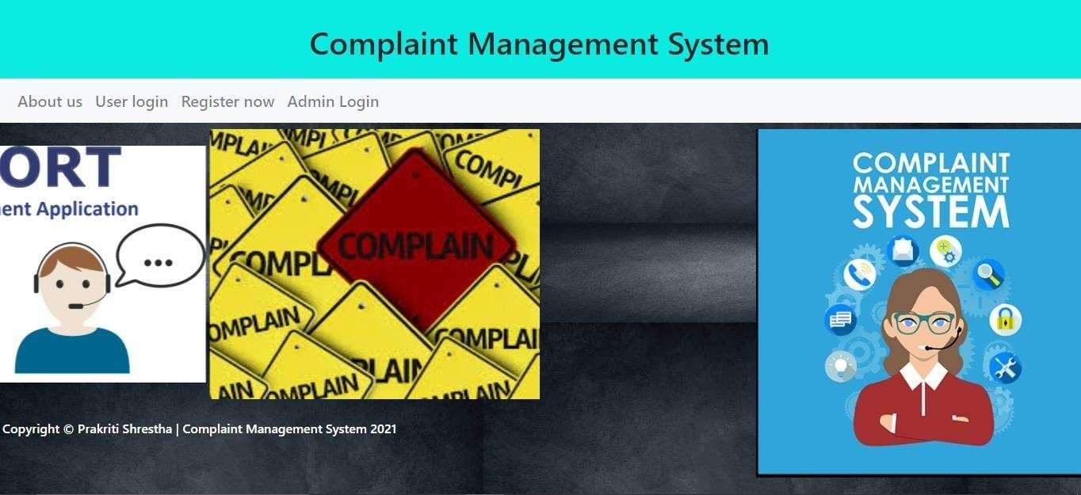

**Home page**

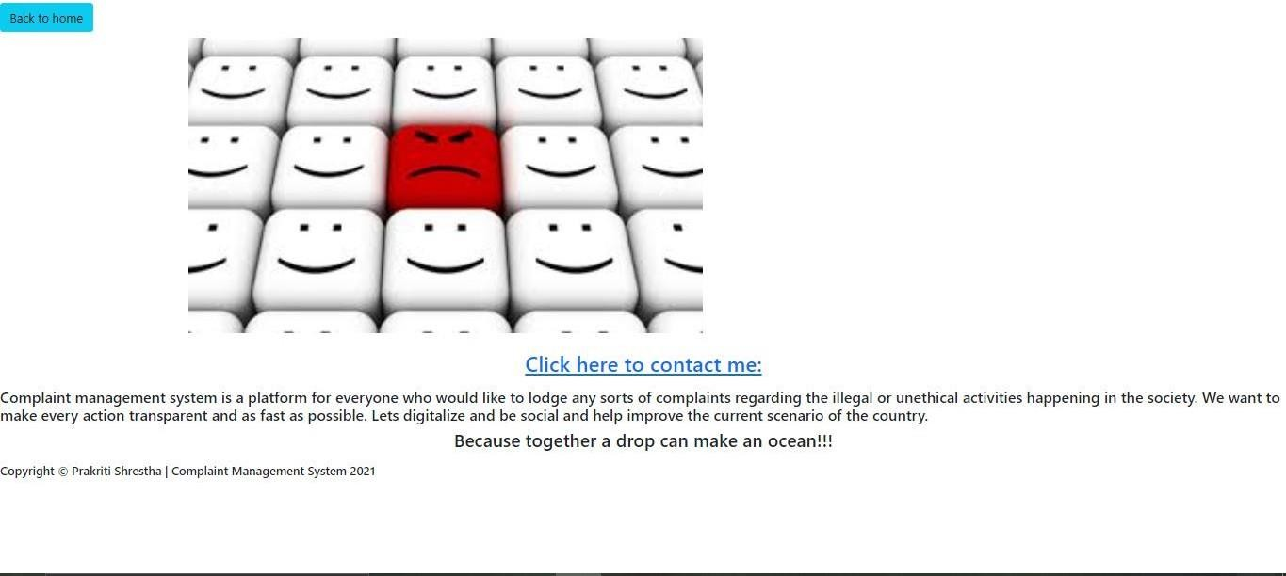

**About Us**

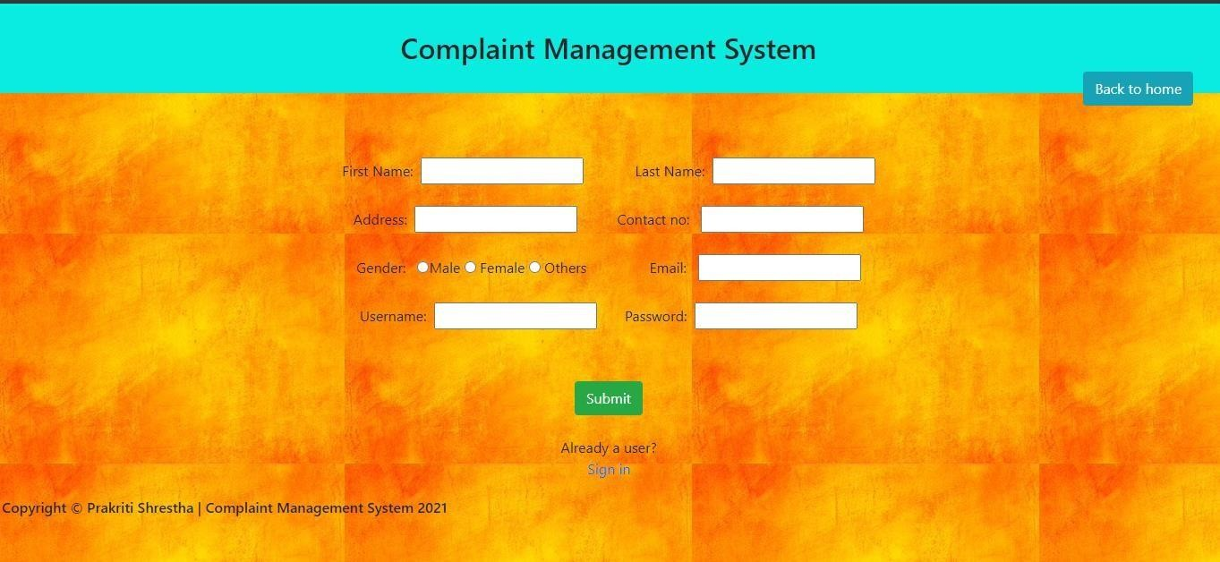

**Registration Page**

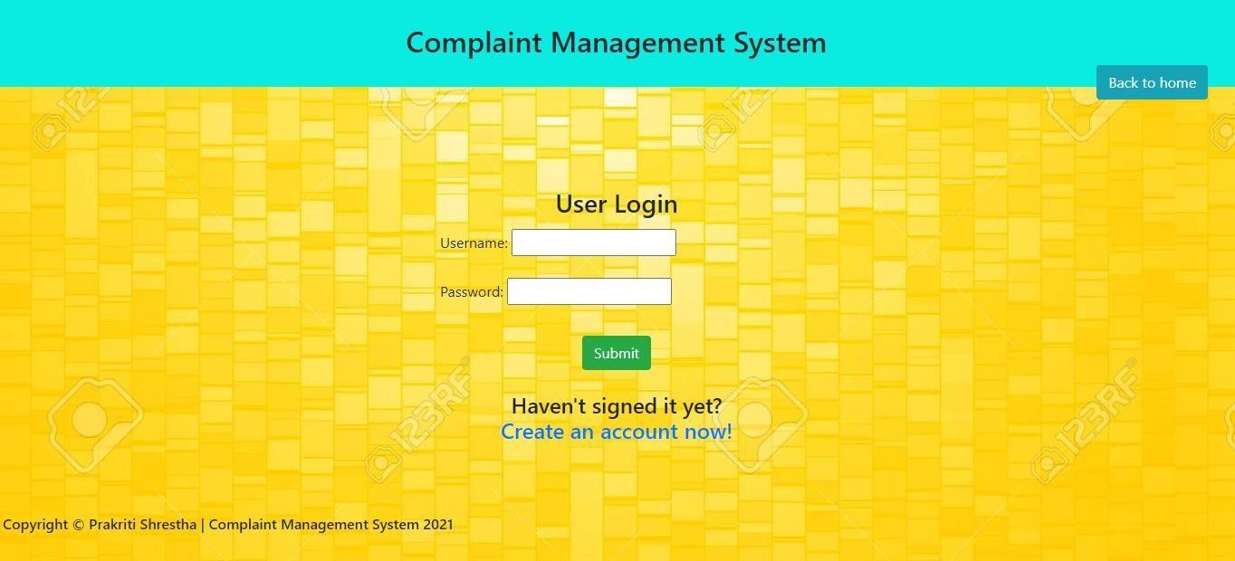

**Login Page**

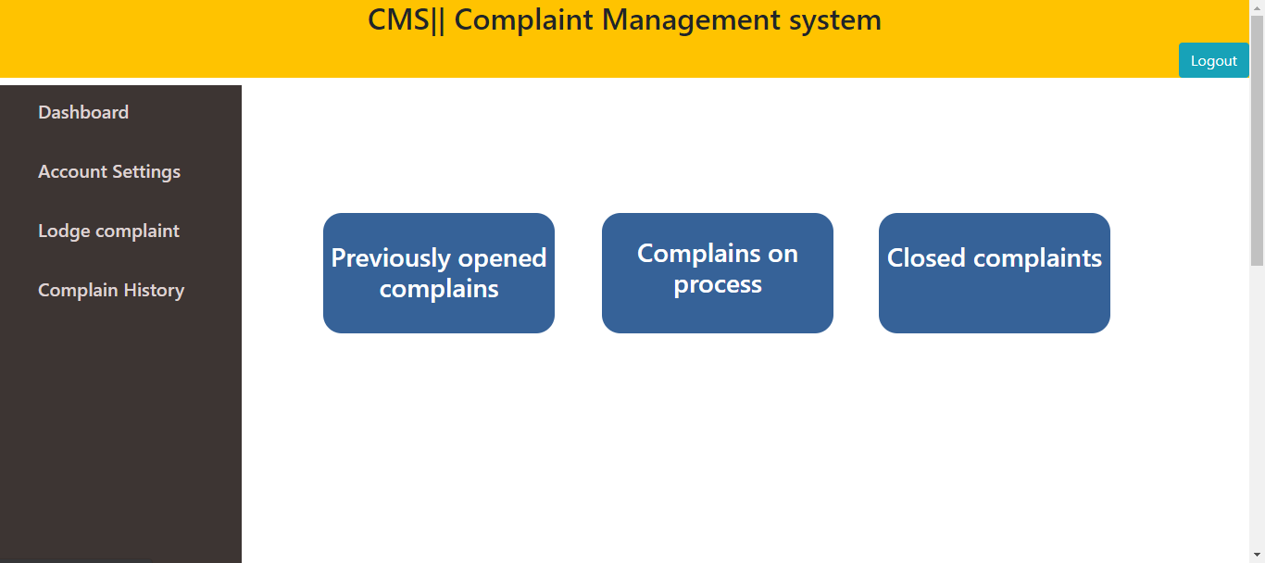

**User Dashboard**

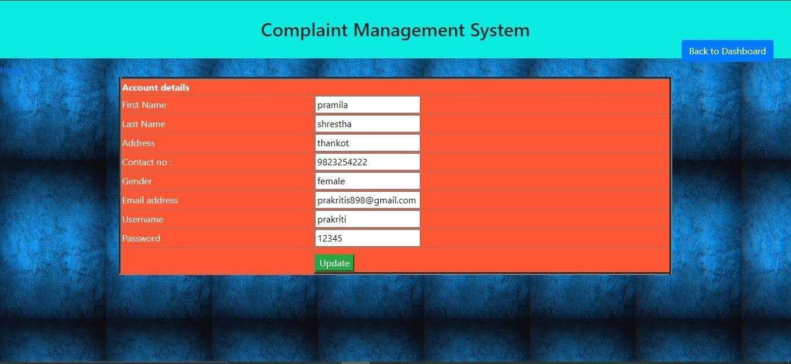

**Edit Personal Information**

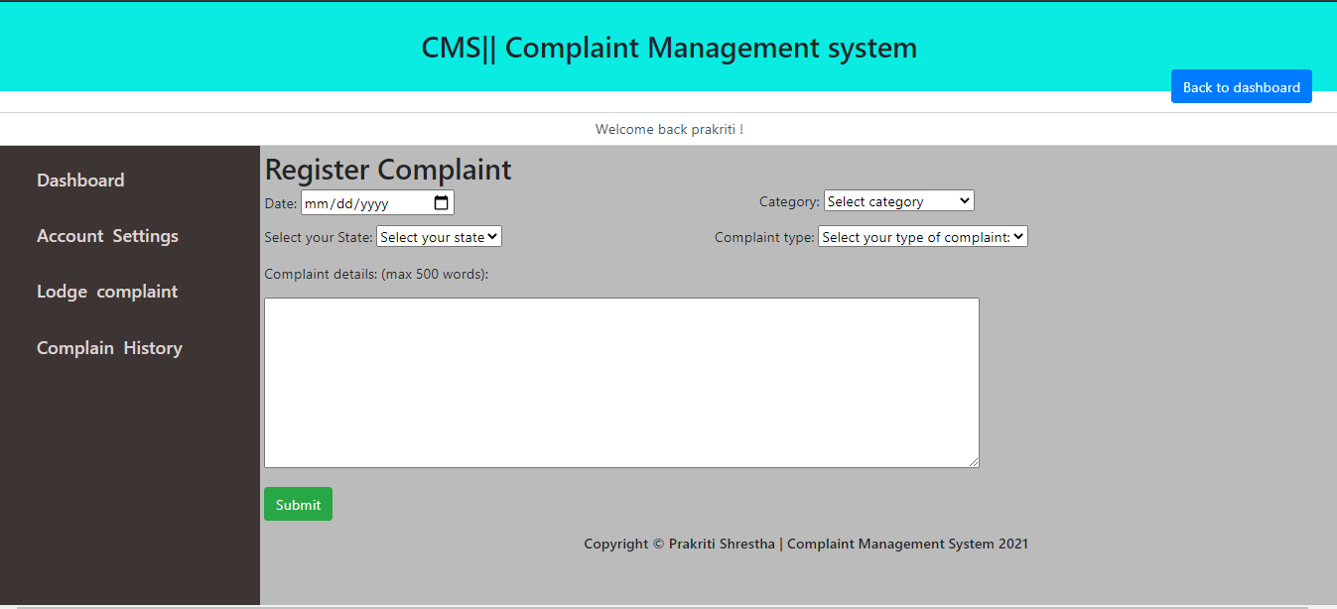

**Lodge Complaint form**

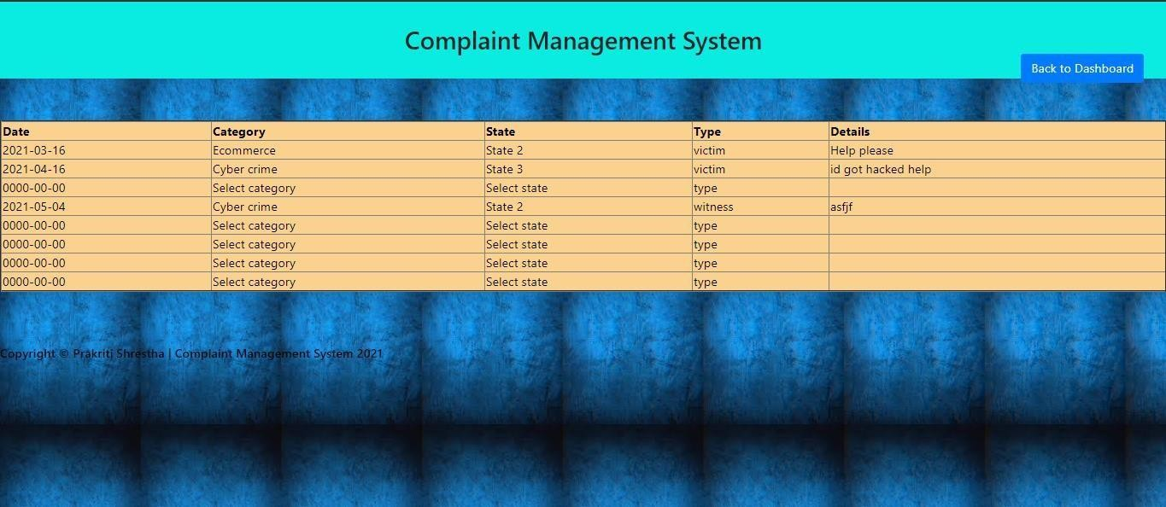

**Complaint History**

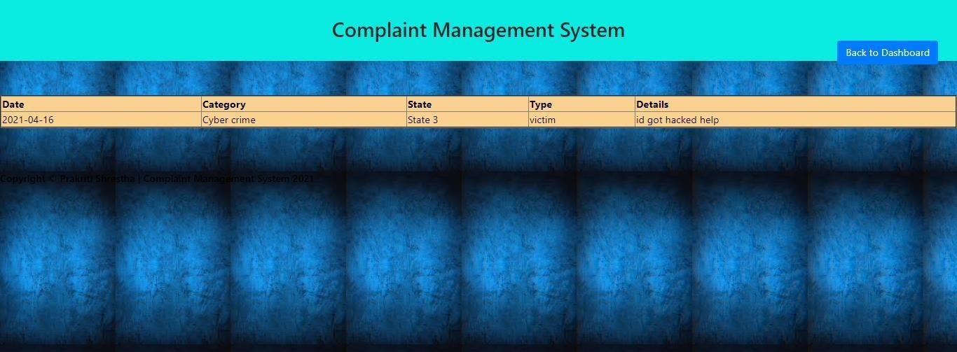

**Complains currently on process**

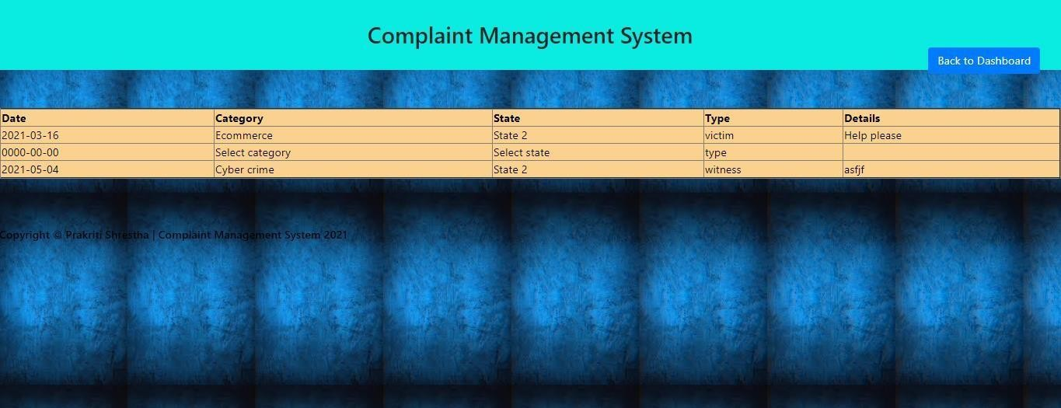

**Closed Complaints**

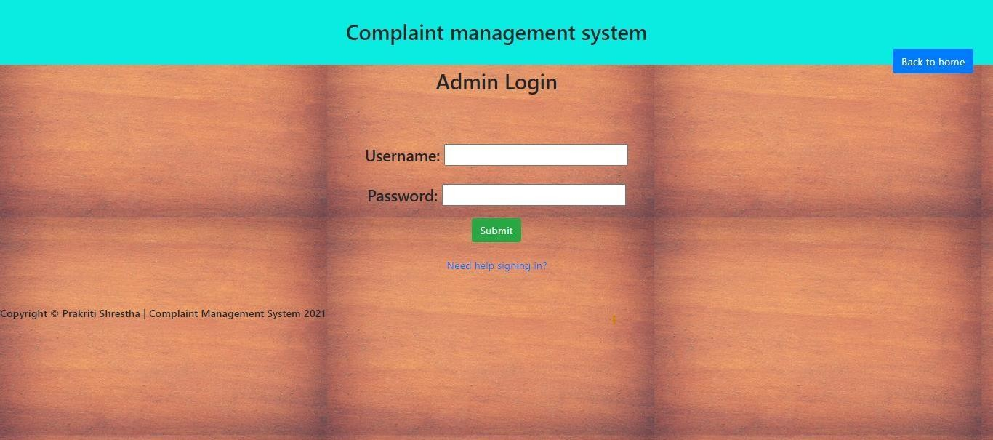

**Admin Login**

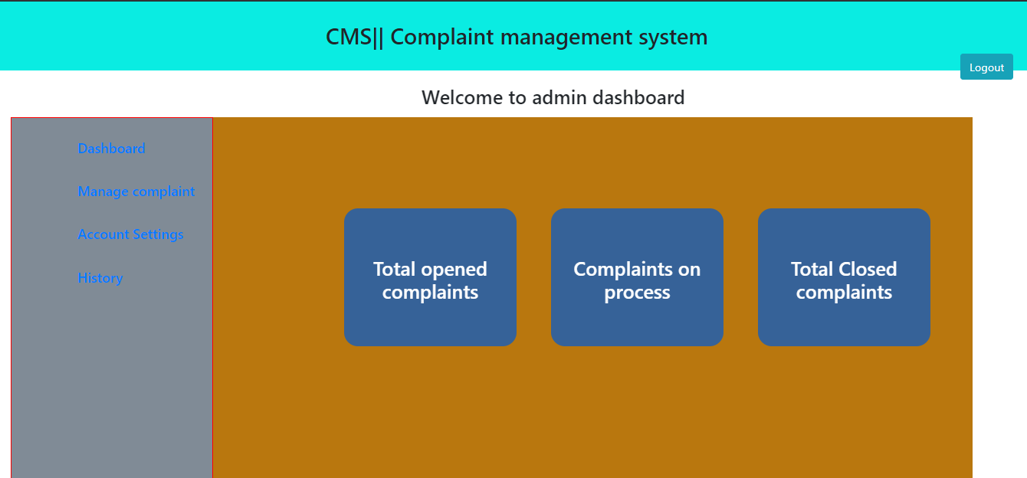

**Admin Dashboard**

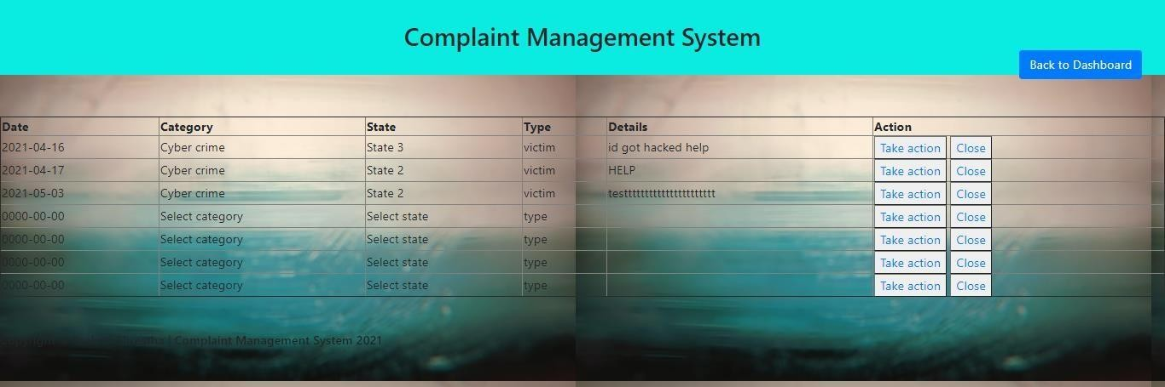

**Manage Complaint**

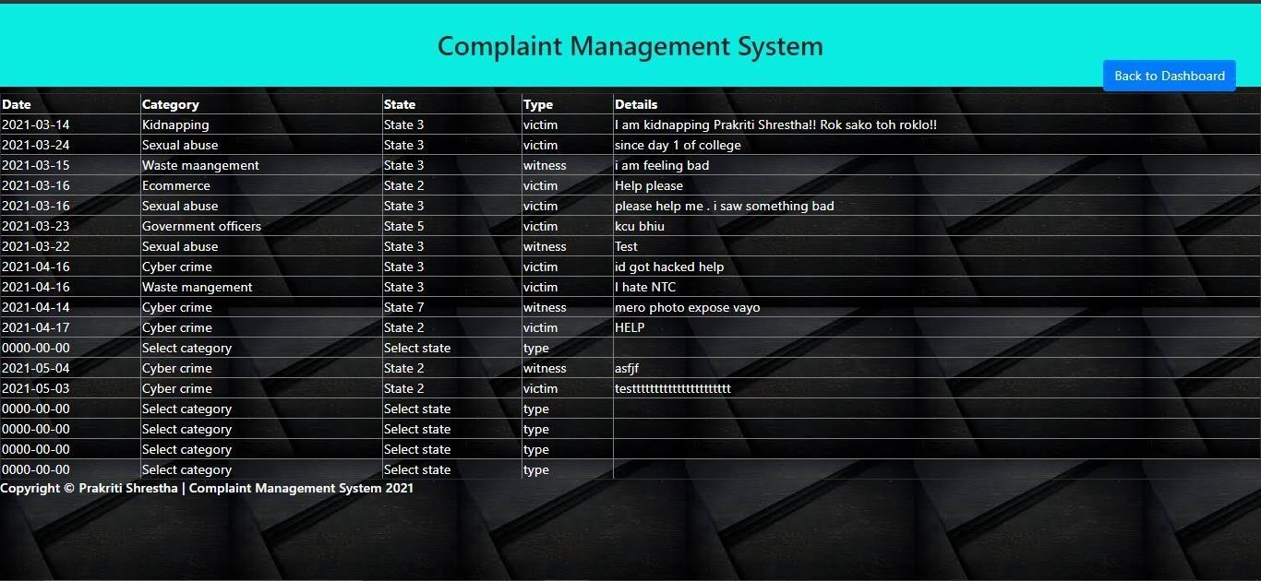

**Total opened Complaints**

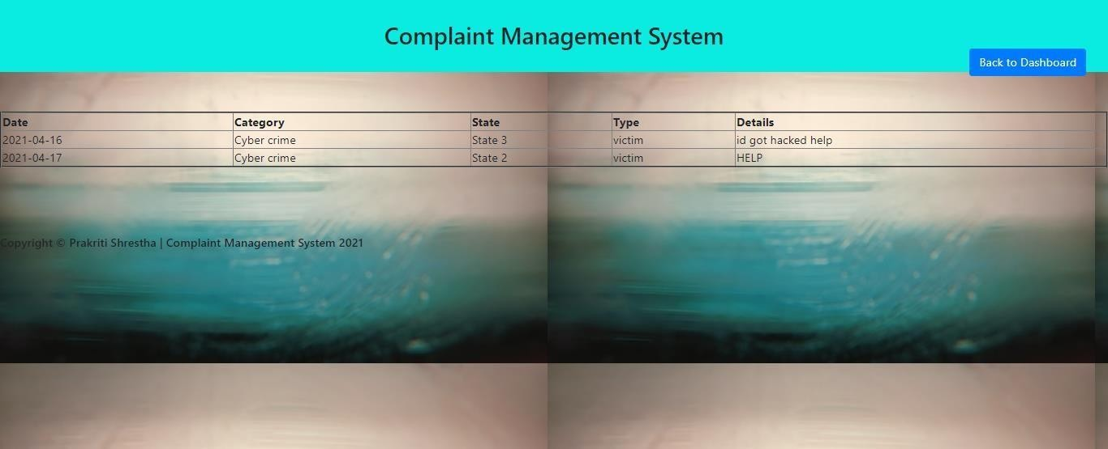

**Total on process complaints**

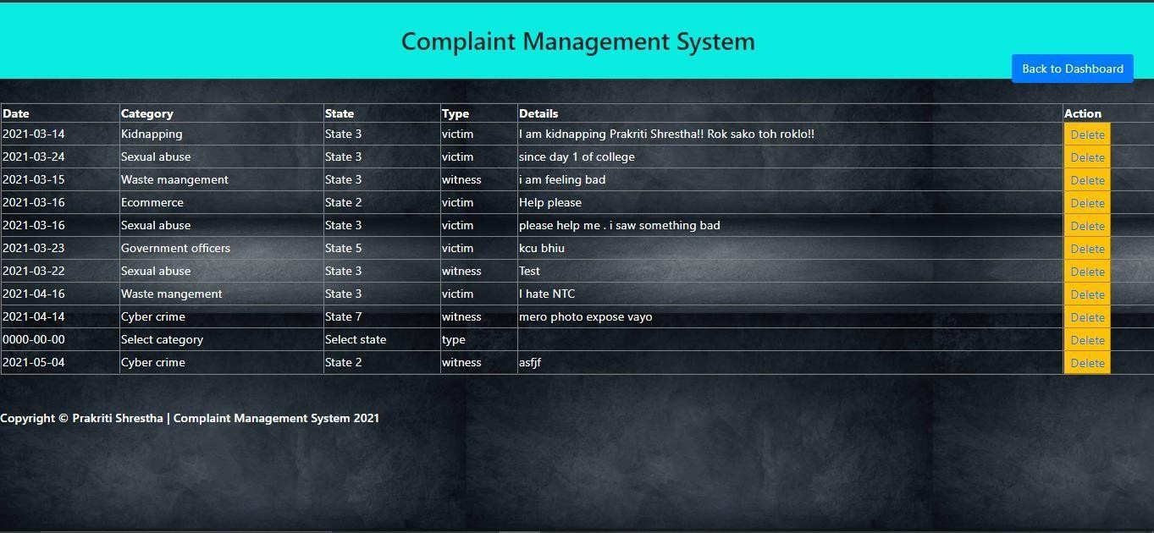

**Total Closed complaints**

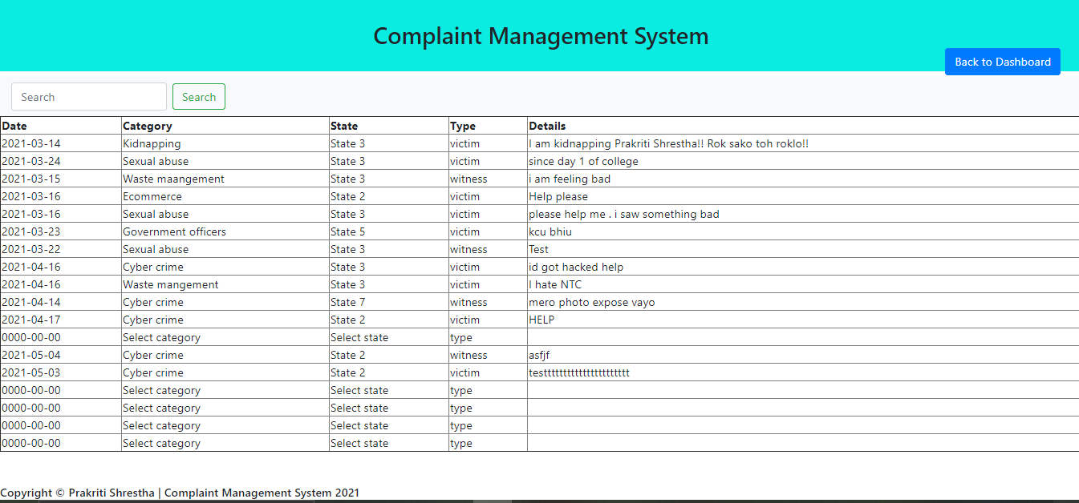

**Total history**