CAREER DEVELOPMENT

This career development exercise has yielded me keen learning in terms of the importance of having a well-specified, systematized way to getting professional goals. Specifying my goals into detailed specifications, identifying shortcomings in skills, and conceiving probable steps has allowed me to view my career path in a more logical way. I now realize that success does not necessarily mean having a vision but bridging the gap between where I am now and where I must be.

The exercise again emphasized the importance of making SMART goals; specific, measurable, achievable, relevant, and time bound. I might have started with, "I want to develop my career," but now appreciate the advantages of being specific on what it is that I mean. An example is to be specific on a leadership role in two years with defined objectives to make it more tangible and feasible. Understanding my skill gaps, for example technical leadership or communication, now allows me to target specific activities such as running meetings or developing influence to work on them in an orderly manner.

In the future, I will implement these learnings through formulating a well-thought-out action plan, mentorship, and actively seeking chances in accordance with my career vision. This exercise did not just clear my path but also instilled confidence within me that with unwavering effort, I can realize my career dreams.

SKILLS AND INTERESTS

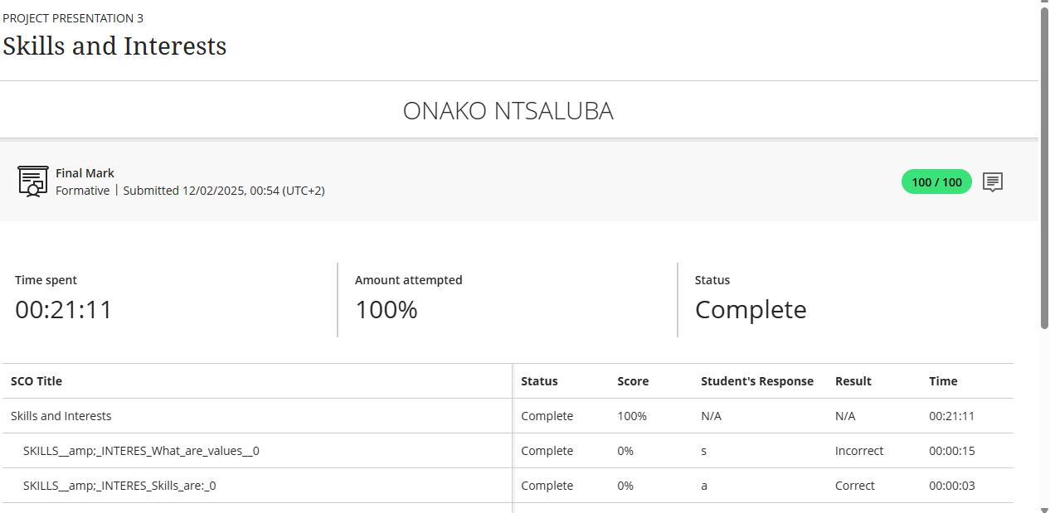

This module has been an enlightening exploration of how aligning my career with my core values, interests, and skills can lead to greater success. By determining my own values, challenge, innovation, and teamwork, for instance I now understand that the moment is here to search for jobs where these values are a priority. That is, if I find my energy and motivation in autonomy and creativity, a schedule-controlled, micromanaged workplace will make me unhappy despite the seniority of the post. Being so self-aware has encouraged me to be more reflective in my career choices, making sure they reflect personal values and long-term happiness.

In addition, the module emphasized the importance of determining transferable and adaptable skills, such as problem-solving, communication, and leadership. Refocusing on my strength’s adjustment to new situations or analytical thinking has made me stronger and indicated how in various kinds of employment, these can be applied.

This exercise has taught me that not only is a successful career founded upon being capable, but also upon being in sync with who I am. Having values, interests, and skills at the centre of my working life, I can build a career that is worthwhile and enriching. In the future, I will continue to assess these criteria regularly so that I can be on a path that really enriches me.

PERSONALITY ASSESSMENT

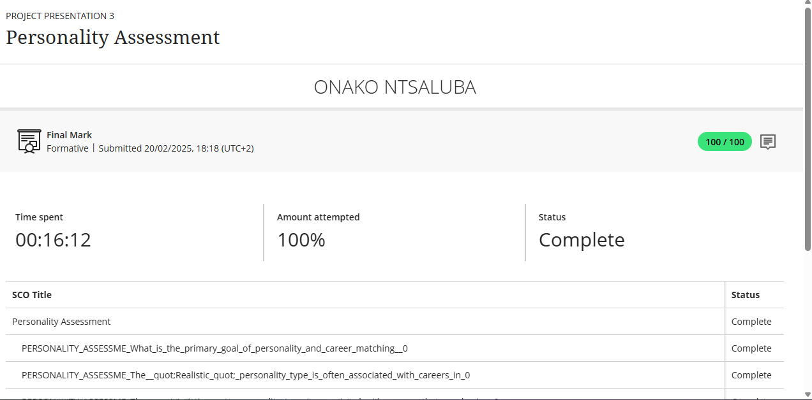

This Personality Assessment course has imparted to me the knowledge of how my innate traits and nature shape my performance and job satisfaction. One of the most practical lessons established was the six occupational interest types (Realistic, Investigative, Artistic, Social, Enterprising, Conventional) and corresponding jobs. For instance, if I test high in Investigative and Artistic dimensions, research science or graphics design would be better for me than the usual clerical job. This model helped me reflect on the experience why some charged me up and others dragged me down and how to choose employment that plays to my natural strengths. I now understand that job satisfaction is rooted in self-knowledge, not competence or external approval.

The module also dispelled widespread myths of friends, or family members as being good career role models. Instead, it relied on introspection and evidence-based measures (like personality tests) to locate true compatibility.

I plan to take personality tests from now on to know my strengths and preferences and then move on to research careers that are suitable for them. For example, if I discover that I'm highly Social and Enterprising, then I may consider a career in teaching or management, where I get to mentor and interact with people daily. In total, this awareness has re-established that career success is not always about ability—it's all about setting. With the right settings that allow for my kind of personality, work can be a source of energy and not something to dread.

CREATE A CV

This module on CV creation has transformed my understanding of how to craft a compelling, professional resume that stands out to employers. I’ve learned that a CV is not just a summary of my work history, but a strategic marketing tool designed to showcase my unique value. The trick was that employers will usually spend only seconds glancing over a CV, so all of it right down to the layout and the exact words used must be deliberate. For instance, having the most important qualifications listed first and using action verbs brings my achievements to life. This contrasted with my previous method of merely reciting duties.

The second importance was to customize my CV for every job application. Instead of using a template, I now realize the importance of aligning the skills and experiences highlighted in the job description with my own. For instance, if the job is project management, I'll put my leadership roles first and include measurable achievements. The module also assisted in clarifying the trade-off of brevity and detail keeping the CV short (1–2 pages) but full of measurable outcomes to demonstrate impact.

The module introduced the application of a CV and cover letter. While the CV provides factual evidence of my qualifications, the cover letter provides narrative information by expounding on my reasons and fitness for the role. The simultaneous application of the two helps ensure that I market myself as qualified and culturally appropriate to prospective employers.

CV SUBMISSION

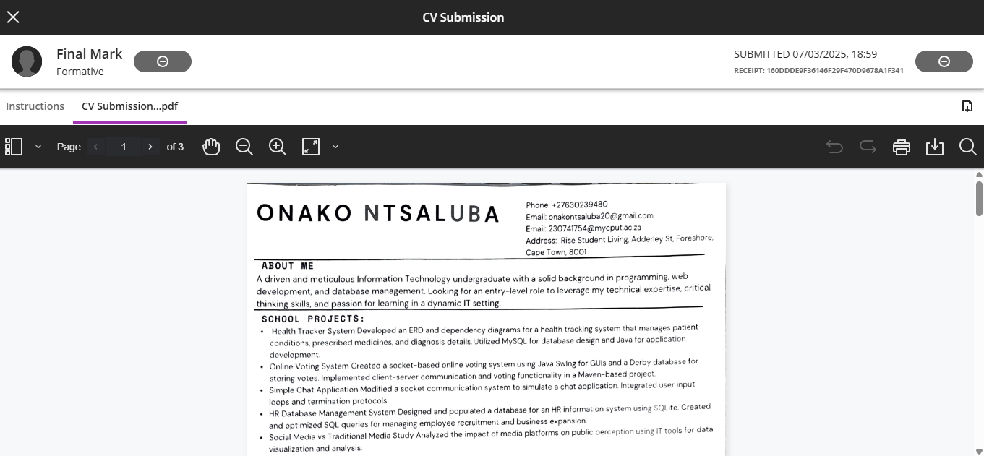

Writing and submitting my CV was a reflexive process that brought to my attention the importance of communication strategy and deliberate self-presentation. The process brought to my attention that a CV is not just a resume, but a targeted marketing document that must be positioned to align with both my professional self and what the employer is looking for. I learned how to strategically select and emphasize most valuable skills and experiences for IT positions, such as my Java programming assignments and database administration course, and avoid making general statements that add no value.

The exercise revealed weaknesses in my work experience, so I added internships or freelance work to pad out my work experience section. I also discovered structure and concision are important applying consistent formatting, bullet points, and brief text made my CV easy to read. In the future, I'll update my CV regularly by adding new qualifications and get feedback to make it more impactful.

In the end, this exercise only reminded me that a good CV is an action document that is breathing to my career. It's not where I have been but how I align my journey to open the doors to where I want to be.