**CMSI 485 – Classwork 3**

**Instructions:**

This worksheet will not only provide you with practice problems for your upcoming exam, but will add to your deep understanding of the mechanics of many probabilistic reasoning systems.

* Provide answers to each of the following questions and write your responses in the blanks. If you are expected to show your work in arriving at a particular solution, space will be provided for you.
* Place the names of your group members below:

**Group Members:**

1. **______________________________________________________**
2. **______________________________________________________**
3. **______________________________________________________**
4. **______________________________________________________**

**Problem 1 – Bayesian Network Exact Inference**

*Consider the following Bayesian Network and use it to answer the questions that follow.*

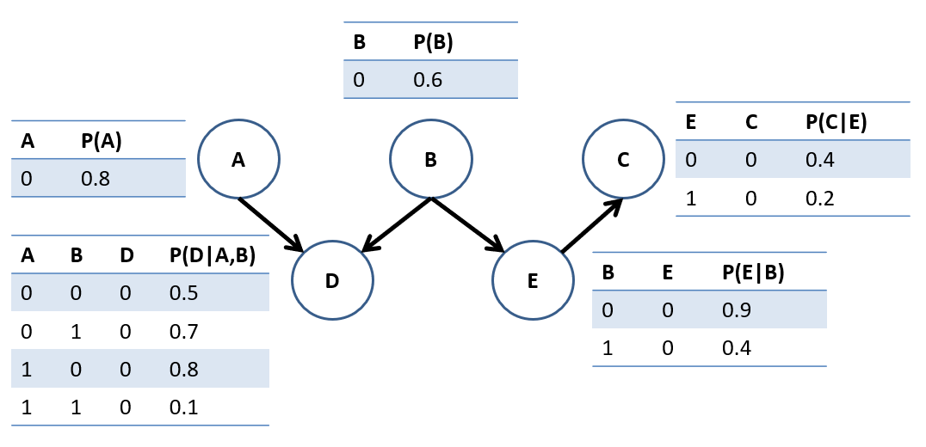

While examining Exact Inference in Bayesian Networks, we saw some methods for *simplifying* queries and the resulting computations that can yield large performance improvements when implemented. E.g., variables whose CPTs never affect the query outcome can be ignored.

* 1. For each of the following queries, determine *which variables’ CPTs* will at all affect the answer to the query. Justify your responses in the boxes that follow. Hint: in your justification, express the query in terms of: $P\left(Q | e\right)=α∑P(…)$ with $α=\frac{1}{P\left(e\right)}$

$P\left(A | B=b,D=d\right)$

|  |  |  |  |  |  |
| --- | --- | --- | --- | --- | --- |
| CPTs Used: | _________ A | _________ B | _________ C | _________ D | _________ E |
| Justification: |  |  |  |  |  |
|  |  |  |  |  |  |

|  |  |  |  |  |  |
| --- | --- | --- | --- | --- | --- |
| CPTs Used: | _________ A | _________ B | _________ C | _________ D | _________ E |
| Justification: |  |  |  |  |  |
|  |  |  |  |  |  |

* 1. Using the Bayesian Network on the previous page, find the solutions to the following.
     1. $P(A=0|B=1,D=1)$*(Box your answer once finished)*

|  |
| --- |
|  |

* + 1. *(Box your answer once finished)*

|  |
| --- |
|  |

**Problem 2 – Decision Networks & MEU**

*Use the following Decision Network with chance nodes $A,B,C$, decision node $D∈\left\{0,1\right\}$, and utility node $U$ to answer the questions that follow.*

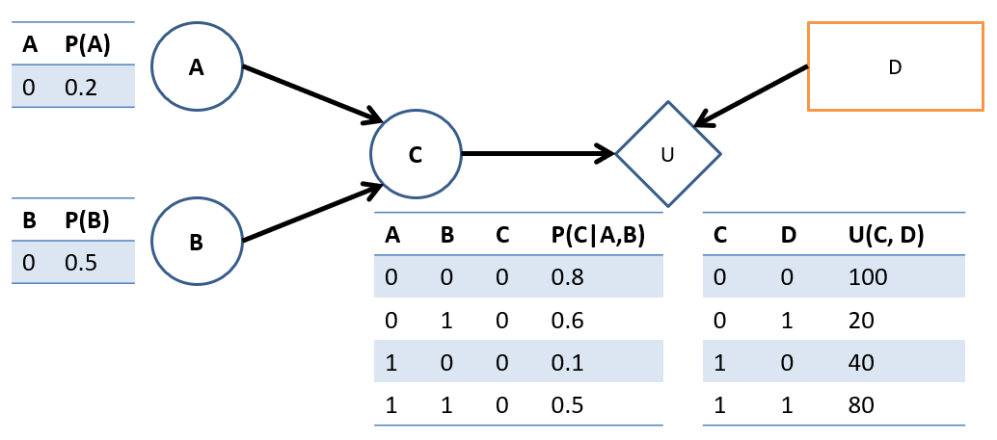

2.1. Find the $MEU\left(B=0\right)$ (i.e., the Maximum Expected Utility with evidence $B=0$).

|  |
| --- |
|  |

2.2. Given your computations above, what decision should your agent make by $MEU?$

______________________________________________________________________________

**Problem 3 – Value of Perfect Information**

*Using the network and your answer from the previous problem, we’re going to compute the Value of Perfect Information (VPI) of knowing the state of variable $A$ when $B=0$ is given. Let’s do so step-by-step:*

3.1. Find $MEU\left(A=0, B=0\right)$.

|  |
| --- |
|  |

3.2. Using the your answer to 4.1 and knowledge that $MEU\left(A=1,B=0\right)=74$ (freebee!) find $MEU\left(A,B=0\right)$.

|  |
| --- |
|  |

3.3. Compute the $VPI\left(A | B=0\right)$.

|  |
| --- |
|  |

3.4. If the utility scores represent dollar amounts, what would be a fair price for $A$ when $B=0$?

______________________________________________________________________________