# Job Provider Section Review

1. Homepage
2. Homepage is not as per the ppt sent. I don’t want to see my personal n contact details-REMOVE IT. Profile page= Homepage. Please align as per that.
3. I do not want to see my details at all in homepage and it is shown twice. Why in LHS below panel again shows my details?? Remove it.
4. Change Name Show Job Post to **Job Gallery**
5. LHS panel order needs to be redone. Profile> Post Jobs> Job Gallery>Search Candidate>Archive>Update Profile> Package details>Account Settings>Logout.

Note: In Archive any waitlisted person would be kept by the job provider/org. for his later reference and not the audition he is interested in. basically the job provider/org saving d candidate profile for later.

1. When u enter any of the LHS options – a) Name as on homepage is not same as when it navigates to the page. b) the Name is not positioned properly.
2. Post A Job
   1. Not able to update package for jobs. So is not able to see the job post section. Please check
3. Job Gallery
   1. Interested Candidate- need 3 options-a) Accept b) Reject c) View Profile
   2. Wen training institute person view candidate profile – need 3options a)accept b) Reject c) Archive
   3. Align the banner just above the white space.
4. Search Candidate
   1. Interested Candidate- need 3 options- a) View Profile b)Send Email c) Archive
   2. Wen training institute person view candidate profile – need 3 options a) Like b)Send Email c) Archive
   3. Likes/interest page of candidate- Keep the topic as Interests and below that write Auditions, jobs, institutes.
   4. The interested auditions, jobs, training institutes need not scroll on their own. Keep it manual. Highlight the scrolling arrow.
5. Update Profile
   1. Should have Sections with Name (Personal Details> About The Organization> Contact Details> Package Details)

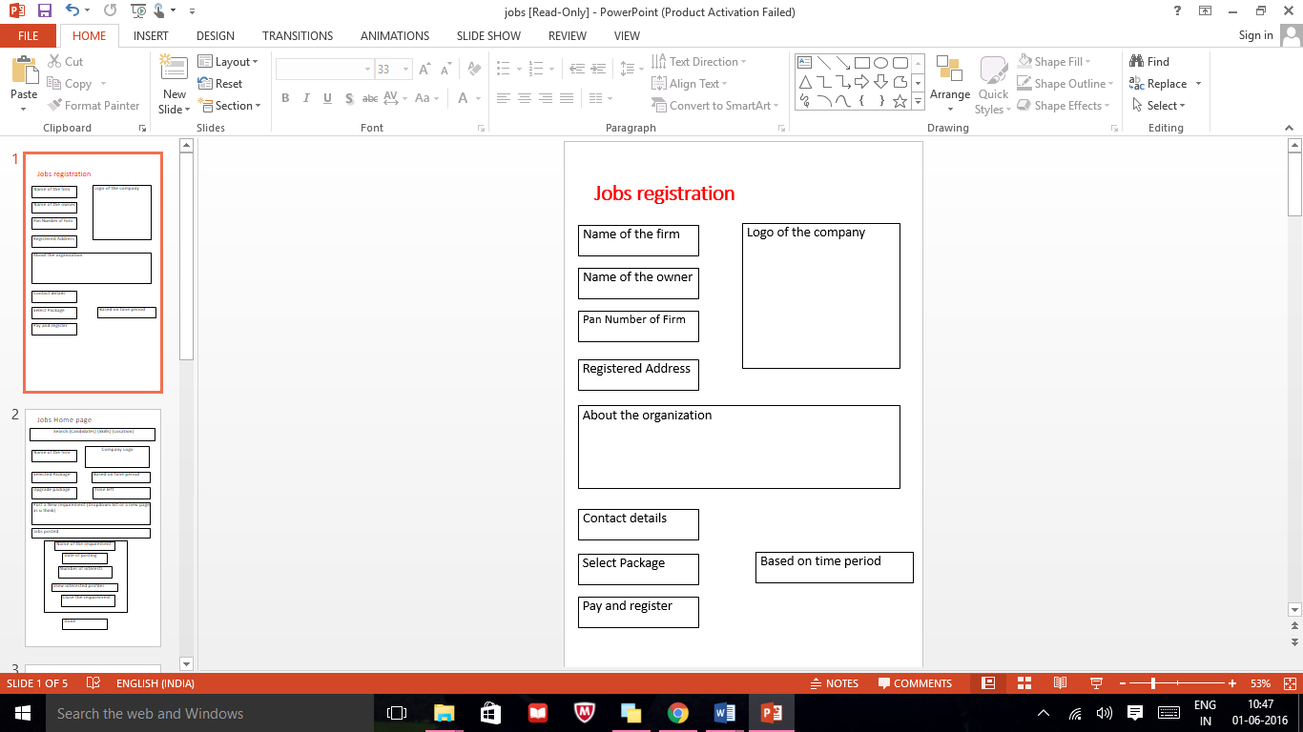

* 1. Mentioned sections should separately have Save/Edit Options( Except Package details)
  2. Duplicate the Package detail section here- at the end keep option for “Continue to Pay” & navigate payments Page.
  3. Name of the Owner not Owner Name

1. Package Detail
   1. In home- tab name is package details- in the page- y package info. And again package detail below. Keep one name.
   2. Check alignment-The name of the page should be aligned in each page just above the white section.