|  |
| --- |
| *Indicate the answer choice that best completes the statement or answers the question.* |

|  |  |  |  |  |  |  |  |  |  |  |  |  |
| --- | --- | --- | --- | --- | --- | --- | --- | --- | --- | --- | --- | --- |
| 1. What print statement will output a single '\' character?   |  |  |  | | --- | --- | --- | |  | a. | print('\') | |  | b. | print('\\') | |  | c. | print('"\"') | |  | d. | print('\\\') | |

|  |  |  |  |  |  |  |  |  |  |  |  |  |
| --- | --- | --- | --- | --- | --- | --- | --- | --- | --- | --- | --- | --- |
| 2. What special character does the '\b' escape sequence generate?   |  |  |  | | --- | --- | --- | |  | a. | It generates a border special character. | |  | b. | It generates a bold special character, causing all text after the character to be bolded. | |  | c. | It denotes a block of text follows the escape sequence. | |  | d. | It produces a backspace special character, which performs the same function as the backspace key. | |

|  |  |  |  |  |  |  |  |  |  |  |  |  |
| --- | --- | --- | --- | --- | --- | --- | --- | --- | --- | --- | --- | --- |
| 3. Which of the following is NOT a valid name that can be used for a variable?   |  |  |  | | --- | --- | --- | |  | a. | total | |  | b. | 1ending | |  | c. | propertyValue | |  | d. | TEST | |

|  |  |  |  |  |  |  |  |  |  |  |  |  |
| --- | --- | --- | --- | --- | --- | --- | --- | --- | --- | --- | --- | --- |
| 4. What is the largest value of an int data type in the Python programming language?   |  |  |  | | --- | --- | --- | |  | a. | 2,147,483,647 | |  | b. | 4,294,967,294 | |  | c. | 2,147,483,647^100 | |  | d. | The value is limited only by the memory of the host computer. | |

|  |  |  |  |  |  |  |  |  |  |  |  |  |
| --- | --- | --- | --- | --- | --- | --- | --- | --- | --- | --- | --- | --- |
| 5. In Python, what data type is used to represent real numbers between -10^308 and 10^308 with 16 digits of precision?   |  |  |  | | --- | --- | --- | |  | a. | int | |  | b. | float | |  | c. | string | |  | d. | array | |

|  |
| --- |
| *Indicate one or more answer choices that best complete the statement or answer the question.* |

|  |  |  |  |  |  |  |  |  |  |  |  |  |
| --- | --- | --- | --- | --- | --- | --- | --- | --- | --- | --- | --- | --- |
| 6. What are the two different means by which a floating-point number can be written? (Choose two.)   |  |  |  | | --- | --- | --- | |  | a. | decimal notation | |  | b. | line notation | |  | c. | scientific notation | |  | d. | octal notation | |

|  |
| --- |
| *Indicate the answer choice that best completes the statement or answers the question.* |

|  |  |  |  |  |  |  |  |  |  |  |  |  |
| --- | --- | --- | --- | --- | --- | --- | --- | --- | --- | --- | --- | --- |
| 7. Which of the following functions and expressions will convert the ASCII character "Z" to its numeric equivalent ASCII code?   |  |  |  | | --- | --- | --- | |  | a. | ord('Z') | |  | b. | chr('Z') | |  | c. | ord(chr('Z')) | |  | d. | chr(ord('Z')) | |

|  |  |  |  |  |  |  |  |  |  |  |  |  |
| --- | --- | --- | --- | --- | --- | --- | --- | --- | --- | --- | --- | --- |
| 8. What effect does the following print statement have? print("Hello" * 5)   |  |  |  | | --- | --- | --- | |  | a. | The string "Hello" is converted into an int type of value 1 and then multiplied by 5, producing "5". | |  | b. | The string is indexed and the character count is multiplied with the total number of characters in the string, producing "25". | |  | c. | The print statement produces a type error as you cannot multiply a string type with an integer type. | |  | d. | The print statement will produce "HelloHelloHelloHelloHello". | |

|  |  |  |  |  |  |  |  |  |  |  |  |  |
| --- | --- | --- | --- | --- | --- | --- | --- | --- | --- | --- | --- | --- |
| 9. In Python, what does the "%" operator do in the expression 6 % 4?   |  |  |  | | --- | --- | --- | |  | a. | It performs an exponentiation to the 4th power. | |  | b. | It returns a remainder or modulus. | |  | c. | It returns a float as a result of division. | |  | d. | It returns the percentage of the operation. | |

|  |  |  |  |  |  |  |  |  |  |  |  |  |
| --- | --- | --- | --- | --- | --- | --- | --- | --- | --- | --- | --- | --- |
| 10. In evaluating a loop, you find the following statement: "value += 1". What happens to the value variable upon each iteration of the loop?   |  |  |  | | --- | --- | --- | |  | a. | The variable is reset to an int type, with a value of 1. | |  | b. | The variable's value is changed to a positive value. | |  | c. | The variable is increased by 1 each iteration through the loop. | |  | d. | The variable is incremented by itself. | |

|  |  |  |  |  |  |  |  |  |  |  |  |  |
| --- | --- | --- | --- | --- | --- | --- | --- | --- | --- | --- | --- | --- |
| 11. An off-by-one error is an example of what type of error in programming?   |  |  |  | | --- | --- | --- | |  | a. | logic error | |  | b. | syntax error | |  | c. | type error | |  | d. | input error | |

|  |  |  |  |  |  |  |  |  |  |  |  |  |
| --- | --- | --- | --- | --- | --- | --- | --- | --- | --- | --- | --- | --- |
| 12. What character is used as the format operator when formatting output?   |  |  |  | | --- | --- | --- | |  | a. | ^ | |  | b. | $ | |  | c. | % | |  | d. | @ | |

|  |  |  |  |  |  |  |  |  |  |  |  |  |
| --- | --- | --- | --- | --- | --- | --- | --- | --- | --- | --- | --- | --- |
| 13. Given the following statement: "%4d" % var1, which of the following is accurate?   |  |  |  | | --- | --- | --- | |  | a. | The variable var1 must be an integer value. | |  | b. | The variable var1 must be a string value. | |  | c. | The variable var1 will be in octal format. | |  | d. | The variable var1 will be formatted regardless of type. | |

|  |  |  |  |  |  |  |  |  |  |  |  |  |
| --- | --- | --- | --- | --- | --- | --- | --- | --- | --- | --- | --- | --- |
| 14. What statement should you use to print the value of total with a precision of 5 digits?   |  |  |  | | --- | --- | --- | |  | a. | print("The total is %5." % total) | |  | b. | print("The total is %0.5d" % total) | |  | c. | print("The total is %f" % float(total, 5)) | |  | d. | print("The total is %0.5f" % total) | |

|  |  |  |  |  |  |  |  |  |  |  |  |  |
| --- | --- | --- | --- | --- | --- | --- | --- | --- | --- | --- | --- | --- |
| 15. What comparison operator is used to test whether an expression does NOT equal another expression?   |  |  |  | | --- | --- | --- | |  | a. | -= | |  | b. | != | |  | c. | /= | |  | d. | _= | |

|  |  |  |  |  |  |  |  |  |  |  |  |  |
| --- | --- | --- | --- | --- | --- | --- | --- | --- | --- | --- | --- | --- |
| 16. If A is True, what will the statement "not A" return?   |  |  |  | | --- | --- | --- | |  | a. | Undefined | |  | b. | True | |  | c. | False | |  | d. | BooleanError | |

|  |  |  |  |  |  |  |  |  |  |  |  |  |
| --- | --- | --- | --- | --- | --- | --- | --- | --- | --- | --- | --- | --- |
| 17. Inside of a loop, after a termination condition has been met, what statement can be used to cause an exit from the loop and execute the remainder of the script?   |  |  |  | | --- | --- | --- | |  | a. | exit | |  | b. | break | |  | c. | quit | |  | d. | halt | |

|  |  |  |  |  |  |  |  |  |  |  |  |  |
| --- | --- | --- | --- | --- | --- | --- | --- | --- | --- | --- | --- | --- |
| 18. What function call will generate a random number in the range of 1 through 6 using the random module?   |  |  |  | | --- | --- | --- | |  | a. | random.randnum(1, 6) | |  | b. | random.randint(range(1-6)) | |  | c. | random.randint(1, 6) | |  | d. | random.random(1, 6) | |

|  |  |  |  |  |  |  |  |  |  |  |  |  |
| --- | --- | --- | --- | --- | --- | --- | --- | --- | --- | --- | --- | --- |
| 19. Assuming that the value of x is 4, and the value of y is 6, what is the value of the following expression? (x - y)**2 > y   |  |  |  | | --- | --- | --- | |  | a. | True | |  | b. | False | |  | c. | Undefined | |  | d. | TypeError | |

20. 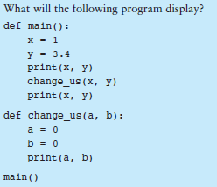13.4 \n 00

21. 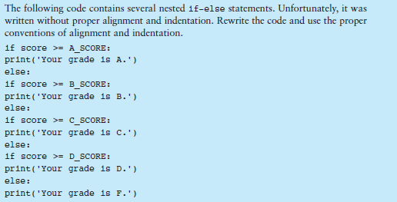

if score >= A_SCORE:

print("Your grade is A.")

elif score >= B_SCORE:

print("Your grade is B.")

elif score >= C_SCORE:

print("Your grade is C.")

elif score >= D_SCORE:

print("Your grade is D.")

else

print("Your grade is F.")

22. 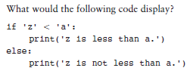z is not less than a

23. 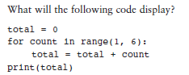21

24. 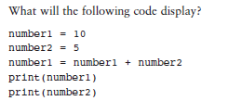15 \n 5

25. 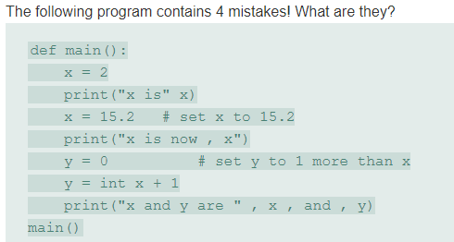

Need a comma in the first print statement

Move parenthesis in second print statement to after “now”

Don’t need int in front of x

Third print statement needs the and, removed

26. 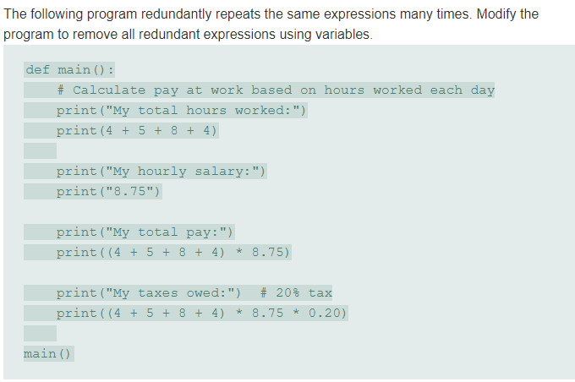

27. 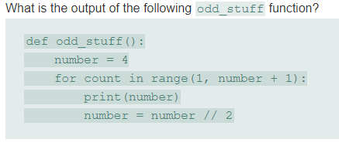

28. 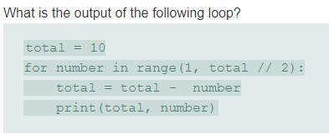

29. 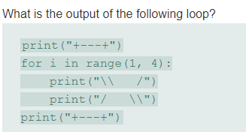

30. 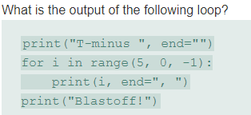

31. 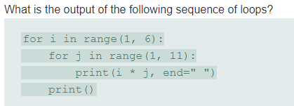

32. 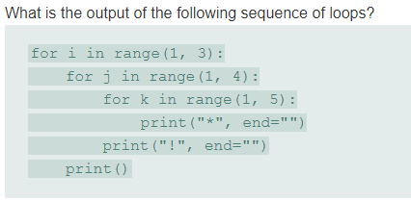

33. 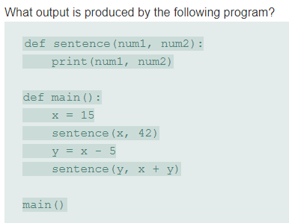

34. 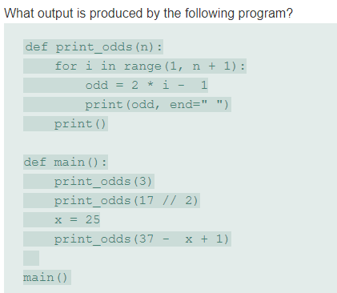

35. 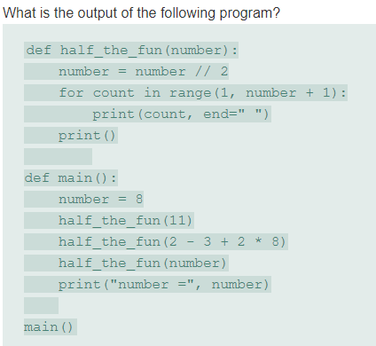

36. 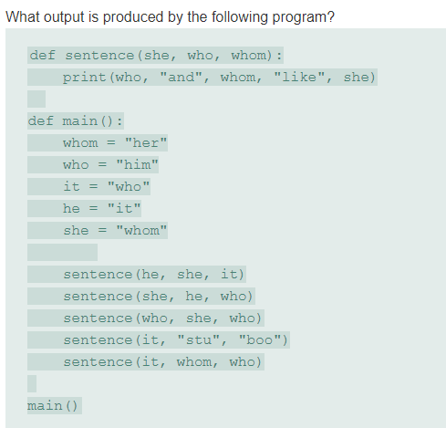

37. 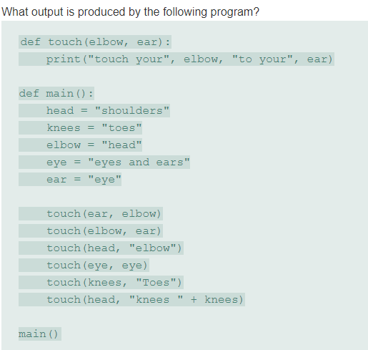

38. 