**GROUP MEMBERS**

1. Ondela Citywayo (Group Leader)
2. Segai Bryton Mampshika
3. Mthunzi Malebadi
4. Sinesipho Sibulo
5. Vhuvhwano Mawela Masalesa

**Speech-to-Text API Trade-Off Analysis**

1. **Performance**

* Works fast for small audio clips.
* Converts. webm to .wav using pydub, which Google’s API understands better.
* May slow down with large or long recordings.
* Suggestion: Limit max audio duration (e.g., 30 seconds) on the frontend.

**2. Security**

* API keys are used to protect your routes.
* Secrets are stored securely (e.g., in a .env file).
* May still need HTTPS if deployed publicly.
* Suggestion: Add file type & size validation on upload and ensure TLS (SSL) is enabled in production.

**3. Scalability**

* Good for demo or classroom-level use.
* Will slow down with multiple concurrent users or long uploads.
* Suggestion: Use background tasks (e.g., Celery) for long jobs and consider scaling with a cloud backend if needed later.

**4. Authentication & Rate Limiting (You Implemented These!)**

* API key authentication is enabled.
* Flask-Limiter protects routes (e.g., limit to 5 requests/minute).
* Suggestion: Customize rate limits per user or IP if needed.

Code:

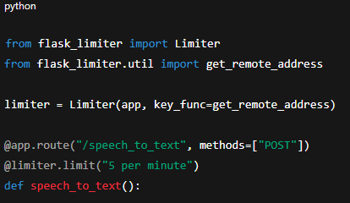

**5. Error Handling & User Feedback**

* Gracefully handles:
  + Missing files
  + Unintelligible speech
  + API service failures
* Sends clear error messages back to the frontend.

Suggestion: Improve logging (e.g., using logging module with traceback) to debug backend errors faster.

**Summary Table**

|  |  |  |
| --- | --- | --- |
| Feature | What Works Well | Needs Work / Improve |
| Performance | Fast for small audio | Slows with long audio |
| Security | API keys +. env for secrets | Needs file validation & HTTPS for deployment |
| Scalability | Great for 1–2 users | Not ready for high traffic |
| Authentication | Already implemented | — |
| Rate Limiting | Flask-Limiter working well | — |
| Error Handling | Clear messages for common issues | Could use logging module for deeper errors |