Department of Computer Technology and Information Systems

## CTIS221 – Object Oriented Programming

SPRING 2018 - 2019

# **Lab Guide 5 - Week 4-1**

|  |
| --- |
| **OBJECTIVE:** Classes, Constructors and Object Creation |
| **Instructor** : Burcu LİMAN  **Assistant** : Leyla SEZER |

**Q1. a)**

* Create the following class “**Cosmetics**” with its **data members** and one member method **display**().

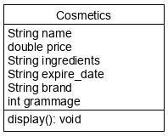

* Create another class as “CosmeticsMain” which will create an object from Cosmetics class and displays its content

**Output:**

****COSMETICS INFO ******

Name: null

Price: 0.0

Ingredients: null

Expire DATE: null

Brand: null

Grammage: 0

**b)**

* Implement the **constructors** shown below and then create **three** objects from **Cosmetics** class in the **CosmeticsMain** class by using these constructors.
* No-arg constructor; assigns the data members to its given values;

name = "Vaseline";

price = 2.0;

ingredients = "Aqua, Glyccerin, SLS";

brand = "Unilever";

expire_date = "2020";

grammage = 100;

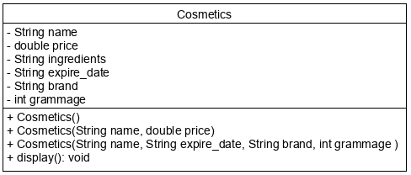

Cosmetics**Main Class;**

Cosmetics cos = new Cosmetics();

Cosmetics cos1 = new Cosmetics("Powder",121);

Cosmetics cos2 = new Cosmetics("FoundationCream","2022","Clinic",150);

cos.display();

cos1.display();

cos2.display();

**Output:**

****COSMETICS INFO ******

Name: Vaseline

Price: 2.0

Ingredients: Aqua, Glycerin, SLS

Expire DATE: 2020

Brand: Unilever

Grammage: 100

****COSMETICS INFO ******

Name: Powder

Price: 121.0

Ingredients: null

Expire DATE: null

Brand: null

Grammage: 0

****COSMETICS INFO ******

Name: FoundationCream

Price: 0.0

Ingredients: null

Expire DATE: 2022

Brand: Clinic

Grammage: 150

* Change the name of the first object to “Tonic” then display the content again.

**CosmeticsMain Class;**

cos.name = "Tonic";

cos.display();

**Output:**

****COSMETICS INFO ******

Name: Tonic

Price: 2.0

Ingredients: Aqua, Glycerin, SLS

Expire DATE: 2020

Brand: Unilever

Grammage: 100

**c)** Put the following visibility modifiers and then try to change the name of the first object.

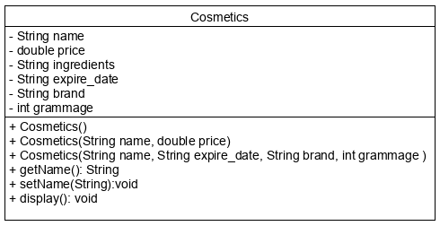

* You will notice that, this time the name variable is not accessible. In order to reach the variables, you have to implement getters/setters as shown in the UML class diagram below.

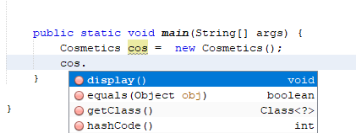

* In **CosmeticsMain** class, change the cos object name to “Serum” and get the following output.

Cosmetics cos = new Cosmetics();

cos.setName("Serum");

System.out.println("Name of the cos object is "+cos.getName());

**Output:**

Name of the cos object is Serum

**Q2.** Create the following class “Exam” with the given data members and member methods

* No-argconstructor; assigns the data members to its given values;
  + name = "No Name";
  + percentage = 0;
  + date = "NULL";
  + numOfQuestion = 0;
  + type = "NULL";
  + duration =0;
* **display**() member method, displays the object content as in the example run.
* **changePercentage**() member method, changes the percentage according to the exam type; if it is “LAB” percentage increase 10 point, otherwise 5 points.
* **increaseDuration()** member method, increase the exam duration according to number of questions. If number of questions is greater than 30; duration will increase 15 minutes, however if number of questions is between 20 and 30; duration will increase 10 minutes.

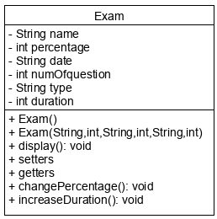

Write a java program named as “ExamMain”, whichcreates 2 exam objects from the **Exam** class, withthe given values below, and then displays the content of objects. Finally program invokes changePercentage() method for the first exam, increaseDuration() method for the second exam and displays the final format of all these two exams.

* Exam1;
  + Name: 487Midterm,
  + Percentage: 20,
  + Date: 20/02/2019,
  + Number of question: 21,
  + Type: LAB,
  + Duration: 135
* Exam2;
  + Name: 359Quiz1,
  + Percentage: 10,
  + Date: 25/03/2019,
  + Number of question: 25,
  + Type: ESSAY,
  + Duration: 120

**Output:**

------EXAM INFO------

Name: 487Midterm

Percentage: 20

Date: 20/02/2019

Number of Question: 21

Type: LAB

Duration: 135

------EXAM INFO------

Name: 359Quiz1

Percentage: 10

Date: 25/03/2019

Number of Question: 25

Type: ESSAY

Duration: 120

------EXAM INFO------

Name: 487Midterm

Percentage: 30

Date: 20/02/2019

Number of Question: 21

Type: LAB

Duration: 135

------EXAM INFO------

Name: 359Quiz1

Percentage: 10

Date: 25/03/2019

Number of Question: 25

Type: ESSAY

Duration: 130