Department of Computer Technology and Information Systems

## CTIS221 – Object Oriented Programming

SPRING 2018 - 2019

# **Lab Guide 6 - Week 4-2**

|  |
| --- |
| **OBJECTIVE:** Classes, Constructors and Object Creation, toString method |
| **Instructor** : Burcu LİMAN  **Assistant** : Leyla SEZER |

**Q1.** Create the following **Museum** class structure with the given data members also write the constructor, getters, setters and a toString method;

* Non-default constructor; generates the museum number (between 1-20) by using random() method.
* Write a toString() method as in the example run.

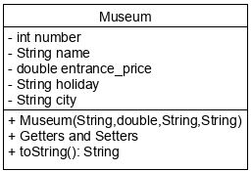

Create another class as MuseumMain; in which creates 4 museum objects and displays the content of the objects by using the toString method.

Museum m1 = new Museum("Cumhuriyet", 6.0, "FRIDAY", "ANKARA");

Museum m2 = new Museum("Mevlana", 15.0, "MONDAY", "KONYA");

Museum m3 = new Museum("Topkapi Sarayi", 25, "NONE", "İSTANBUL");

Museum m4 = new Museum("Konuralp", 5.0, "TUESDAY", "DÜZCE");

System.out.println(m1);

System.out.println(m2);

System.out.println(m3);

System.out.println(m4);

**Output:**

-----Museum-----

Number=10

Name=Cumhuriyet

Entrance_price=6.0

Holiday=FRIDAY

City=ANKARA

-----Museum-----

Number=9

Name=Mevlana

Entrance_price=15.0

Holiday=MONDAY

City=KONYA

-----Museum-----

Number=15

Name=Topkapi Sarayi

Entrance_price=25.0

Holiday=NONE

City=İSTANBUL

-----Museum-----

Number=11

Name=Konuralp

Entrance_price=5.0

Holiday=TUESDAY

City=DÜZCE

**Q2. a)** Create the following **IDETools** class structure with the given data members also write the constructor, getters, setters and a toString method;

* Non-default constructor; gets all the data member from the user and assigns them to original ones.
* Write a toString() method as in the example run.

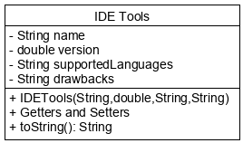

* Create another class as IDEMain; in which the program gets the number of IDE tools from the user and gets each IDE Tool information from the user. Finally, displays each IDETools object on the screen.

**Output:**

How many IDE TOOLs do you want to enter:

3

Enter 1. IDE name:

Netbeans

Enter version:

8

Enter Supported Languages:

C++,Java

Enter Drawbacks:

Longtime to Open

IDETools

Name=Netbeans

Version=8.0

SupportedLanguages=C++,Java

Drawbacks=Longtime to Open

Enter 2. IDE name:

Eclipse

Enter version:

11

Enter Supported Languages:

C, C++, Java, Perl, PHP, Python

Enter Drawbacks:

May be intimidating to newcomer

IDETools

Name=Eclipse

Version=11.0

SupportedLanguages=C, C++, Java, Perl, PHP, Python

Drawbacks=May be intimidating to newcomer

Enter 3. IDE name:

Code::Blocks

Enter version:

6

Enter Supported Languages:

C, C++, Fortran

Enter Drawbacks:

Advanced coders may be frustrated with the limitations

IDETools

Name=Code::Blocks

Version=6.0

SupportedLanguages=C, C++, Fortran

Drawbacks=Advanced coders may be frustrated with the limitations

**b)** Write the same question by adding a getInput() method inside the IDETools class. The getInput() method will get all the data members from the user and assigns them to the original ones.

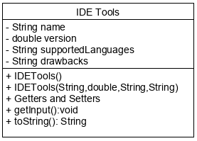

**ADDITIONAL QUESTION**

1. Create a **Time** class with the given information below.

|  |
| --- |
| Time |
| - hour: int  - minute: int  - second: int |
| + Time (long, long , long )  + Time (long)  + displayTime(): void  + changeTime(t2: Time, operation: String): void |

* Write the data members.
* Write a non-default constructor that takes a milliseconds and converts it into hour, minute and second the related.
* Write an other non-default constructor that takes hour, minute and second and assigns them to data members.
* Write a displayTime method that displays the time on the screen. (See example run.)
* Write a changeTime method that takes a Time object and a string operation code. The method adds the time if operation is addition, subtracts otherwise. Then, it informs the user by displaying “Time has been changed” message.

**Example Run:**

The number System.currentTimeMillis() method returns is 1529493999841

1529493999 seconds.

25491566 minutes.

424859 hours.

Add (a) or subtract (s) time?

a

Enter the amount of hours:

100

Enter the amount of minutes:

70

Enter the amount of seconds:

16

Time has changed.

1529493983 seconds.

25491496 minutes.

424759 hours.