Department of Computer Technology and Information Systems

## CTIS221 – Object Oriented Programming

SPRING 2018 - 2019

# **Lab Guide 10 - Week 7-1**

|  |
| --- |
| **OBJECTIVE:** String and String Buffer, Inheritance is-a relation |
| **Instructor** : Burcu LİMAN  **Assistant** : Leyla SEZER |

**Q1.** Create the class **LabMaintenanceForm**; with the given data members and given member methods.

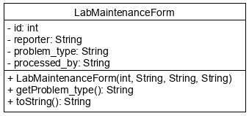

* Write a Java program that gets 3 strings from the user which have the words separated with “*” character. Then program separates strings and converts them into a LabMaintenanceForm objects array. Finally, program display the content of an array. (Use **split()** method)

Before displaying output with toString(), do the following first.

* Put the “CTIS_” at the beginning of the problem_type 🡪 (do it with the insertAt method of StringBuffer)
* While you are displaying your LabMaintenanceForm objects, find the problem_type index into the output of toString method with using indexOf method. Display the index you find as “Problem's position is at“ .

**Output:**

Enter 1. string:

1*Leyla Sezer*Network*Zafer Demirtas

Enter 2. string:

2*Rusen Asan*Software*Cuneyt Sevgi

Enter 3. string:

3*Hatice Yilmaz*System*Serkan Genc

LabMaintenanceForm

Id=1

Reporter=Leyla Sezer

Problem_type=CTIS_Network

Processed_by=Zafer Demirtas

Problem's position is at 59

LabMaintenanceForm

Id=2

Reporter=Rusen Asan

Problem_type=CTIS_Software

Processed_by=Cuneyt Sevgi

Problem's position is at 58

LabMaintenanceForm

Id=3

Reporter=Hatice Yilmaz

Problem_type=CTIS_System

Processed_by=Serkan Genc

Problem's position is at 61

**Q2.**

Write a Java program that stores and displays the file information. Create **File, Video** and **Image** classes as shown in the following UML Class Diagram.

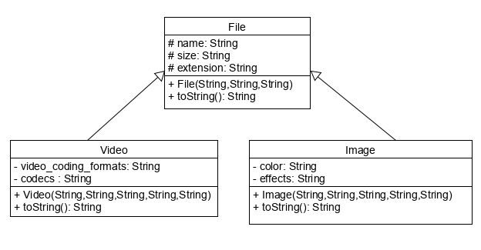

Create a **File** class, with the following instructions;

* Write data members; **name**, **size**, **extension**.
* Write **non-default constructor** and **toString**() method.

Create a **Video** class **which extends from** **File**, with the following instructions;

* Write data members; **video_coding_formats**, **codecs**.
* Write **non-default constructor** and **toString**() method.

Create an **Image** class **which extends from** **File,** with the following instructions;

* Write data members; **color**, **effects**.
* Write **non-default constructor** and **toString**() method.

Create a **FileMain** class, with the following instructions;

* Create **4** objects, two of them from **Video** class, others from **Image** class.
* Display the content of each one as in the output.

Video v1 = new Video("Award Ceremony Video 2018", "12GB", "mpeg","MPEG4", "3D codecs");

Video v2 = new Video( "Html Tutorial", "4.5GB", "flv","Adobe Flash Platform", "2D codecs");

Image img1 = new Image("Sheraton otel", "350MB", "jpeg","GrayScale", "Animations");

Image img2 = new Image("Swiss otel", "562MB", "gif","Multi-Color", "Graphics");

System.out.println(v1);

System.out.println(v2);

System.out.println(img1);

System.out.println(img2);

**Output:**

Video File

Name=Award Ceremony Video 2018

Size=12GB

Extension=mpeg

Video_Coding_Formats=MPEG4

Codecs=3D codecs

Video File

Name=Html Tutorial

Size=4.5GB

Extension=flv

Video_Coding_Formats=Adobe Flash Platform

Codecs=2D codecs

Image File

Name=Sheraton hotel

Size=350MB

Extension=jpeg

Color=GrayScale

Effects=Animations

Image File

Name=Swiss hotel

Size=562MB

Extension=gif

Color=Multi-Color

Effects=Graphics

**Q3.**

Write a Java program that stores and displays the probiotics information. Create **Probiotics, Yogurt** and **Cheese** classes as shown in the following Inheritance Class Diagram.

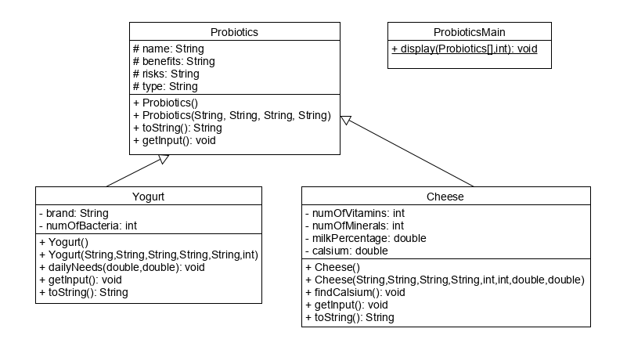

Create a **Probiotics** class, with the following instructions;

* Write data members; **name, benefits, risks, type.**
* Write **default constructor.**
* Write **non-default constructor.**
* Write **toString()** method to show the content of the Probiotic object.
* Write **getInput()** method that gets the data members from the user.

Create a **Yogurt** class **which extends from** **Probiotics**, with the following instructions;

* Write data members; **brand, numOfBacteria.**
* Write **default constructor.**
* Write **non-default constructor** and **toString**() method.
* Write **getInput()** method that gets the data members from the user.
* Write a member method **dailyNeeds**() that gets double **kg** and double **height** of a person, calculates and displays the daily yogurt needs according to the body mass index of the person as in the output screen.
  + Body mass index = kg / (height * height),
  + If it is lower than 25, the person needs 300 gr, otherwise 400 gr.

Create a **Cheese** class **which extends from** **Probiotics**, with the following instructions;

* Write data members; **numOfVitamins, numOfMinerals, milkPercentage, calsium.**
* Write **default constructor.**
* Write **non-default constructor;** assign **calcium to zero**, because it is calculated in the **findCalsium()** method.
* Write **toString**() method.
* Write **getInput()** method that gets the data members from the user.
* Write a member method **findCalsium**() that calculates and assigns the calcium value, according to given conditions;
  + If type is “stager” calcium is 200.
  + If numOfVitamins>7 and numOfMinerals>10 and milkPercentage> 5 calsium is 182,
  + If numOfVitamins>7 and numOfMinerals>10 and milkPercentage< 5 calsium is 168,
  + Else calcium is 150.

Create a **ProbioticsMain** class, with the following instructions;

* Write a static method **display**() that gets a Probiotics array and actual size of the array as parameters, then displays the content of the array.
* In the main method, program asks the user which type of probiotics s/he wants to get (Y/C) until user enters “**stop**”.
* If the user enter “Y” that means user select yogurt, program gets yogurt object content from the user and gets kg and height to find and display daily needs of the user.
* Then, put the yogurt object to the Probiotics array, increase the index of the array.
* If the user enter “C” that means user select cheese, program gets cheese object content from the user and calculates the calcium by using **findCalsium**() method.
* Then, put the cheese object to the Probiotics array, increase the index of the array.
* Finally when the user enters stop, program terminates and the content of the array will be shown.

**Output:**

Which Probiotics do you want to buy (Yogurt/Cheese):? (Y/C)

Y

Enter Name:

suzme yogurt

Enter Benefits:

increase body immunity

Enter Risks:

decrease iron for over doses

Enter Type:

organic suzme

Enter Yogurt Brand:

Pınar

Enter Number Of Bacteria:

8

Enter your kg and height:

60 1,65

**You need 300 gr yogurt a day**

Which Probiotics do you want to buy (Yogurt/Cheese):? (Y/C)

C

Enter Name:

Sütaş Kaşar

Enter Benefits:

High Calsium

Enter Risks:

Not recommended for renal patients

Enter Type:

stager

Enter Number Of Vitamins:

12

Enter Number Of Minerals:

11

Enter Milk Percentage:

6

Which Probiotics do you want to buy (Yogurt/Cheese):? (Y/C)

stop

Yogurt Probiotics

Name=suzme yogurt

Benefits=increase body immunity

Risks=decrease iron for over doses

Type=organic suzme

Brand=Pınar

Number Of Bacteria=8

Cheese Probiotics

Name=Sütaş Kaşar

Benefits=High Calsium

Risks=Not recommended for renal patients

Type=stager

Number Of Vitamins=12

Number Of Minerals=11

Milk Percentage=6.0

Calsium=200.0