Department of Computer Technology and Information Systems

## CTIS221 – Object Oriented Programming

SPRING 2018 - 2019

# **Lab Guide 7 - Week 5-1**

|  |
| --- |
| **OBJECTIVE:** Classes, Constructors, Static, Final Static, Static Methods |
| **Instructor** : Burcu LİMAN  **Assistant** : Leyla SEZER |

**Q1.** Create the following class structure;

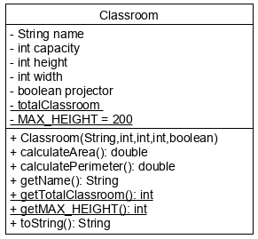

**Classroom class;**

* **Classroom** class with the data members; **name, capacity, height, width, projector and static totalClassroom and static final MAX_HEIGHT** which is **200**.
* Write a non-default constructor **Classroom(String,int ,int, int, boolean).**
* Write a member method **calculateArea**(), that calculates the Area of a classroom.
* Write a member method **calculatePerimeter**(), that calculates the Perimeter of a classroom.
* Write a member method **getName**(), that returns the name of the Classroom.
* Write a static member method **getTotalClassroom**(), that returns the total number of Classrooms which are created.
* Write a static member method **getMAX_HEIGHT**(), that returns the MAX_HEIGHT value.
* Write a member method **toString**(), that returns the Classroom object information.

**ClassroomMain class;**

* Program gets several number of classroom objects from the user until “stop” is entered.
* After getting one classroom object from the user, program displays the object information as in the example output.
* Program also displays the **Area** and **Perimeter** of each classroom object.
* If the Perimeter of a classroom is greater than MAX_HEIGHT that classroom referred to as a “HUGE CLASSROOM”, otherwise referred to as a “NORMAL CLASSROOM”. Display the appropriate message depending on the perimeter of a classroom.
* Finally, when the user enters “stop”, program shows the total number of classroom created.

**Output:**

Enter classroom name:

E107

Enter E107 capacity:

32

Enter E107 height:

20

Enter E107 width:

36

E107 has any projector:

true

Classroom INFO

Name=E107

Capacity=32

Height=20

Width=36

Projector=true

Area of E107

720.0

Perimeter of E107

112.0

NORMAL CLASSROOM

Enter classroom name:

DB01

Enter DB01 capacity:

95

Enter DB01 height:

45

Enter DB01 width:

78

DB01 has any projector:

false

Classroom INFO

Name=DB01

Capacity=95

Height=45

Width=78

Projector=false

Area of DB01

3510.0

Perimeter of DB01

246.0

HUGE CLASSROOM

Enter classroom name:

stop

Total number of classes are 2

**Q2.** Create the following **Cargo** and **CargoMain** classes;

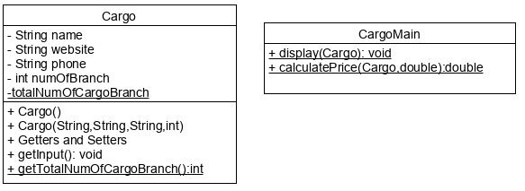

**Cargo class;**

* Write data members; **name**, **website**, **phone**, **numOfBranch** and static member **totalNumOfCargoBranch**;
* Write **a no-arg** constructor;
  + Use the following code;

this("null","null","null", 0);

* Write a **non-default** constructor.
* Write **setters** and **getters** wherenecessary.
* Write a member method **getInput** that gets all data members from the user.
* Write a static member method **getTotalnumOfCargoBranch** that returns the total of created Cargo objects numOfBranch.

**CargoMain class;**

* Write a static method **display** that gets a Cargo object and displays its content as in the example run.
* Write a static method **calculatePrice** that gets a Cargo object and double gr of the cargo packet and calculates the total price of cargo service according to the following criteria;
  + If number of branches of Cargo is greater than 20; unit price of gr is 5 TL,
  + Otherwise; unit price of gr is 3.5 TL.
* In the main method, program asks how many Cargo Information will be get from the user.
* For each Cargo object, the program will get the input and then,asks the user, the gr of the package..
* Next, according to the user’s packet gr, program calculates the price of the cargo service and displays all cargo information with the calculated cargo price.
* Finally, program shows the total number of Cargo branches for all.

**Output:**

Enter how many cargo info is entered:

3

Enter Cargo Name:

Aras Kargo

Enter Website:

www.araskargo.com

Enter Phone:

4440606

Enter Number of Branch:

23

Enter your packet gr:

100

****CARGO INFORMATION*****

Name: Aras Kargo

Website: www.araskargo.com

Phone: 4440606

Number of Branch: 23

Aras Kargo send your packet 500.0 TL

Enter Cargo Name:

MNG Kargo

Enter Website:

www.mng.com

Enter Phone:

4449090

Enter Number of Branch:

16

Enter your packet gr:

23

****CARGO INFORMATION*****

Name: MNG Kargo

Website: www.mng.com

Phone: 4449090

Number of Branch: 16

MNG Kargo send your packet 80.5 TL

Enter Cargo Name:

Yurt Ici

Enter Website:

www.yurtici.com

Enter Phone:

44430360

Enter Number of Branch:

35

Enter your packet gr:

200

****CARGO INFORMATION*****

Name: Yurt Ici

Website: www.yurtici.com

Phone: 44430360

Number of Branch: 35

Yurt Ici send your packet 1000.0 TL

Total number of branches for all cargo: 74