Department of Computer Technology and Information Systems

## CTIS221 – Object Oriented Programming

SPRING 2018 - 2019

# **Lab Guide 8 - Week 6-1**

|  |
| --- |
| **OBJECTIVE:** Array of objects |
| **Instructor** : Burcu LİMAN  **Assistant** : Leyla SEZER |

**Q1.** Modify the **Q2/Labguide7** according to the following UML class diagrams:

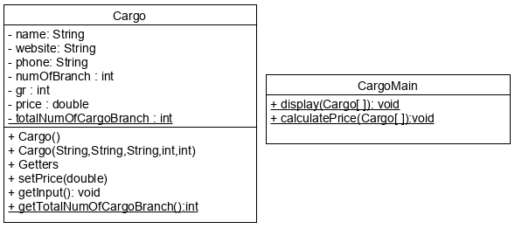

Create a **Cargo class**,with the following instructions**;**

* Add data members; **gr and price**.
* Add **getGr(), getPrice()** and **setPrice**() member methods.
* Get the value of **gr** inside the **getInput**() member method.
* Price of the cargo’s will be calculated in the CargoMain class so, no need to assign a value to it in both of the constructors.

Create the **CargoMain** class, with the following instructions;

* Change the static method **display** that gets a Cargo array and displays array content as in the example run.
* Change the static method **calculatePrice** that gets a Cargo array and calculates the price of each Cargo Company according to the following criteria.
  + If number of branches of Cargo is greater than 20; unit price of gr is 5 TL,
  + Otherwise; unit price of gr is 3.5 TL.
* In the main method, program asks how many Cargo Information will be get from the user.

Declare and create an array to store Cargo objects.

* For each Cargo object, the program will get the input and then store that object into the array. .
* Next, program calculates the price of the cargo service and displays all cargo information with the calculated cargo price as in the example run.

**Output:**

Enter how many cargo info is entered:

3

Enter Cargo Name:

FedEx

Enter Website:

www.fedex.com

Enter Phone:

8951236

Enter Number of Branch:

56

Enter your packet gr:

123

Enter Cargo Name:

surat kargo

Enter Website:

www.surat.com

Enter Phone:

4445692

Enter Number of Branch:

24

Enter your packet gr:

56

Enter Cargo Name:

PTT kargo

Enter Website:

www.pttkargo.com

Enter Phone:

8963211

Enter Number of Branch:

48

Enter your packet gr:

45

****CARGO 1 INFORMATION*****

Name: FedEx

Website: www.fedex.com

Phone: 8951236

Number of Branch: 56

Gr: 123

Price:615.0

****CARGO 2 INFORMATION*****

Name: surat kargo

Website: www.surat.com

Phone: 4445692

Number of Branch: 24

Gr: 56

Price:280.0

****CARGO 3 INFORMATION*****

Name: PTT kargo

Website: www.pttkargo.com

Phone: 8963211

Number of Branch: 48

Gr: 45

Price:225.0

**Q2**. Create a **Lab class**, with the following instructions;

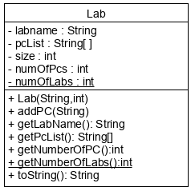

* Data members; **labname**, **pcList** array which stores the PC numbers in a String format, **size**, **numOfPcs** and a static member **numOfLabs**.
* Write a non-default constructor, that only gets String **labname** and integer **size** of the lab.
* Write a member method **addPC**() that gets a PC number.
* Write members methods **getLabName**(), **getPcList**(), **getNumberOfPC**() and **getNumberOfLabs**().
* Write a **toString**() method that shows the array content.

Create a **LabMain** class, with the following instructions;

* Create two lab objects with the parameters “**CTISL1**”, 24 and “**CTISL7**, **28**; as the name of the lab and its size.
* Add “LAB105”, “LAB109”, “LAB121”, “LAB110”, “LAB115” pc numbers to “CTISL1”.
* Add “LAB701”, “LAB705”, “LAB719”, “LAB725” pc numbers to “CTISL7”.
* Display the number of labs which is created.
* Display the number of PCs in CTISL1.
* Display CTISL1’spc numbers by invoking the **getPcList**() method.
* Display each lab content by invoking **toString**() method.

**Output:**

Number of labs: 2

Number of PCs in CTISL1: 5

LAB105

LAB109

LAB121

LAB110

LAB115

Number of pcs in CTISL7: 4

LAB701

LAB705

LAB719

LAB725

Number of pcs in CTISL1: 5

LAB105

LAB109

LAB121

LAB110

LAB115

**Q3**. Write a Java program that stores and displays the gift information of a person. Create **Seminar** and **SeminarList** classes as shown in the following Class Diagrams.

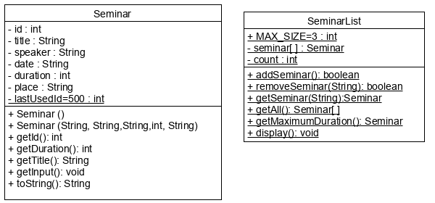

Create a **Seminar** class, with the following instructions;

* Write the data members.
* Write default constructor.
* Write a non-default constructor that takes **title**, **speaker, date, duration** and **place** as parameters and assigns the values. Also, sets the **lastUsedId** as the object’s **id** and increments it.
* Write **get** methods for **id, title and duration**.
* Write a **getInput**() member method, that gets the data members from the user and assign the values.
* Write a **toString**() method that returns the information of **id, title, speaker, date, duration and price**.

Create a **SeminarList** class, with the following instructions;

* Write a static final member for the maximum size of an array. The value will be 3.
* Write an object array **seminars**[] created from Seminar class, with MAX_SIZE as its size.
* Write a data member named **count** to store the number of seminars.
* Write an **addSeminar**(…) method, gets the Seminar information by using getInput() method then stores the new Seminar object to the array. Also asks the user if s/he wants to continue to enter a new seminar info (Y/N). When the user enters ‘N’ loop terminates. Method also checks if the max_size is reached or not.
* Write a **removeSeminar**(…) method that takes the id of the seminar to be removed. (Since the type of the parameter is String, you will have to parse it to integer) Search for it in the array. If found, move the last element of the array to its index and decrement count. If successful, return true, otherwise return false.
* Write a **getSeminar**(…) method that takes title as parameter, searches for that seminar in the object array. If found, return the object, otherwise, return null.
* Write a **getAll**() method that returns seminars object array.
* Write a **getMaximumDuration**() method that searches for the seminar with the maximum duration and returns the seminar object.
* Write a **display()** method to display the objects of Seminar array.

Create a Main **SeminarMain** class, with the following instructions;

* In **main** method, do the following:
  + Input 4 seminars and store them into the array inside SeminarList class.
  + Display the contents of the array inside SeminarList class by calling the display method.
  + Ask the user which seminar to remove and then remove it.
  + Ask the user which seminar to search and then display it.
  + Display the seminar with maximum duration.

**Output:**

Seminar no. 1:

Enter title: Business Analysis

Enter Spekear: Fitnat Budak

Enter Date: 06/03/2019

Enter Duration: 55

Enter Place: DB01

Business Analysis is added to the list

Do you want to continue (Y/N)?

Y

Seminar no. 2:

Enter title: Machine Learning

Enter Spekear: Batur Orkun

Enter Date: 11/02/2019

Enter Duration: 45

Enter Place: CE106

Machine Learning is added to the list

Do you want to continue (Y/N)?

Y

Seminar no. 3:

Enter title: VOIP Technologies

Enter Spekear: Pelin Tokat

Enter Date: 02/05/2019

Enter Duration: 40

Enter Place: CE104

VOIP Technologies is added to the list

Do you want to continue (Y/N)?

Y

Error: Max size is reached! Cannot add any more seminars

-----------------

Here is a list of the seminars:

----Seminar INFO----

Id=500

Title=Business Analysis

Speaker=Fitnat Budak

Date=06/03/2019

Duration=55

Place=DB01

----Seminar INFO----

Id=501

Title=Machine Learning

Speaker=Batur Orkun

Date=11/02/2019

Duration=45

Place=CE106

----Seminar INFO----

Id=502

Title=VOIP Technologies

Speaker=Pelin Tokat

Date=02/05/2019

Duration=40

Place=CE104

------------------

Which Seminar would you like to delete?

501

Machine Learning is removed.

----Seminar INFO----

Id=500

Title=Business Analysis

Speaker=Fitnat Budak

Date=06/03/2019

Duration=55

Place=DB01

----Seminar INFO----

Id=502

Title=VOIP Technologies

Speaker=Pelin Tokat

Date=02/05/2019

Duration=40

Place=CE104

Which seminar would you like to search?

VOIP Technologies

Here is the Seminar you were looking for...

----Seminar INFO----

Id=502

Title=VOIP Technologies

Speaker=Pelin Tokat

Date=02/05/2019

Duration=40

Place=CE104

-----------------

Business Analysis has the maximum duration of 55