Department of Computer Technology and Information Systems

## CTIS221 – Object Oriented Programming

SPRING 2018 - 2019

# **Lab Guide 9 - Week 6-2**

|  |
| --- |
| **OBJECTIVE:** Array of objects, GUI, String and String Buffer |
| **Instructor** : Burcu LİMAN  **Assistant** : Leyla SEZER |

**Q1.**

Write a Java program that stores and displays the seminars information. Create **Seminar** and **SeminarList** classes as shown in the following Class Diagram.

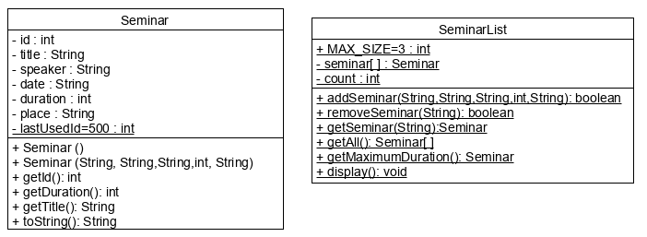

Create a **Seminar** class, with the following instructions;

* Write the data members.
* Write a non-default constructor takes **title**, **speaker, date, duration** and **place** as parameter and assigns the values. Also, sets the **lastUsedId** as the object’s **id** and increments it.
* Write **get** methods for **lastUsedId**, **id, title and duration**.
* Write a **toString**() method that returns **id, title, speaker, date, duration and place**.

Create a **SeminarList** class, with the following instructions;

* Write a static final member for the maximum size of an array. The value will be 3.
* Write an object array **seminars**[] created from Seminar class, with MAX_SIZE as size.
* Write a data member named **count** to store the number of seminars.
* Write an **addSeminar**() method, that takes a String title, String speaker, String date, integer duration and String place as parameter and check if the array is full. If it’s not full, add the Seminar object to the Seminar object array and returns true. If the array is full, returns false.
* Write a **removeSeminar**() method that takes the id of the seminar to be removed. (Since the type of the parameter is String, you will have to parse it to integer) Search for it in the array. If found, move the last element of the array to its index and decrement count. If successful, return true, otherwise returns false.
* Write a **getSeminar**() method that takes title as parameter, searches for that seminar in the object array. If found, return the object, otherwise, return null.
* Write a **getCount**() method that returns the count value.
* Write a **getAll**() method that returns seminars object array.
* Write a **getMaximumDuration**() method that searches for the seminar with the maximum duration and returns the seminar object.
* Write display method.

Create a JFrame called **SeminarGUI,** and design following GUI**.**

* The id text field is not editable.
* Give title to frame as “Seminars”**.**

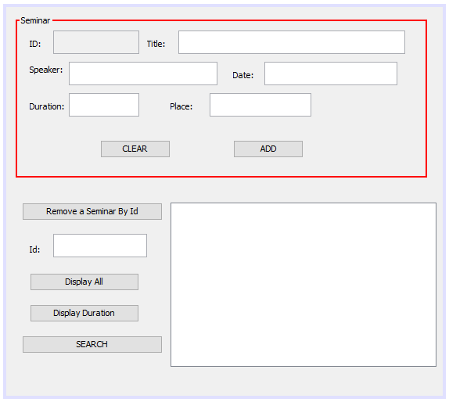 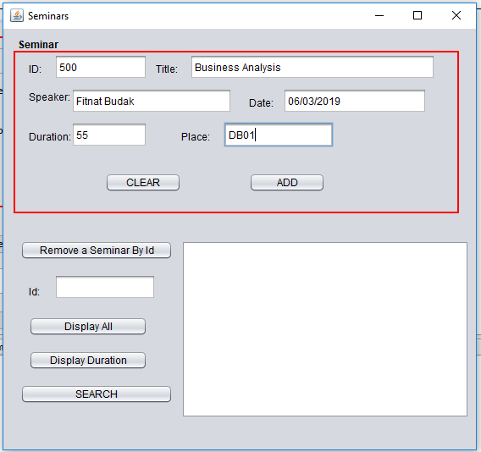

* **Input 3 Seminars** and store them into the array inside SeminarList class.
* When the user enters all the information about a Seminar from the GUI, after user clicks on the **ADD** button, the information added to the array inside SeminarList class. Also added message will be shown inside the textArea. The Id text field generates the id by using **lastUsedId** static data. Generate **getLastUsedId**() member method to Seminar class.
* When the user clicks on the **CLEAN** button, all the text Fields will be clean.

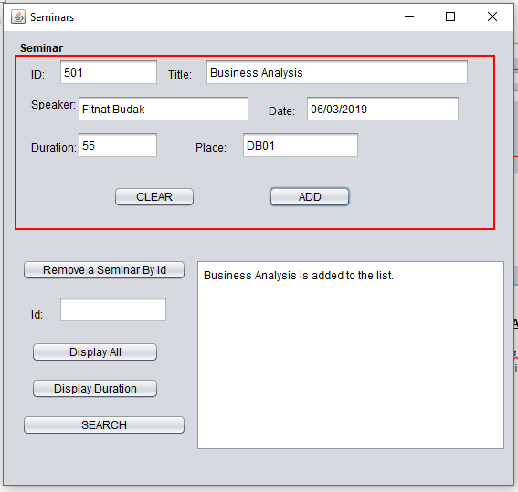 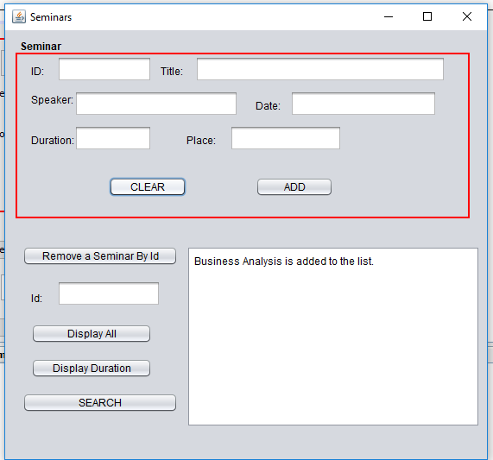

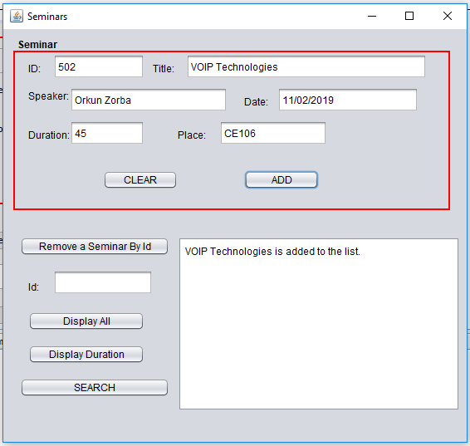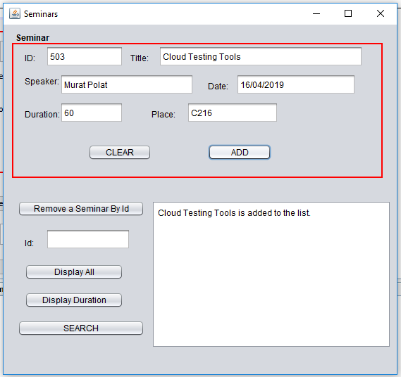

* When the user click on the **Display All** button, the content array will be shown inside the text Area.

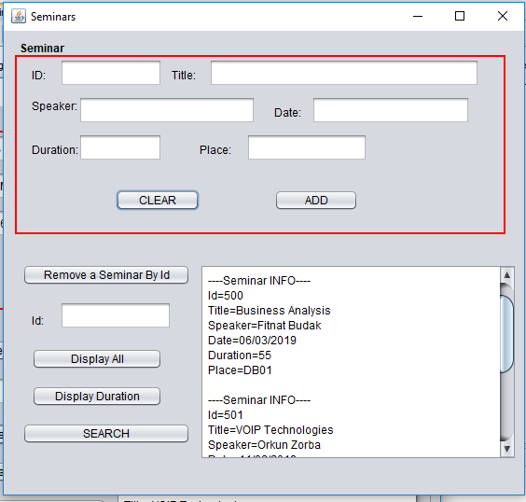

* When user clicks on **Remove a Seminar By Id** Button, program removes the seminar with the given id.

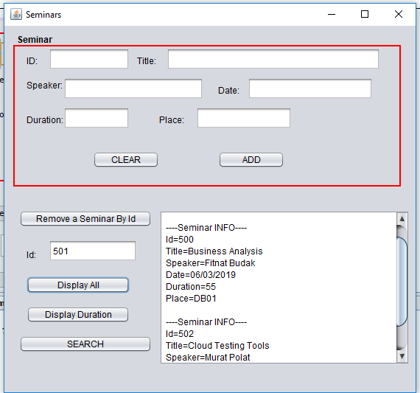

* When the user clicks on the **Display Duration** Button, the Seminar object with the maximum duration will be shown in the text area.

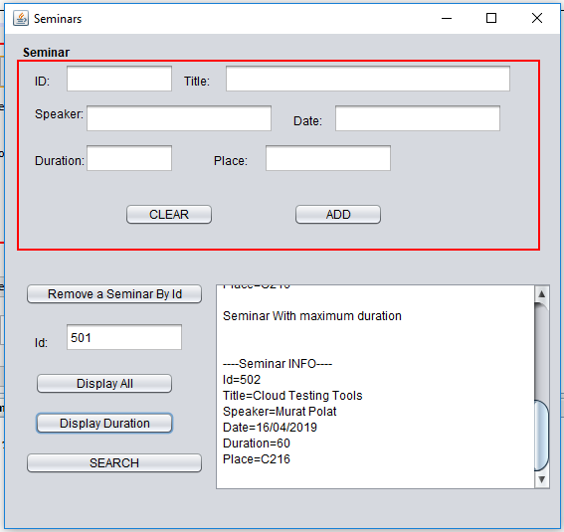

* When the user clicks on **Search** Button the frame Search frame will be seen on the screen;

To make this connection correctly; create a **SearchGUI** object inside the **SeminarMainGUI**, then call the method**setVisible**() inside **SEARCH** button. Then give the parameter **SeminarMainGUI** object inside the constructor of **SearchGUI** class.

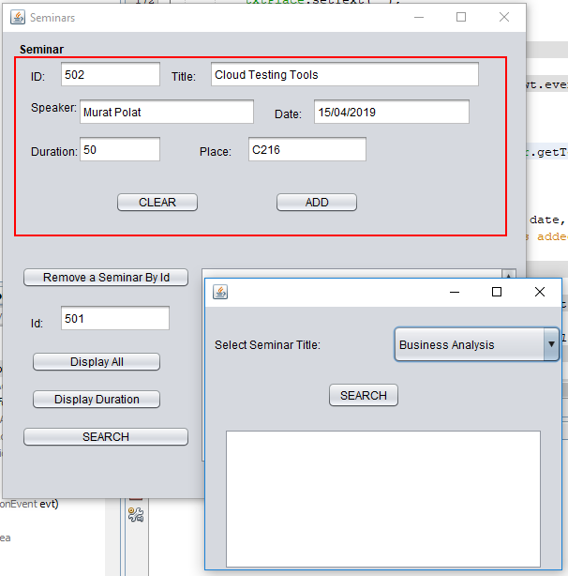

* The combo box which is inside the SearchGUI will be filled automatically with the Seminar Titles. Do not forget to update the combo box any addition or deletion to Seminars.

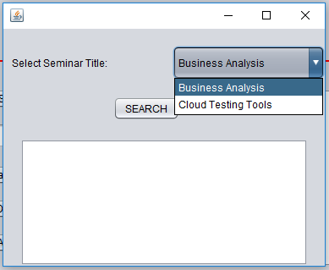

* When the user select the seminar title and clicks the SEARCH button the related seminar info shown inside the text area.

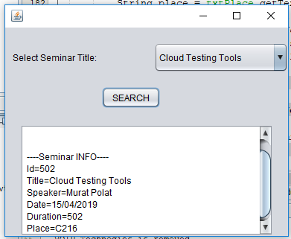

* When the user clicks on the X from the top right side of Search GUI only search GUI will be close (make DISPOSE).

