Department of Computer Technology and Information Systems

CTIS221 – Object Oriented Programming
SPRING 2018 - 2019

Lab Guide 1 - Week 2-1
OBJECTIVE: Acquainted with NetBeans IDE 8.1, Java GUI API, Swing GUI Components
Instructor : Burcu LİMAN
Assistant : Leyla SEZER

NetBeans refers to both a platform for the development of Java desktop applications, and an integrated development environment (IDE) developed using the NetBeans Platform.

Firstly, you must install Java SE Development Kit (JDK), then you can install NetBeans.

Using NetBeans IDE 8.1
While using Netbeans 8.1, there are some steps you have to follow:
- In the “File” menu, select “New Project…”

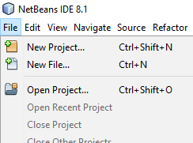

- Here, select “Java Application” and click “Next”.

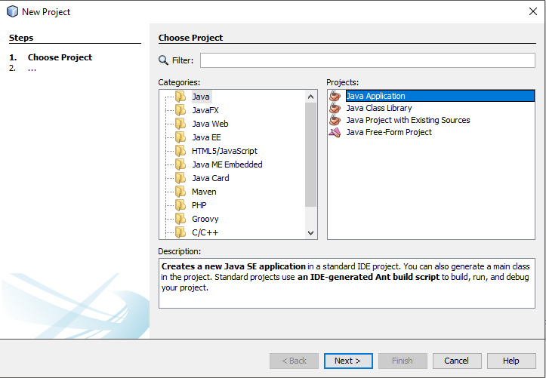

- You can select a type of project according your need. As it is seen, “Project Location” is set as “D\CTIS221”. Due to the fact, you have no privilege to create a project in C: drive in labs, you have to set your project’s absolute path as D:\ drive. Name your project as JavaApplication1.

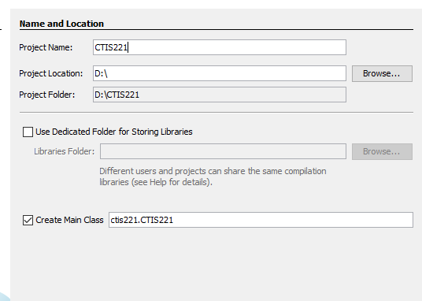
- Now, NetBeans IDE provides you the following window screen. You are going to write your code here.

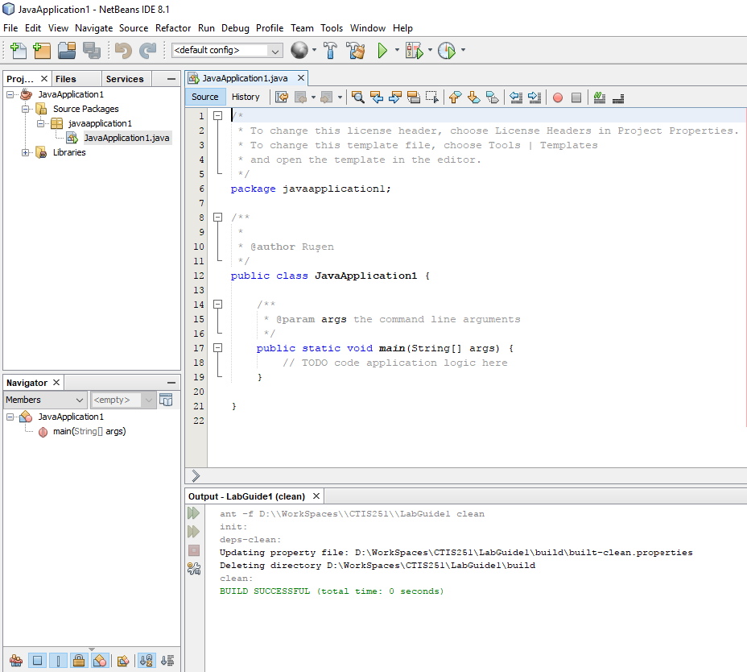

- To run a project, there are 3 ways:

- First one is to use the menu item Run Project in Run menu.

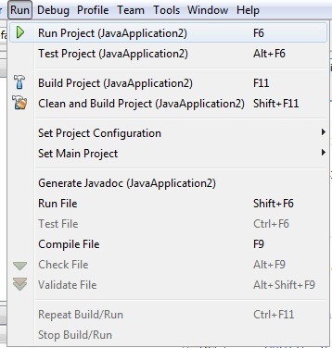

- Second is to run the project from 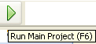 icon.

- Third is to run the project using “F6” function key.

- You can import necessary libraries for your project by right clicking on your project and selecting Properties.
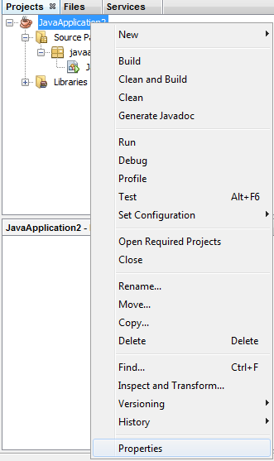

7. Select Libraries item from the menu on the left. Here, you can set “Java Platform” with your preinstalled JDK. You can add pre-written classes and external libraries (jar and zip). Also, you can set “Run” and “Compile” configurations. After adding external libraries, the project will have the related library in the project tab in project hierarchy.

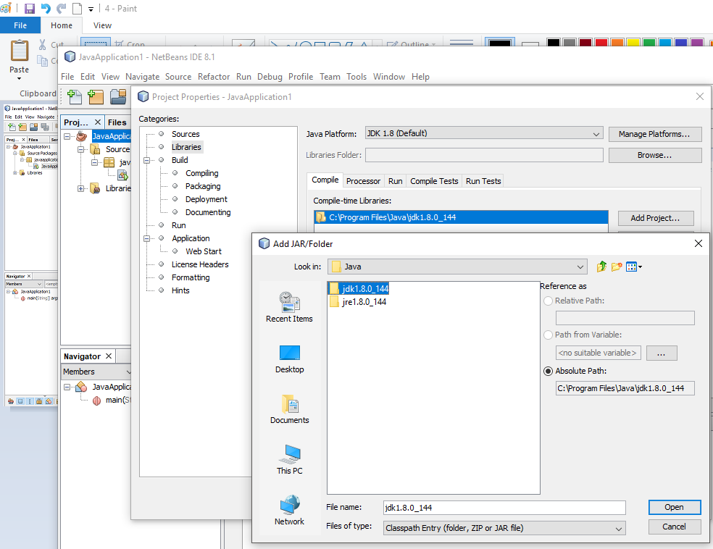

8. You can refactor your project, for example simply by selecting your class, you can rename it and the related class definitions in your code will be replaced with the new name.

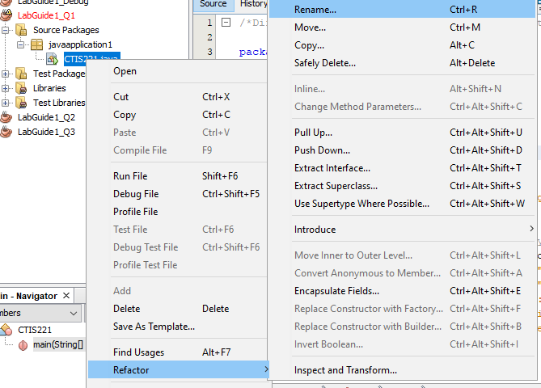

9. You can also move the project, for example simply by selecting your class, you can move it to another project or another location.

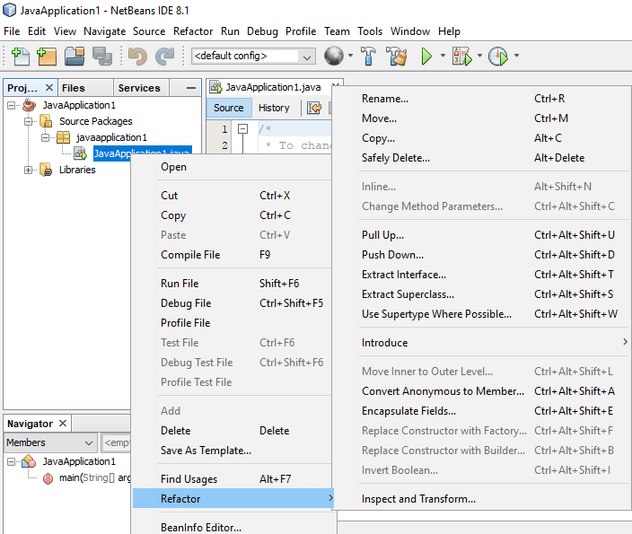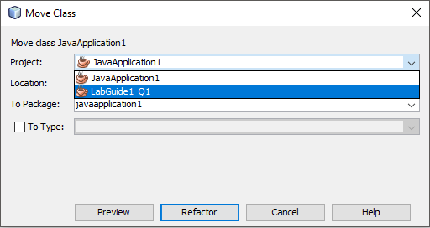

10. When you run the project, the console will have the following “Output” window.

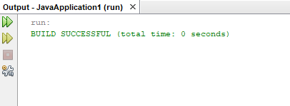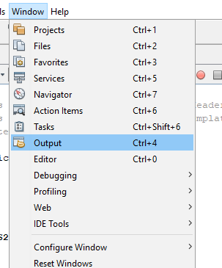

11. If you lose the output screen accidentally, here is the tip to reappear it.

12. In Java programming language, you don’t have to memorize anything. The classes and their methods are predefined and you are going to use them according to your needs. However, in order to get acquainted with java classes and methods, you need to understand the javadoc principles.

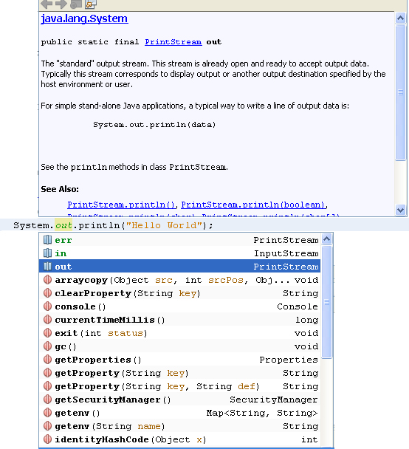

13. When the coder for example writes a code, but he/she is not very sure of the methods or classes meanings, he/she simply can use the “CTRL+SPACE” combination. Here, after writing “System.”, the coder can use this combination and see the System class’ related methods and their explanations. To write “System.out.println();” use short cut sout+tab.

14. To debug your project, simply click on “Debug” menu and “Debug Project” menu item.

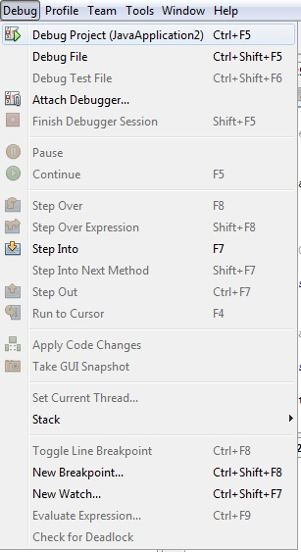

15. Generally, sophisticated Java tools have the same perception when debugging, simply you can put a breakpoint and control the debugging output. To put a breakpoint, just click on the line number.

- Do not concern adding variables, sophisticated Java tools automatically add the variables and you can control them easily as seen below.

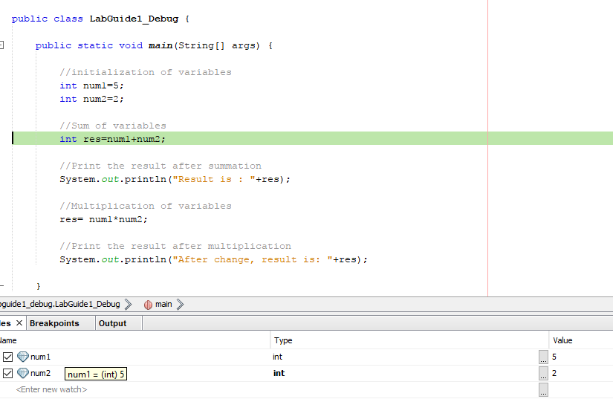

Example:

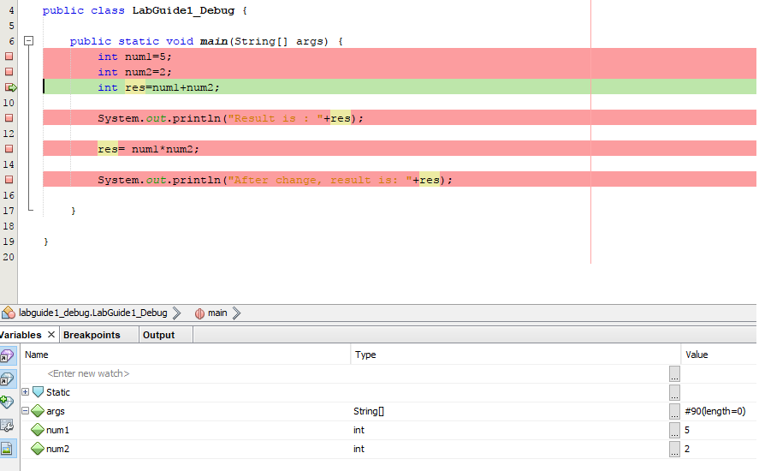

num 1 = 5
num 2 = 2
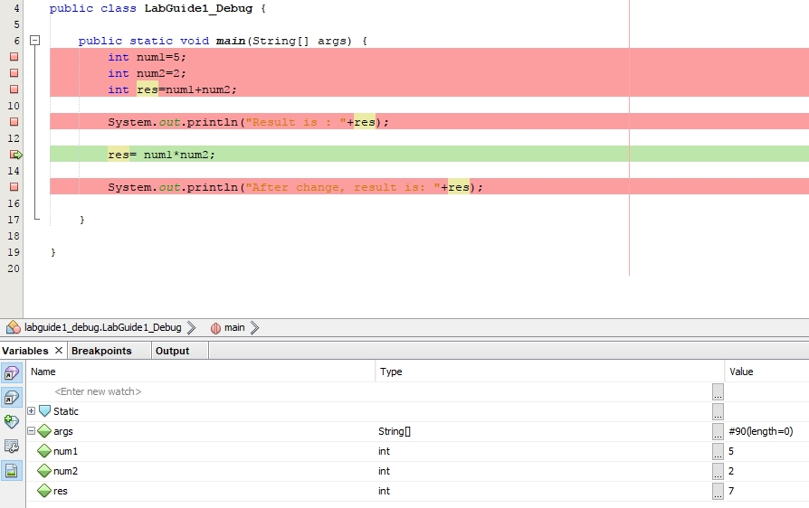

res ( num1+num2 ) = 7

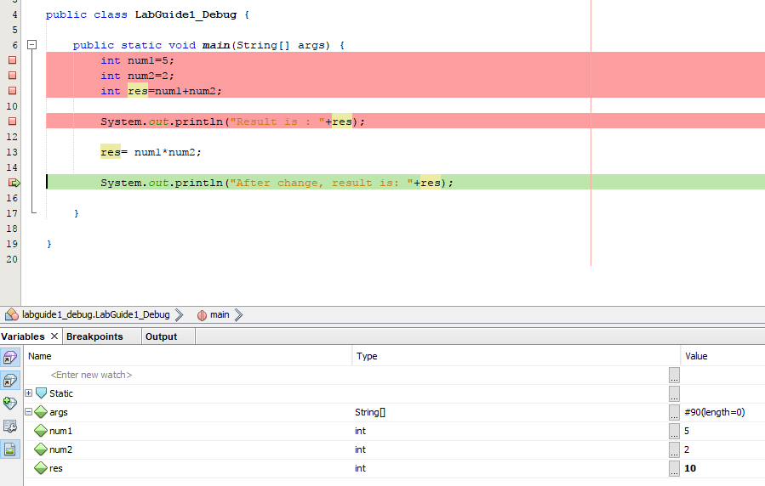

res ( num1*num2 ) = 10

17. You can control debugging operations from the menu items below.

Exercises
1. Modify the CTIS221.java file to get the following output.

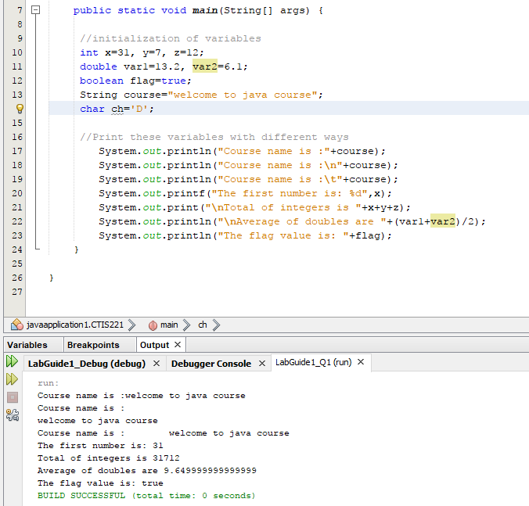

2. Create a Graphical User Interface (GUI) like below screenshot.

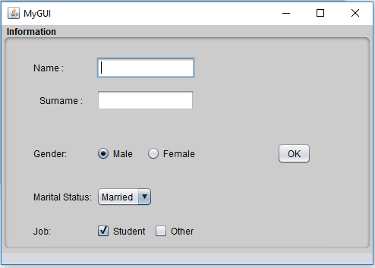
Text Field
Button

Label

Radio Button

Panel

Check Box
Combobox

- Create a Java Application without a main class.
- Add a JFrame Form
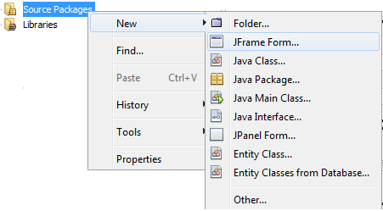
- You can use Palette and Properties Windows in order to customize your GUI.

