Department of Computer Technology and Information Systems

CTIS221 – Object Oriented Programming
SPRING 2018 - 2019

Lab Guide 4 - Week 3-2
OBJECTIVE: Introduction to GUI, and Event Handling
Instructor : Burcu LİMAN
Assistant : Leyla SEZER

Q1. Write a java program that creates the following JFrame, it contains 2 JButtons (OK, CANCEL), 1 JLabel (INFO) and 1 JTextField.
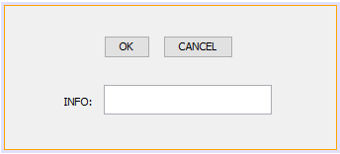

- When the user clicks on the OK button “OK button is clicked” message will be shown inside the text field, otherwise “CANCEL button is clicked” message is shown.
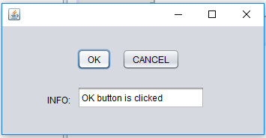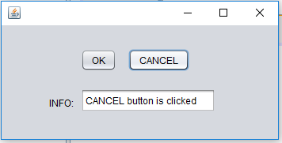

Q2. Write a java program that gets student name, surname and status information, then display the student description as shown below.
Create the following JFrame;
- There are 4 Labels,
- 2 Text Fields,
- 2 Radio Buttons (do not forget to make ButtonGroup and make selected one of them),
- 1 Button,
- 1 Text Area.
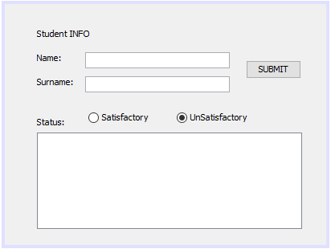

When the user enters the student name, surname and selects the status from Radio Buttons and afterclicks on the SUBMIT button, the student information will be shown in the Text Area as shown below.

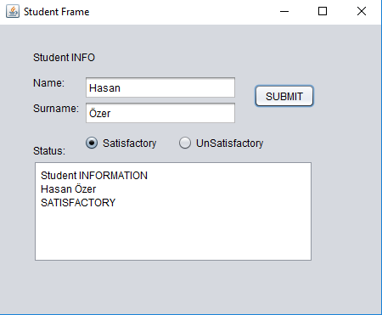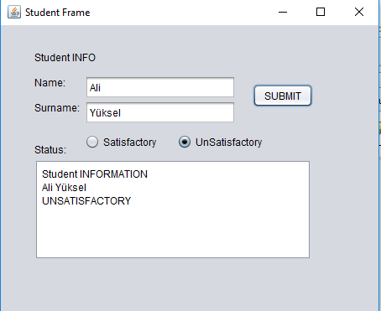

Q3. In a BookStore there are 5 types of book with following unit prices; 3.5, 2.8, 10, 7.4, 6.9. Write a java program that gets quantities of each book from the user and calculates the each books total price, also program shows the total price of all books.

- Create the following frame with the given components,
- After the user enters the quantities of each book, user clicks the ADD button and “Book Quantities are added” message will be shown. Also thetotal prices of each book will be calculated and stored inside a suitable array

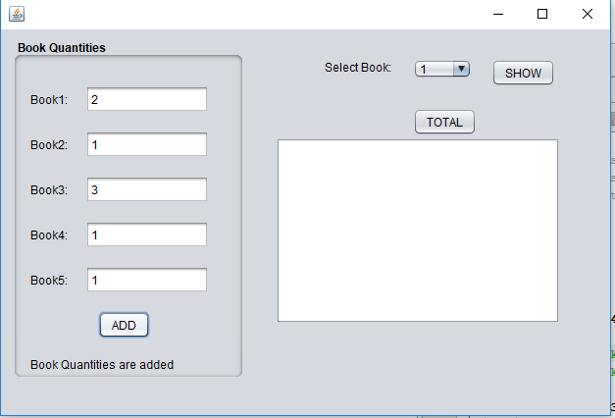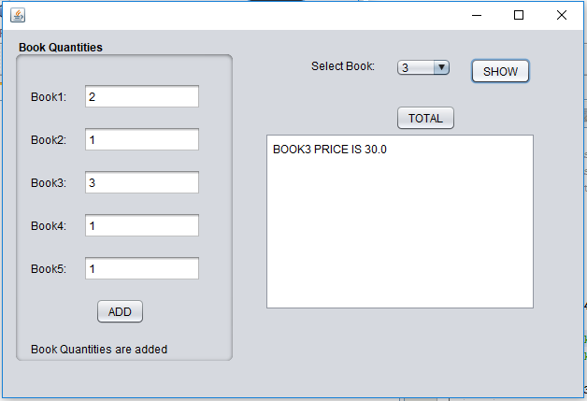

- The combo box will be filled by the book numbers (1, 2, 3, 4, 5). When the user selects the book number and clicks on the SHOW button, the related books’ total price will be shown in the text area.

- Finally, when the user click on the TOTAL button, the total price of all books will be shown in the text area.

