|  |
| --- |
| **System Requirements Specification**  Version 1.0 |
| |  |  |  | | --- | --- | --- | |  | Released: | 05.03.2021 | | Document Author: | Berk Önder | |

<EA Repository Location>

**Scope: 3**

Identification: 3

System Overview: 3

Document Overview: 3

**States and Modes: 4**

**Capability Requirements; Functional: 4**

**Other Requirements; Non-Functional, Interfaces, Security, Safety, Data etc.: 4**

**Qualification Provisions: 5**

**Traceability: 5**

**Diagrams: 6**

Requirement Diagram: 6

6

Component Diagram: 6

6

Use Case Diagram: 7

Activity Diagram: 7

**Scope:**

**Identification:**

* Project title is Smart Home Automation System,
* Abbreviation is SHAS,
* Version number is v1.0.

**System Overview:**

* Purpose and general nature of the system is to make homes safer, technological and simpler.
* Home automation systems allow us to change the functionality of things in the house as we want, using sensors or with the help of tablets, smartphones.
* In the history of system development, I created my project name and shortname, subject and contents, short description, schedule, methods to be used and estimated budget.
* Operation and Maintenance.
* Sponsor of the project is self-sponsor.
* Acquirer of the project is Berk Önder.
* Developer of the project is Berk Önder.
* User of the system is people are who live with my house.

**Document Overview:**

* My purpose in this document is to determine the functions of the home automation system I will do, to create its diagrams (Component, Requirements, Use Case, Activity), to determine other requirements (Non-Functional, Interfaces, Securty, Safety, Data etc.), States and Modes, Qualification Provisions Traceability and determining the scope of the project (Identification, System Overview, Document Overview)
* The confidentiality of this document will remain only between the instructor of the course, Hürkan Orkun Zorba, and myself, Berk Önder, who made the project.

**States and Modes:**

* Init state: When the application is stated this, the application will expect an input from the user and it become an active state
* Emergency state: In this state, If an unexpected error occurs in the application, an error message will be sent to the user and it become a degraded state.
* Active state: In this state, the application will execute the user's request and put itself in active state and it become an idle state.

**Capability Requirements; Functional:**

* Display status: The system shall enable user to display the current status of the home in terms of light of the home, heat of the home.
* Change light status: The system shall enable user to change light status of the home in terms of on/of.
* Change heat status: The system shall enable user to change heat status of the home.
* Alarm Ringing: The system shall enable user to open the sound sensor at the home. With this way, if the burglar enters the house, the alarm will sound and a message will be sent to the user.
* Send Notification: The system shall enable user when there is a problem in the sensors, it send a notification to the user.
* Get information: The system shall enable user to show the information of the lights of the home
* Set Sound Sensor Level: The system shall enable user the change the sound sensor level.

**Other Requirements; Non-Functional, Interfaces, Security, Safety, Data etc.:**

* Availability: System will be up 7/24 active.
* Performance: The system will open in less than 5 seconds while the user opens the application from the phone or tablet.
* Response Time: The system will response user input less than 5 seconds.
* Usability: The system will be easy to use. Application will be very simple in terms of UI. There will be some buttons to open and close the light.
* Tool & Language: The system will be implemented in Arduino IDE and C++ will be used.
* Communication with Arduino will be provided via Wifi, bluetooth.

**Qualification Provisions:**

1. Test: The operation of the system, or a part of the system, using instrumentation or other special test equipment to collect data for later analysis. All tests for buttons for on/off and change will be done while executing the code (Unit testing)
2. Demonstration: The operation of the system, or a part of the system, that relies on observable functional operation not requiring the use of special equipment or analysis. I'll test the keys(on/off and change) and demonstrate with a little demo
3. Analysis: The processing of accumulated data obtained from other qualification methods. Examples are reduction, interpolation, or extrapolation of test results. I will analyze the times that I have determined in non-functional requirements.
4. Inspection: The visual examination of system components, documentation, etc. I will visually examine whether it meets the requirements I have written at the end of the project.

**Traceability:**

1. User Requirement 1: User can turn on/off the lights from their phones and tablets. This requirement is equal to Change light status in functional requirements.
2. User Requirement 2: User can display the light status of their homes. This requirement is equal to Display status in functional requirements.
3. User Requirement 3: User can change the heat status of their homes. This requirement is equal to Change heat status in functional requirements.
4. User Requirement 4: User can change the sound sensor level in their homes. This requirement is equal to Set sound sensor Level in functional requirements.

**Diagrams:**

**Requirement Diagram:**

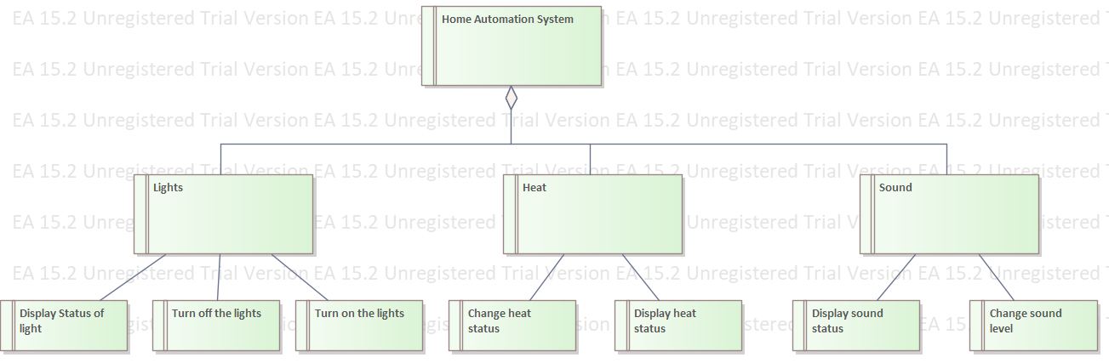

**Component Diagram:**

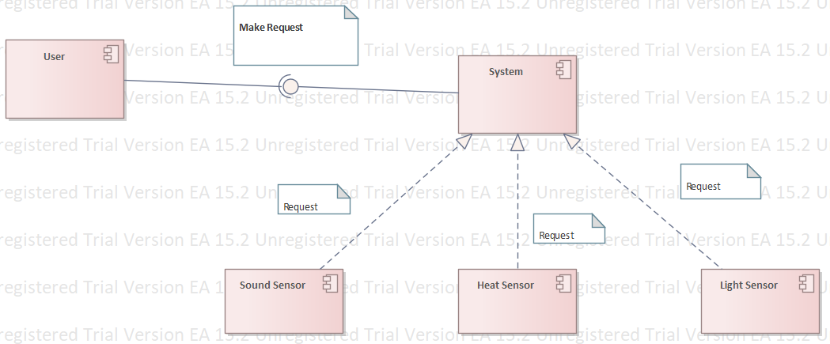

**Use Case Diagram:**

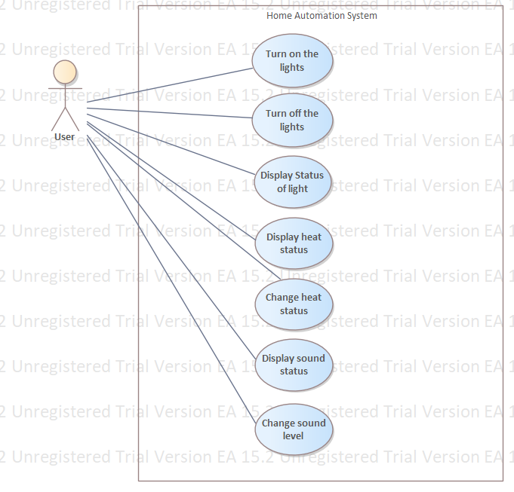

**Activity Diagram:**

