|  |
| --- |
| **System/Subsystem Design Description**  Version 1.0 |
| |  |  |  | | --- | --- | --- | |  | Released: | 18.03.2021 | | Document Author: | Berk Önder | |

**Table of Contents**

**Scope: 3**

Identification: 3

System Overview: 3

Document Overview: 3

**System-wide Design Decisions: 4**

Inputs: 4

**System Architectural Design: 5**

States and Modes: 5

Design Conventions: 5

System Components: 5

Purpose of Components: 6

Development Status: 6

**Concept of Execution: 6**

**Interface Design: 6**

**Requirements Traceability: 7**

**Notes: 7**

**Diagrams: 7**

Component Diagram: 7

Deployment Diagram: 7

Package Diagram: 8

**Scope:**

**Identification:**

* Project title is Smart Home Automation System,
* Abbreviation is SHAS,
* Version number is v1.0.

**System Overview:**

* Purpose and general nature of the system is to make homes safer, technological and simpler.
* Home automation systems allow us to change the functionality of things in the house as we want, using sensors or with the help of tablets, smartphones.
* In the history of system development, I created my system requirement specification document. In this document I stated that, I determined my functional vs non functional requirements. I also extracted the use case, requirement and component diagrams of the system.
* Operation and Maintenance.
* Sponsor of the project is self-sponsor.
* Acquirer of the project is Berk Önder.
* Developer of the project is Berk Önder.
* User of the system is people are who live with my house.

**Document Overview:**

* My purpose in this document is to decide System-wide design decisions, make decisions about the system's behavioral design and other decisions. Also, System architectural design of my project and System components. My document will finish with the System components, Concept of execution, Interface design, identification, diagrams and requirements traceability of my project.

1. The confidentiality of this document will remain only between the instructor of the course, Hürkan Orkun Zorba, and myself, Berk Önder, who made the project.

**System-wide Design Decisions:**

1. The smart home automation system always expects an input from the user. This input is waiting from the user's phone or tablet. Whenever there is an input, the system will give an output for the incoming input. In this project, there are inputs that can come from the user such as light on-off, temperature adjustment and sound detection from the sound sensor. The smart home automation project will behave in this way by the user's point of view.
2. In terms of meeting the requirements, 3 sensors will be used in the project: sound, heat, light. Whenever the user wants to turn the light on or off in any part of the house, he will be able to meet this requirement via wifi or wireless from the application. The same will be true for heat and sound sensors. In this way, the project will meet the requirements.
3. On the security and privacy side, only people in my own home will use this application. Arduino will be used in this project and the data flow between sensors, Arduino and mobile device will not be accessible from outside. Communication between Arduino and mobile devices will take place via wifi or wireless signals. In this respect, the system will be secure and confidential. In addition, when there is any breakdown or trouble in the system, the code maintenance will be done from the Arduino. If there is a burning or malfunction in the sensors, the sensor will be changed and the error will be eliminated by coding this sensor again. When we look at it from this perspective, we see that the system is flexible and maintainable.
4. When we look at the shapes of the Arduino and the sensors, they are square or rectangular and weigh about 2-3 kilograms. They are usually green or white in color.

**Inputs:**

* Display status: The system shall enable user to display the current status of the home in terms of light of the home, heat of the home.
* Change light status: The system shall enable user to change light status of the home in terms of on/off.
* Change heat status: The system shall enable user to change heat status of the home.
* Alarm Ringing: The system shall enable user to open the sound sensor at the home. With this way, if the burglar enters the house, the alarm will sound and a message will be sent to the user.
* Send Notification: The system shall enable user when there is a problem in the sensors, it send a notification to the user.
* Get information: The system shall enable user to show the information of the lights of the home
* Set Sound Sensor Level: The system shall enable user the change the sound sensor level.

Note: When we look at the input and output part, when any input comes from the user, the system will process it in less than 5 seconds and output an input to the user. For example: When the user presses the turn on the hall light button on his mobile device, the hall light will be turned on within 5 seconds and an output will be returned to the user that the light has been turned on.

**System Architectural Design:**

**States and Modes:**

* **FF-RQ-01:** *Init state:* When the application is stated this, the application will expect an input from the user and it become an active state
* **FF-RQ-02:** *Emergency state:* In this state, If an unexpected error occurs in the application, an error message will be sent to the user and it become a degraded state.
* **FF-RQ-03:** *Active state:* In this state, the application will execute the user's request and put itself in active state and it become an idle state.

**Design Conventions:**

* **Keep it Simple:** All designs and shapes to be made in this project will be quite simple and understandable.

**System Components:**

1. Arduino, sound sensor, temperature sensor, light sensor, mobile device, tablet.

**Purpose of Components:**

1. **Arduino:** The aim of Arduino in this project is to establish a connection between sensors and users' mobile devices and tablets by writing code into it.
2. **Sound Sensor:** The purpose of the sound sensor in this project is to inform the user when a certain sound is heard or when a certain sound level is exceeded.
3. **Temperature Sensor:** The heat sensor, on the other hand, gives the user the chance to adjust the temperature.
4. **Light Sensor:** The light sensor, on the other hand, shows users the status of the light anywhere in the house and allows it to turn on and off.
5. **Mobile Devices and Tablets:** Users can send input to the system with their mobile device or tablet and receive an output in return.

**Development Status:**

|  |  |
| --- | --- |
| **Component** | **Development Status** |
| Arduino | In Progress |
| Sound Sensor | In Progress |
| Temperature Sensor | In Progress |
| Light Sensor | In Progress |
| Mobile device and Tablets | In Progress |

**Concept of Execution:**

1. **Diagrams:** All diagrams will be at the end of the document.

**Interface Design:**

1. When we look at the interface design, there will be simple and easy-to-use interfaces. When the user selects the light section, he will be able to turn off the light of the room he wants with the on or off button. The same will be true for the sound and temperature sensor.

**Requirements Traceability:**

|  |  |  |  |  |  |  |
| --- | --- | --- | --- | --- | --- | --- |
| ID | Requirements Id | Component | Category | Priority | Specification | Test Cases |
| 1 | SHAS_REQ_01 | Arduino | Mandatory | High | In Progress | - |
| 2 | SHAS_REQ_02 | Sound Sensor | Mandatory | High | In Progress | - |
| 3 | SHAS_REQ_03 | Temperature Sensor | Mandatory | High | In Progress | - |
| 4 | SHAS_REQ_04 | Light Sensor | Mandatory | High | In Progress | - |
| 5 | SHAS_REQ_05 | Mobile Device and Tablet | Mandatory | High | In Progress | - |

**Notes:**

1. **General information:** In this document, I stated the designs and decisions I will make, my inputs and outputs, components and their purposes.

**Diagrams:**

**Component Diagram:**

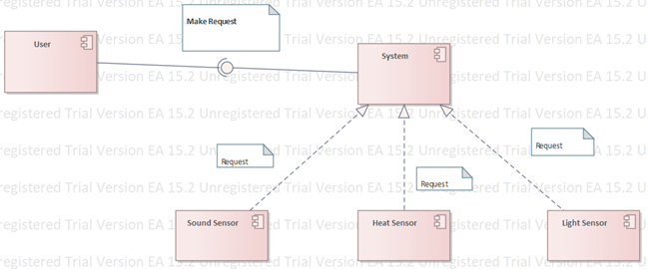

**Deployment Diagram:**

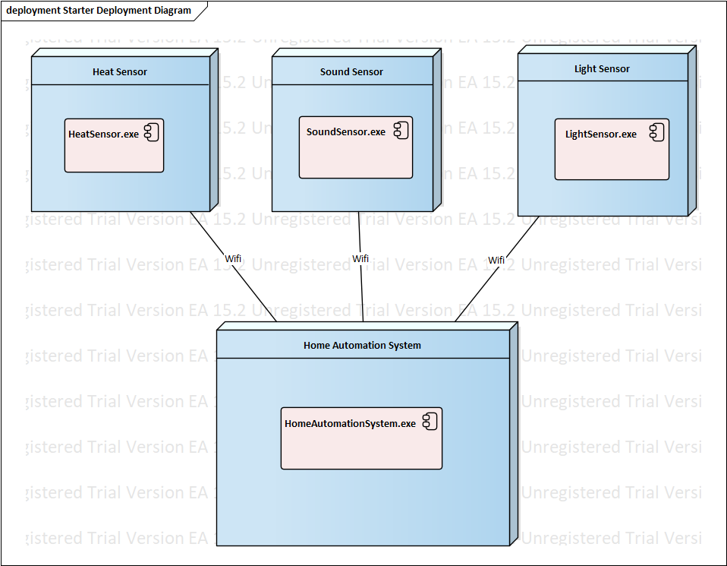

**Package Diagram:**

