A genomic view of African biodiversity
  - Second-year progress report
Ondrej Pelanek
Lead supervisor: Prof. Andrea Manica
Co-supervisor: Dr Emily Mitchell

1 Summary
Understanding how past climate shaped present-day population structure is a central problem in biogeography. This project combines palaeoclimatic species distribution models with population-genomic data to test alternative spatial demographic histories across African mammals.
The example below shows the main styles used in the report while keeping this reference document deliberately short. It includes headings, normal text, a figure and caption, a small table, and a bibliography entry.

2 Introduction
Past climatic change can alter the distribution and connectivity of populations, leaving genomic signatures that persist long after environmental conditions change. The focal case study is the hartebeest (Alcelaphus buselaphus), for which climatic suitability was reconstructed across approximately 800,000 years.

2.1 Example methods section
Occurrence records were filtered, spatially thinned and modelled using repeated multi-algorithm ensembles. Models were evaluated with spatial cross-validation and then projected through palaeoclimate time slices.

2.1.1 Long-term climatic suitability
Long-term summaries distinguish broadly suitable areas from regions that remain suitable even during recurrent climatic lows. This short paragraph illustrates third-level heading and body-text formatting.

2.1.1.1 Example fourth-level heading
This brief example shows the fourth-level heading style used for a more detailed subsection within the analytical workflow.
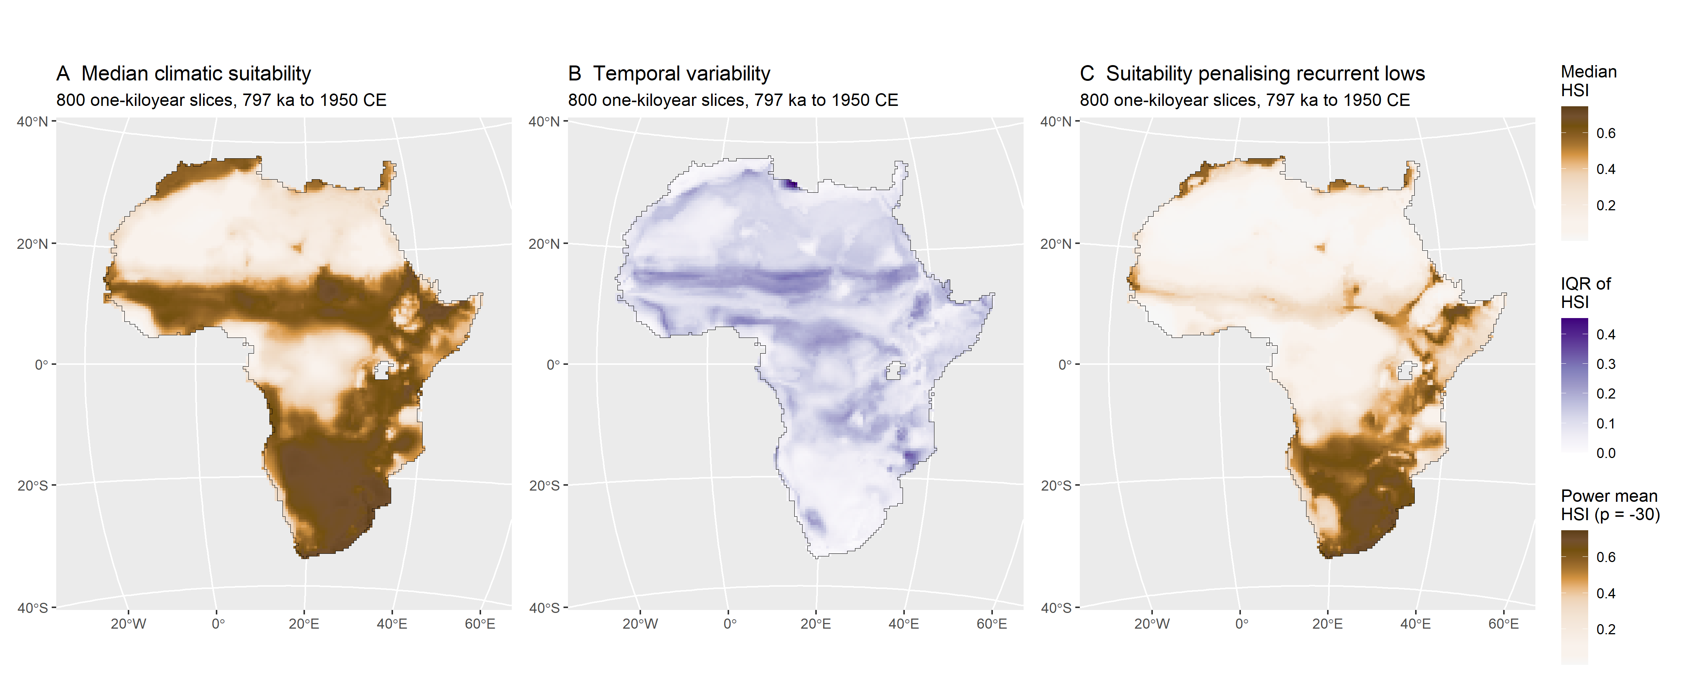
Figure 1: Principal spatial summaries of climatic habitat suitability across the approximately 800-kyr reconstruction. (A) Temporal median; (B) interquartile range across slices; and (C) power mean, highlighting areas of persistent suitability.

2.2 Example results section
Suitable habitat remained extensive through time, although its position and continuity changed repeatedly. The figure illustrates how a compact caption sits beneath a publication-style multi-panel figure.

3 Planned work
The next stage will apply the same climate-informed framework to additional species while maintaining a realistic scope for the remaining thesis chapters.
Table 1: Example timetable.
Period | Chapter | Main task
2026–2027 | Herbivores | Complete CISGeM analyses
2027–2028 | Carnivores | Extend comparative framework

4 References
Krapp, M., Beyer, R. M., Edmundson, S. L., Valdes, P. J., and Manica, A. 2021. A statistics-based reconstruction of high-resolution global terrestrial climate for the last 800,000 years. Scientific Data 8: 228.
Leonardi, M., Colucci, M., Pozzi, A. V., Scerri, E. M. L., and Manica, A. 2024. tidysdm: Leveraging the flexibility of tidymodels for species distribution modelling in R. Methods in Ecology and Evolution 15: 1789–1795.

