Czech Automotive Industry Report 2024

Executive Summary
The Czech automotive industry continues to demonstrate robust growth and resilience, maintaining its position as a cornerstone of the national manufacturing sector. In 2024, the automotive manufacturing sector (NACE 29) generated revenues of **1.79 trillion CZK**, representing a 4.6% year-over-year increase. The sector employs approximately **167,000 workers** and shows strong productivity gains with added value per employee reaching **1.89 million CZK** in 2024.

Key Findings

Revenue Growth
- **Total revenues (2024)**: 1,795 billion CZK
- **Year-over-year growth**: +78.4 billion CZK (+4.6%)
- **Five-year growth (2020-2024)**: +47.8%
- **Product sales**: 1,676 billion CZK
- **Goods trading**: 119 billion CZK

Employment & Productivity
- **Total workforce**: 167,082 employees (2024)
- **Workforce trend**: Slight decline from 172,406 (2020), reflecting automation and efficiency improvements
- **Added value per employee**: 1,890,557 CZK (2024)
- **Productivity growth**: +66.6% increase since 2020, demonstrating significant efficiency gains

Sector Performance Trends (2020-2024)
The automotive sector has shown remarkable resilience through challenging periods:
- Revenue grew consistently from 1.21 trillion CZK (2020) to 1.79 trillion CZK (2024)
- Productivity per employee increased by 755,841 CZK over the five-year period
- The sector successfully navigated supply chain disruptions and semiconductor shortages

Data Visualizations

Personal Vehicles Registered in Czechia by Year
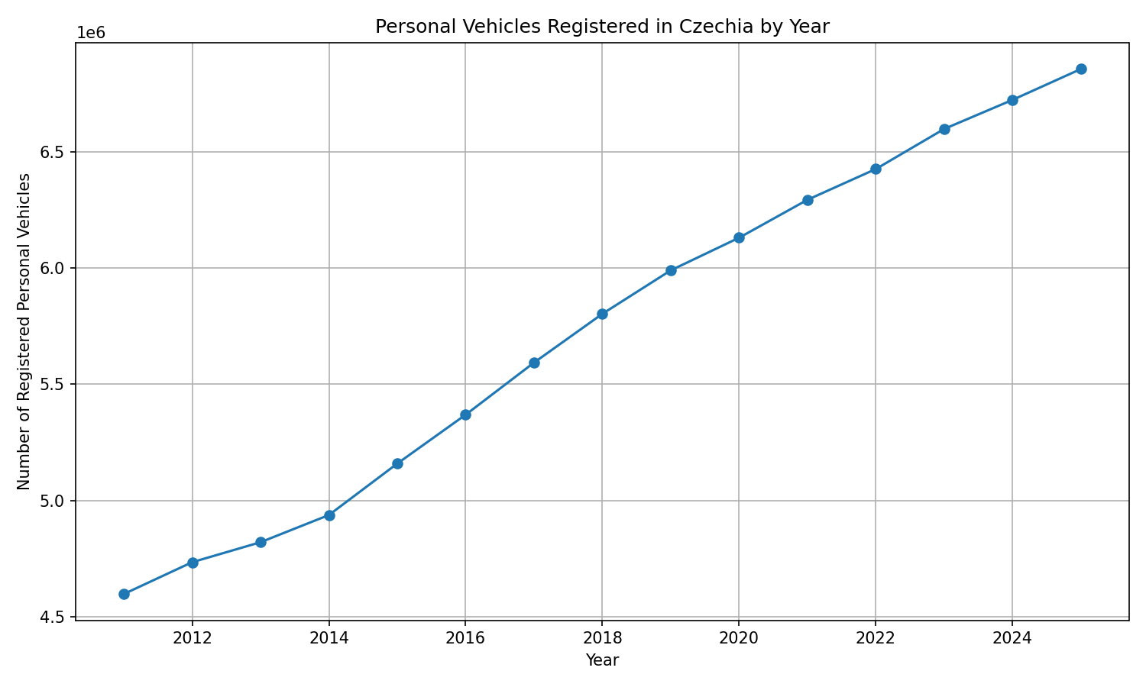
Personal Vehicles Registered in Czechia by Year
The number of registered personal vehicles increased from 4,597,450 in 2011 to 6,855,606 in 2025, representing an increase of 2,258,156 vehicles, or approximately 49.1%. This sustained growth in vehicle registrations reflects strong domestic demand and underscores the importance of the automotive sector to the Czech economy. The consistent upward trend indicates healthy consumer confidence and continued market expansion, providing a solid foundation for automotive manufacturing and related services.

Sector Trends

Positive Developments
- 1. **Strong Revenue Momentum**: Continuous revenue growth across all major subsectors
- 2. **Productivity Excellence**: Added value per employee nearly doubled since 2020
- 3. **Market Demand**: Domestic vehicle registrations show sustained growth, indicating healthy end-market demand
- 4. **Export Strength**: Czech automotive products remain competitive in European markets

Challenges
- 1. **Labor Market Constraints**: Slight workforce decline despite growing revenues
- 2. **Margin Pressures**: Need to balance productivity gains with cost inflation
- 3. **Technology Transition**: Ongoing shift toward electric and hybrid vehicles requires significant investment

Risks
- **Supply Chain Vulnerabilities**: Dependence on international component suppliers
- **Energy Costs**: Rising energy prices impact manufacturing competitiveness
- **Regulatory Changes**: EU emissions standards and green transition requirements
- **Geopolitical Uncertainty**: Trade relations and market access concerns
- **Talent Shortage**: Competition for skilled technical workforce

Opportunities
- **Electric Vehicle Production**: Growing EV market presents expansion opportunities
- **Advanced Manufacturing**: Industry 4.0 and automation adoption
- **Nearshoring Trends**: Czech Republic well-positioned as European manufacturing hub
- **Innovation Partnerships**: Collaboration with automotive OEMs and technology companies
- **Circular Economy**: Development of recycling and sustainable manufacturing practices
- **Export Growth**: Expanding into new markets beyond traditional European customers

Conclusion
The Czech automotive industry demonstrates strong fundamentals with consistent revenue growth, impressive productivity gains, and robust domestic demand. The sector has successfully adapted to post-pandemic challenges while maintaining employment levels and increasing output efficiency.
Looking ahead, the industry faces a critical transition period as it adapts to electrification, digitalization, and sustainability requirements. Success will depend on continued investment in technology, workforce development, and maintaining competitive advantages in quality and innovation. With strategic focus on emerging opportunities in electric mobility and advanced manufacturing, the Czech automotive sector is well-positioned for sustained growth through 2025 and beyond.
---
*Report generated: May 14, 2026*
*Data sources: Ministry of Industry and Trade CR, NACE Sector C (Manufacturing)*

