Software Requirements Specification (SRS)

Pharmacy Management System
A Comprehensive Digital System for Pharmacy Operations, Inventory Management, and Sales Processing
Document Version: 1.0
Date: January 07, 2026
Location: Dar es Salaam, Tanzania

Contents
Contents
Software Requirements Specification (SRS) 1
Pharmacy Management System 1
Contents 2
PHASE 1: PLANNING AND REQUIREMENT ANALYSIS 4
1. Introduction 4
1.1 Purpose 4
1.2 Scope 4
2. Stakeholders 4
3. Feasibility Study 5
3.1 Technical Feasibility 5
3.2 Economic Feasibility 6
3.3 Operational Feasibility 6
3.4 Legal Feasibility 7
3.5 Schedule Feasibility 7
4. System Requirements 8
4.1 Functional Requirements 8
4.2 Non-Functional Requirements 11
5. Use Cases 15
5.1 Admin Use Cases 15
5.2 Pharmacist Use Cases 16
5.3 Cashier Use Cases 16
5.4 Supplier Use Cases (Optional) 16
5.5 System (Automated) Use Cases 16
6. Use Case Diagram 17
Use Case Diagram Description 18
7. Data Flow Diagrams (DFD) 19
7.1 Level 0 DFD (Context Diagram) 19
7.2 Level 1 DFD (Major Processes) 20
7.3 Level 2 DFD (Detailed Processes) 20
PHASE 2: DESIGN PHASE 23
1. Database Design 23
1.1 Database Technology 23
1.2 Database Schema Overview 23
1.3 Table Definitions 24
1.3.1 Users Table 24
1.3.2 Suppliers Table 24
1.3.3 Medicines Table 25
1.3.4 Sales Table 25
1.3.5 Sale_Items Table 25
1.3.6 Prescriptions Table 26
1.3.7 Inventory_Logs Table 26
2. Entity Relationship Diagram (ERD) 27
3. User Interface Overview 28
3.1 UI/UX Design Principles 28
3.2 Color Palette 28
3.3 Key Screen Templates 29
3.3.1 Homepage 29
3.3.2 Sign In Page 31
3.3.3 Pharmacist Dashboard 32
3.3.4 Customer Page 33
3.3.5 Cashier Page 34
3.3.6 Admin Dashboard 35
4. Sequence Diagrams 36
4.1 User Login Sequence 36
4.2 Cashier Sales Process Sequence 37
4.3 Admin Medicine Management Sequence 38
5 CONCLUSION 39
Document Approval 39

PHASE 1: PLANNING AND REQUIREMENT ANALYSIS

1. Introduction

1.1 Purpose
This document provides a comprehensive and detailed description of the requirements for the Pharmacy Management System. The SRS document is intended for pharmacy stakeholders (pharmacy owners, administrators, staff), system developers, academic evaluation, and project governance. It serves as the authoritative reference for system development, testing, and validation.

1.2 Scope
The Pharmacy Management System is a comprehensive digital platform designed to streamline and automate pharmacy operations including medicine inventory management, sales processing, prescription handling, and reporting. The system supports user authentication, medicine data management, stock tracking, sales transactions, supplier management, and comprehensive reporting without integration to external national healthcare systems.

Key Features:
- Secure user authentication with role-based access control
- Medicine inventory management with add, update, and delete capabilities
- Stock tracking with expiry date monitoring
- Sales processing with automatic price calculation
- Prescription verification and dispensing
- Supplier management and purchase order tracking
- Comprehensive sales and inventory reports
- Low-stock and expiry alerts
- Role-based dashboards for admin, pharmacist, and cashier
- Receipt generation for transactions

2. Stakeholders
Stakeholder | Role | Responsibilities
Developer | Technical Implementation | Build and maintain system functionality, implement features
UI/UX Designer | Interface Design | Create intuitive, user-friendly interfaces for all user roles
Patient/Customer | End User | Purchase medicines, submit prescriptions, receive receipts
Pharmacist | Medicine Handler | Verify prescriptions, dispense medicines, update stock, check expiry dates
Cashier | Transaction Handler | Process sales, calculate totals, receive payments, print receipts
Admin | System Administrator | Manage users, medicines, suppliers, view reports, oversee system
Supplier | Medicine Provider | View purchase orders, deliver medicines, provide invoice details
Testers | Quality Assurance | Test system functionality, identify bugs, ensure quality

3. Feasibility Study

3.1 Technical Feasibility
The Pharmacy Management System can be developed using common technologies such as a computer, basic software, and a database. No advanced hardware is required.
The system can be developed using modern web technologies that are well-established and proven:
- Frontend: HTML, CSS, JavaScript (React JS)
- Backend: Python (Django) or Node.js with REST API architecture
- Database: PostgreSQL or MySQL
- Reporting: Report generation libraries for sales and inventory reports
- Hosting: Cloud-based hosting or local server deployment

Browser Compatibility:
Modern browsers (Chrome, Firefox, Safari, Edge)

Technical Achievability:
The system's core features—authentication, inventory management, sales processing, and report generation—are technically achievable using existing frameworks and established development tools. All proposed functionality aligns with current industry standards and best practices.

Device Compatibility:
The platform will be accessible on:
- Desktop computers
- Tablets
- Point of Sale (POS) terminals
→ Technically feasible.

3.2 Economic Feasibility
Development and maintenance costs are low compared to benefits like reduced errors, better stock control, and improved efficiency.

Cost Analysis:
- Minimal Infrastructure: No complex system integrations reduce capital expenditure
- Technology Stack: Open-source tools (React, Django/Node.js, PostgreSQL)

Main Costs:
- Web development (labor)
- Server hosting and maintenance
- Database management
- Potential ongoing support and maintenance

Operational Cost Recovery:
The platform reduces administrative workload through automation of inventory tracking and sales processing, enabling operational cost recovery through reduced manual errors, better stock management, and staff time savings.
→ Economically feasible.

3.3 Operational Feasibility
The system automates inventory, sales, and records. Pharmacy staff can use it with minimal training.

User-Friendly Operation:
The platform is designed for ease of use by pharmacy staff with minimal technical training:
- For Admin: Dashboard for managing users, medicines, suppliers, and viewing reports
- For Pharmacist: Simple medicine search, prescription verification, stock updates
- For Cashier: Intuitive sales interface, automatic calculations, receipt printing

Training Requirements:
Minimal—basic orientation on platform navigation

Accessibility:
The clean design ensures accessibility for users with varying technical proficiency levels.
→ Operationally feasible.

3.4 Legal Feasibility
The system supports secure record keeping and complies with pharmacy regulations when proper access control is used.

Compliance Framework:
The system operates within established legal and ethical boundaries:
- Pharmacy Tool: Functions as an internal management system for pharmacy operations
- Data Protection: Complies with data protection regulations for personal and medical information
- Prescription Handling: Supports proper prescription verification and record keeping
- Audit Trail: Maintains comprehensive logs for regulatory compliance

Regulatory Alignment:
The system aligns with pharmacy regulatory frameworks and data protection requirements for healthcare-related systems.
→ Legally feasible.

3.5 Schedule Feasibility
The system can be developed and implemented within a short time (about 1–2 months).

Development Timeline:
The system can be developed within a reasonable academic and practical timeframe.

Agile Approach:
Using iterative development and Agile methodology enables incremental feature deployment and rapid iteration based on feedback.
→ Schedule feasible.
A normal Pharmacy Management System is feasible in all aspects and suitable for improving pharmacy operations.

4. System Requirements

4.1 Functional Requirements

4.1.1 User Authentication
Requirement ID | Requirement | Priority
FR-001 | System shall allow users to log in securely | High
FR-002 | System shall manage user roles (admin, pharmacist, cashier) | High
FR-003 | System shall restrict access to features based on user roles | High
FR-004 | System shall support password recovery | Medium
FR-005 | System shall enforce password encryption and secure storage | High
Description:
Users authenticate through a secure login interface. Authentication tokens manage session state, and the system enforces role-based access control to prevent unauthorized access to protected features.

4.1.2 Medicine Management
Requirement ID | Requirement | Priority
FR-006 | System shall allow the admin to add, update, and delete medicines | High
FR-007 | System shall record medicine quantities and expiry dates | High
FR-008 | System shall allow searching for medicines by name | High
FR-009 | System shall store medicine details in the database | High
Description:
Admin users can manage the medicine catalog by adding new medicines, updating existing records, and removing obsolete entries. The system maintains comprehensive medicine data including names, quantities, prices, and expiry dates.

4.1.3 Inventory Management
Requirement ID | Requirement | Priority
FR-010 | System shall update stock after each sale automatically | High
FR-011 | System shall generate low-stock alerts | High
FR-012 | System shall generate expiry alerts | High
FR-013 | System shall generate inventory reports | High
FR-014 | System shall allow pharmacist to update medicine stock | High
Description:
The inventory management module tracks medicine stock levels in real-time. Automated alerts notify staff of low stock levels and approaching expiry dates, enabling proactive inventory management.

4.1.4 Sales Processing
Requirement ID | Requirement | Priority
FR-015 | System shall process medicine sales | High
FR-016 | System shall calculate total cost automatically | High
FR-017 | System shall allow receiving payment | High
FR-018 | System shall print receipt | High
FR-019 | System shall store prescription records | High
FR-020 | System shall store transaction records | High
Description:
The sales processing module handles complete transaction workflows from medicine selection through payment processing. The system automatically calculates totals, processes payments, and generates receipts for customers.

4.1.5 Reporting and Analytics
Requirement ID | Requirement | Priority
FR-021 | System shall generate sales reports | High
FR-022 | System shall generate inventory reports | High
FR-023 | System shall calculate sales totals automatically | High
FR-024 | Admin dashboard shall display basic system statistics | Medium
Description:
The reporting module provides comprehensive analytics on sales performance and inventory status. Reports can be generated on demand and include detailed breakdowns of transactions and stock levels.

4.1.6 Supplier Management
Requirement ID | Requirement | Priority
FR-025 | System shall manage supplier information | High
FR-026 | System shall allow suppliers to view purchase orders | Medium
FR-027 | System shall track medicine deliveries | Medium
FR-028 | System shall store invoice details | Medium
Description:
The supplier management module maintains supplier records and tracks purchase orders. Suppliers can view orders and delivery schedules, streamlining the procurement process.

4.2 Non-Functional Requirements

4.2.1 Performance
Requirement ID | Requirement | Target
NFR-001 | System shall respond to user actions quickly | < 3 seconds response time
NFR-002 | System shall handle concurrent users | Minimum 20-50 simultaneous users
NFR-003 | Database query response time | < 500ms for 95% of queries
NFR-004 | Receipt generation time | < 5 seconds

4.2.2 Security
Requirement ID | Requirement | Implementation
NFR-005 | System shall be secure and protect sensitive data | Encryption for data at rest and in transit
NFR-006 | System shall support role-based access control | RBAC for admin, pharmacist, cashier features
NFR-007 | Password encryption | Secure hashing algorithm
NFR-008 | Session management | Secure session tokens with expiration
NFR-009 | Input validation | All user inputs validated and sanitized
NFR-010 | SQL injection prevention | Parameterized queries and ORM usage
Description:
Security measures ensure user data protection, secure authentication, and prevention of common vulnerabilities. Only authorized users can access role-specific features and sensitive data.

4.2.3 Usability
Requirement ID | Requirement | Standard
NFR-011 | System shall be easy to use and user-friendly | Simple, intuitive, clean design
NFR-012 | Navigation | Clear, self-explanatory navigation flows
NFR-013 | User documentation | In-app help and simple user guides
NFR-014 | Error messages | Clear, actionable error messaging
Description:
The interface is designed for users with minimal technical expertise. Navigation should be intuitive, and all elements should have clear purposes.

4.2.4 Reliability
Requirement ID | Requirement | Target
NFR-015 | System shall be reliable and available during business hours | 99% uptime during operating hours
NFR-016 | System shall allow data backup and recovery | Daily automated backups
NFR-017 | Error handling | Graceful error recovery with user notification
NFR-018 | Logging | Comprehensive audit logging of system actions
Description:
The system must remain available and operational, with safeguards against data loss. Automated backups ensure data persistence and recovery capability.

4.2.5 Scalability
Requirement ID | Requirement | Approach
NFR-019 | System shall be scalable for future expansion | Modular architecture design
NFR-020 | Database scaling | Connection pooling for efficiency
NFR-021 | Future expansion | Design for incremental feature integration
Description:
The architecture supports future expansion. New features can be added without major restructuring, and the system can scale to accommodate multiple pharmacy branches.

4.2.6 Compatibility
Requirement ID | Requirement | Scope
NFR-022 | System shall work on standard computers | Windows, macOS, Linux
NFR-023 | System shall be maintainable and easy to update | Modular code structure
NFR-024 | System shall comply with pharmacy regulations | Local regulatory compliance
NFR-025 | Browser support | Chrome, Firefox, Safari, Edge (latest 2 versions)
Description:
The system shall function seamlessly across devices and browsers. The design ensures usability on all standard computer systems.

5. Use Cases

5.1 Admin Use Cases
- Login
- Add / update / delete users
- Assign user roles
- Add / update / delete medicines
- View inventory reports
- View sales reports
- Manage suppliers
- Logout

5.2 Pharmacist Use Cases
- Login
- Search medicines
- Verify prescriptions
- Dispense medicines
- Update medicine stock
- Check expiry dates
- View available medicines
- Logout

5.3 Cashier Use Cases
- Login
- Search medicines
- Process medicine sales
- Calculate total price
- Receive payment
- Print receipt
- Logout

5.4 Supplier Use Cases (Optional)
- View purchase orders
- Deliver medicines
- Provide invoice details

5.5 System (Automated) Use Cases
- Update inventory automatically
- Calculate sales totals
- Generate low-stock alerts
- Generate expiry alerts
- Store transaction records

6. Use Case Diagram
The Use Case Diagram illustrates the interactions between system actors (Admin, Pharmacist, Cashier, Supplier, and System) and the various use cases in the Pharmacy Management System.
Use Case Diagram - Part 1: Admin and Pharmacist
Admin
Login
Add / update / delete
users
View sales reports
Add / update / delete
medicines
Assign user roles
Logout
View inventory reports
Manage suppliers
Pharmacist
Dispense medicines
View available medicines
Verify prescriptions
Update medicine stock
Login
Check expiry dates
Search medicines
Logout
Figure 6.1: Use Case Diagram showing Admin and Pharmacist use cases
Use Case Diagram - Part 2: Cashier, Supplier and System
Cashier
Login
Print receipt
Receive payment
Calculate total price
Process medicine sales
Search medicines
Logout
Supplier
View purchase orders
Deliver medicines
Provide invoice details
Store transaction
records
Generate expiry alerts
Generate low-stock alerts
Calculate sales totals
Update inventory
automatically
System
Figure 6.2: Use Case Diagram showing Cashier, Supplier and System use cases

Use Case Diagram Description
Actor | Use Cases
Admin | Login, Add/update/delete users, Assign user roles, Add/update/delete medicines, View sales reports, View inventory reports, Manage suppliers, Logout
Pharmacist | Login, Search medicines, Verify prescriptions, Dispense medicines, Check expiry dates, View available medicines, Update medicine stock, Logout
Cashier | Login, Search medicines, Process medicine sales, Calculate total price, Receive payment, Print receipt, Logout
Supplier | View purchase orders, Deliver medicines, Provide invoice details
System | Update inventory automatically, Calculate sales totals, Generate low-stock alerts, Generate expiry alerts, Store transaction records

7. Data Flow Diagrams (DFD)

7.1 Level 0 DFD (Context Diagram)
The Level 0 DFD provides a high-level overview of the system's boundaries and major data flows:

Major Data Flows:
- Customer → System: Search query, medicine requests
- System → Customer: Availability, price, location, service information
- Pharmacy Staff → System: Update inventory, price, services, hours, confirmations
- System → Pharmacy Staff: Confirmation, alerts, reports
Pharmacy Management
System
Customer
Pharmacy staff
Search Query
Availability,Price,location,
service
Update Inventory,
price, Services, hours
Confirmation
Figure 7.1: Level 0 DFD (Context Diagram)
External Entity | Input to System | Output from System
Customer | Search Query | Availability, Price, Location, Service
Pharmacy Staff | Update Inventory, Price, Services, Hours | Confirmation

7.2 Level 1 DFD (Major Processes)
The Level 1 DFD details major system processes:
Process | Input | Output
Add Medicine | Medicine details from Admin/Pharmacist | Stored medicine in Medicine Database
Update Medicine | Updated details, Medicine ID | Updated records in Medicine Database
Delete Medicine | Medicine ID | Removed record from Medicine Database
Search Medicine | Medicine name | Availability info from Medicine Database
Monitor Stocks | Medicine Database data | Alerts to Admin/Pharmacist
Table 1: Level 1 Data Flow Processes - Medicine Management

7.3 Level 2 DFD (Detailed Processes)
The Level 2 DFD provides detailed view of sales processing:
medicine details
updated details
Admin/Phamacist
Add medicine
Update medicine
Delete medicine
Search medicine
Monitor stocks
Medicine
Database
Medicine
Database
Medicine
Database
Medicine
Database
Medicine
Database

medicine ID
alerts
medicine name
availability info
Figure 7.2: Level 1 DFD (Medicine Management)

Level 2 DFD - Sales Processing
Step | Actor | Action
1 | Customer | Submit medicine request
2 | System | Receive sale request
3 | System | Check medicine availability from Medicine Database
4 | Cashier/Pharmacist | Receive availability status
5 | System | Calculate total price based on medicine and quantity
6 | System | Record sale with sale details
7 | System | Process payment
8 | System | Update inventory (sold quantity)
9 | System | Store transaction in Sales Database
10 | Customer | Receive receipt
Table 2: Sales Processing Data Flow
Customer
Cashier/Pharmacist
Receive sale
request
Update Inventory
sale details
Process Payment
Record Sale
Calculate Total
Price
Check medicine
availability
Medicine
Database
medicine ID
availability status
total amount
medicine
& quantity
payment
receipt
Sales Database
Medicine
Database
sold quantity
medicine request
sale details
Level 2 DFD (Sales Processing

Data Stores:
- Medicine Database: Stores all medicine information including ID, name, quantity, price, expiry date
- Sales Database: Stores all transaction records including sale details, amounts, timestamps

PHASE 2: DESIGN PHASE

1. Database Design

1.1 Database Technology
DBMS: MySQL (relational database)
Normalization: Third Normal Form (3NF)
Access Layer: ORM (Sequelize for Node.js, SQLAlchemy for Python)

1.2 Database Schema Overview
The database schema is designed to support pharmacy inventory management, sales processing, prescription handling, and user role management. The schema follows normalization principles to ensure data integrity, reduce redundancy, and optimize query performance.

Schema Summary:
• Tables: 7 primary tables
• Foreign Keys: 5 relationships
• Constraints: Referential integrity, unique constraints, not-null validations

1.3 Table Definitions

1.3.1 Users Table
Field | Data Type | Constraints | Description
user_id | INT | PRIMARY KEY, AUTO INCREMENT | Unique user identifier
full_name | VARCHAR(255) | NOT NULL | User's full name
email | VARCHAR(255) | UNIQUE, NOT NULL | User's email address
password | VARCHAR(255) | NOT NULL | Encrypted password
role | VARCHAR(50) | NOT NULL | User role (admin/pharmacist/cashier/customer)
created_at | DATETIME | DEFAULT CURRENT_TIMESTAMP | Registration timestamp

Purpose: Stores user account information and authentication credentials for administrators, pharmacists, cashiers, and customers.

1.3.2 Suppliers Table
Field | Data Type | Constraints | Description
supplier_id | INT | PRIMARY KEY, AUTO INCREMENT | Unique supplier identifier
supplier_name | VARCHAR(255) | NOT NULL | Supplier company name
phone | VARCHAR(20) | NOT NULL | Contact phone number
address | VARCHAR(500) | NOT NULL | Supplier address

Purpose: Stores supplier information for medicine procurement and inventory management.

1.3.3 Medicines Table
Field | Data Type | Constraints | Description
medicine_id | INT | PRIMARY KEY, AUTO INCREMENT | Unique medicine identifier
medicine_name | VARCHAR(255) | NOT NULL | Name of the medicine
category | VARCHAR(100) | NOT NULL | Medicine category (Pain Relief, Antibiotic, etc.)
price | DECIMAL(10,2) | NOT NULL | Unit price of medicine
quantity | INT | NOT NULL | Current stock quantity
expiry_date | DATE | - | Medicine expiration date
supplier_id | INT | FOREIGN KEY | Reference to supplier

Purpose: Stores medicine inventory information including stock levels, pricing, and expiry tracking.

1.3.4 Sales Table
Field | Data Type | Constraints | Description
sale_id | INT | PRIMARY KEY, AUTO INCREMENT | Unique sale identifier
sale_date | DATETIME | DEFAULT CURRENT_TIMESTAMP | Date and time of sale
total_amount | DECIMAL(10,2) | NOT NULL | Total sale amount
user_id | INT | FOREIGN KEY | Reference to user (cashier)

Purpose: Records all sales transactions processed by cashiers.

1.3.5 Sale_Items Table
Field | Data Type | Constraints | Description
sale_item_id | INT | PRIMARY KEY, AUTO INCREMENT | Unique sale item identifier
sale_id | INT | FOREIGN KEY | Reference to sale
medicine_id | INT | FOREIGN KEY | Reference to medicine
quantity | INT | NOT NULL | Quantity sold
price | DECIMAL(10,2) | NOT NULL | Unit price at time of sale

Purpose: Stores individual line items for each sale transaction.

1.3.6 Prescriptions Table
Field | Data Type | Constraints | Description
prescription_id | INT | PRIMARY KEY, AUTO INCREMENT | Unique prescription identifier
customer_name | VARCHAR(255) | NOT NULL | Name of the customer
doctor_name | VARCHAR(255) | NOT NULL | Prescribing doctor's name
prescription_date | DATE | NOT NULL | Date of prescription

Purpose: Records prescription information for medicines that require doctor's authorization.

1.3.7 Inventory_Logs Table
Field | Data Type | Constraints | Description
inventory_id | INT | PRIMARY KEY, AUTO INCREMENT | Unique log identifier
medicine_id | INT | FOREIGN KEY | Reference to medicine
change_type | VARCHAR(50) | NOT NULL | Type of change (add/remove/adjust)
quantity_changed | INT | NOT NULL | Quantity changed
log_date | DATETIME | DEFAULT CURRENT_TIMESTAMP | Timestamp of change

Purpose: Tracks all inventory changes for audit and stock management purposes.

2. Entity Relationship Diagram (ERD)
The following diagram illustrates the relationships between database entities:

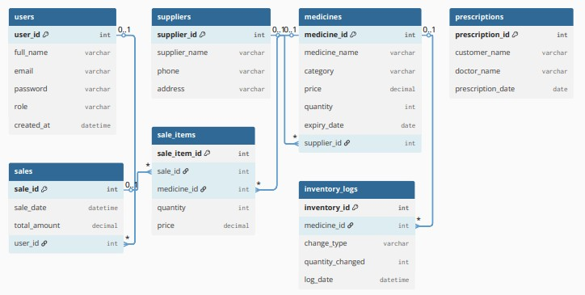

Figure 1: PharmaCare System Entity Relationship Diagram

3. User Interface Overview

3.1 UI/UX Design Principles
The PharmaCare Management System interface is designed following these principles:

• Clean Professional Design: Modern, healthcare-appropriate aesthetics
• Role-Based Navigation: Each user type has a customized dashboard
• Intuitive Workflows: Clear information hierarchy and self-evident navigation
• Accessibility: High contrast ratios, readable fonts, keyboard navigation support
• Mobile-First Responsive: Optimal experience across all device sizes
• Real-time Updates: Instant inventory and sales data refresh
• Card-Based Layout: Organized content presentation using cards

3.2 Color Palette
Color | Hex Code | Usage
Primary Blue | #3B82F6 | Headers, primary buttons, navigation
Light Blue | #EFF6FF | Backgrounds, secondary elements
Success Green | #22C55E | Positive actions, in-stock indicators
Warning Yellow | #F59E0B | Expiring soon alerts
Alert Red | #EF4444 | Errors, expired items, out of stock
Text Gray | #374151 | Primary text content

3.3 Key Screen Templates

3.3.1 Homepage
Purpose: Landing page showcasing PharmaCare features and providing access to the system.

Key Components:
• Hero section with system introduction
• Feature highlights (Secure & Reliable, Real-time Inventory, Patient Care)
• Role-based dashboard descriptions
• Call-to-action buttons (Start Free Trial, Sign In)


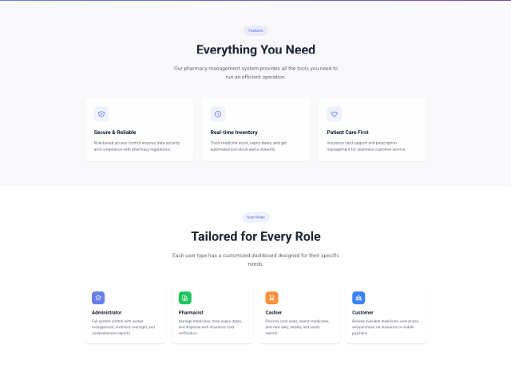

Figure 2: PharmaCare Homepage Design

3.3.2 Sign In Page
Fields:
• Email address input
• Password input
• Sign In button
• Registration link

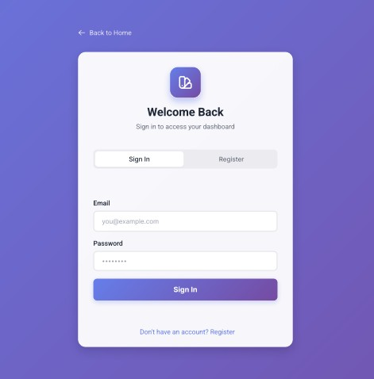
Figure 3: Sign In Page Design

3.3.3 Pharmacist Dashboard
Key Sections:
• Available Medicines count
• Out of Stock alerts
• Expiring Soon notifications (30 days)
• Expired Medicines list
• Medicines Sold statistics
• Total Stock overview
• Insurance Card Dispensing section

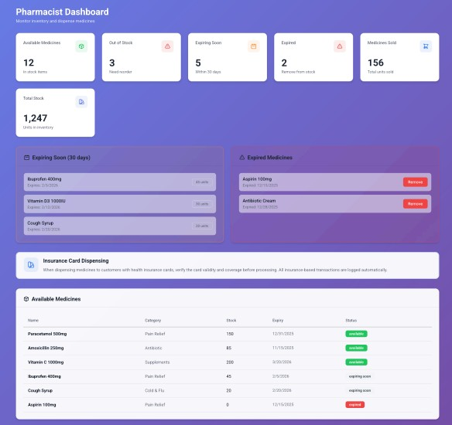
Figure 4: Pharmacist Dashboard Design

3.3.4 Customer Page
Key Sections:
• Medicine browsing and search
• Category filters (All Medicines, Kids Health, etc.)
• Shopping cart functionality
• Medicine details with stock and pricing
• Prescription required indicators

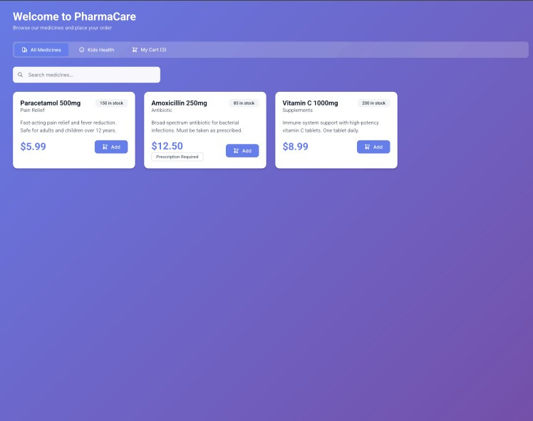

Figure 5: Customer Page Design

3.3.5 Cashier Page
Key Sections:
• Today's Sales summary
• Weekly Sales statistics
• Yearly Sales overview
• Today's Transactions count
• Medicine search and sale processing
• Sales History table
• Cash/Insurance payment indicators

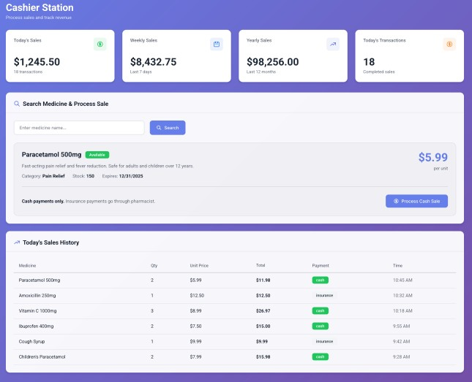
Figure 6: Cashier Station Design

3.3.6 Admin Dashboard
Key Sections:
• Total Workers overview
• Total Medicines count
• Active Shifts monitoring
• Today's Sales summary
• Registered Workers table with shifts
• Recent Sales activity

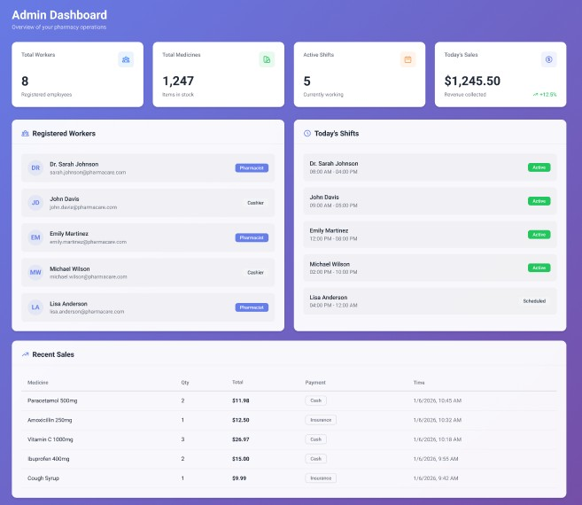

Figure 7: Admin Dashboard Design

4. Sequence Diagrams

4.1 User Login Sequence
This diagram illustrates the authentication flow for all user types.

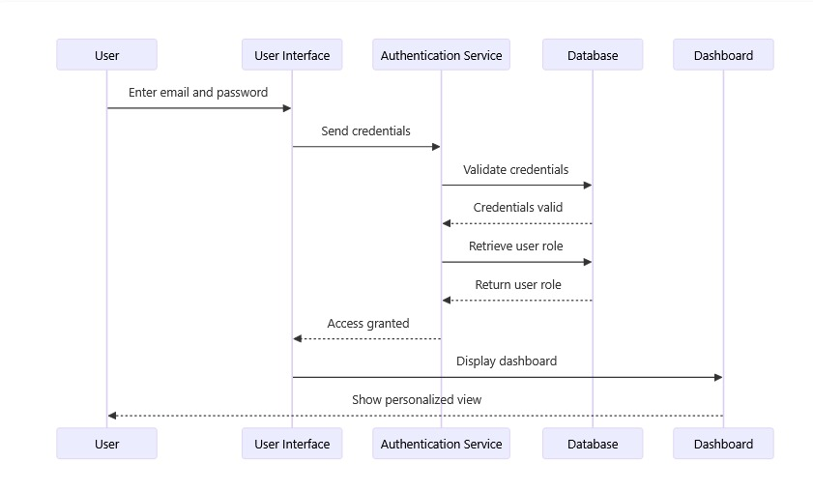
Figure 8: User Login Sequence Diagram

Actor | Action | System Response
User | Enter email and password | Display login form
User Interface | Send credentials | Forward to Authentication Service
Authentication Service | Validate credentials | Query Database
Database | Return validation result | Credentials valid/invalid
Authentication Service | Retrieve user role | Query Database
Database | Return user role | Role information
Dashboard | Display personalized view | Show role-based dashboard

4.2 Cashier Sales Process Sequence
This diagram shows the complete sales transaction flow handled by cashiers.

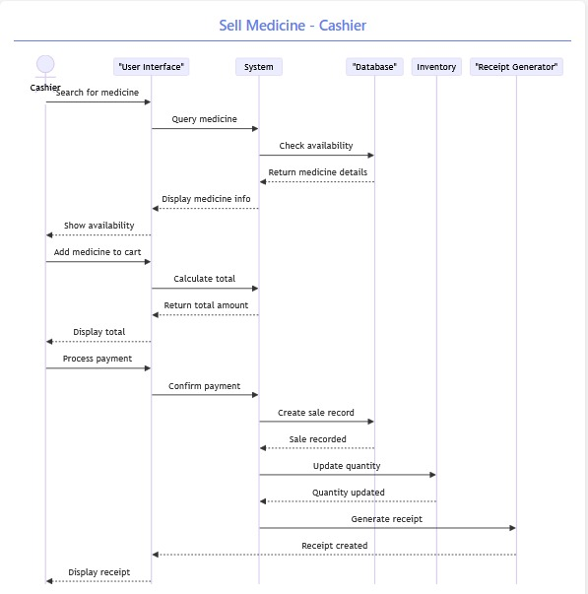

Figure 9: Cashier Sales Process Sequence Diagram

Step | Actor | Action
1 | Cashier | Search for medicine
2 | System | Query medicine availability from Database
3 | Database | Return medicine details
4 | System | Display medicine info and availability
5 | Cashier | Add medicine to cart
6 | System | Calculate total amount
7 | Cashier | Process payment
8 | System | Create sale record in Database
9 | Inventory | Update quantity (reduce stock)
10 | Receipt Generator | Generate and display receipt

4.3 Admin Medicine Management Sequence
This diagram illustrates the medicine addition workflow for administrators and pharmacists.

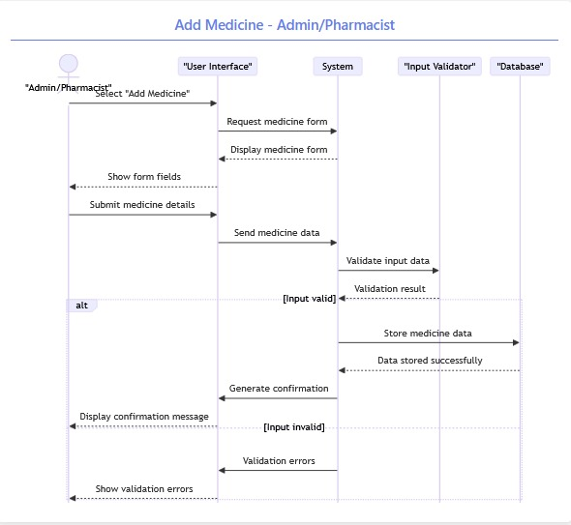
Figure 10: Admin Medicine Management Sequence Diagram

Step | Actor | Action | Result
1 | Admin/Pharmacist | Select 'Add Medicine' | Display medicine form
2 | System | Show form fields | Medicine entry form displayed
3 | Admin/Pharmacist | Submit medicine details | Form submission
4 | Input Validator | Validate input data | Validation result
5 | System (Valid) | Store medicine data | Data stored successfully
6 | System (Valid) | Generate confirmation | Display success message
7 | System (Invalid) | Show validation errors | Display error messages

5 CONCLUSION
The PharmaCare Management System represents a comprehensive solution for modern pharmacy operations. With a clear set of functional and non-functional requirements, a well-designed database schema, and user-centered interface principles, the system is positioned for successful development and deployment.

The modular architecture and role-based approach enable efficient pharmacy management, allowing administrators, pharmacists, cashiers, and customers to perform their respective tasks seamlessly. The system's scalability ensures it can grow to serve larger pharmacy operations while maintaining performance and reliability.

By combining modern web technologies with healthcare-appropriate design principles, PharmaCare will streamline inventory management, sales processing, and prescription handling while providing all stakeholders with convenient access to essential pharmacy services.

Document Approval
Role | Name | Signature | Date
Project Manager | [Your Name] | ___________ | January 08, 2026
Technical Lead | [Your Name] | ___________ | January 08, 2026
QA Lead | [Your Name] | ___________ | January 08, 2026
Stakeholder | [Your Name] | ___________ | January 08, 2026

