OpenRVFcast Project Overview and Code Walkthrough

Legend 2
Background 2
High-Level Coding Strategy 2
targets 2
renv 3
Repository Structure 3
Coding Pipeline Overview 4
Module 1: Data Acquisition 4
Module 2: Data Preparation 5
Module 3: Modeling Framework 5
Module Details 5
Module 1: Data Acquisition 5
Notes on coding strategy 5
Notes on data and data access 6
Targets structure 8
A note on dates 10
A note on space 11
Module 2: Data Preparation 11
Targets structure 11
A note on dates 11
A note on space 11
Module 3: Modeling Framework 12
Modeling approach 12
A note on coding choices to deal with RAM limitations and CV folds 15
Targets structure 15
Miscellaneous Notes and Suggestions 17
Parallelization 17
Metadata 17
Data storage 17
R-Shiny Application for visualizations 17
Immunity Decay Layer 17
Modeling Methods 17
Model Predictions 20
References 20

Legend
This color for: files
This color for: code
This color for: folders
This color for: target names
This color for: important notes

Background
The goal of this ongoing “OpenRVFcast” project is the development of an open-source modeling framework for predicting Rift Valley Fever (RVF) outbreaks in Africa, funded by the Wellcome Trust’s climate-sensitive infectious disease modeling initiative.
Current project code resides in a Github repository within the “One Health Research Consulting” (Mindy Rostal) group. Current funding from Wellcome Trust is passed through NumFOCUS - rOpenSci (Noam Ross).
This project has had a number of different developers (as can be seen in the github commit history), passing from Emma Mendelsohn to Nathan Layman to Morgan Kain and now [PLACEHOLDER] onward (with Noam Ross supervising all developers).
Note: See docs/model_supplement.qmd and docs/model_supplement.html for more details on the data and model

High-Level Coding Strategy

targets
The coding pipeline is built using the {targets} package in R, a powerful tool for creating reproducible and efficient data analysis workflows. By defining a workflow of interdependent tasks, known as ‘targets’, this package ensures that each step in the workflow is only executed when its inputs or code change, thereby optimizing computational efficiency. A modular, scalable, and transparent design makes {targets} an ideal choice for managing pipelines in reproducible research and production environments.
A good introduction to using {targets} can be found here. In brief, a few important points are as follows:
- Nearly all code is contained within functions (which the independent tasks, the ‘targets’ run), which, in this project, are housed within the R/ folder.
- When using {targets}, the series of ‘targets’ that make up the workflow generally live in a file named _targets.R. It is a little different for this project, however, as it uses three separate _targets.R files that are run in sequence (all of which live within the same repo); this is explained in the section “coding pipeline overview” below.
  - All functions in R/ are loaded by sourcing all scripts within the /R folder at the top of each _targets.R file.
- To get up and running, the most important functions are tar_make(named target) which builds the named target and tar_load(named target) which loads the named target into RAM. Other useful functions include tar_visnetwork() to visualize the directional links between the targets (Note: be warned that the network is quite large for each of these _targets.R files and can be a bit difficult to read, though potentially still helpful) and tar_outdated() to see which targets need to be rerun.
  - The _targets.R files are written so that the targets are roughly in sequence from top to bottom (this is not required as {targets} builds the dependency graph regardless of where the targets are located in the script). Though this is not always the case, in general for target B that uses the output of target A, target A will almost always be found earlier in the _targets.R file than target B.
  - tar_load(named target) can be quite expensive in terms of RAM as {targets} loads (hidden) a bunch of the meta whenever tar_load(named target) is run (note, gc() wont help here). For some targets it is a good idea to save the output as a file on disk and return a path to this saved file as the target (and use format = "file" in the target)—this is a common strategy throughout this project.
- Naming conventions are a bit different among the _targets.R files given different developers. For the third (model_framework_targets.R) (see section “code pipeline overview” below) the style is to name functions as verbs and targets as related nouns (e.g., the output from function tune_results_per_outer_fold() results in the target tuned_results_per_outer_fold).

renv
This project uses the {renv} framework to track R package dependencies and versions which are recorded in the renv.lock file. Code used to manage dependencies is in renv/ and other files in the root project directory. On starting an R session in the working directory, one option is to run renv::hydrate() and renv::restore() to install all required R packages and dependencies. Note: Be warned that this can be quite fragile, as installation of the entire suite of needed packages fails if a single error is encountered when installing any package. This can be rather annoying as the installation process can be quite time consuming for a large project. An alternative is to use sequential installation, which is not supported by {renv} natively but can be done with the code in R/stepwise_restore.R.

Repository Structure
Important files and folders to note include:
.env (hidden):
- Set which targets file is “seen” (more on this in section “coding pipeline overview”)
- Set credentials for data acquisition / API keys etc.
- Set flags for which data types to overwrite (more on this in section “module details”)
.Rprofile (hidden):
- Contains settings for {targets}, {renv}, parallel processing, etc. If something breaks with parallel processing, this is the first place to look
_targets.yaml:
- Details for the various {targets} pipelines (e.g., which targets file is “seen”) (see section “coding pipeline overview”)
_targets_settings.R:
- More settings beyond those in .Rprofile. The second place to look if issues arise with parallel processing
packages.R:
- Where packages are loaded
renv.lock:
- {renv} file that lists all of the package versions
README.*:
- ReadMe files for the Github
data/:
- Contains all of the data
models/:
- Contains any model files (for now just the .stan model for the seroprevalence kernel model)
R/:
- Where all of the scripts with all of the functions are held
outputs/:
- All outputs (any products created from files in /data) are saved
documentation/:
- Where this file and other help files live
docs/:
- Home of an app to explore predictions and some other documents

Coding Pipeline Overview
The project pipeline is organized into three distinct “modules” that join together sequentially to form the overall OpenRVFcast pipeline. Each module gets its own _targets.R file. Note: To toggle between which module is “seen” by {targets}, the argument TAR_PROJECT= in the .env file must reference the appropriate named _targets.R file as written in _targets.yaml and as described below.

Module 1: Data Acquisition
- predictor_data_processing_targets.R
- TAR_PROJECT= base
This module is focused on downloading data, doing some minor cleaning, and packaging it for further manipulation in the next module. The code is built with a toggle that controls if data is downloaded from a bucket owned by us or from source. If the toggle is set to download from the bucket and it isn’t found, it defaults to re-downloading the data from source.
The pipeline is built so that the local environment can be empty. Files are downloaded from source or the S3 bucket as necessary to build the covariate stack for new dates when the pipeline is rerun to update the model data file (see Module 2).
For model development it is unnecessary to re-download new data frequently as these data do not contribute to model fitting (see Module 3). However, new data is needed every time true forecasts are made; thus, the full Module 1 Module 2 Module 3 is needed when the objective is forecasting.

Module 2: Data Preparation
- rvf_data_processing_targets.R
- TAR_PROJECT= rvf
In this module the raw (minorly cleaned) data saved to disk in Module 1 is further cleaned and combined into the single master tibble covariate stack that is used in model fitting in Module 3. The key steps in this module are combining covariates with cases, building lagged variables, and collapsing data into w/e spatial aggregation is chosen (currently H3 hex or ADM2).

Module 3: Modeling Framework
- model_framework_targets.R
- TAR_PROJECT= model
This module contains all of the modeling steps from hyperparameter tuning through to final model fitting, prediction visualization, and automated report generation.
Note: There is also a REMIT_targets.R file (which also shows up in _targets.yaml). This is for cleaning and combining data for a different RVF project and is not relevant for this project. It was always my intention to move this to a different branch.
Note: See docs/model_supplement.qmd and docs/model_supplement.html for more details on the data and model

Module Details

Module 1: Data Acquisition
- predictor_data_processing_targets.R
- TAR_PROJECT= base

Notes on coding strategy
- Most data sources are obtained using between 3-5 targets that are run in sequence. In general, the first 1-2 establish the local path where the data will be downloaded and the URL for where the data is housed, the next attempts to download data from the bucket (at one point the bucket was AWS so these functions have the suffix _AWS regardless of whether or not the bucket is in fact with AWS, the next downloads from source, and the final uploads the newly downloaded data to the bucket (again, these upload functions have the _AWS suffix.
  - Options exist to skip bucket download (skip_fetch = TRUE) in the first _AWS function, AWS upload (overwrite = FALSE) in the _AWS_upload function, or download altogether (overwrite = FALSE) in the target that has the data once this is all said and done (Note: these tend to have the suffix _preprocessed).
    - For example, for the Gridded Livestock of the World data the targets are: glw_urls, glw_directory, glw_AWS, glw_preprocessed, and glw_preprocessed_AWS_upload
- Nearly all data targets (i.e., those with _preprocessed) are pointers to .parquet files saved to disk (with the path set up in the corresponding _directory target). These .parquet files are loaded when needed (i.e., passing one target to another often passes a vector of file paths that are loaded within the target that is receiving this vector)
- The pipeline is designed to be resilient to temporary data source issues (though Note: for monthly forecasting each data source is necessary and thus the pipeline will need to be rerun if there is a temporary server issue—which is common unfortunately—before Module 2 can proceed). Many targets include error = “null” in their configuration, which allows the pipeline to continue running even when individual data sources are temporarily unavailable. This is expected behavior and not a cause for concern. When a target fails with error = “null”: The error is logged but the pipeline continues; the failed target will be automatically retried the next time the pipeline runs; downstream targets that depend on the failed data will skip or use cached data; the pipeline will eventually succeed once the data source becomes available. Common scenarios where errors may occur include:
  - NASA MERRA-2 satellite data delays: NASA weather data is sometimes delayed in posting, causing temporary download failures
  - ECMWF API downtime: The ECMWF forecast API may be temporarily unavailable during maintenance (https://status.ecmwf.int/)
  - Copernicus/Sentinel-3 processing delays: Satellite imagery processing can be delayed
  - MODIS/AppEEARS bundle processing: Bundle requests may take time to process or fail temporarily

Notes on data and data access
Many of the computational steps in the first module can be time consuming and either depend on or produce large files. In order to speed up the pipeline, intermediate files are stored in S3-compatible cloud storage for portability. We currently use Cloudflare R2 (S3-compatible storage). The pipeline will still run without access to cloud storage (but is very costly in terms of storage and computation time), but users can add their own S3-compatible storage credentials to the .env file to enable cloud storage and collaboration with team members.
S3-compatible cloud storage credentials to add to the .env file (already present and set to a bucket owned by Noam Ross) include:
AWS_DEFAULT_REGION=auto
AWS_REGION=auto
AWS_BUCKET_ID=your-bucket-name
AWS_ACCESS_KEY_ID=your-access-key
AWS_SECRET_ACCESS_KEY=your-secret-key
AWS_S3_ENDPOINT=your-s3-endpoint
AWS_ENDPOINT_URL=https://${AWS_S3_ENDPOINT}

The pipeline works with any S3-compatible storage including AWS S3, Cloudflare R2, MinIO, etc. See docs/dynamic_branching_guide.md for details on how the pipeline uses cloud storage for incremental updates and team collaboration.
Acquiring the raw source data stores involves first obtaining authentication credentials, such as API keys, tokens, and certificates. There are three primary sources of data that require access credentials
- [ECMWF](https://www.ecmwf.int/): for accessing monthly weather forecasts from the European Centre for Medium-Range Weather Forecasts (ECMWF).
- [COPERNICUS](https://dataspace.copernicus.eu/): for accessing Normalized Difference Vegetation Index (NDVI) data derived from the European Space Agency's Sentinel-3 satellite.
- [APPEEARS](https://appeears.earthdatacloud.nasa.gov/api/): for accessing historical NDVI data prior to the Sentinel-3 mission from NASA MODIS satellites.
Before running the data acquisition pipeline, credentials for all three sources must be added to the .env file.
Note: Those currently in the .env file work but are very old credentials, all of which should be updated.
ECMWF_USERID=
ECMWF_TOKEN=
COPERNICUS_USERNAME=
COPERNICUS_PASSWORD=
APPEEARS_USERNAME=
APPEEARS_PASSWORD=
APPEEARS_TOKEN=

All spatial data were interpolated to a resolution of 0.1° across Africa and standardized to the WGS 84 coordinate reference system. All temporal data layers were joined by date.
If data files become corrupted, they can be re-generated from the raw sources by setting the OVERWRITE_X flags to TRUE in the .env file. This will prevent the pipeline from first downloading the data from cloud storage, re-download and process the raw data from the original sources, and upload the processed files to cloud storage for future use. Note that, under normal use, these should always be set to FALSE. The pipeline will automatically download any missing data without having to change these settings. This is only to replace data that has already been downloaded and processed mainly for pipeline development purposes.

Targets structure
- The targets file for this module (predictor_data_processing_targets.R) is broken up into 4 groups of similar targets with the use of the function tar_plan().
  - static_targets: These covariates are static over time. They are obtained following the coding strategy described in bullet one above.
    - Soil -- Soil types (https://www.fao.org/soils-portal/data-hub/soil-maps-and-databases/harmonized-world-soil-database-v20/en/): Soil types based on the Food and Agriculture Organization of the United Nations (https://www.fao.org/home/en). Harmonized World Soil Database v2.0 (HWSD) with soil types aggregated into 8 categories: clay (heavy) + clay loam (1), silt loam + silty clay (2), sandy clay + clay (3), loam + silty clay loam (4), sandy clay loam (5), sandy loam + silt (6), loamy sand + silt loam (7), and sand (8) based on similarity in the USDA sand-silt-clay ternary texture class diagram (https://www.fao.org/soils-portal/data-hub/soil-maps-and-databases/harmonized-world-soil-database-v20/en/) (further detail given in code).
    - Aspect -- Slope and aspect data from the FAO Global Terrain Slope and Aspect; https://www.fao.org/ (full urls given in code)
    - Slope -- Slope and aspect data from the FAO Global Terrain Slope and Aspect; https://www.fao.org/ (full urls given in code)
    - Gridded Livestock of the World -- censused in 2010 and available at a native resolution of 5 arc-minutes; https://dataverse.harvard.edu/api/access/datafile (full urls given in code)
    - Elevation -- Elevation data accessed via the elevation_global() function of the geodata package (https://rdrr.io/cran/geodata/man/elevation.html) in R, drawn from the Shuttle Radar Topography Mission (SRTM) at resolution of 0.5 minutes of a degree; geodata::elevation_global()
    - Bioclimatic variables -- Bioclimactic data from the WorldClim version 2.1 accessed via the worldclim_global() function of the geodata package (https://rdrr.io/cran/geodata/man/worldclim.html) in R and represent the global mean values across the period of 1970-2000 at a 2.5m resolution; geodata::worldclim_global(). Bioclimactic variables included: Annual_Mean_Temperature, Mean_Diurnal_Range, Isothermality, Temperature_Seasonality, Max_Temperature_of_Warmest_Month, Min_Temperature_of_Coldest_Month, Temperature_Annual_Range, Mean_Temperature_of_Wettest_Quarter, Mean_Temperature_of_Driest_Quarter, Mean_Temperature_of_Warmest_Quarter, Mean_Temperature_of_Coldest_Quarter, Annual_Precipitation, Precipitation_of_Wettest_Month, Precipitation_of_Driest_Month, Precipitation_Seasonality, Precipitation_of_Wettest_Quarter, Precipitation_of_Driest_Quarter, Precipitation_of_Warmest_Quarter, and Precipitation_of_Coldest_Quarter
    - Landcover -- Landcover data was accessed via the landcover() function of the geodata (https://rdrr.io/cran/geodata/man/elevation.html) package in R, drawn from the ESA WorldCover Database with a spatial resolution of 30 arc-seconds. Values for each landcover type (trees, grassland, shrubs, cropland, built, bare, snow, water, wetland, mangroves, and moss), reflect the fraction of each a landcover class at each location; geodata::landcover()
  - dynamic_targets: Dynamic data sources are those that vary with time. Dynamic predictors can be highly conflated with each other due to a shared dependence on time, to account for this shared dependence, we used the anomaly, or difference between current values and historical means, instead of using the raw values. Anomalies were calculated by first determining the difference between the current value and its historical mean for that day-of-year (DOY) and scaled by dividing by the standard deviation for that DOY. Focusing on anomalous values helped mitigate the strong correlation with time that naturally exists in environmental variables like temperature and NDVI. Seasonality was then accounted for by including year and day-of-year (DOY) as predictors in the model. They are obtained following the coding strategy described in bullet one above.
    - Sentinel NDVI -- 2018-present, ~10 day period (see code for details)
    - MODIS NDVI -- 2005-present, 16 day period (see code for details)
    - ECMWF's Climate Data Store (CDS) recorded weather – large number of variables available, see code for chosen few. ECMWF's Climate Data Store (CDS) weather data was acquired across Africa using ecmwfr::wf_request(). Note: versions of this pipeline prior to ~June 2026 used NASA weather, however it can takes upwards of 5 weeks for these data to become available online, thus we moved to using ECMWF, whose data becomes available after 5 days.
    - NDVI historical means -- NDVI data was sourced from both the NASA's Moderate Resolution Imaging Spectroradiometer (MODIS: https://modis.gsfc.nasa.gov/data/dataprod/mod13) and the European Space Agency's Copernicus (Sentinel-3: https://user.eumetsat.int/catalogue/EO:EUM:DAT:0340) missions. MODIS is due to be retired in 2025 while Sentinel-3 NDVI data is available from September 2018. MODIS and Sentinel-3 NDVI values were interpolated to a daily interval from their native 16 day (MODIS) and ~10 day (Sentinel-3) intervals using a step-function. NDVI values were averaged when data from both sources were available.
    - ECMWF weather forecast data -- large number of variables available, see code for chosen few.
  - derived_data_targets: A set of data processing targets to build forecast covariates and calculate anomalies
    - Recorded weather anomalies – essentially determines deviations from the norm (see code for details). The difference, or anomaly value, was found by subtracting each weather value from the average value for that day-of-year (DOY). Outbreak occurrence is not always directly influenced by the immediately preceding conditions. Biological systems often involve delayed responses. For example, heavy precipitation may promote a mosquito hatch, which can lead to an outbreak only after a delay. To account for the influence of past environmental conditions, we included lagged weather and NDVI data, specifically the average values from 0-30, 30-60, 60-90, 90-120, and 120-150 days prior.
    - Forecast anomalies -- essentially determines deviations from the norm (see code for details). We also included long-range projections of future weather provided by the European Centre for Medium-Range Weather Forecasts (ECMWF) and accessed through the Copernicus Climate Data Store (CDS) (https://cds.climate.copernicus.eu/). The projected data represent the mean of a 51-member ensemble and include the expected average temperature, precipitation, and relative humidity for each location across different forecast intervals. Historical forecasts were available through hindcasts, which apply the current forecasting methods to historical data to simulate what forecasts would have been available at those times based on past conditions.
  - full_data_targets: Pulls together all of the various data sources into the master tibble which gets loaded in the next pipeline. The dataset is saved to a series of .parquet files that are housed in a folder set by the target africa_full_predictor_data_directory
Note: There is also a REMIT_targets tar_plan() but this isn’t used for this project and can/should be moved to a different branch.

A note on dates
One important target with a choice of consequence is dates_in_predictors, which determines what dates are used to build the covariate stack. The date/covariate/modeling strategy used here is to build the covariate stack using two random days per month. This allows the covariate stack to be both manageable in size and have a high-enough frequency to capture seasonal variation for making near-term forecasts.

A note on space
The target continent_raster_template is important because it establishes template into which all of the continuous covariates are projected, which allows the whole stack to line up spatially. Note: For more safe joins, we generally round lat, long coordinates to the 4th decimal place, which is within the 0.1 degree resolution for which the data is obtained. Throughout this entire module covariates are kept continuous. In the next module covariates are collapsed into regions.

Module 2: Data Preparation
- rvf_data_processing_targets.R
- TAR_PROJECT= rvf

Targets structure
As previously stated, this module consists of code that builds the single cleaned/joined covariate stack tibble for model fitting. The targets file for this module is broken up into 3 groups of similar targets with the use of the function tar_plan().
- data_import_targets: Outputs from the previous module as well as other needed data objects are loaded including:
  - rvf_seroprevalence: Pan-African serorepvalence data from the published literature gathered for another project. Used here to build an immunity decay layer (in the modeling_targets tar plan; see point b below)
  - rvf_response: WAHIS case data that is summarized by date into the various forecasts windows that are used (argument forecast_intervals)
  - region_map: Set up the spatial regions into which the continuous covariates will be summarized; either region_districts (ADM2 regions) OR region_hexes (H3 hexes) depending on the choice for using_hexes
- modeling_targets: A target where the data is built for the .stan model and then the target where the .stan model is run to create the immunity decay layer for the covariate stack (for detailed methods on the immunity decay layer model see the end of this document)
- rvf_processing_targets: A few targets that summarize the data into the chosen regions occurs, build lagged covariates, and create the single master tibble for model fitting

A note on dates
The target dates_in_predictors shows up here once again. As it is written, it will return the same exact dates as it does in the previous module, though it may be sensible/safer to save the output from Module 1 to disk and reload it here.

A note on space
If a different spatial scale of aggregation is desired add the option to region_map; if a comparison of alterative region options is desired above and beyond simply running the model through a couple of different times and manually comparing, a larger rework of the pipeline will be needed.

Module 3: Modeling Framework
- model_framework_targets.R
- TAR_PROJECT= model
As previously stated, this is where the modeling occurs. There is a lot to say here… Best to start with an overview on the modeling approach and then follow that up with the targets structure to link each target to the appropriate point about the modeling approach.

Modeling approach
The core of the model is a boosted regression tree fit with xgboost. See functions make_recipe(), and make_model() for the code that sets up the model (these are called within a number of other functions/targets). Given substantial uncertainty in case counts (for which many are NA), we predict when and where outbreaks occur (binary), irrespective of the size of the outbreak. Note: The model itself is rather “simple”; further development is potentially warranted (e.g., interaction constraints to control feature relationships, monotonic constraints).
The pipeline implements a temporally and spatially nested cross-validation strategy for hyperparameter tuning. To form these nested cross-validation folds we split the training data (data prior to some date, for now set to 2020-12-19; Note: as more data is obtained, this date could be moved forward in time for a longer training period) into a series of temporal chunks, which we call “outer folds” (Figure 1 [next page]). Then, for each outer temporal fold, we split the data into N spatial leave-one-out “inner folds”, where the model is fit using N-1 spatial chunks and model performance is evaluated on the left-out chunk (Figure 1). Data is folded in the target folded_data_training_raw.
Hyperparameter tuning then proceeds as follows:
- The model is fit for all inner folds within each outer fold for each of the hyperparameter sets in the “global” grid of possible hyperparameters (which is set up with targets tune_pars and tuning_grid). For each inner fold for each outer fold performance is evaluated with a weighted logloss (see functions compute_metrics_vec() and finalize_hyperparameters_from_inner().
- The best few hyperparameter sets are chosen and a “local” grid around these hyperparameters is built. The tuning process repeats.
- The best hyperparameter set is chosen across all sets across all inner folds -by- outer folds in function finalize_hyperparameters_from_inner(). A single best hyperparameter set is used for model fitting.
Note: For just monthly forecasting, machinery exists to simply reuse the tuning from a previous “tuning run”. See the .env variable PURPOSE=forecast.
Model fitting and evaluation then occurs by fitting the model to all of the data within the “training” window and predicting outbreaks in the “test” window. The model fitting and evaluation for the “test” period is set up to mirror how model deployment will occur, whereby model fitting re-occurs every 6 months (i.e., when 6 months of new data has accumulated that was not used in the previous model fit; Figure 2 [two pages down]). For example, the model is first fit with data through 2020-12-19, which is the last date with data contained within the “training” dataset. Model predictions are evaluated from 2021-01-17 (the first of the two random dates in the month following 2020-12-19) to 2021-05-14 (the second of the two random dates in the 5th month of the evaluation period). Then, the model uses data through 2021-05-14 and predicts for the first date in the next month through the second date in the 5th month of the evaluation period (Figure 2). In this way, model performance is matched to how forecasts will be made in practice. Note: For each model fit (e.g., the model fit using data through 2020-12-19), forecasts for each date in the 5 month evaluation period are assessed for a total of 10 forecast evaluations per forecast window (Figure 2). Because of the random dates per month, there is some overlap in the same forecasts windows between consecutive dates. We do not think this is a big issue, but is something to keep in mind.

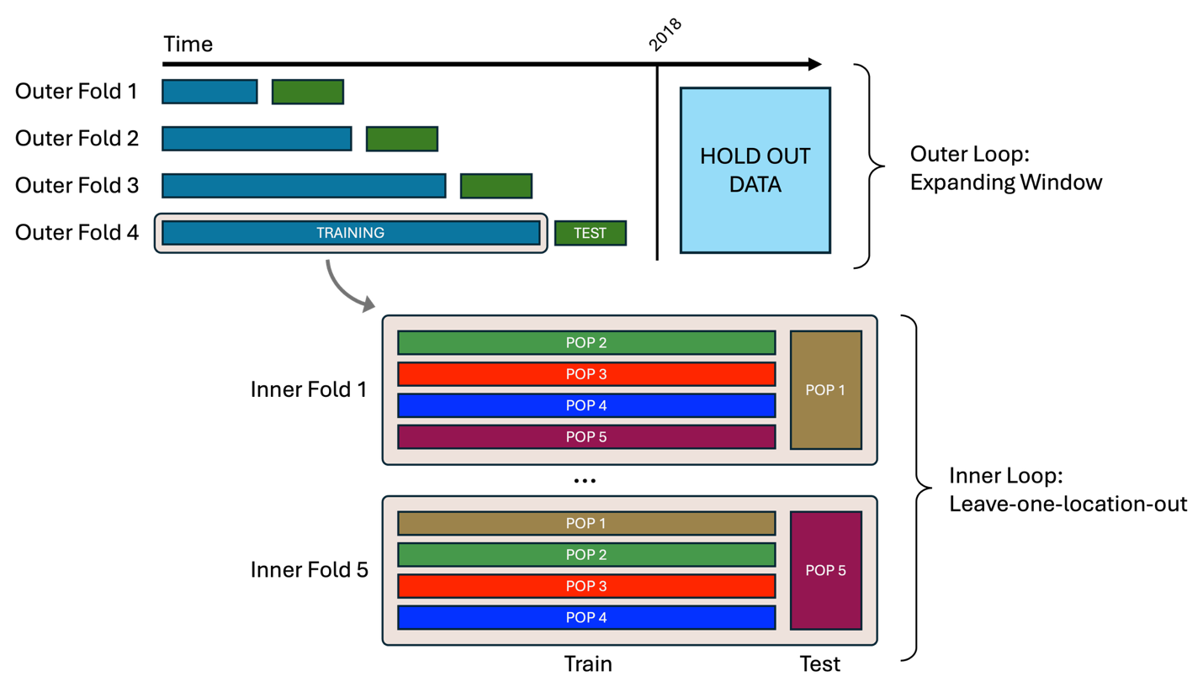

Figure 1: Visual representation of the cross-validation folds. The upper portion of the figure illustrates breaking the data training data (here shown as all data prior to 2018; Note: currently, training data extends through the end of 2020) into “outer” temporal folds. Data after 2018/2020 is set aside for testing data for the final model fits for evaluation performance after hyperparameter tuning (blue box). Here, each consecutive outer fold contains more data than the previous in an “expanding window”. The blue bars show the data used for training in each outer fold and the green bar (with the word “test”) shows the data used to evaluate model performance for that outer fold. The bottom portion of this figure shows how data in each temporal fold is split into N spatial leave-one-out “inner folds”, where the model is fit using N-1 spatial chunks (as shown here the long thin horizontal rectangles) and model performance is evaluated on the left out chunk (the larger vertical rectangle).

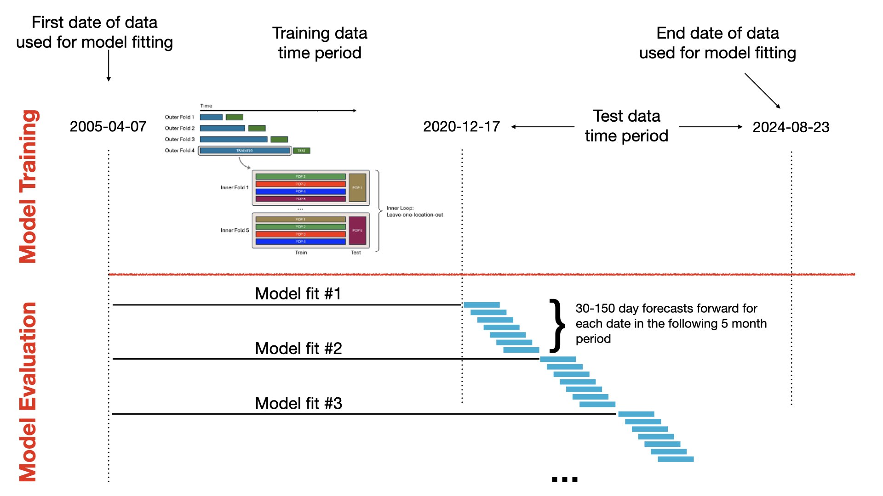

Figure 2: Visual representation of model fitting. The upper portion of the figure shows what is presented in Figure 1. The bottom half shows the re-fitting of the model for model evaluation (blue stacked/staggered rectangles).

A note on coding choices to deal with RAM limitations and CV folds
Given the large number of inner and outer folds, computation is quite extensive (it is unrealistic to run this model anywhere but on a sizeable compute machine). Given the large dataset, RAM usage can easily get out of hand. Though this project is easily parallelizable, it is still easy to be a bit loose with RAM use. Many of the coding choices used here are to deal with RAM use (e.g., store sets of indices for what data is needed for what fits and pass these instead of subset data).
Partially for RAM reasons, partially because of some issues with parallelization, and partially because of the complexity of the inner + outer folds, the folding is mostly done with custom functions and not with {parsnip, dials, tidymodels} (etc.) functions (though these packages are still heavily used).

Targets structure
- model_data_targets: Lots of setup: loading data, setting up paths for saving outputs, setting up a few parameters for modeling (all of these targets are commented well)
- cross_validation_targets: Building all of the data objects for running the hyperparameter tuning. Notable targets include:
  - splitted_data – Split data between the training set and the holdout testing set
  - clustered_Africa_districts – Splitting the whole region (here all of Africa) up into N spatial regions where N = the chosen number of spatial folds. As described previously, leave-one-out cross validation is conducted spatially such that for each fit one spatial chunk is left out (where model performance for each inner fold is evaluated on the left-out chunk)
  - folded_data_training_raw + folded_data_training – Build the inner spatial folds (see section “modeling approach” above) and drop any outher folds with too little data (controlled with arguments epidemic_threshold_total and epidemic_threshold_space)
  - folded_data_testing – Building the chunks of time over which the fitted model (after optimizing hyperparameters) will be evaluated for performance
- model_tuning_targets: All steps to build the hyperparameter set that will be used for model fitting. This section starts with setting up the grid of hyperparameters and ends with the selection of the single best hyperparameter set. Everything in-between executes the fitting across inner and outer folds as described in section “modeling approach” above.
- model_fitting_targets: A small 2-function group where: a) the model is fit and predictions are made for all of the time periods over which predictions are evaluated (see target folded_data_testing); b) the predictions are cleaned up for downstream use
- model_evaluation_targets: Where all of the model evaluation takes place and where outputs are saved for the report. Notable targets include:
  - shap_prep_a + shap_by_forecast_interval + shap_comparison: a strategy to calculate variable importance -by- forecast interval
  - calibration_curves + plotted_calibration: calibration curves are generated and plot (see here and here for some info)
  - variable_importance: variable importance plots
  - examined_fits_within: the primary function for plotting predictions by space, but also contains confusion matrices and some density plots
  - examined_fits_across: compares summaries/performance between the various time chunks
  - app_file_needs + built_app_components_predictions + built_app_components_data: build necessary components for the visualization app
- report_targets: A single target that pulls together the summaries / plotting that occurs in model_evaluation_targets and saves a pdf report to disk

Miscellaneous Notes and Suggestions

Parallelization
Parallelization can be quite fragile. Currently with the parameter choices spread between .Rprofile and _targets_settings.R parallelization is working on my local machine and on the compute machine owned by Noam; however, this isn’t to say it will work on your machine. Resources are a bit thin online for {crew, mirai}, but a good place to start is the document Nate wrote in this repo: docs/dynamic_branching_guide.md

Metadata
It remains on the ToDo list to build a single unified ReadMe file for the entire data stack. Currently, the locations of further information about each covariate are highly variable, with some of the best info for some covariates being in code commenting, closed Github issues, the Github ReadMe, or just at the source where the data is downloaded. You may have to hunt a bit if you are particularly interested in some detail about one of the covariates. Cleaning, lagging, etc. are explained quite well in commenting in the code if you follow the pipeline.

Data storage
For speed and memory consideration we use .parquet files which are interacted with using the R package {arrow}. Building the master covariate stack from the many .parquet files uses the package {duckdb}, which has a bit of its own language to learn if that needs to be edited for any reason.

R-Shiny Application for visualizations
The app can be run in various ways, but most easily by opening the file in R Studio and clicking the “Run App” button. We will eventually host this (or a related) application online for better access by stakeholders.

Immunity Decay Layer

Modeling Methods
Most RVF forecasting efforts have not used seroprevalence data (e.g., see Redding et al., 2017; Mulwa et al., 2025), while those that have used but a fraction of the available data (e.g., see Chemison et al., 2024), likely because there is no central repository for these data. For a different pan-African RVF modeling project (private repository, contact us for details), we built a comprehensive animal seroprevalence dataset from the published literature. Given our goal of an automated forecasting pipeline, it is impossible for us to simply use raw extracted seroprevalence as an additional covariate because we compiled our seroprevalence data by means of a labor-intensive manual extraction effort from published literature. Thus, we built a spatio-temporal seroprevalence predictive model designed to be fit once using the full seroprevalence dataset, after which future seroprevalence values can be predicted as part of the automated pipeline using publicly available data obtained as part of the data scraping phase. Specifically, we developed a Bayesian spatio-temporal model to relate our aggregated seroprevalence dataset to WAHIS outbreaks, data that is updated using one of our scraping functions.
A challenge is that serological surveys and outbreak reports are sparse, noisy, and misaligned in space and time, such that many seroprevalence values have few “paired” outbreaks recorded nearby. Our model treats seroprevalence as arising from: 1) the accumulated impacts of nearby outbreaks, the effects of which decay spatially and temporally; and, 2) spatially structured background variation not explained by the recorded outbreaks (to account for high underreporting of cases). That is, our model combines a mechanistic spatio-temporal kernel for outbreak influence with a flexible spatial random field to absorb residual structure not explained by the outbreak data.
Serological observations were modeled using a binomial likelihood. For each serosurvey $i=1,…,N$, with $y_{i}$ positive samples out of $n_{i}$ tested, we assumed
$$y_{i}∼\text{Binomial}(n_{i},p_{i}),$$
where $p_{i}$ denotes the latent seroprevalence probability at the location and time of the survey. The logit-transformed seroprevalence was expressed as the additive linear predictor
$$\text{logit}\left(p_{i}\right)=β_{0}+b_{c_{i}}+αE_{i},$$
were $β_{0}$ represents a global baseline log-odds of seropositivity across the study region, $b_{c_{i}}$ is a spatially structured background effect associated with H3 hex grid cell $c_{i}$ containing survey $i$ (further detail on the next page), and $E_{i}$ is the cumulative spatio-temporal influence of past outbreaks on that survey. The coefficient $α$ scales cumulative outbreak exposure into log-odds units. The global intercept $β_{0}$ and outbreak scaling coefficient $α$ were given normal priors centered at zero with moderate variance.
The outbreak influence term $E_{i}$captures the combined effects of all outbreaks occurring prior to survey $i$, weighted by their spatial proximity and temporal recency. For each outbreak $j$ with onset time $τ_{j}$ and location $\left(x_{j}{,y}_{j}\right)$, we defined $d_{ij}$ as the Euclidean distance between outbreak $j$ and survey $i$, and $Δt_{ij}=t_{i}-τ_{j}$ as the elapsed time between outbreak onset and the survey in years. Ideally, we would have access to a finer temporal scale (e.g., months); however, much of the extracted seroprevalence data lacked this resolution. Naturally, only outbreaks with $Δt_{ij}>0$ were allowed to contribute. We modeled outbreak influence using the separable exponential kernel
$$K(d_{ij},Δt_{ij})=exp\left(-\frac{d_{ij}}{ρ_{s}}\right)exp\left(-\frac{Δt_{ij}}{ρ_{t}}\right),$$
where $ρ_{s}>0$ is a spatial decay scale (in kilometers) and $ρ_{t}>0$ is a temporal decay scale (in years). Biologically, the temporal decay parameter $ρ_{t}$ primarily captures demographic turnover as RVF immunity is lifelong. The spatial and temporal decay parameters $ρ_{s}$ and $ρ_{t}$were assigned log-normal priors reflecting plausible distance and time scales while allowing order-of-magnitude uncertainty. The cumulative exposure at survey $i$ was then defined as
$$E_{i}=\sum_{j∈N(i)}{K(d_{ij},Δt_{ij})},$$
where $N(i)$ denotes the set of outbreaks within prespecified spatial (500 km) and temporal cutoffs (8 years). Cutoffs were used to enable sparse computation by excluding distant or temporally remote outbreaks; these cutoffs were chosen sufficiently large that contributions beyond them were negligible given the exponential kernel.
To account for spatial variation in seroprevalence not explained by detected outbreaks, we included a spatial background field $b$ defined on the same H3 grid into which cases and our other spatial covariates were summarized. The background field serves as a spatially varying intercept that captures persistent differences in seroprevalence attributable to unobserved outbreaks. Spatial dependence in the background field was modeled using an intrinsic conditional autoregressive (ICAR) (Besag et al., 1991) prior defined on the adjacency graph of the H3 grid cells. The ICAR prior penalizes differences between adjacent cells rather than absolute values, inducing smooth spatial variation
$$p(\tilde{b})∝exp⁡\left(-\frac{1}{2}\sum_{g∼h}{(}{\tilde{b}}_{g}-{\tilde{b}}_{h})^{2}\right),$$
where $\tilde{b}$ denotes a centered version of the raw field (and where $g∼h$ indicates hex cells sharing a boundary). The study region includes multiple disconnected components (e.g., mainland Africa and Madagascar), so we imposed a sum-to-zero constraint separately within each connected component of the adjacency graph. This ensures that the background field represents deviations around the global intercept $β_{0}$ within each landmass, while allowing the overall baseline to be learned globally. We defined the centered field as
$${\tilde{b}}_{g}=b_{g}^{raw}-\frac{1}{∣G_{\text{comp}(g)}∣}\sum_{h∈G_{\text{comp}(g)}}{b_{h}^{raw}},$$
which enforces $\sum_{g∈G_{c}}{{\tilde{b}}_{g}}=0$ for each component $c$, where $G_{c}$ denote the set of grid cells belonging to connected component $c$. The final background effect $b_{g}$that appears in the linear predictor was then
$$b_{g}=σ_{b}{\tilde{b}}_{g},$$
where $σ_{b}>0$ controls the overall amplitude of spatial variation on the log-odds scale. The background amplitude parameter $σ_{b}$was given a half-normal prior. To anchor the raw field and avoid non-identified directions in the parameterization, we assigned a weakly informative Gaussian prior to $b^{raw}$.
The model was fit in Stan using 4 chains, 5000 warmup samples, and saving 5000 samples. To ensure computational scalability, all outbreak–serosurvey pairs within the spatial and temporal cutoffs were precomputed, and outbreak contributions were summed using a sparse “ragged array” representation. Convergence was assessed using standard diagnostics, including effective sample size, $\hat{R}$, and inspection of trace plots.
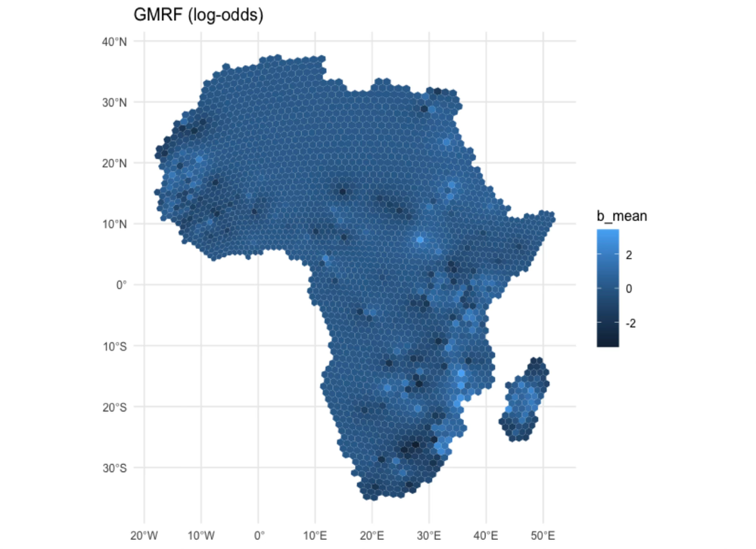
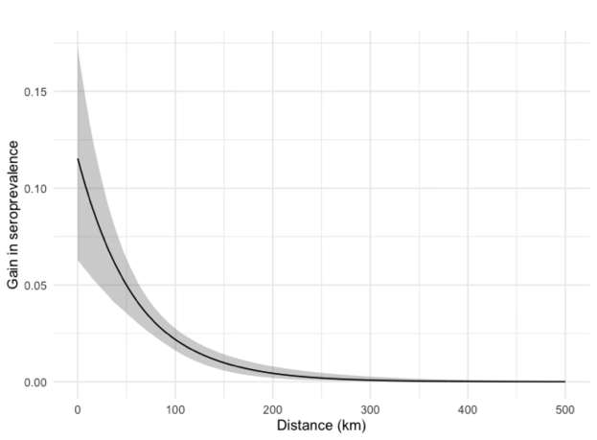
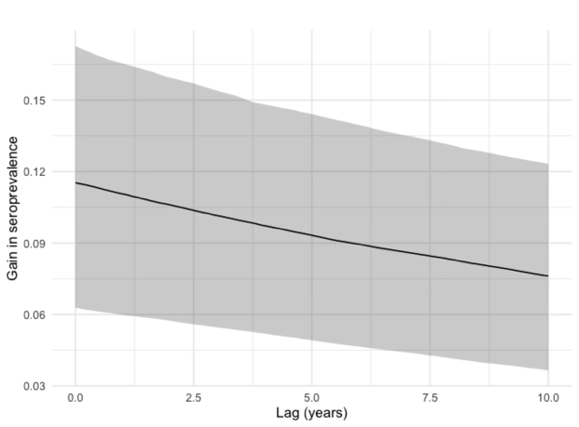
Figure 3: Immunity model predictions. A) Map of the background field defined on the H3 grid; B) Fitted spatial decay; C) Fitted (highly uncertain) temporal decay.

A
B
C

Model Predictions

References
Besag, J., York, J., & Mollié, A. (1991). Bayesian image restoration, with two applications in spatial statistics. Annals of the institute of statistical mathematics, 43(1), 1-20.
Chemison, A., Ramstein, G., Jones, A., Morse, A., & Caminade, C. (2024). Ability of a dynamical climate sensitive disease model to reproduce historical Rift Valley Fever outbreaks over Africa. Scientific reports, 14(1), 3904.
Mulwa, D., Kazuzuru, B., Misinzo, G., & Bett, B. (2025). Machine learning approach to predicting Rift Valley fever disease outbreaks in Kenya. Zoonotic Diseases, 5(3), 20.
Redding, D. W., Tiedt, S., Lo Iacono, G., Bett, B., & Jones, K. E. (2017). Spatial, seasonal and climatic predictive models of Rift Valley fever disease across Africa. Philosophical Transactions of the Royal Society B: Biological Sciences, 372(1725).

