OpenRVFcast Project Overview and Code Walkthrough

Legend 1
Background 2
High-Level Coding Strategy 2
targets 2
renv 3
Repository Structure 3
Coding Pipeline Overview 4
Module 1: Data Acquisition 4
Module 2: Data Preparation 5
Module 3: Modeling Framework 5
Module Details 5
Module 1: Data Acquisition 5
Notes on coding strategy 5
Targets structure 6
A note on dates 7
A note on space 7
Module 2: Data Preparation 7
Targets structure 7
A note on dates 8
A note on space 8
Module 3: Modeling Framework 8
Modeling approach 8
A note on coding choices to deal with RAM limitations and CV folds 11
Targets structure 11
Miscellaneous Notes and Suggestions 12
Parallelization 12
Metadata 12
Data storage 13

Legend
This color for: files
This color for: code
This color for: folders
This color for: target names
This color for: important notes

Background
The goal of this ongoing “OpenRVFcast” project is the development of an open-source modeling framework for predicting Rift Valley Fever (RVF) outbreaks in Africa, funded by the Wellcome Trust’s climate-sensitive infectious disease modeling initiative.
Current project code resides in a Github repository within the “One Health Research Consulting” (Mindy Rostal) group. Current funding from Wellcome Trust is passed through NumFOCUS - rOpenSci (Noam Ross).
This project has had a number of different developers (as can be seen in the github commit history), passing from Emma Mendelsohn to Nathan Layman to Morgan Kain and now onward (with Noam Ross supervising all developers).

High-Level Coding Strategy

targets
The coding pipeline is built using the {targets} package in R, a powerful tool for creating reproducible and efficient data analysis workflows. By defining a workflow of interdependent tasks, known as ‘targets’, this package ensures that each step in the workflow is only executed when its inputs or code change, thereby optimizing computational efficiency. A modular, scalable, and transparent design makes {targets} an ideal choice for managing pipelines in reproducible research and production environments.
A good introduction to using {targets} can be found here. In brief, a few important points are as follows:
- Nearly all code is contained within functions (which the independent tasks, the ‘targets’ run), which, in this project, are housed within the R/ folder.
- When using {targets}, the series of ‘targets’ that make up the workflow generally live in a file named _targets.R. It is a little different for this project, however, as it uses three separate _targets.R files that are run in sequence (all of which live within the same repo); this is explained in the section “coding pipeline overview” below.
  - All functions in R/ are loaded by sourcing all scripts within the /R folder at the top of each _targets.R file.
- To get up and running, the most important functions are tar_make(named target) which builds the named target and tar_load(named target) which loads the named target into RAM. Other useful functions include tar_visnetwork() to visualize the directional links between the targets (Note: be warned that the network is quite large for each of these _targets.R files and can be a bit difficult to read, though potentially still helpful) and tar_outdated() to see which targets need to be rerun.
  - The _targets.R files are written so that the targets are roughly in sequence from top to bottom (this is not required as {targets} builds the dependency graph regardless of where the targets are located in the script). Though this is not always the case, in general for target B that uses the output of target A, target A will almost always be found earlier in the _targets.R file than target B.
  - tar_load(named target) can be quite expensive in terms of RAM as {targets} loads (hidden) a bunch of the meta whenever tar_load(named target) is run (note, gc() wont help here). For some targets it is a good idea to save the output as a file on disk and return a path to this saved file as the target (and use format = "file" in the target)—this is a common strategy throughout this project.
- Naming conventions are a bit different among the _targets.R files given different developers. For the third (model_framework_targets.R) (see section “code pipeline overview” below) the style is to name functions as verbs and targets as related nouns (e.g., the output from function tune_results_per_outer_fold() results in the target tuned_results_per_outer_fold).

renv
This project uses the {renv} framework to track R package dependencies and versions which are recorded in the renv.lock file. Code used to manage dependencies is in renv/ and other files in the root project directory. On starting an R session in the working directory, one option is to run renv::hydrate() and renv::restore() to install all required R packages and dependencies. Note: Be warned that this can be quite fragile, as installation of the entire suite of needed packages fails if a single error is encountered when installing any package. This can be rather annoying as the installation process can be quite time consuming for a large project. An alternative is to use sequential installation, which is not supported by {renv} natively but can be done with the code in R/stepwise_restore.R.

Repository Structure
Important files and folders to note include:
.env (hidden):
- Set which targets file is “seen” (more on this in section “coding pipeline overview”)
- Set credentials for data acquisition / API keys etc.
- Set flags for which data types to overwrite (more on this in section “module details”)
.Rprofile (hidden):
- Contains settings for {targets}, {renv}, parallel processing, etc. If something breaks with parallel processing, this is the first place to look
_targets.yaml:
- Details for the various {targets} pipelines (e.g., which targets file is “seen”) (see section “coding pipeline overview”)
_targets_settings.R:
- More settings beyond those in .Rprofile. The second place to look if issues arise with parallel processing
packages.R:
- Where packages are loaded
renv.lock:
- {renv} file that lists all of the package versions
README.*:
- ReadMe files for the Github
data/:
- Contains all of the data
models/:
- Contains any model files (for now just the .stan model for the seroprevalence kernel model)
R/:
- Where all of the scripts with all of the functions are held
outputs/:
- All outputs (any products created from files in /data) are saved

Coding Pipeline Overview
The project pipeline is organized into three distinct “modules” that join together sequentially to form the overall OpenRVFcast pipeline. Each module gets its own _targets.R file. Note: To toggle between which module is “seen” by {targets}, the argument TAR_PROJECT= in the .env file must reference the appropriate named _targets.R file as written in _targets.yaml and as described below.

Module 1: Data Acquisition
- predictor_data_processing_targets.R
- TAR_PROJECT= base
This module is focused on downloading data, doing some minor cleaning, and packaging it for further manipulation in the next module. The code is built with a toggle that controls if data is downloaded from a bucket owned by us or from source. If the toggle is set to download from the bucket and it isn’t found, it defaults to re-downloading the data from source. In most cases for model development work, the data has already been downloaded, cleaned, and packaged and this module can be skipped.
For deployment and auto-updating of data for new forecasts (running the full pipeline from start to finish), a decision will need to be made for how often new data is downloaded (different sources are updated at different frequencies) vs relying on already downloaded data to make new forecasts.

Module 2: Data Preparation
- rvf_data_processing_targets.R
- TAR_PROJECT= rvf
In this module the raw (minorly cleaned) data saved to disk in Module 1 is further cleaned and combined into the single master tibble covariate stack that is used in model fitting in Module 3. The key steps in this module are combining covariates with cases, building lagged variables, and collapsing data into w/e spatial aggregation is chosen (currently H3 hex or ADM2).

Module 3: Modeling Framework
- model_framework_targets.R
- TAR_PROJECT= model
This module contains all of the modeling steps from hyperparameter tuning through to final model fitting, prediction visualization, and automated report generation.
Note: There is also a REMIT_targets.R file (which also shows up in _targets.yaml). This is for cleaning and combining data for a different RVF project and is not relevant for this project. It was always my intention to move this to a different branch.

Module Details

Module 1: Data Acquisition
- predictor_data_processing_targets.R
- TAR_PROJECT= base

Notes on coding strategy
- Most data sources are obtained using between 3-5 targets that are run in sequence. In general, the first 1-2 establish the local path where the data will be downloaded and the URL for where the data is housed, the next attempts to download data from the bucket (at one point the bucket was AWS so these functions have the suffix _AWS regardless of whether or not the bucket is in fact with AWS, the next downloads from source, and the final uploads the newly downloaded data to the bucket (again, these upload functions have the _AWS suffix.
  - Options exist to skip bucket download (skip_fetch = TRUE) in the first _AWS function, AWS upload (overwrite = FALSE) in the _AWS_upload function, or download altogether (overwrite = FALSE) in the target that has the data once this is all said and done (Note: these tend to have the suffix _preprocessed).
    - For example, for the Gridded Livestock of the World data the targets are: glw_urls, glw_directory, glw_AWS, glw_preprocessed, and glw_preprocessed_AWS_upload
- Nearly all data targets (i.e., those with _preprocessed) are pointers to .parquet files saved to disk (with the path set up in the corresponding _directory target). These .parquet files are loaded when needed (i.e., passing one target to another often passes a vector of file paths that are loaded within the target that is receiving this vector)

Targets structure
- The targets file for this module (predictor_data_processing_targets.R) is broken up into 4 groups of similar targets with the use of the function tar_plan().
  - static_targets: These covariates are static over time. They are obtained following the coding strategy described in bullet one above.
    - Soil -- Harmonized World Soil Database (HWSD2) https://gaez.fao.org/pages/hwsd (further detail given in code)
    - Aspect -- https://www.fao.org/ (full urls given in code)
    - Slope -- https://www.fao.org/ (full urls given in code)
    - Gridded Livestock of the World -- https://dataverse.harvard.edu/api/access/datafile (full urls given in code)
    - Elevation -- geodata::elevation_global()
    - Bioclimatic variables -- geodata::worldclim_global()
    - Landcover -- geodata::landcover()
  - dynamic_targets: These covariates vary over time. They are obtained following the coding strategy described in bullet one above.
    - Sentinel NDVI -- 2018-present, 10 day period (see code for details)
    - MODIS NDVI -- 2005-present, ~10 day period (see code for details)
    - NASA Power recorded weather – large number of variables available, see code for chosen few
    - ECMWF weather forecast data -- large number of variables available, see code for chosen few
  - derived_data_targets: A set of data processing targets to build forecast covariates and calculate anomalies
    - Recorded weather anomalies – essentially determines deviations from the norm (see code for details)
    - Forecast anomalies -- essentially determines deviations from the norm (see code for details)
  - full_data_targets: Pulls together all of the various data sources into the master tibble which gets loaded in the next pipeline. The dataset is saved to a series of .parquet files that are housed in a folder set by the target africa_full_predictor_data_directory
Note: There is also a REMIT_targets tar_plan() but this isn’t used for this project and can/should be moved to a different branch.

A note on dates
One important target with a choice of consequence is dates_in_predictors, which determines what dates are used to build the covariate stack. The date/covariate/modeling strategy used here is to build the covariate stack using two random days per month. This allows the covariate stack to be both manageable in size and have a high-enough frequency to capture seasonal variation for making near-term forecasts.

A note on space
The target continent_raster_template is important because it establishes template into which all of the continuous covariates are projected, which allows the whole stack to line up spatially. Throughout this entire module covariates are kept continuous. In the next module covariates are collapsed into regions.

Module 2: Data Preparation
- rvf_data_processing_targets.R
- TAR_PROJECT= rvf

Targets structure
As previously stated, this module consists of code that builds the single cleaned/joined covariate stack tibble for model fitting. The targets file for this module is broken up into 3 groups of similar targets with the use of the function tar_plan().
- data_import_targets: Outputs from the previous module as well as other needed data objects are loaded including:
  - rvf_seroprevalence: Pan-African serorepvalence data from the published literature gathered for another project. Used here to build an immunity decay layer (see modeling_targets) below
  - rvf_response: WAHIS case data that is summarized by date into the various forecasts windows that are used (argument forecast_intervals)
  - region_map: Set up the spatial regions into which the continuous covariates will be summarized; either region_districts (ADM2 regions) OR region_hexes (H3 hexes) depending on the choice for using_hexes
- modeling_targets: A target where the data is built for the .stan model and then the target where the .stan model is run to create the immunity decay layer for the covariate stack
- rvf_processing_targets: A few targets that summarize the data into the chosen regions occurs, build lagged covariates, and create the single master tibble for model fitting

A note on dates
The target dates_in_predictors shows up here once again. As it is written, it will return the same exact dates as it does in the previous module, though it may be sensible/safer to save the output from Module 1 to disk and reload it here.

A note on space
If a different spatial scale of aggregation is desired add the option to region_map; if a comparison of alterative region options is desired above and beyond simply running the model through a couple of different times and manually comparing, a larger rework of the pipeline will be needed.

Module 3: Modeling Framework
- model_framework_targets.R
- TAR_PROJECT= model
As previously stated, this is where the modeling occurs. There is a lot to say here… Best to start with an overview on the modeling approach and then follow that up with the targets structure to link each target to the appropriate point about the modeling approach.

Modeling approach
The core of the model is a boosted regression tree fit with xgboost. See functions make_recipe(), and make_model() for the code that sets up the model (these are called within a number of other functions/targets). Given substantial uncertainty in case counts (for which many are NA), we predict when and where outbreaks occur (binary), irrespective of the size of the outbreak. Note: The current model is rather simple, further development is likely warranted (e.g., interaction constraints to control feature relationships, monotonic constraints).
The pipeline implements a temporally and spatially nested cross-validation strategy for hyperparameter tuning. To form these nested cross-validation folds we split the training data (data prior to some date, for now set to 2020-12-19) into a series of temporal chunks, which we call “outer folds” (Figure 1 [next page]). Then, for each outer temporal fold, we split the data into N spatial leave-one-out “inner folds”, where the model is fit using N-1 spatial chunks and model performance is evaluated on the left out chunk (Figure 1). Data is folded in the target folded_data_training_raw.
Hyperparameter tuning then proceeds as follows:
- The model is fit for all inner folds within each outer fold for each of the hyperparameter sets in the full grid of possible hyperparameters (which is set up with targets tune_pars and tuning_grid). For each inner fold performance is evaluated with a weighted logloss if there are no outbreaks in the left out spatial chunk and both the weighted logloss and precision recall area under the curve yardstick::pr_auc() if there are some outbreaks (see function compute_metrics_vec() called from within, for example, target tuned_results_per_outer_fold. For each outer fold, the best hyperparameter set is chosen given choices for how these metrics are weighted (given emphasis on predicting 1s). In this inner fold training, the “test” data for the outer fold is not yet used (as shown in Figure 1).
- Each outer fold is then fit with the best hyperparameter set for that outer fold based on the training across inner folds, with performance being evaluated on the “test” data. The single best hyperparameter set (chosen using the same method as previously) is now chosen as the overall best set for model fitting.
Model fitting and evaluation then occurs by fitting the model to all of the data within the “training” window and predicting outbreaks in the “test” window. The model fitting and evaluation for the “test” period is set up to mirror how model deployment will occur, whereby model fitting re-occurs every 6 months (i.e., when 6 months of new data has accumulated that was not used in the previous model fit; Figure 2 [two pages down]). For example, the model is first fit with data through 2020-12-19, which is the last date with data contained within the “training” dataset. Model predictions are evaluated from 2021-01-17 (the first of the two random dates in the month following 2020-12-19) to 2021-05-14 (the second of the two random dates in the 5th month of the evaluation period). Then, the model uses data through 2021-05-14 and predicts for the first date in the next month through the second date in the 5th month of the evaluation period (Figure 2). In this way, model performance is matched to how forecasts will be made in practice. Note: For each model fit (e.g., the model fit using data through 2020-12-19), forecasts for each date in the 5 month evaluation period are assessed for a total of 10 forecast evaluations per forecast window (Figure 2). Because of the random dates per month, there is some overlap in the same forecasts windows between consecutive dates. We do not think this is a big issue, but is something to keep in mind.

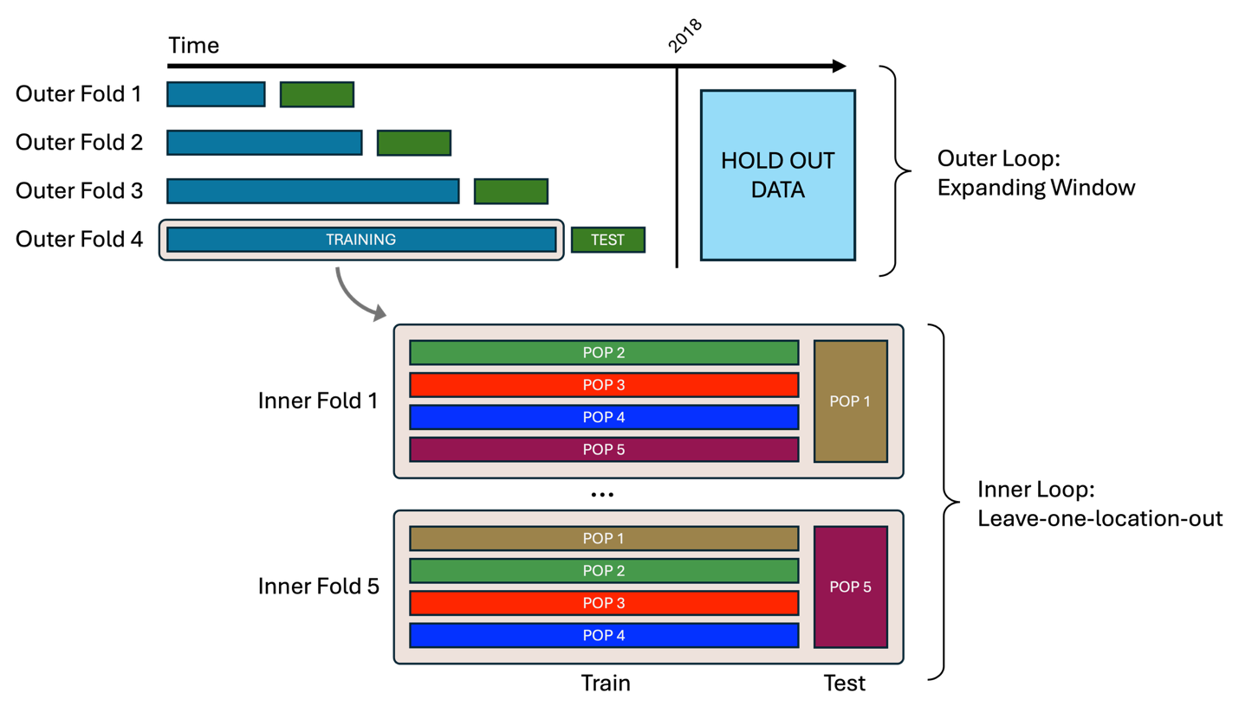

Figure 1: Visual representation of the cross-validation folds. The upper portion of the figure illustrates breaking the data training data (here shown as all data prior to 2018; Note: currently, training data extends through the end of 2020) into “outer” temporal folds. Data after 2018/2020 is set aside for testing data for the final model fits for evaluation performance after hyperparameter tuning (blue box). Here, each consecutive outer fold contains more data than the previous in an “expanding window”. The blue bars show the data used for training in each outer fold and the green bar (with the word “test”) shows the data used to evaluate model performance for that outer fold. The bottom portion of this figure shows how data in each temporal fold is split into N spatial leave-one-out “inner folds”, where the model is fit using N-1 spatial chunks (as shown here the long thin horizontal rectangles) and model performance is evaluated on the left out chunk (the larger vertical rectangle).

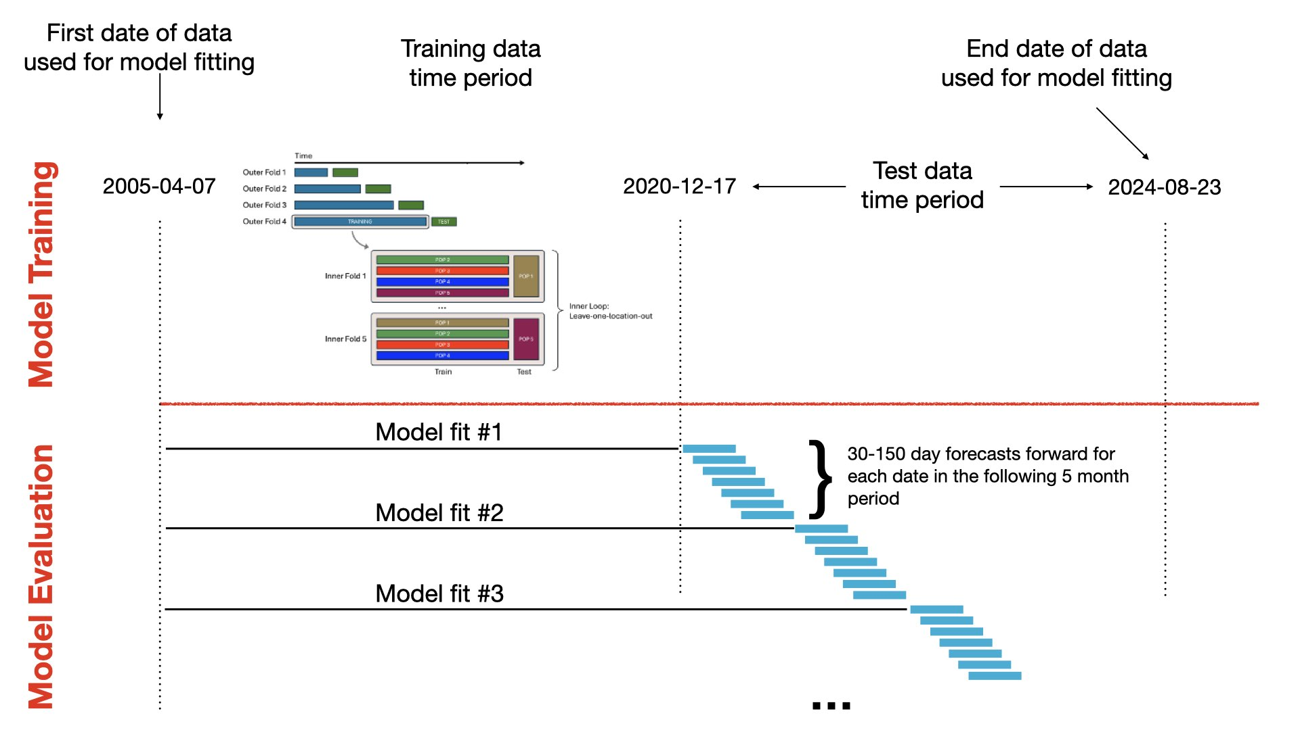

Figure 2: Visual representation of model fitting. The upper portion of the figure shows what is presented in Figure 1. The bottom half shows the re-fitting of the model for model evaluation (blue stacked/staggered rectangles).

A note on coding choices to deal with RAM limitations and CV folds
Given the large number of inner and outer folds, computation is quite extensive (it is unrealistic to run this model anywhere but on a sizeable compute machine). Given the large dataset, RAM usage can easily get out of hand. Though this project is easily parallelizable, it is still easy to be a bit loose with RAM use. Many of the coding choices used here are to deal with RAM use (e.g., store sets of indices for what data is needed for what fits and pass these instead of subset data).
Partially for RAM reasons, partially because of some issues with parallelization, and partially because of the complexity of the inner + outer folds, the folding is mostly done with custom functions and not with {parsnip, dials, tidymodels} (etc.) functions (though these packages are still heavily used).

Targets structure
- model_data_targets: Lots of setup: loading data, setting up paths for saving outputs, setting up a few parameters for modeling (all of these targets are commented well)
- cross_validation_targets: Building all of the data objects for running the hyperparameter tuning. Notable targets include:
  - splitted_data – Split data between the training set and the holdout testing set
  - clustered_Africa_districts – Splitting the whole region (here all of Africa) up into N spatial regions where N = the chosen number of spatial folds. As described previously, leave-one-out cross validation is conducted spatially such that for each fit one spatial chunk is left out (where model performance for each inner fold is evaluated on the left-out chunk)
  - folded_data_training_raw + folded_data_training – Build the inner spatial folds (see section “modeling approach” above) and drop any outher folds with too little data (controlled with arguments epidemic_threshold_total and epidemic_threshold_space)
  - folded_data_testing – Building the chunks of time over which the fitted model (after optimizing hyperparameters) will be evaluated for performance
- model_tuning_targets: All steps to build the hyperparameter set that will be used for model fitting. This section starts with setting up the grid of hyperparameters and ends with the selection of the single best hyperparameter set. Everything in-between executes the fitting across inner and outer folds as described in section “modeling approach” above.
- model_fitting_targets: A small 2-function group where: a) the model is fit and predictions are made for all of the time periods over which predictions are evaluated (see target folded_data_testing); b) the predictions are cleaned up for downstream use
- model_evaluation_targets: Where all of the model evaluation takes place and where outputs are saved for the report. Notable targets include:
  - calibration_curves + plotted_calibration: calibration curves are generated and plot (see here and here for some info)
  - variable_importance: variable importance plots
  - examined_fits_within: the primary function for plotting predictions by space, but also contains confusion matrices and some density plots
  - examined_fits_across: compares summaries/performance between the various time chunks
- report_targets: A single target that pulls together the summaries / plotting that occurs in model_evaluation_targets and saves a pdf report to disk

Miscellaneous Notes and Suggestions

Parallelization
Parallelization can be quite fragile. Currently with the parameter choices spread between .Rprofile and _targets_settings.R parallelization is working on my local machine and on the compute machine owned by Noam; however, this isn’t to say it will work on your machine. Resources are a bit thin online for {crew, mirai}, but a good place to start is the document Nate wrote in this repo: docs/dynamic_branching_guide.md

Metadata
It remains on the ToDo list to build a single unified ReadMe file for the entire data stack. Currently, the locations of further information about each covariate are highly variable, with some of the best info for some covariates being in code commenting, closed Github issues, the Github ReadMe, or just at the source where the data is downloaded. You may have to hunt a bit if you are particularly interested in some detail about one of the covariates. Cleaning, lagging, etc. are explained quite well in commenting in the code if you follow the pipeline.

Data storage
For speed and memory consideration we use .parquet files which are interacted with using the R package {arrow}. Building the master covariate stack from the many .parquet files uses the package {duckdb}, which has a bit of its own language to learn if that needs to be edited for any reason.

