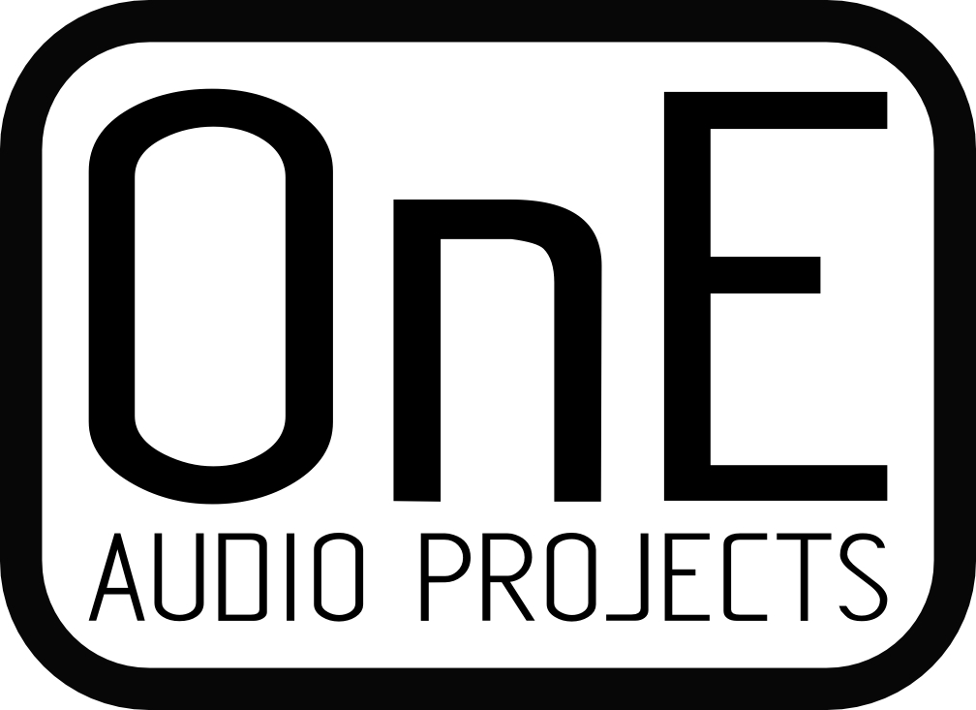 | AA2380V1 CPLD software  OSVA project main board  MAXV CPLD Embedded software definition. | AA2380v1_software.odt
 |  | OnEAudioProjects
contact@oneaudio.net
www.oneaudio.net

Document Revision | Date | Modifications | Author
1,0 | 21/05/2019 | Original revision : Stand alone mode of AA2380V1 (no MAX10 board). | O.N

Contents
1) Design entity list : 2
1) Rotary encoder and LED indicators 2
2) How to select all of this ? 2
3) AA2380PAN Leds behavior : 2
4) Channel LEDs (tricolors). 3
Each channel LEDs can indicate some channel specific infos : 3
Red = Digital overflow indicator . 3
Green = Ideal signal amplitude ( -3 to -10 dBFS input level) 3
Blue = Calibration in process. 3
Available colors are: 3
Red 3
Blue 3
Green 3
White (blue+red+green) 3
Violet (red+blue) 3
Turquoise (blue +green) 3
Yellow (red+green) 3
2) Analog front-end relays selections 4
3) ADC’s SPI reading 4
4) Averaging process selection (direct or SinC mode) 5
5) SPDIF generator 6
6) External master clock and PLL generator 7
7) Isolated serial interface data transfert 8
8) Synch PWM outputs 9
9) Test I/O connector (unisolated) 10

Design entity list :

Rotary encoder and LED indicators
Inputs :
- Rotary encoder (left or right rotate)
- Encoder push-button
- CONF0 to CONF3 jumpers input (4 inputs).
- UIO_05 to UIO_09 jumpers input. (5 inputs)
Outputs:
- LED average : AVG0 – AVG1 – AVG2
- LED sampling rate : 192k – 96k – 48k
- LED mode : SE/DIFF – CAL – BW/FILTER
- Tricolors channels LED

The selection mode that we should select are :
- Sampling rate from 48,96 or 192 Hz
- Averaging ratio from : 1,2,4,8,16 or 32x
- Analog filter selection mode : low or high
- Input type : Single-ended or differential
- DC Calibration : start calibration process
- Digital filter type : SinC or None.

How to select all of this ?
- J17 (CONFX jumpers)
  - The two jumpers CONF0 and CONF1 select sampling rate.
  - The jumper CONF02 select “SE/DIFF” coupling mode.
  - The jumper CONF02 select “BW/FILTER” Analog filter selection mode
- J12 (UI0 optional OPT I/O)

  - The three jumpers UIO_05,UIO_06 and UIO_07 select averaging value.
  - The jumper UIO_08 select “FIRnSinC” Digital filter type.

The DC Calibration process “ CAL” is initiated by pressing ~1s the encoder push button.
The “CAL” led will blink during all calibration process time.

AA2380PAN Leds behavior :

- The three LEDs “192k”,“96k” and “48k” show actual sampling rate selection.
- The three LEDs “average” indicated averaging ration in binary form.
- The LED “SE/DIFF” show connection mode is use (1= Differential 0= Single-ended).
- The LED “BW/FILTER” show analog filter bandwidth (1= High/384kHz 0 = Low/38,4kHz ).
- The led “CAL” is blinking at 2Hz when DC calibration process time is active.

Channel LEDs (tricolors).

Each channel LEDs can indicate some channel specific infos :
- Red = Digital overflow indicator .
- Green = Ideal signal amplitude ( -3 to -10 dBFS input level)
- Blue = Calibration in process.

Available colors are:
- Red
- Blue
- Green
- White (blue+red+green)
- Violet (red+blue)
- Turquoise (blue +green)
- Yellow (red+green)

Analog front-end relays selections
Relays are selected according to SE/DIFF and Filter BW mode used.
Note : Both channels are selected together with same mode.

ADC’s SPI reading
The ADC reading can be made in several ways.
First, there is the simplest mode where adc acquisition speed

Averaging process selection (direct or SinC mode)

SPDIF generator
The S/PDIF output send both channels data in serial form to be send on PC sound-card.
The interface allow three effective audio sampling rate output : 48kHz, 96kHz and 192kHz.
Each data output are 24 bits coded. This interface is transformer isolated.

External master clock and PLL generator
The external master clock input support frequency from .. to … MHz.

Isolated serial interface data transfert

Synch PWM outputs
The two PWM output are used to generate two isolated 1kHz and 10kHz sine wave.
These sine wave are generated synchronously with sampling rate, and so can be used to lock-up an external oscillator for real synchronous sampling.
A full synchronous sampling allow to use unweighted FFT with accurate bins amplitude measurement.

Test I/O connector (unisolated)
TBD

END OF MANUAL

All right reserved, document copy without author authorization is prohibited.
Copyright OnE Audio Projects
www.oneaudio.net
contact@oneaudio.net
The full thread describing the project construction can be find on DIYaudio.com forum.
DIY bare printed circuit board with full project design folder are available for sale.
“Frex” member.

Others OnE Audio Designs (bare PCB available):

- AT2380V2, 0..-127.5dB 2 ch digital stepped attenuator with amplitude track.
- ERMSDCV2, DC-1MHz RMS voltmeter & 80dB 10Hz-100kHz Ultra low noise amplifier.
- EOSC10KV3, AN67 ultra low THD 1/10 kHz reference sine oscillator.
- AA5381V1, 24bits/192kHz stand alone high performance Analog
to Digital converter CS5381CZZ based.
- EHAMP08, Remote controlled TPA6120 based headphone amplifier.
- EXDAC, Fully symmetric outputs dual PCM1792A high performance audio DAC with headphone amplifier.

