Joel Ruiz II  
Dr. Laura Grabowski  
CSCI 4350  
February 20, 2015

**Homework 2: A* Algorithm**

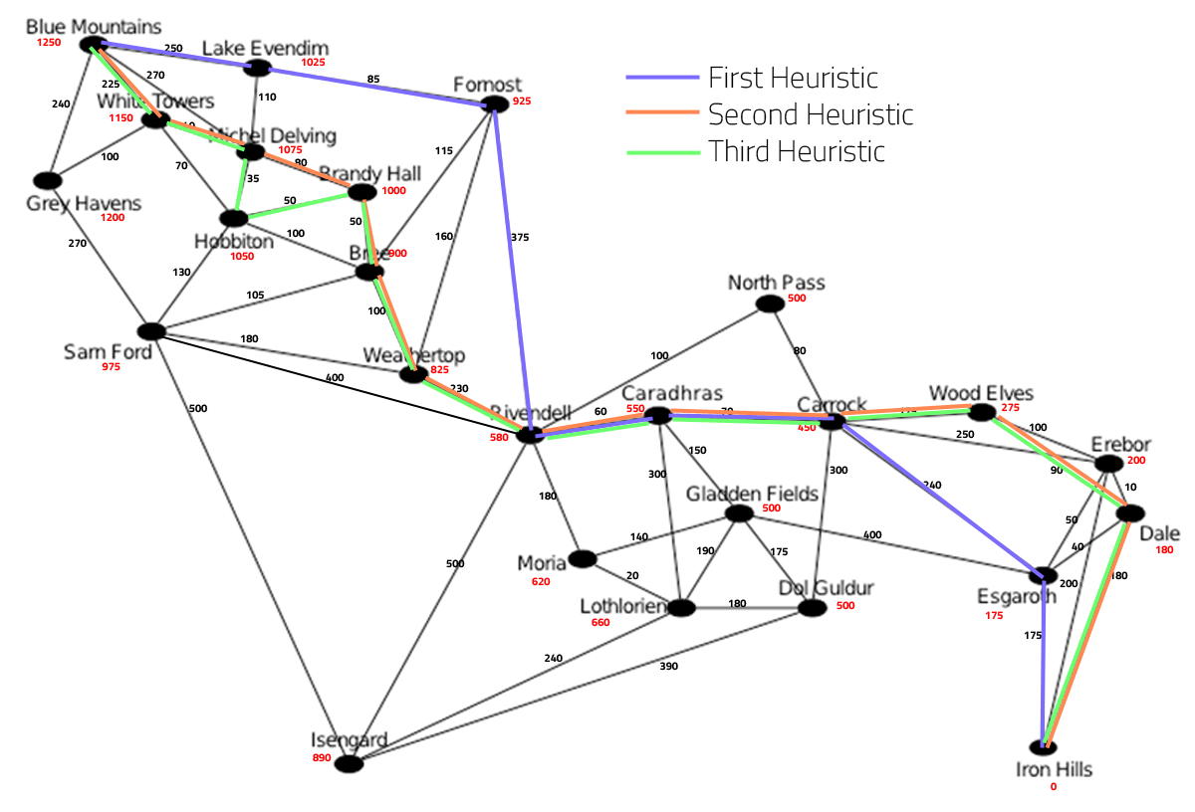

**Introduction**

The A* Algorithm to travel through middle earth from Blue Mountains to Iron Hills was performed using 3 different heuristics. The first heuristic only considers the distance, and provides the “shortest” route. The second and third heuristics include the path quality and path risk level. It is also possible to change the starting city by simply changing the start city’s name in main.cpp.

In designing the structure of this code, I wanted to minimize the amount of runtime that was required to process the A* algorithm. For this reason, I chose to use “std::set” for the Opened and Closed lists. This container allows a sorted insertion and removal in O(log n) and finding the minimum f(x) in O(1). Although, the A* algorithm was found to have an exponential space and time complexity, anything that could help reduce its runtime was welcomed. The “set” was originally sorted by the heuristic total, but was later changed to be sorted in priority of highest to lowest: heuristic, path depth, and goal distance.

The code also supports creating custom heuristic functions. The AStar class is templated to enable passing in a custom Heuristic class. This allows the creation of new heuristics, for examples please view “astarhueristic.h” from the code files and “main.cpp” for usage.

**First Heuristic – Shortest Distance**

This heuristic simply takes the current distance traveled + the path distance to next city. It will find the optimal path based on shortest distance. Total distance traveled is 1255 miles.

|  |  |  |  |  |  |
| --- | --- | --- | --- | --- | --- |
| **#** | **Dist** | **g(x)** | **h(x)** | **f(x)** | **City** |
| 1 | 0 | 0 | 1250 | 1250 | Blue Mountains |
| 2 | 250 | 250 | 1025 | 1275 | Lake Evendim |
| 3 | 85 | 335 | 925 | 1260 | Fornost |
| 4 | 375 | 710 | 580 | 1290 | Rivendell |
| 5 | 60 | 770 | 550 | 1320 | Caradhras |
| 6 | 70 | 840 | 450 | 1290 | Carrock |
| 7 | 240 | 1080 | 175 | 1255 | Esgaroth |
| 8 | 175 | 1255 | 0 | 1255 | Iron Hills |

I was unsure if this was the shortest distance, so I performed a manual walkthrough to prove it. Here are the results of the manual walkthrough:

|  |  |  |  |  |  |  |  |
| --- | --- | --- | --- | --- | --- | --- | --- |
| **City** | **g(x)** | **h(x)** | **f(x)** |  |  |  |  |
| Blue Mountains | 0 | 1250 | 1250 | **Neighbor** | **g(x)** | **h(x)** | **f(x)** |
|  |  |  |  | Lake Evendim | 250 | 1025 | 1275 |
|  |  |  |  | Michel Delving | 270 | 1075 | 1345 |
|  |  |  |  | White Towers | 225 | 1150 | 1375 |
|  |  |  |  | Grey Havens | 240 | 1200 | 1440 |
| Lake Evendim | 250 | 1025 | 1275 |  |  |  |  |
|  |  |  |  | Fornost | 335 | 925 | 1260 |
|  |  |  |  | Michel Delving | 360 | 1075 | 1435 |
| Fornost | 335 | 925 | 1260 |  |  |  |  |
|  |  |  |  | Bree | 450 | 900 | 1350 |
|  |  |  |  | Weathertop | 495 | 825 | 1320 |
|  |  |  |  | Rivendell | 710 | 580 | 1290 |
| Rivendell | 710 | 580 | 1290 |  |  |  |  |
|  |  |  |  | North Pass | 810 | 500 | 1310 |
|  |  |  |  | Caradhras | 770 | 550 | 1320 |
|  |  |  |  | Moria | 890 | 620 | 1510 |
|  |  |  |  | Isengard | 1210 | 890 | 2100 |
| North Pass | 810 | 500 | 1310 |  |  |  |  |
|  |  |  |  | Carrock | 890 | 450 | 1340 |
| Caradhras | 770 | 550 | 1320 |  |  |  |  |
|  |  |  |  | Carrock | 840 | 450 | 1290 |
|  |  |  |  | Gladden Fields | 920 | 500 | 1420 |
|  |  |  |  | Lothlorien | 1070 | 660 | 1730 |
| Carrock | 840 | 450 | 1290 |  |  |  |  |
|  |  |  |  | Wood Elves | 1015 | 275 | 1290 |
|  |  |  |  | Erebor | 1090 | 200 | 1290 |
|  |  |  |  | Esgaroth | 1080 | 175 | 1255 |
|  |  |  |  | Dol Guldur | 1140 | 500 | 1640 |
| Esgaroth | 1080 | 175 | 1255 |  |  |  |  |
|  |  |  |  | Erebor | 1130 | 200 | 1330 |
|  |  |  |  | Dale | 1120 | 180 | 1300 |
|  |  |  |  | Iron Hills | 1255 | 0 | 1255 |
| Iron Hills |  |  | 0 |  |  |  |  |

**Second Heuristic – Shortest Distance with Best Road Quality**

This heuristic uses a compound interest formula based on the road quality and risk level percentages. In this heuristic, quality is weighted much higher than risk level. Percentages are formed for quality and risk by dividing by their max values to scale into a closed interval of [0,1]. The percentage for quality is inversed to provide bad quality roads with higher interest.

As the percentages are in linear form, an easing function is used to transform the linear form to an exponential form. This will push road qualities between [0, 0.5] closer to 0, and as quality approaches 1, it will increase closer to 1 at an exponential rate. This allows us to make bad quality roads increase the total travel distance exponentially more than good quality roads. Finally, the quality and risk percentages are compounded into the path’s distance, based on how many days of travel the path will require. Total distance traveled is 1305 miles.

|  |  |  |  |  |  |
| --- | --- | --- | --- | --- | --- |
| **#** | **Dist** | **g(x)** | **h(x)** | **f(x)** | **City** |
| 1 | 0 | 0 | 1250 | 1250 | Blue Mountains |
| 2 | 225 | 352 | 1150 | 1502 | White Towers |
| 3 | 40 | 399 | 1075 | 1474 | Michel Delving |
| 4 | 35 | 434 | 1050 | 1484 | Hobbiton |
| 5 | 50 | 491 | 1000 | 1491 | Brandy Hall |
| 6 | 50 | 551 | 900 | 1451 | Bree |
| 7 | 100 | 697 | 825 | 1522 | Weathertop |
| 8 | 230 | 1104 | 580 | 1684 | Rivendell |
| 9 | 60 | 1185 | 550 | 1735 | Caradhras |
| 10 | 70 | 1284 | 450 | 1734 | Carrock |
| 11 | 175 | 1597 | 275 | 1872 | Wood Elves |
| 12 | 90 | 1704 | 180 | 1884 | Dale |
| 13 | 180 | 1926 | 0 | 1926 | Iron Hills |

**Easing Functions**

To understand the easing function, here are the graphs (courtesy of Scott Davidson from Grasshopper3D.com) for the functions available in the code. It is fairly easy to add more easing functions.



**Third Heuristic – Shortest Distance with Lowest Risk Level**

This heuristic uses the same compound interest formula as our second heuristic. However, in this heuristic, risk level is weighted much higher than quality. Both quality and risk are transformed to an exponential form as was done in the second heuristic and compounded into the path’s distance. This resulted in a similar path taken by the second heuristic, but with one less city to travel through. Total distance traveled is 1300 miles.

|  |  |  |  |  |  |
| --- | --- | --- | --- | --- | --- |
| **#** | **Dist** | **g(x)** | **h(x)** | **f(x)** | **City** |
| 1 | 0 | 0 | 1250 | 1250 | Blue Mountains |
| 2 | 225 | 321 | 1150 | 1471 | White Towers |
| 3 | 40 | 366 | 1075 | 1441 | Michel Delving |
| 4 | 80 | 455 | 1000 | 1455 | Brandy Hall |
| 5 | 50 | 514 | 900 | 1414 | Bree |
| 6 | 100 | 656 | 825 | 1481 | Weathertop |
| 7 | 230 | 1053 | 580 | 1633 | Rivendell |
| 8 | 60 | 1134 | 550 | 1684 | Caradhras |
| 9 | 70 | 1231 | 450 | 1681 | Carrock |
| 10 | 175 | 1542 | 275 | 1817 | Wood Elves |
| 11 | 90 | 1663 | 180 | 1843 | Dale |
| 12 | 180 | 1934 | 0 | 1934 | Iron Hills |

**Conclusion**

In testing of the 2nd and 3rd heuristics I found that the road quality and risk levels were too similar to cause a drastic change in routes. If I were to pick a route to travel, I would definitely take the route found by the third heuristic, as it requires less paths to follow and based on the compounded risk probability, its route gives me the best chance of survival!