**Program 2: A* Search – Traveling in Middle-earth**

**DUE DATE: Wednesday, March 4, 2015, 11:00 PM (through Blackboard)**

**SCENARIO:** You are a dwarf merchant preparing to make your annual trip from your home in the Blue Mountains to the Iron Hills to sell your wares. You will travel with a small group of 3-4 other dwarves and a dozen or so ponies to ride and carry goods and supplies. This journey is long and possibly quite dangerous. You need to plan a route that will be both fast and as safe as possible.

**PROBLEM:** Use the A* algorithm to find the lowest cost path from the Blue Mountains to the Iron Hills. **You will do your program in two steps. BE SURE THAT YOU TURN IN A PROGRAM THAT HANDLES BOTH STEPS**.

**Step 1 (40 points):** Use a simple heuristic that uses ONLY the distances:

*g* = distance from the parent node to the current node + distance from start to parent node (Table 2 “Distance” column)

*h =* estimated distance from current node to the goal node (Table 1)

This heuristic is just like the one used in the “traveling in Romania” example that we did in class.

**Step 2 (50 points):** Modify your program by designing your own heuristic that uses the ALL of the following information:

1. Estimated distance from each location on the map to the goal location (the Iron Hills), shown in Table 1. This value will still be at least part of the *h* value in your heuristic.
2. Information about point-to-point travel. This information will be used to find the *g* value in your heuristic.
   1. Distances between the two points (in miles).
   2. The quality of the road between the two points (0 is complete wilderness, 10 is an excellent road).
   3. The risk level of traveling between each pair of locations, shown in Table 2. The risk level goes from 0 (no risk) to 10 (certain death).
3. Connections between locations, shown in Figure 1.

You must use all of the information provided in order to get your final estimated cost to the goal (the *f* value), but the exact heuristic calculation is up to you. **You will design and test 2 different heuristics that use all of the information given above. The designs of the heuristics are up to you, but you must modify how you use at least one of the pieces of information given.**

**Program Output:** Program output for both steps will be a list of the locations in the path that your implementation selects.

**Bonus Step (5 points):** Modify your program so that the search can start from any location on the map. The goal will remain the same (Iron Hills).

**Please be sure to submit your input data file(s) with your code for testing.**

**Discussion (10 points):** After you have run Steps 1 and 2, you will briefly analyze how the various versions of the heuristic worked.

**In a separate word-processed file**, provide the following:

1. Clear descriptions for each of the 3 heurstics used (Step 1 heuristic, 2 versions of Step 2 heuristic).

2. The solutions found using each of the 3 heuristics you tested and show the associated heuristic costs and (3) a brief (1 paragraph) explanation of why the different heuristics performed differently (or not, depending on what you find).

**WHAT YOU WILL TURN IN:**

1. C++ source code (remember that it MUST compile with g++ on the lab machines, using no extra command line flags).
2. Your input files.
3. Your word-processed discussion.

**GENERAL REQUIREMENTS:**

Please see the handout from Program 2 Genetic Algorithms for more information on requirements and submissions.

Table 1. Estimated distance in miles to the goal location (Iron Hills).

|  |  |  |  |
| --- | --- | --- | --- |
| **Location** | **Distance to Iron Hills** | **Location** | **Distance to Iron Hills** |
| Blue Mountains | 1250 | Caradhras | 550 |
| Grey Havens | 1200 | North Pass | 500 |
| White Towers | 1150 | Carrock | 450 |
| Michel Delving | 1075 | Gladden Fields | 500 |
| Lake Evendim | 1025 | Lothlorien | 660 |
| Fornost | 925 | Isengard | 890 |
| Hobbiton | 1050 | Moria | 620 |
| Brandy Hall | 1000 | Dol Guldur | 500 |
| Bree | 900 | Wood Elves | 275 |
| Sarn Ford | 975 | Esgaroth | 175 |
| Weathertop | 825 | Erebor | 200 |
| Rivendell | 580 | Dale | 180 |

Table 2. Point-to-point Information. NOTE: All connections are bidirectional, but point-to-point information is listed only once for the sake of brevity.

|  |  |  |  |  |
| --- | --- | --- | --- | --- |
| **From** | **To** | **Distance (miles)** | **Road Quality** | **Risk Level** |
| Blue Mountains | Lake Evendim | 250 | 0 | 4 |
| Michel Delving | 270 | 6 | 2 |
| White Towers | 225 | 7 | 2 |
| Grey Havens | 240 | 7 | 2 |
| Lake Evendim | Fornost | 85 | 1 | 6 |
| Michel Delving | 110 | 0 | 5 |
| Grey Havens | White Towers | 100 | 10 | 1 |
| Sarn Ford | 270 | 3 | 3 |
| White Towers | Michel Delving | 40 | 8 | 1 |
| Hobbiton | 70 | 8 | 1 |
| Michel Delving | Hobbiton | 35 | 10 | 0.5 |
| Brandy Hall | 80 | 9 | 0.5 |
| Hobbiton | Brandy Hall | 50 | 9 | 0.5 |
| Bree | 100 | 8 | 1.5 |
| Sarn Ford | 130 | 6 | 3 |
| Brandy Hall | Bree | 50 | 8 | 1.5 |
| Bree | Fornost | 115 | 6 | 3 |
| Weathertop | 100 | 5 | 4 |
| Sarn Ford | 105 | 6 | 3 |
| Fornost | Weathertop | 160 | 2 | 5 |
| Rivendell | 375 | 2 | 5 |
| Sarn Ford | Weathertop | 180 | 2 | 5.5 |
| Rivendell | 400 | 2 | 5.5 |
| Isengard | 500 | 0 | 6 |

|  |  |  |  |  |
| --- | --- | --- | --- | --- |
| **From** | **To** | **Distance** | **Road Quality** | **Risk Level** |
| Weathertop | Rivendell | 230 | 5 | 4.5 |
| Rivendell | North Pass | 100 | 0 | 6.5 |
| Caradhras | 60 | 2 | 6.5 |
| Moria | 180 | 1 | 9 |
| Isengard | 500 | 1 | 8.5 |
| North Pass | Carrock | 80 | 0 | 7 |
| Caradhras | Carrock | 70 | 0 | 7 |
| Gladden Fields | 150 | 2 | 6 |
| Lothorien | 300 | 3 | 5.5 |
| Moria | Gladden Fields | 140 | 2 | 9.5 |
| Lothlorien | 20 | 2 | 9.5 |
| Gladden Fields | Esgaroth | 400 | 0 | 6 |
| Dol Guldur | 175 | 0 | 8 |
| Lothlorien | 190 | 1 | 7 |
| Lothlorien | Dol Guldur | 180 | 0 | 8.5 |
| Isengard | 240 | 2 | 8 |
| Carrock | Wood Elves | 175 | 1 | 8 |
| Erebor | 250 | 1 | 8 |
| Esgaroth | 240 | 1 | 8 |
| Dol Guldur | 300 | 0 | 8.5 |
| Dol Guldur | Isengard | 390 | 0 | 8.5 |
| Wood Elves | Dale | 90 | 9 | 3 |
| Erebor | 100 | 9 | 3 |
| Esgaroth | Dale | 40 | 10 | 1.5 |
| Erebor | 50 | 10 | 1.5 |
| Iron Hills | 175 | 9 | 3 |
| Dale | Erebor | 10 | 10 | 1 |
| Iron Hills | 180 | 9 | 3 |
| Erebor | Iron Hills | 200 | 9 | 3 |

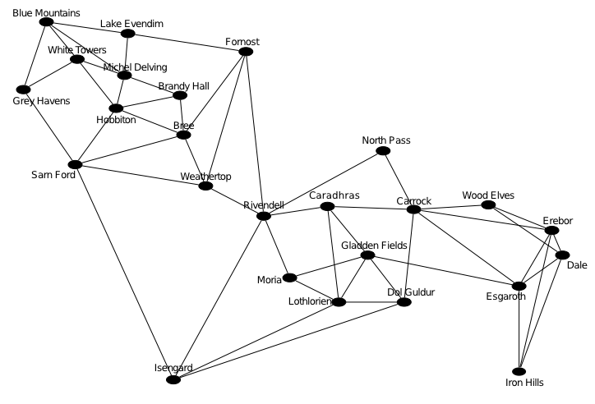

Figure 1. Connections between locations. NOTE: NOT DRAWN TO SCALE! SEE TABLES 1 AND 2 FOR INFORMATION. THIS GRAPH IS FOR CONNECTIVITY INFORMATION ONLY1