**17) Explain UNIX**

Unix is an operating system which was discovered by Dennis Ritchie and Ken Thompson at AT&T bell labs in 1960. Since then, it has been under constant development and has various flavours.

Some of the UNIX based Operating systems Sun Solaris, GNU/Linux, and MacOS X

**Characteristics of UNIX**

* It is open-source software.
* It is free ware.
* Multiuser Operating system
* Multitasking Operating system
* Supports both GUI and CUI.
* More secure as compared with other operating systems.

**Components of LINUX operating system**

LINUX has two important components

1-Shell 2-Kernel



Shell

Kernel

Hardware



**User**

**Shell**

It is outer layer of OS.

Shell reads the commands given by Programmer.

Check the validity of that command

If given command is valid then Shell convert that command into Kernel understandable format and handover it to Kernel.

Acts as an interface between user and Kernel.

**Kernel**

Kernel is the core part of OS.

It acts as a interface between Shell and hardware.

Kernel is responsible for executing user command with the help of hardware.

Memory allocation, Process allocation is handled by Kernel.

**Q-18) Explain Grep**

**Grep**is an acronym that stands for **G**lobal **R**egular **E**xpression **P**rint.

Grep is a Linux / Unix command-line tool used to search for a string of characters in a specified file. The text search pattern is called a regular expression. When it finds a match, it prints the line with the result. The grep command is handy when searching through large log files.

**Example1**-In the given text file searching a particular keyword and printing the lines in which that word is available using grep command

**grep keyword fileName**

**Syntax**

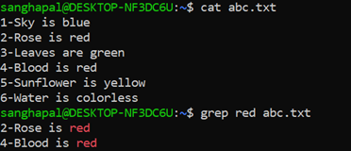

**Example2-** In the given text file searching a particular keyword and printing the lines in which that word is unavailable using grep command

grep -v keyword fileName

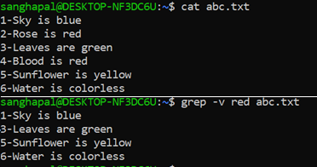**Syntax**

**Example3-** In the given text file searching a particular keyword and printing the lines in which that word is available with

Case1- Searched keyword + Succeeding line

Case2- Preceding line+ Searched keyword

Case3- Preceding line +Searched keyword + a succeeding line

Note – Numbers after alphabet A/B/C indicates number of lines to be printed. We can change that number according to need.

grep -A1 keyword filename

grep -B1 keyword filename

grep -C1 keyword filename

**Syntax**

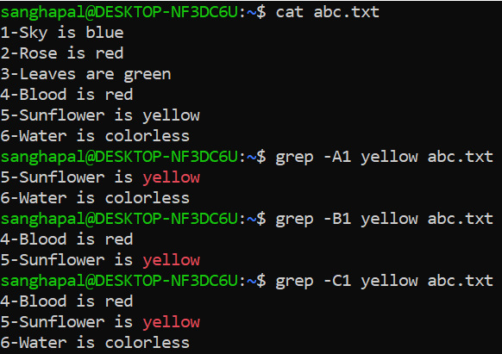

**Q-19) Explain Pipe**

Output of one command is given as an input to another command.

Two or more commands can be combined with the help of Pipe.

Command1

Command3

Command2

**Syntax-**

Two commands Command1 | Command2

Multiple commands Command1 | Command2 | Command3 | Command4

**Example1-** Sort the list using Pipe

Here we are displaying the content of a text file and sorting at the same time with the help of piping.

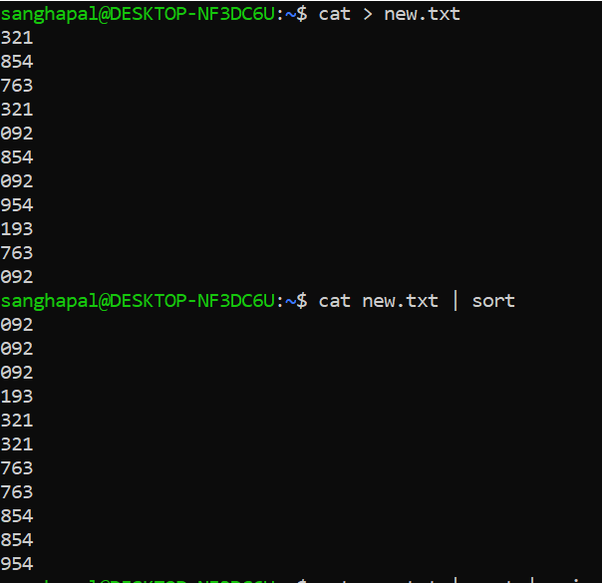

**Example2-** Sort the list and remove duplicate tags using Pipe

Here we are displaying the content of a text file, sorting and removing duplicate tags at the same time with the help of piping.

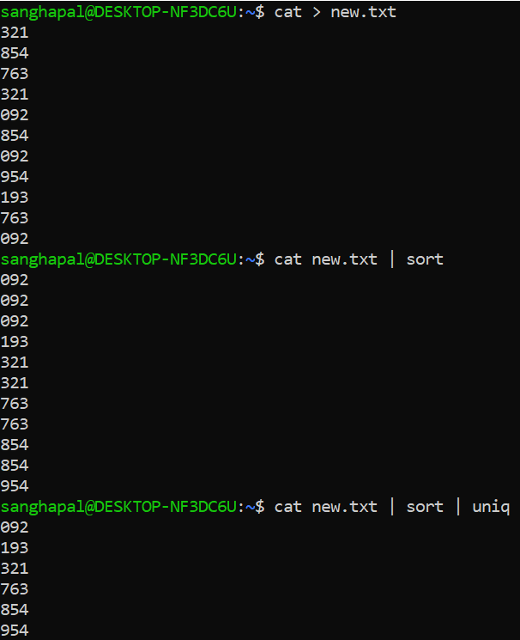

**Q-20) Explain difference between Process and Thread**

