## 需求分析及功能描述

## E-R概念模型设计与分析

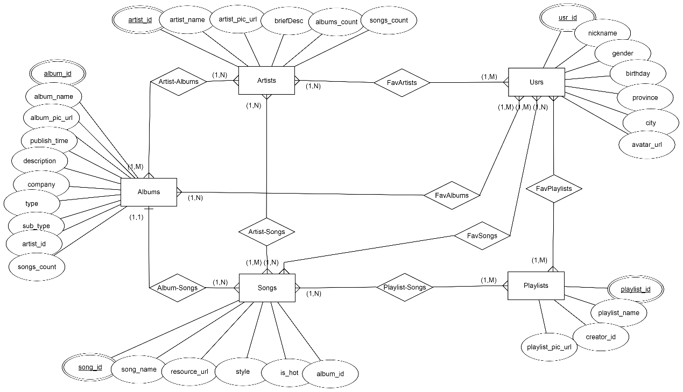

## 关系数据模型

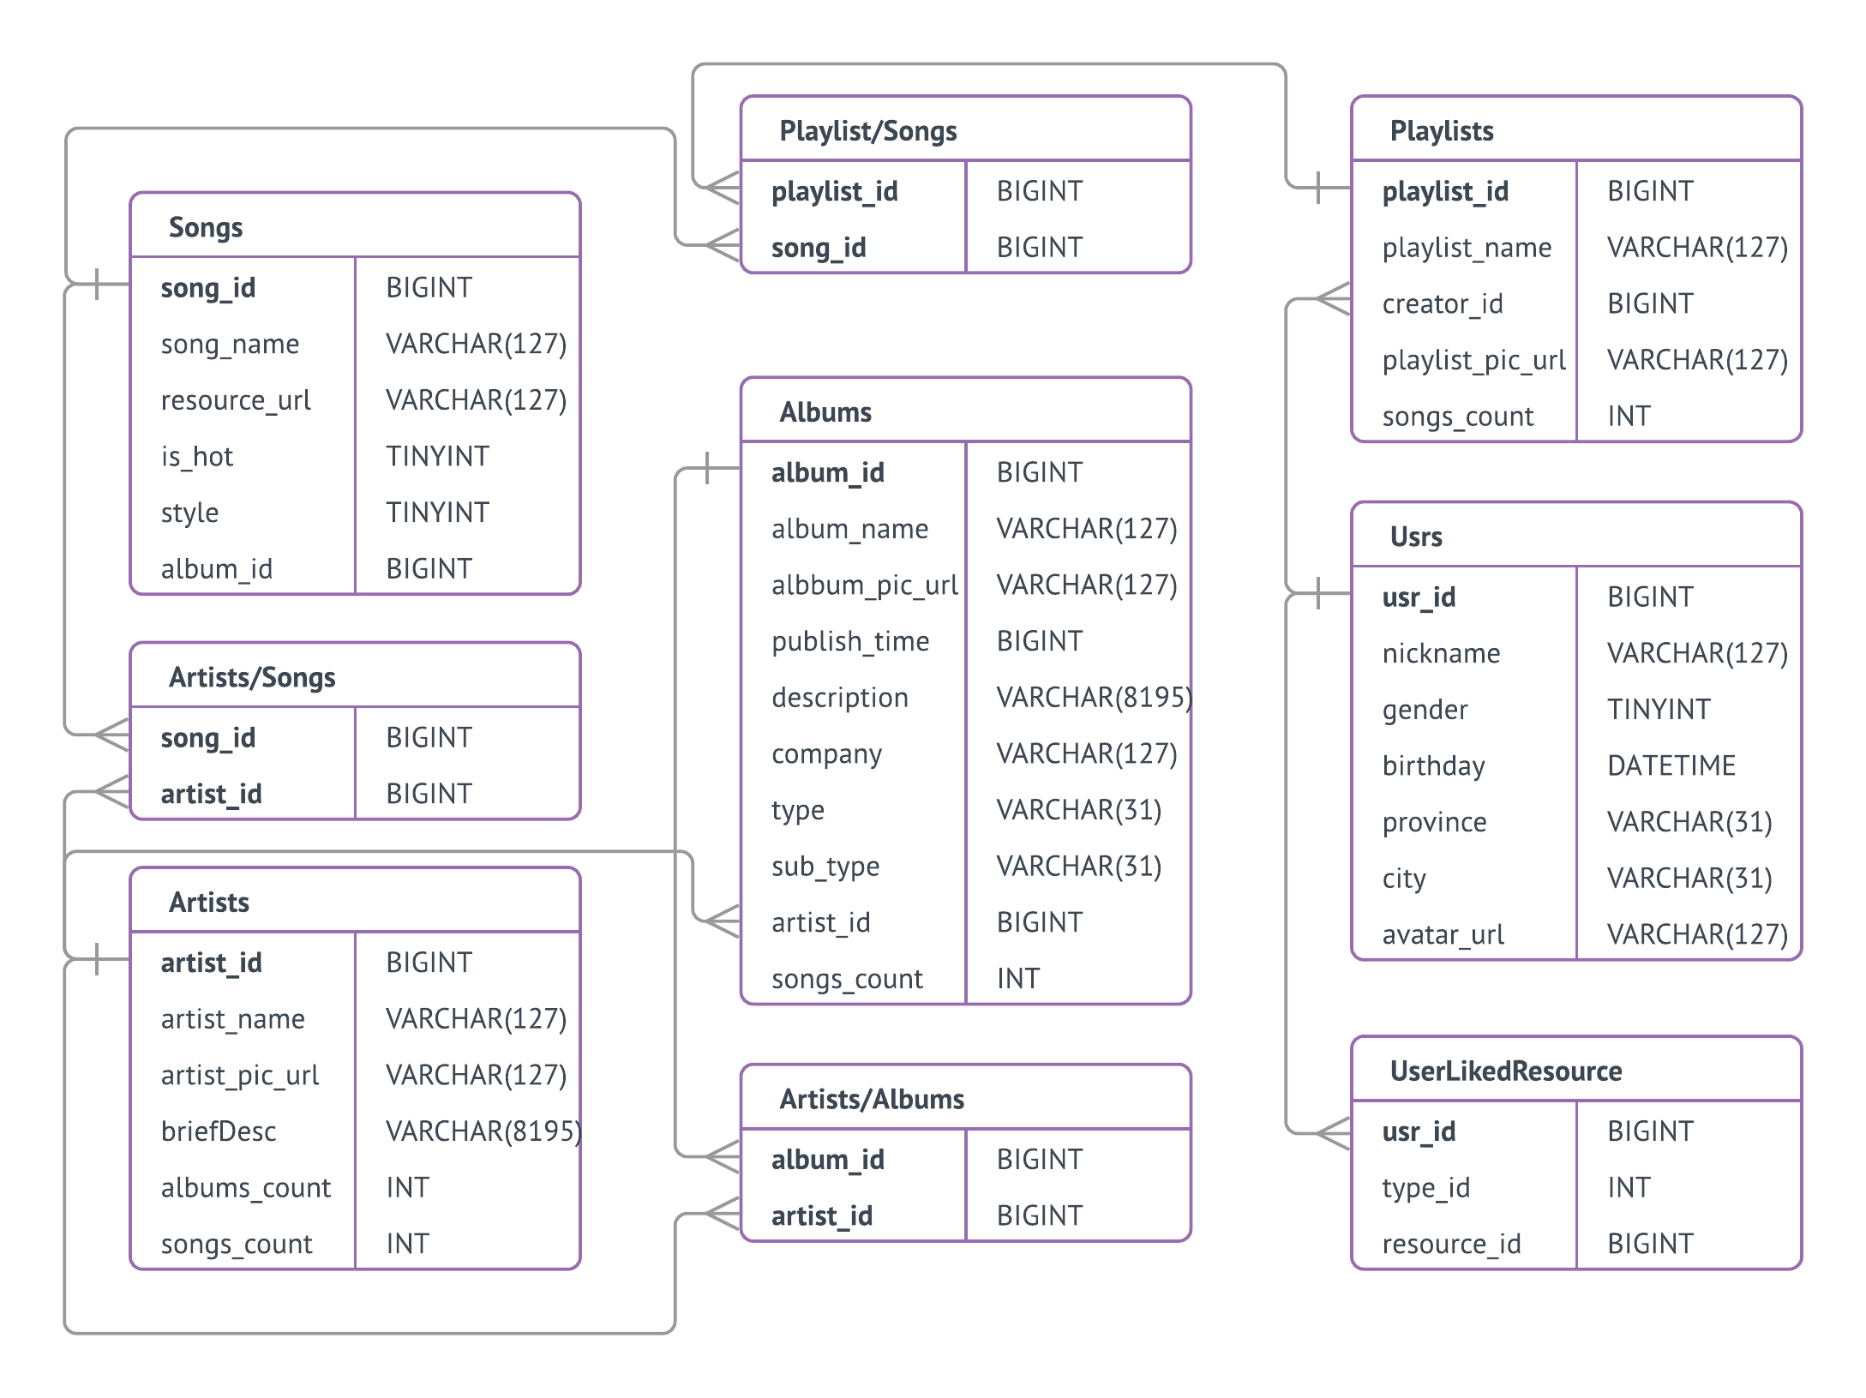

## 数据库构建代码

|  |
| --- |
| -- create_music_database.sql  -- ﻿DROP DATABASE MUSIC;  **CREATE** DATABASE MUSIC**;**  **USE** MUSIC**;**  **CREATE** **TABLE** SONGS **(**  song_id **BIGINT** UNSIGNED **NOT** **NULL,**  song_name **VARCHAR(**127**)** **NOT** **NULL,**  resource_url **VARCHAR(**127**)** **NOT** **NULL** **DEFAULT** ''**,**  style **VARCHAR(**31**),**  is_hot **TINYINT** UNSIGNED **NOT** **NULL** **DEFAULT** 0**,**  album_id **BIGINT** UNSIGNED **NOT** **NULL,**  **PRIMARY** **KEY** **(**song_id**)**  **)** **CHARACTER** **SET** utf8**;**  **CREATE** **TABLE** ARTISTS **(**  artist_id **BIGINT** UNSIGNED **NOT** **NULL,**  artist_name **VARCHAR(**127**)** **NOT** **NULL,**  artist_pic_url **VARCHAR(**127**),**  briefDesc **VARCHAR(**8191**),**  albums_count **INT** UNSIGNED **NOT** **NULL** **DEFAULT** 0**,**  songs_count **INT** UNSIGNED **NOT** **NULL** **DEFAULT** 0**,**  **PRIMARY** **KEY** **(**artist_id**)**  **)CHARACTER** **SET** utf8**;**  **CREATE** **TABLE** ALBUMS **(**  album_id **BIGINT** UNSIGNED **NOT** **NULL,**  album_name **VARCHAR(**127**)** **NOT** **NULL,**  album_pic_url **VARCHAR(**127**)** **,**  publish_time **BIGINT** UNSIGNED **NOT** **NULL,**  description **VARCHAR(**8191**),**  company **VARCHAR(**127**),**  type **VARCHAR(**31**),**  sub_type **VARCHAR(**31**),**  artist_id **BIGINT** UNSIGNED **NOT** **NULL,**  songs_count **INT** UNSIGNED **NOT** **NULL,**  **FOREIGN** **KEY** **(**artist_id**)** **REFERENCES** ARTISTS**(**artist_id**)**  **ON** **DELETE** **CASCADE**  **ON** **UPDATE** **CASCADE**  **PRIMARY** **KEY** **(**album_id**)**  **)CHARACTER** **SET** utf8**;**  **CREATE** **TABLE** USRS**(**  usr_id **BIGINT** UNSIGNED **NOT** **NULL,**  nickname **VARCHAR(**127**)** **NOT** **NULL,**  gender **TINYINT** **NOT** **NULL** **DEFAULT** 0**,**  birthday **DATETIME,**  province **VARCHAR(**31**)** **,**  city **VARCHAR(**31**)** **,**  avatar_url **VARCHAR(**127**)** **,**  **PRIMARY** **KEY** **(**usr_id**)**  **)CHARACTER** **SET** utf8**;**  **CREATE** **TABLE** PLAYLISTS**(**  playlist_id **BIGINT** UNSIGNED **NOT** **NULL,**  creator_id **BIGINT** UNSIGNED **NOT** **NULL,**  playlist_pic_url **VARCHAR(**127**),**  **PRIMARY** **KEY** **(**playlist_id**)**  **)CHARACTER** **SET** utf8**;**  **CREATE** **TABLE** Artist_Songs**(**  artist_id **BIGINT** UNSIGNED **NOT** **NULL,**  song_id **BIGINT** UNSIGNED **NOT** **NULL,**  **FOREIGN** **KEY** **(**song_id**)** **REFERENCES** SONGS**(**song_id**)**  **ON** **DELETE** **CASCADE**  **ON** **UPDATE** **CASCADE,**  **FOREIGN** **KEY** **(**artist_id**)** **REFERENCES** ARTISTS**(**artist_id**)**  **ON** **DELETE** **CASCADE**  **ON** **UPDATE** **CASCADE** **,**  **PRIMARY** **KEY** **(**artist_id**,** song_id**)**  **)CHARACTER** **SET** utf8**;**  **CREATE** **TABLE** Artist_Hot_Songs**(**  artist_id **BIGINT** UNSIGNED **NOT** **NULL,**  song_id **BIGINT** UNSIGNED **NOT** **NULL,**  **FOREIGN** **KEY** **(**song_id**)** **REFERENCES** SONGS**(**song_id**)**  **ON** **DELETE** **CASCADE**  **ON** **UPDATE** **CASCADE,**  **FOREIGN** **KEY** **(**artist_id**)** **REFERENCES** ARTISTS**(**artist_id**)**  **ON** **DELETE** **CASCADE**  **ON** **UPDATE** **CASCADE** **,**  **PRIMARY** **KEY** **(**artist_id**,** song_id**)**  **)CHARACTER** **SET** utf8**;**  **CREATE** **TABLE** Artist_Albums**(**  artist_id **BIGINT** UNSIGNED **NOT** **NULL,**  album_id **BIGINT** UNSIGNED **NOT** **NULL,**  **FOREIGN** **KEY** **(**album_id**)** **REFERENCES** ALBUMS**(**album_id**)**  **ON** **DELETE** **CASCADE**  **ON** **UPDATE** **CASCADE** **,**  **FOREIGN** **KEY** **(**artist_id**)** **REFERENCES** ARTISTS**(**artist_id**)**  **ON** **DELETE** **CASCADE**  **ON** **UPDATE** **CASCADE,**  **PRIMARY** **KEY** **(**artist_id**,** album_id**)**  **)CHARACTER** **SET** utf8**;**  **CREATE** **TABLE** Usr_Liked_Resource**(**  usr_id **BIGINT** UNSIGNED **NOT** **NULL,**  type_id **INT** UNSIGNED **NOT** **NULL**  **CHECK(**type_id **in** **(**1**,** 10**,** 127**,** 1270**)),** /*appoint to resource type*/  resource_id **BIGINT** UNSIGNED **NOT** **NULL,** /*can be song_id, artist_id, album_id, playlist_id*/  **FOREIGN** **KEY** **(**usr_id**)** **REFERENCES** USRS**(**usr_id**)**  **ON** **DELETE** **CASCADE**  **ON** **UPDATE** **CASCADE**  **)CHARACTER** **SET** utf8**;**  **CREATE** **TABLE** Playlist_Songs**(**  playlist_id **BIGINT** UNSIGNED **NOT** **NULL,**  song_id **BIGINT** UNSIGNED **NOT** **NULL,**  **FOREIGN** **KEY** **(**song_id**)** **REFERENCES** SONGS**(**song_id**)**  **ON** **DELETE** **CASCADE**  **ON** **UPDATE** **CASCADE,**  **FOREIGN** **KEY** **(**playlist_id**)** **REFERENCES** PLAYLISTS**(**playlist_id**)**  **ON** **DELETE** **CASCADE**  **ON** **UPDATE** **CASCADE**  **)CHARACTER** **SET** utf8**;** |

## 实体应用程序