Q learning:

* Q-value indicates the quality of a particular action a in given state s
 $Q(s,a)$

 + Current estimate of the sum of future rewards
    - Will increase as agent gets closer to highest reward.
* Q-values stored in Q-table
  + One row for each possible state, and one column for reach action
  + Represents the policy for acting in the current environment.
* Temporal differences provide method of calculating how much the Q-value for the action taken in the previous state should be changed, based on what AI agent has learned.
$TD\left(s_{t},a_{t}\right)=r_{t}+γ*max⁡Q\left(s_{t+1},a\right)-Q(s_{t},a_{t})$

* Bellman Backup

$Q^{new}\left(s_{t},a_{t}\right)=Q^{old}\left(s_{t},a_{t}\right)+α*TD\left(s_{t},a_{t}\right)$

$α=learning rate$

Q Learning Process:

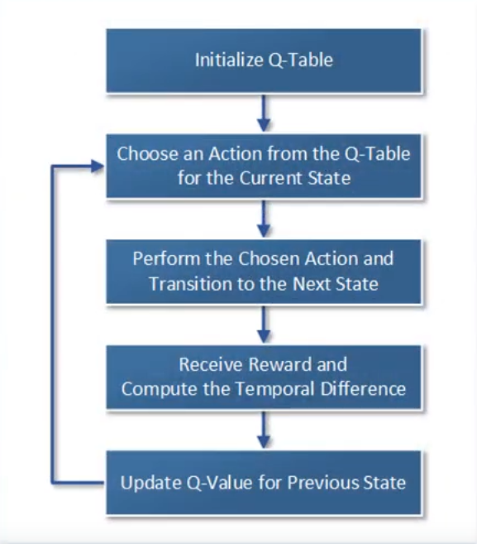

Notes:

* In order to prevent the highest Q-value from being selected every time, implement an “Epsilon greedy algorithm” which includes an element of chance in which action it selects.