**分样单**

|  |  |  |  |  |  |  |
| --- | --- | --- | --- | --- | --- | --- |
| **样品编号** | **样品名称** | **测试项目及标准** | **储存条件** | **测试部门** | **紧急程度** | **备注** |
|  |  |  |  |  |  |  |
|  |  |  |  |  |  |  |
|  |  |  |  |  |  |  |
|  |  |  |  |  |  |  |
|  |  |  |  |  |  |  |
|  |  |  |  |  |  |  |
|  |  |  |  |  |  |  |

样品流转 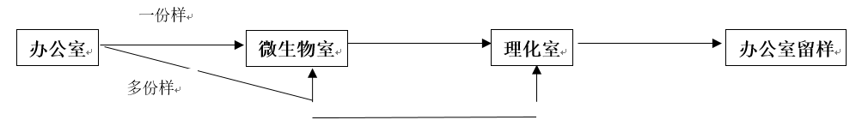

分样人: _____________ 收样人: ______________ 收样人: ______________ 收样人: ______________

分样时间:_________ __ 收样时间: _____________ 收样时间: _____________ 收样时间: _____________