# 网址<http://oneseek.cn/javaee_1/>

# 截图

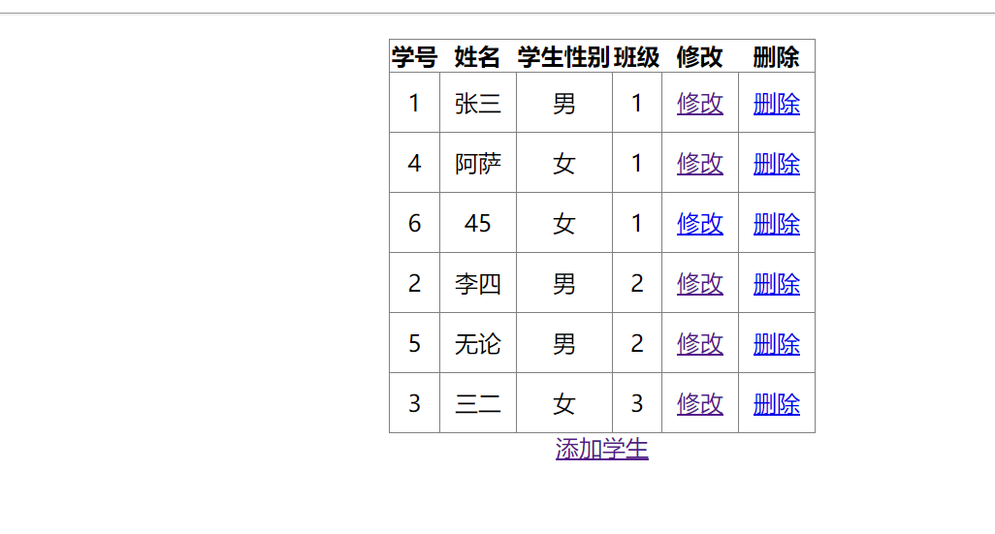

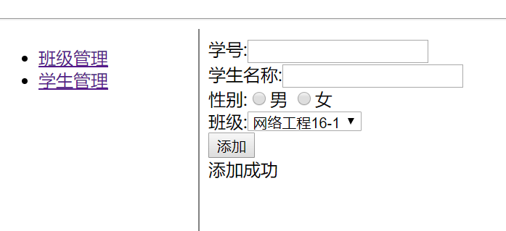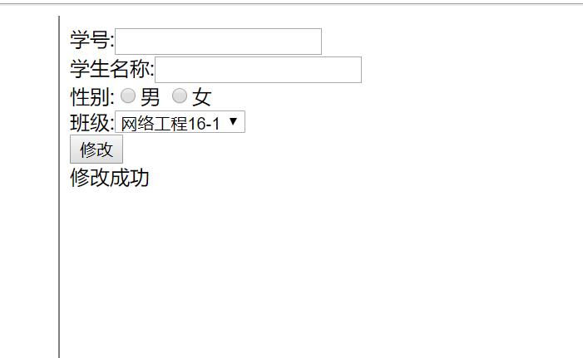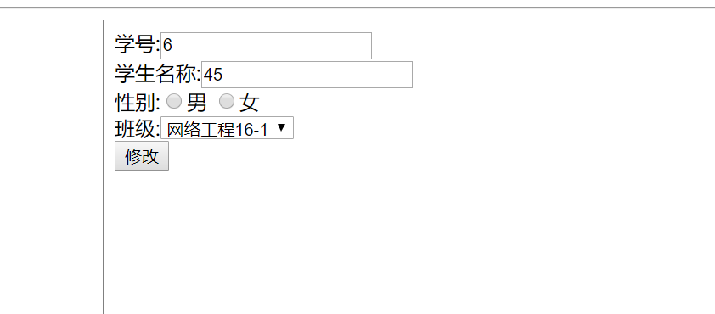

# Servlet代码

## StudentServlet.java

package servlet;  
  
import java.io.IOException;  
import java.util.List;  
  
import javax.servlet.ServletException;  
import javax.servlet.annotation.WebServlet;  
import javax.servlet.http.HttpServlet;  
import javax.servlet.http.HttpServletRequest;  
import javax.servlet.http.HttpServletResponse;  
  
import dao.StudentDao;  
import vo.Bj;  
import vo.Student;  
  
*/**  
 * Servlet implementation class studentServlet  
 */*@WebServlet("/studentServlet")  
public class StudentServlet extends HttpServlet {  
 private static final long *serialVersionUID* = 1L;  
  
 */**  
 \** ***@see*** *HttpServlet#HttpServlet()  
 */* public StudentServlet() {  
 super();  
 // *TODO Auto-generated constructor stub* }  
  
 */**  
 \** ***@see*** *HttpServlet#doGet(HttpServletRequest request, HttpServletResponse response)  
 */* protected void doGet(HttpServletRequest request, HttpServletResponse response) throws ServletException, IOException {  
 // *TODO Auto-generated method stub* request.setCharacterEncoding("UTF-8");  
  
 String action=request.getParameter("action");  
 if("list".equals(action)){  
 this.list(request,response);  
 }else if("add".equals(action)){  
 this.add(request,response);  
 }else if("edit".equals(action)){  
 this.edit(request,response);  
 }else if("update".equals(action)){  
 this.update(request,response);  
 }else if("delete".equals(action)){  
 this.delete(request,response);  
 }  
  
  
 }  
 private void list(HttpServletRequest request, HttpServletResponse response){  
 StudentDao studentDao=new StudentDao();  
 try {  
 List<Student> studentList = studentDao.queryAll();  
 request.setAttribute("studentList",studentList);  
 request.getRequestDispatcher("/student/list.jsp").forward(request, response);  
 } catch (Exception e) {  
 // *TODO Auto-generated catch block* e.printStackTrace();  
 }  
 }  
  
 private void add(HttpServletRequest request, HttpServletResponse response){  
 StudentDao studentDao=new StudentDao();  
 try {  
 Student student=new Student();  
 student.setSname(request.getParameter("student_name"));  
 Bj bj = new Bj();  
 bj.setBjname(request.getParameter("student_bj_id"));  
 bj.setId(Integer.*parseInt*(request.getParameter("student_bj_id")));  
 student.setBj(bj);  
  
 student.setSno(request.getParameter("student_no"));  
 student.setSex(request.getParameter("student_sex"));  
 studentDao.add(student);  
 request.setAttribute("info","添加成功");  
 request.getRequestDispatcher("/student/add.jsp").forward(request, response);  
 } catch (Exception e) {  
 // *TODO Auto-generated catch block* e.printStackTrace();  
 }  
 }  
 private void edit(HttpServletRequest request, HttpServletResponse response){  
 StudentDao studentDao=new StudentDao();  
 try {  
 Student student = studentDao.findStudentById(Integer.*parseInt*(request.getParameter("id")));  
 request.setAttribute("student",student);  
 request.getRequestDispatcher("/student/edit.jsp").forward(request, response);  
 } catch (Exception e) {  
 // *TODO Auto-generated catch block* e.printStackTrace();  
 }  
 }  
 private void update(HttpServletRequest request, HttpServletResponse response) {  
 StudentDao studentDao=new StudentDao();  
 try {  
 Student student=new Student();  
 student.setId(Integer.*parseInt*(request.getParameter("student_id")));  
 student.setSno(request.getParameter("student_no"));  
 student.setSname(request.getParameter("student_name"));  
 student.setSex(request.getParameter("student_sex"));  
  
 Bj bj = new Bj();  
 bj.setId(Integer.*parseInt*(request.getParameter("student_bj_id")));  
 bj.setBjname(request.getParameter("student_bj_id"));  
 student.setBj(bj);  
  
 studentDao.update(student);  
 request.setAttribute("info","修改成功");  
 request.getRequestDispatcher("/student/edit.jsp").forward(request, response);  
 } catch (Exception e) {  
 // *TODO Auto-generated catch block* e.printStackTrace();  
 }  
 }  
 private void delete(HttpServletRequest request, HttpServletResponse response){  
 StudentDao StudentDao=new StudentDao();  
 try {  
 StudentDao.delete(Integer.*parseInt*(request.getParameter("id")));  
 request.getRequestDispatcher("/studentServlet?action=list").forward(request, response);  
 } catch (Exception e) {  
 // *TODO Auto-generated catch block* e.printStackTrace();  
 }  
 }  
  
 */**  
 \** ***@see*** *HttpServlet#doPost(HttpServletRequest request, HttpServletResponse response)  
 */* protected void doPost(HttpServletRequest request, HttpServletResponse response) throws ServletException, IOException {  
 // *TODO Auto-generated method stub* this.doGet(request, response);  
 }  
  
}

# 页面源码：

## add.jsp

<%@ **page** pageEncoding="UTF-8"%>  
<%@**taglib** prefix="c" uri="http://java.sun.com/jsp/jstl/core" %>   
<**c:set** var="basePath" value="${pageContext.request.contextPath}"/>  
<!DOCTYPE html>  
<html>  
<head>   
 <meta charset="utf-8" />   
 <meta name="viewport" content="width=device-width, initial-scale=1.0" />   
 <title>学生列表</title>  
 <style>   
   
 </style>   
<body>   
<form action="${basePath}/studentServlet?action=add" method="post">  
  
 学号:<input name="student_no" value=""/><br>  
 学生名称:<input name="student_name" value=""/><br>  
 性别:<input name="student_sex" type="radio" value="男"/>男  
 <input name="student_sex" type="radio" value="女"/>女  
 <br>  
 班级:<select name="student_bj_id">  
 <option value="1">网络工程16-1</option>  
 <option value="2">计开发16-1</option>  
 <option value="3">计测试16-1</option>  
 <option value="4">空间16-1</option>  
</select>  
 <br>  
 <input type="submit" value="添加"/>  
</form>  
${info}  
</body>   
</html>

## edit.jsp

<%@ **page** contentType="text/html;charset=UTF-8" language="java" pageEncoding="UTF-8"%>  
<%@**taglib** prefix="c" uri="http://java.sun.com/jsp/jstl/core" %>  
<**c:set** var="basePath" value="${pageContext.request.contextPath}"/>  
<!DOCTYPE html>  
<html>  
<head>   
 <meta charset="utf-8" />  
 <meta name="viewport" content="width=device-width, initial-scale=1.0" />   
 <title>学生列表</title>  
 <style>   
   
 </style>   
<body>   
<form action="${basePath}/studentServlet?action=update" method="post">  
 <input type="hidden" name="student_id" value="${student.id}"/>  
  
 学号:<input name="student_no" value="${student.sno}"/><br>  
 学生名称:<input name="student_name" value="${student.sname}"/><br>  
 性别:<input name="student_sex" type="radio" value="男"/>男  
 <input name="student_sex" type="radio" value="女"/>女  
 <br>  
 班级:<select name="student_bj_id">  
 <option value="1">网络工程16-1</option>  
 <option value="2">计开发16-1</option>  
 <option value="3">计测试16-1</option>  
 <option value="4">空间16-1</option>  
 </select>  
 <br>  
 <input type="submit" value="修改"/>  
</form>  
${info}  
</body>   
</html>

## list.jsp

<%@ **page** contentType="text/html;charset=UTF-8" language="java" pageEncoding="UTF-8"%>  
<%@**taglib** prefix="c" uri="http://java.sun.com/jsp/jstl/core" %>  
<**c:set** var="basePath" value="${pageContext.request.contextPath}"/>  
<!DOCTYPE html>  
<html>  
<head>   
 <meta charset="utf-8" />  
 <meta name="viewport" content="width=device-width, initial-scale=1.0" />   
 <title>学生列表</title>  
 <style>   
   
 </style>   
<body>   
<form action="${basePath}/studentServlet?action=update" method="post">  
 <input type="hidden" name="student_id" value="${student.id}"/>  
  
 学号:<input name="student_no" value="${student.sno}"/><br>  
 学生名称:<input name="student_name" value="${student.sname}"/><br>  
 性别:<input name="student_sex" type="radio" value="男"/>男  
 <input name="student_sex" type="radio" value="女"/>女  
 <br>  
 班级:<select name="student_bj_id">  
 <option value="1">网络工程16-1</option>  
 <option value="2">计开发16-1</option>  
 <option value="3">计测试16-1</option>  
 <option value="4">空间16-1</option>  
 </select>  
 <br>  
 <input type="submit" value="修改"/>  
</form>  
${info}  
</body>   
</html>