  lab Task 03  Introduction to Information and Communication Technology  Sir Zakria Bacha | Name: Mohsin Ali  Roll Number: 25P-0545  Section: BCS-1C

Task 1 - Adding Two Numbers (Little Man Computer
1. Ask the user to enter the first number.
2. Ask the user to enter the second number.
3. Add the two numbers together.
4. Store the result in a third variable.
5. Finally, show the result (output) on the screen.

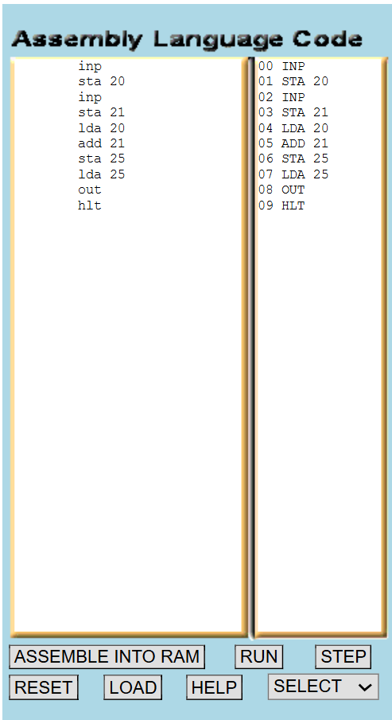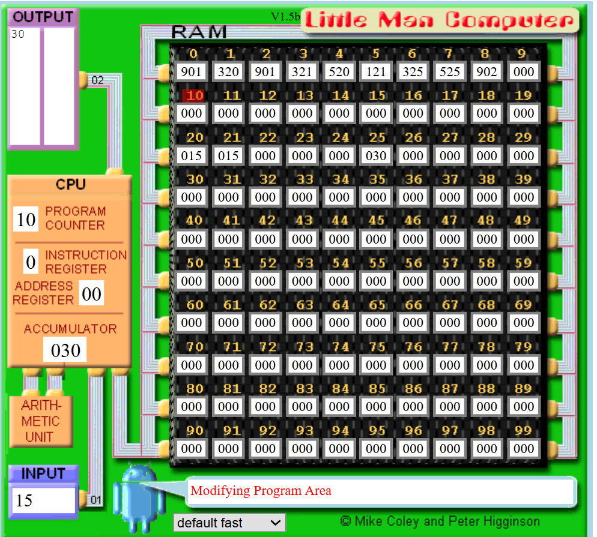

Task 2 – Adding Three Numbers (Little Man Computer – LMC)
1. Ask the user to enter the first number.
2. Ask the user to enter the second number.
3. Ask the user to enter the third number.
4. Add all three numbers together.
5. Store the result in a separate variable.
6. Finally, show the result (output) on the screen.

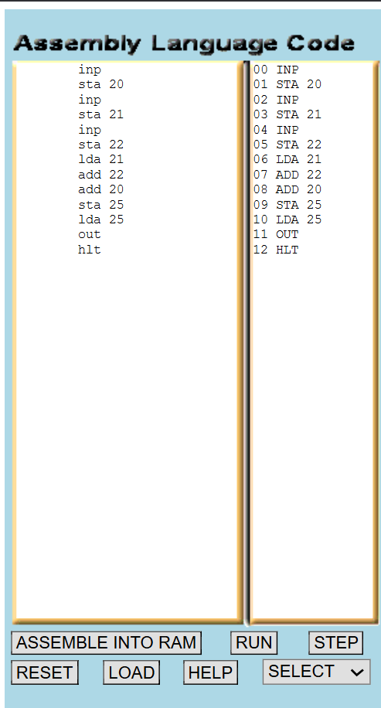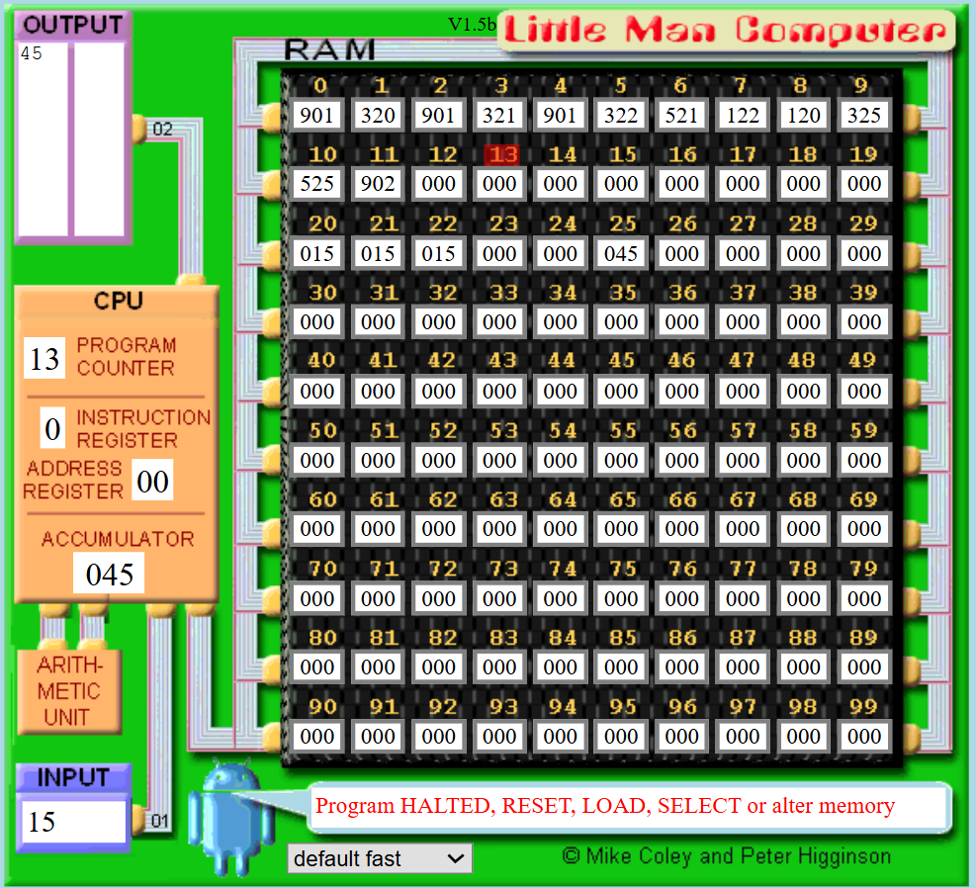

Task 3 – Subtracting Two Numbers (Little Man Computer – LMC)
1. Ask the user to enter the first number.
2. Ask the user to enter the second number.
3. Store first number in location 20 And Second number in location 25
4. Load both numbers from the memory location
5. Subtract the two numbers together.
6. Store the result in a third variable.
7. Finally, show the result (output) on the screen.

