  Lab Task 1/Assignment 1:  Information and Communication Technology Instructor Name: Sir Zakria Bacha | Details:  Number System Conversions  Name: Mohsin Ali  Roll Number: 25P-0545  Date: 29-08-2025  Section: BCS-1C

Binary | Decimal
1101₂ | 13₁₀
1010101₂ | 85₁₀
Binary to Decimal Conversion
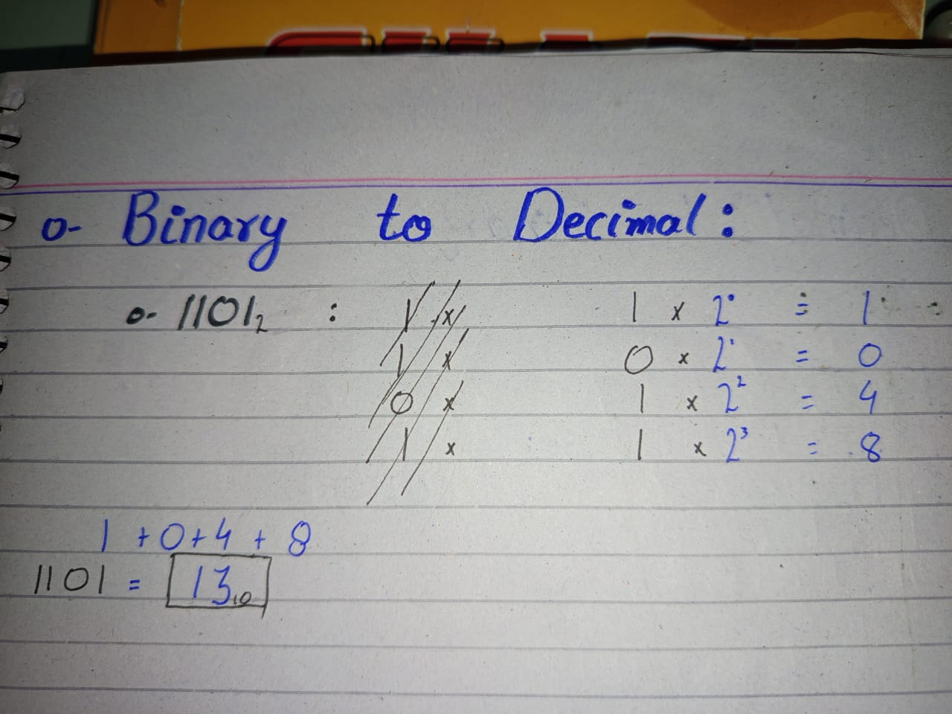
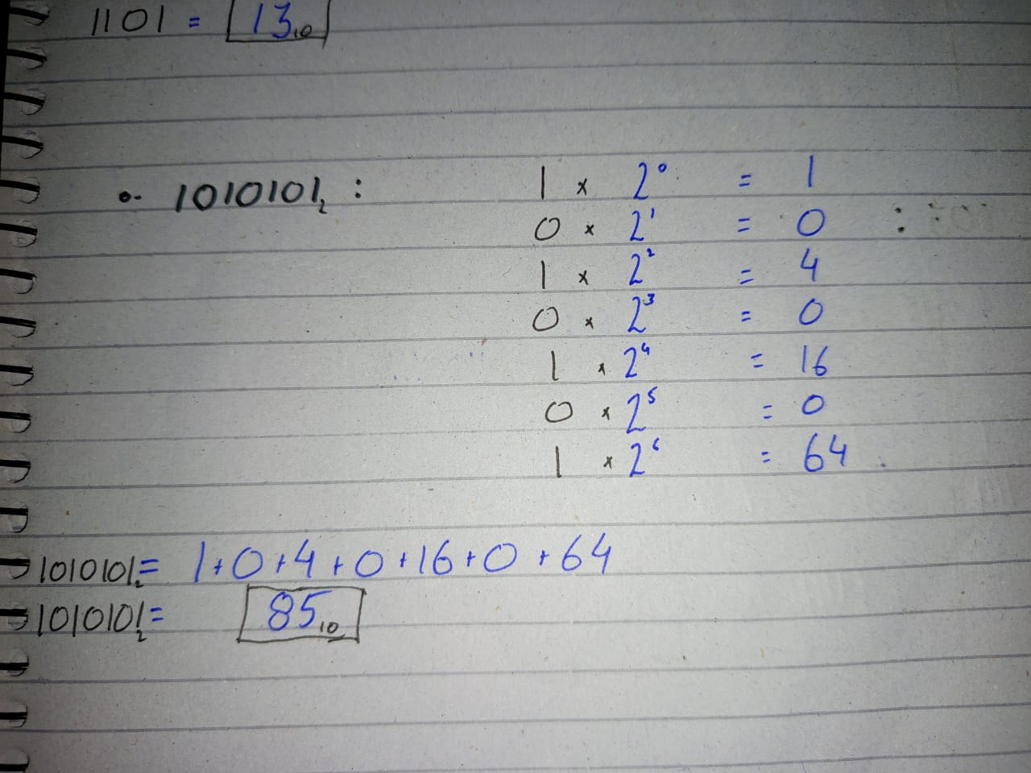
Decimal to Binary Conversion
Decimal | Binary
45₁₀ | 101101₂
103₁₀ | 1100111₂

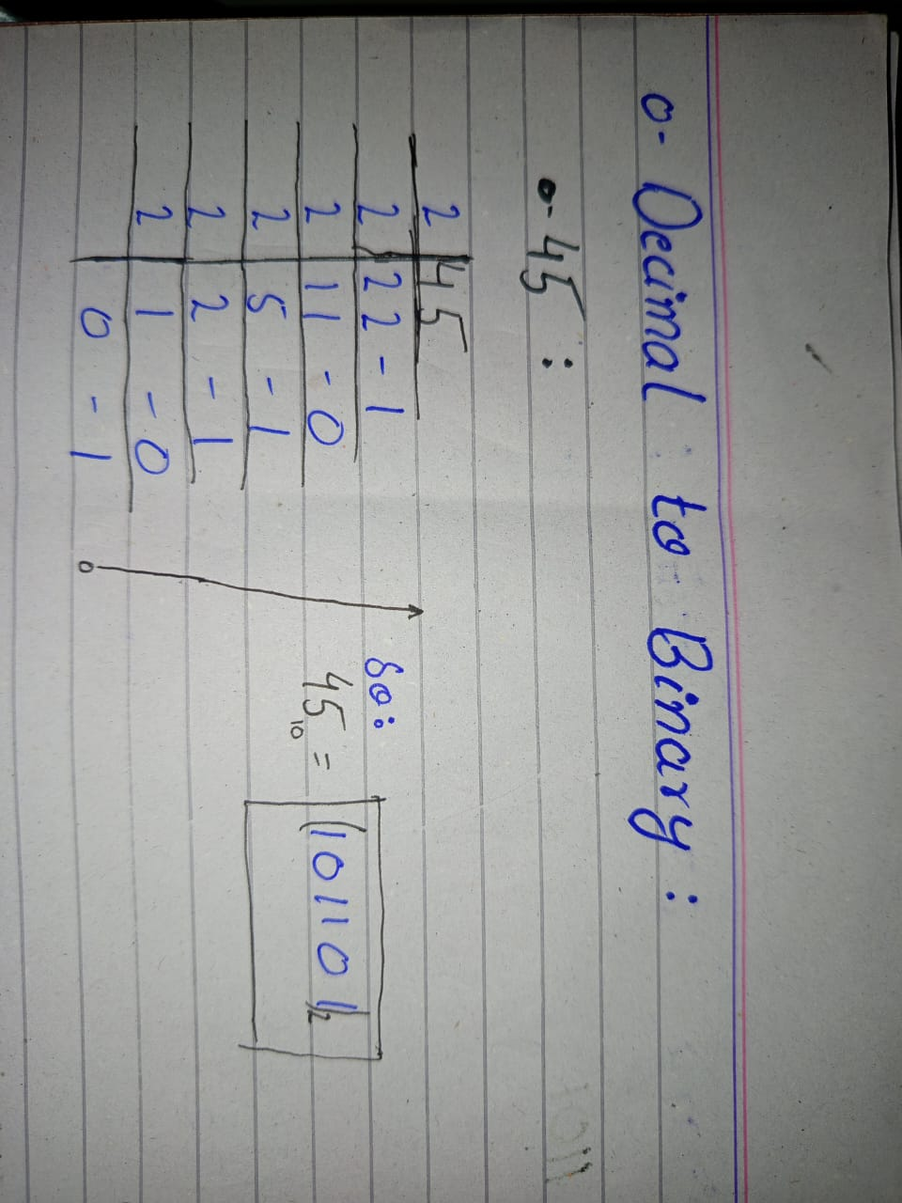
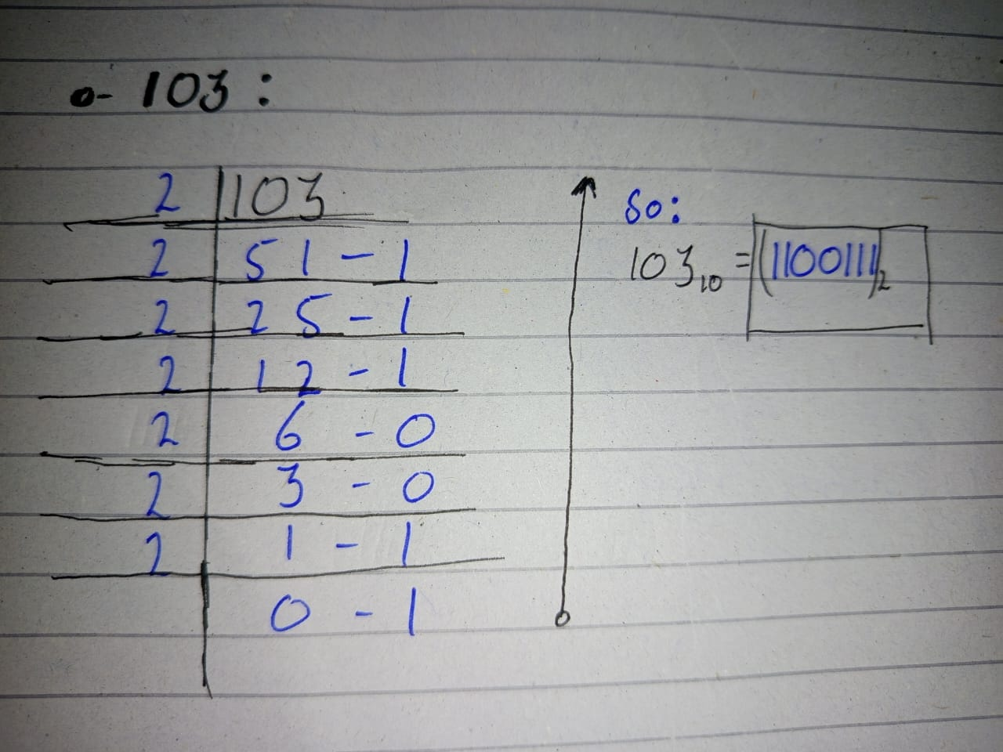
Binary to Hexadecimal
(Hexadecimal to Binary Equivalent Table is provided after 1 page)
Binary | Hexadecimal
10111101₂ | BD₁₆
11001011₂ | CB₁₆

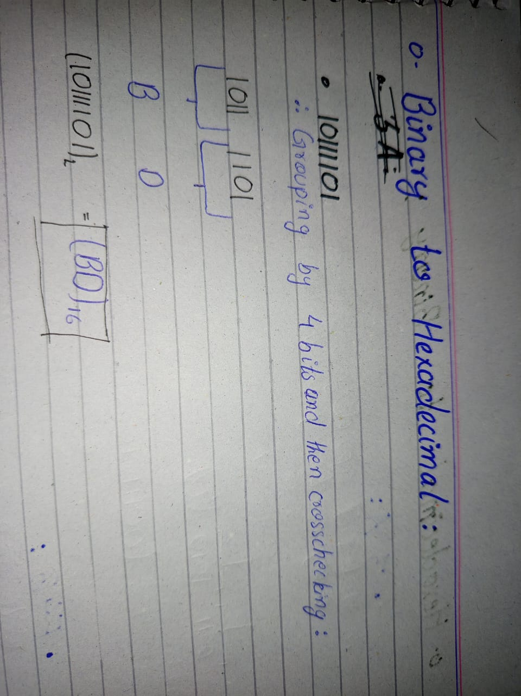
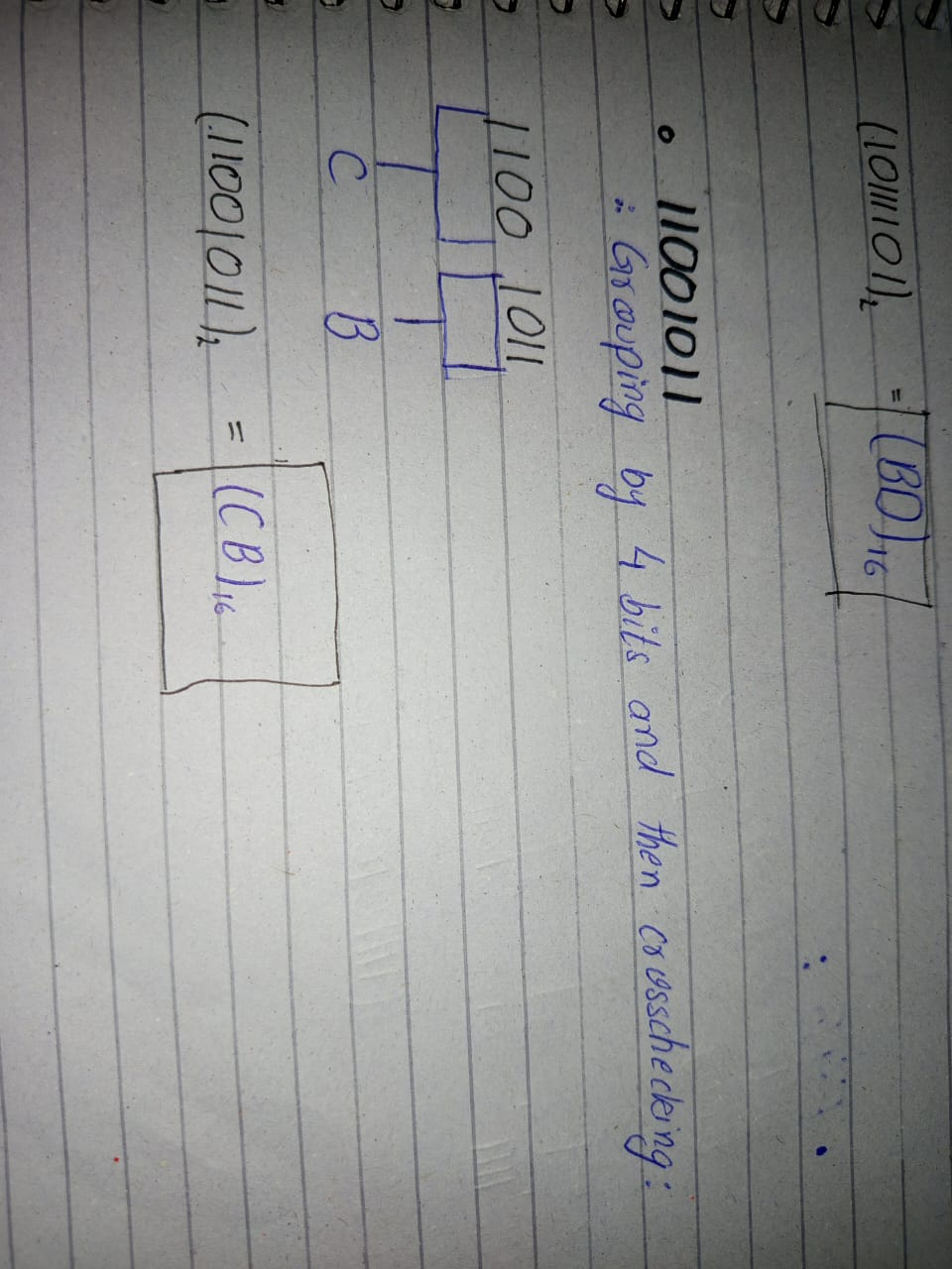

Hexadecimal to Binary
(Hexadecimal to Binary Equivalent Table is provided in the next page)
Hexadecimal | Binary
3A | 00111010₂
F4B | 111101001011₂
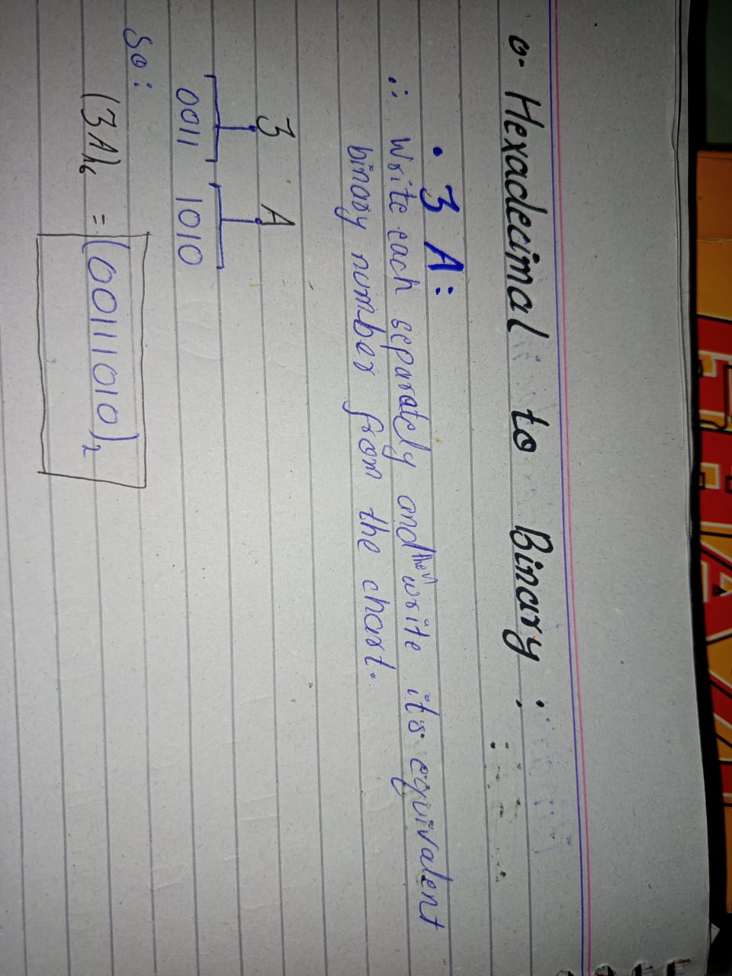
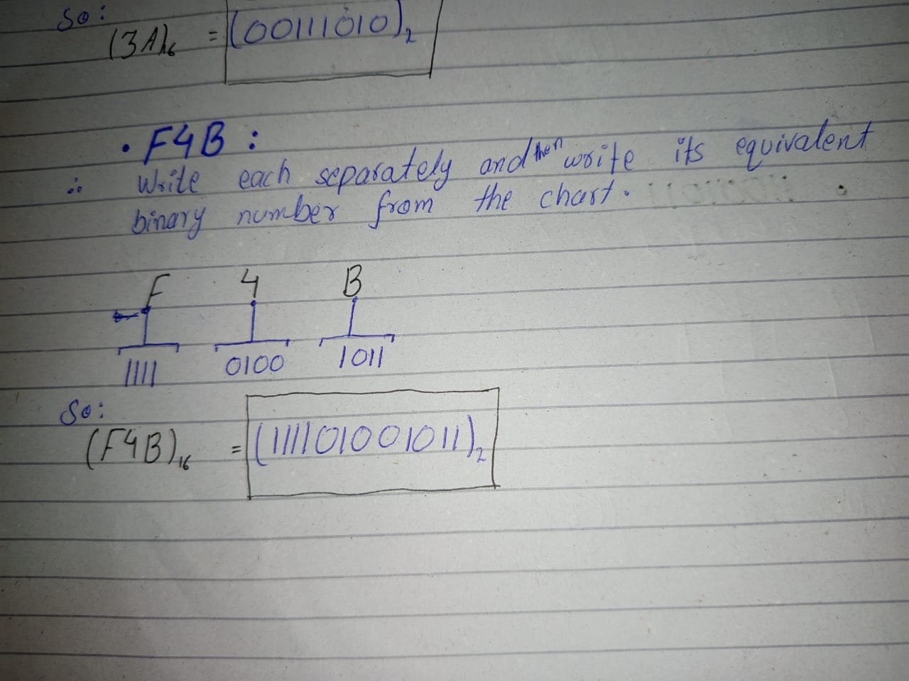

Hexadecimal to Binary Equivalent Table

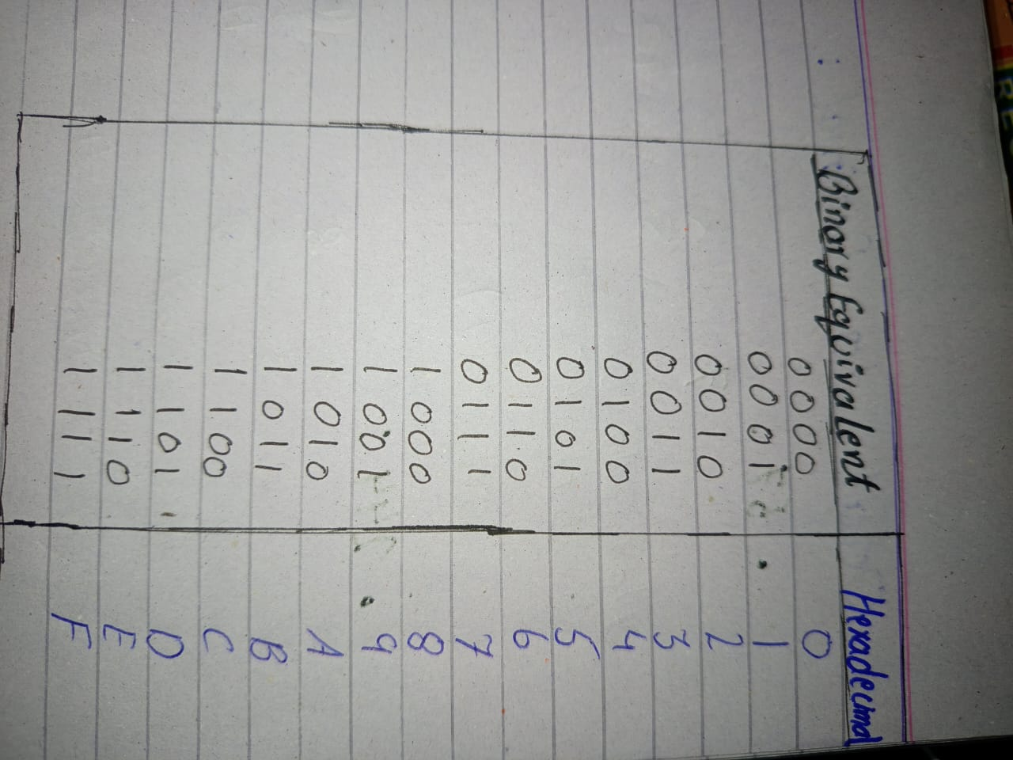

Referred to This table for conversion:
- Binary to Hexadecimal.
- Hexadecimal to Binary.

Octal to Decimal Conversion
Octal | Decimal
57₈ | 47₁₀
244₈ | 164₁₀

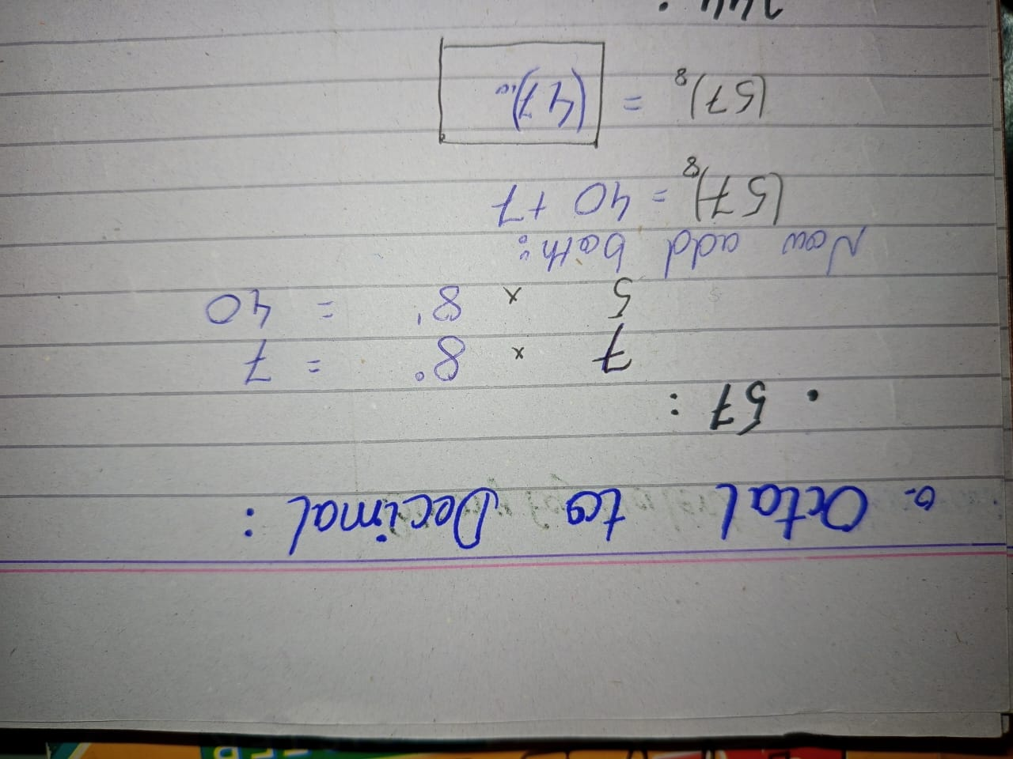
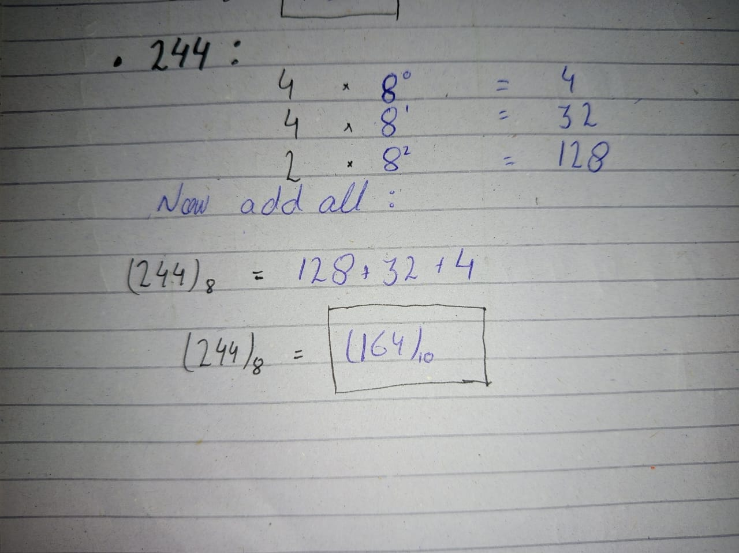

Decimal to Octal Conversion
Decimal | Octal
156₁₀ | 234₈
73₁₀ | 111₈
